Release Notes

Version 2014.07
Copyright 2013 MYOB Technology Pty Ltd and Exalt Technologies. All Rights Reserved.
Disclaimer
MYOB have made every attempt to ensure the accuracy, relevance and completeness of this material but excludes (to the extent allowed by legislation) any warranties regarding it. Furthermore MYOB, its staff and agents shall not be liable for any loss, cost or damage (however incurred including negligence) arising out of errors or omissions in the material, especially if such materials contain information sourced from third parties or the ATO. In some cases the materials provided contain case studies (applying particular accounting standards or legislation) and anecdotes which may not directly apply to the user's circumstances and are used as representative examples only and should not be considered as authoritative advice regarding any accounting standard, law or industry opinion. MYOB advises that if the user wishes to rely on the case studies contained in the material then it must seek professional advice before doing so. Furthermore reliance on the representative examples in the seminar materials is at the user's own risk.
Copyright
Furthermore the seminar and materials may not be copied, altered, edited, disposed of or distributed without the prior written consent of MYOB.
Trademark Rights
All trademarks used in this material are owned by MYOB Technology Pty Ltd or the indicated registered owners of the trademarks. Users are forbidden from using, copying or transporting the trademarks without express prior written consent. AppleShare and Macintosh are registered trademarks of Apple Computer, Inc., registered in the United States and other countries. LiveLinks is a trademark of Ceedata Holdings Pty Ltd. Microsoft, MS-DOS, Windows, Windows NT, Windows BackOffice and Outlook are either registered trademarks or trademarks of Microsoft Corporation in the United States and other countries. Novell and Netware are registered trademarks of Novell, Inc.,
MYOB Technology Pty Ltd ®
ABN 30 086 760 269
Level 3, 235 Springvale Rd
Glen Waverley VICTORIA 3150
MYOB Insolvency Version 4.1.45 Release Notes
Printed: 26 June 2014

Contents
Release summary 4
Features 5
Electronic Lodgement of Form 524 5
Changes to ASIC Process 5
EXAD Process 5
How to initiate production of the XML File 5
Changes to the Receipts and Payments Wizard 6
Changes to Form 524 Wizard 9
Document authorisation 9
User Interface Changes 10
Appointment Method Details 10
Appointment Court 10
Appointment Court State 11
Custom Task Filter 12
Document Production Preview 12
Other Features 13

Release summary
MYOB Insolvency Version 2014.07 is a beta system release.
The key changes and enhancements in this version are:
- ASIC electronic lodgement Form 524
- Added Features as detailed
- ATO PAYG and SGC rate updates

Features
This section contains specific details on the key features included in MYOB Insolvency Version 2014.7 release.

Electronic Lodgement of Form 524
ASIC is introducing an e-Lodgement process for the current 524 - Accounts and Statements by Liquidator.

Changes to ASIC Process
The process involves uploading an XML file containing all financial information. The information provided to ASIC is largely unchanged for the current information of the Form 524.

EXAD Process
The following provides a workflow of the online submission

How to initiate production of the XML File
Form 524 - Accounts and Statements by Liquidator (e-Lodgement) is available from the following menus:
- Circulars and Mailing > Forms > Form 524 (e-Lodgement) menu, and the
- Reports and Forms > Statutory Forms and Lodgements > Forms and Lodgements > Form 524 (e-Lodgement) menu

Changes to the Receipts and Payments Wizard
When producing Form 524 - Accounts and Statements by Liquidator (e-Lodgement) there has been several changes to the Receipts and Payments Wizard
Finishing the Form 524 (e Lodgement) wizard creates:
- A summary PDF version of the Form 524 including a sign off.
- A Detailed Receipts and Payments report for the same period as the Form 524.
- A lodgement record containing an associated XML file stored in the database.
Where document approval has been implemented the signoff sheet will be unnecessary.

Output folder
The PDF summary and detailed receipts and payments is output to the job’s document management \\<job folder>\Lodgements\524\.

Generating the XML file
The software now produces an XML output in a prescribed format stipulated by ASIC.
To extract the XML output file you need to locate the Form 524 PDF in the job document folder.
Right mouse click on the document and select Lodgement Details.
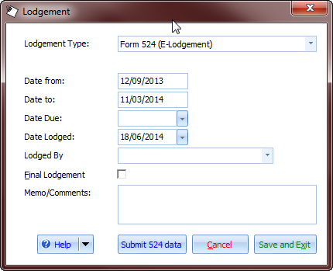
By clicking Submit 524 Data the following dialogue appears:
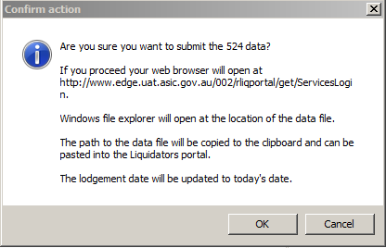
When clicking the OK button:
- The XML file is extracted into a temporary folder, and
- The path to the temporary folder XML file is copied to the clipboard
- The ASIC liquidator portal is opened in a web browser
It is important to extract the XML file using this method to ensure that any changes to the Form 524 created by running the Form 524 Wizard are is reflected in the XML data file.
The Date Lodged will be updated as soon as you select Submit 524 Data to extract XML.
You can also view and submit the XML from the Document tab by right clicking the document and selecting Submit 524 Data. The lodgement record may also be accessed from the Lodgement section of the Homepage.
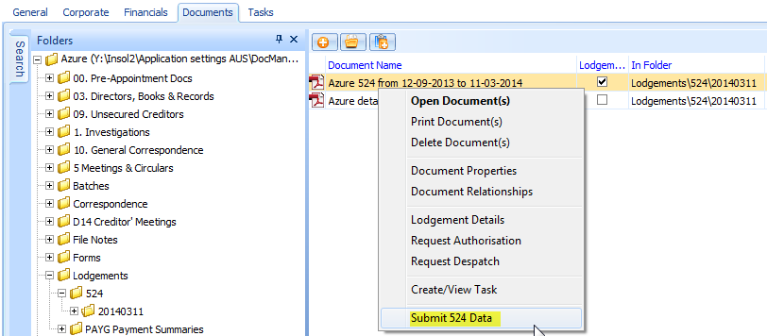

Linking the XML to the Document Lodgement
The XML that is submitted to ASIC is not available as a separate file in Document Management when the documents are created. By allowing the user to create the XML from the lodgement ensures that there isn’t multiple copies if XML files separately situated in job folders and the XML is coupled to the PDF report Pro-forma.
Submitting the XML file
Instructions on how to upload the XML files are contained in instructions provided by ASIC A quick guide to lodging a Form 524 in the new ‘structured data’ format.

Further Explanation of the workflow to extract and lodge the XML file
As soon as you generate the XML, the default web browser will automatically open to the Liquidators’ Portal Login page.
The temporary folder containing the XML file will also open, and the file path will be copied to the user’s clipboard.
To lodge the form:
- Log into the Liquidators’ Portal,
- click Start New Form
- Select Form 524 Presentation of Accounts and Statement (Structured Data)
- Click the Browse button
- Paste the path to the XML into the file name field and click OK. If you cannot paste then you would need to browse to the temporary folder containing the XML file.
- With the XML file selected click Next and then complete the declaration.
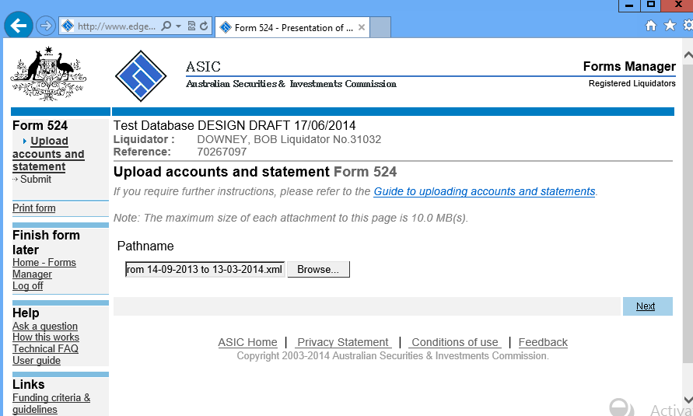

Verification of the XML file
When submitting the XML file errors with consistency of data may occur. All efforts have been made to pre-validate information, however, there still may be mismatches of data where the details in MYOB differ from the details held by ASIC.
Should you receive an error message trying to submit the Form 524 and you cannot resolve the issue by updating your data and re-running the Form 524 Wizard, call support on 1300 555 666.

Changes to Form 524 Wizard
The Form 524 Wizard accommodates for information captured in the

Document authorisation
If you have Document Authorisations enabled the document authorisation task will be created when you finish the Form 524 Wizard containing
- A link to the simple PDF 524
- A Link to the Detailed Receipts and Payments Report
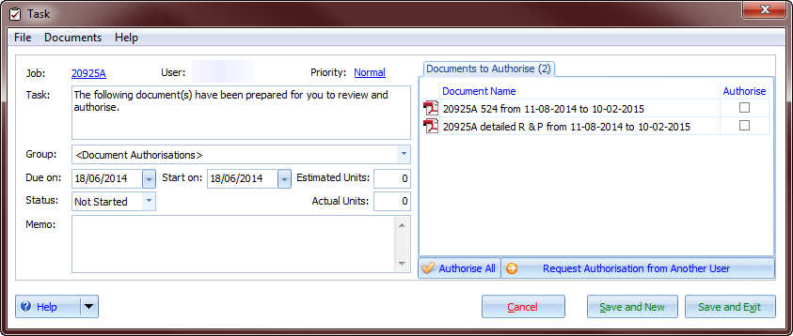

User Interface Changes
The following enhancements and resolved issues have been included in MYOB Insolvency Version 2014.7:

Appointment Method Details
The following changes have been made to the appointment details:

Appointment Court
The appointment court has been limited to defined set of values.
The appointment screen has been updated with a court selector:

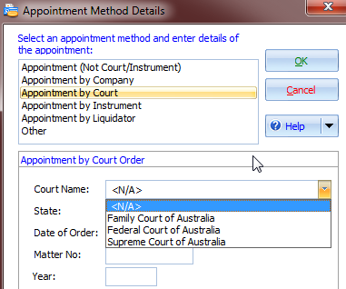

Appointment Court State
The appointment court state is limited to defined set of values.
The appoint screen has been updated with a court state selector:
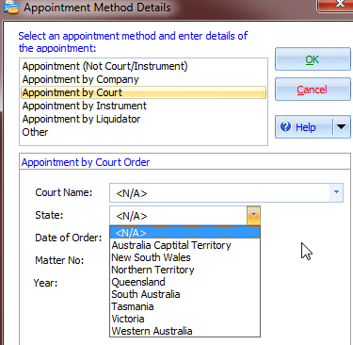

Custom Task Filter
You may now add a custom task filter that is configurable and always available when you open the software.
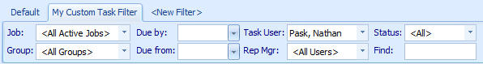
You may use the “Find” search to return tasks which contains the entered text in the task title or memo fields.

Document Production Preview
      - You may now preview a document from any stage of Document production.
      - 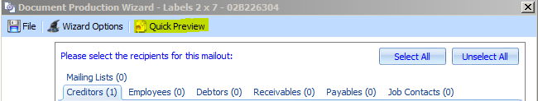

Other Features
Job Loading | The performance of loading jobs has been optimised.
Document Production | A new updated grid has been added for corporate/personal information.
 | You may add a Job Contact or Counterparty from the Other tab in Document Merge Options.
 | We have added a framework for adding PDF documents to document production.
 | You may not change Merge Template Category for standard template or system form.
 | Eliminated error when producing dividend letters if alternate payee reference is more than 20 characters long.
 | New Replace field - Last Bank Reconciliation date.
 | You may specify separate Document Management Default Folders for corporate and personal jobs.
 | You may Browse Categories in document production. Once selected becomes the default view of document production.
 | You may skip the creation of a document authorisation task.
Counterparties | You may search on postcode.
Counterparty Maintenance | User can create a counterparty but cannot add the bank details until the counterparty has been added to a job.
Reports | Job Shortname appears on Debtor Contribution Advice "detail" and "summary" reports
 | When you produce an abstract R&P for transitioned jobs with <All> job types selected, the transfer to administrator journals are excluded from the report.
 | A Receipts and Payments Problem Transactions report shows entries that cause the receipts and payment to be out of balance, e.g. adding tax line to a bank entry or accounts payable liability account.
 | File note report to show links to related records (i.e. asset, creditor, meeting).
 | Add option on 524 wizard - "Hide employee payee name” in receipts and payments detail
Accounts Payable | Posting a negative payment against an AP invoice updates the amount paid on the liability correctly.
 | Purchase Order number filter added to Purchase Order Register
 | A duplicate invoice number check has been added when creating an invoice from the PO register
 | You can delete a payment with cheque numbers if a receipt contains a long reference
 | You may filter the Debtor Statement of Account to exclude written off amounts
Creditors | Deleted creditor names now appear on the creditor audit report.
 | You may not delete employees that have transactions allocated to them.
 | You may un-admit all creditor claims
 | You may exporting Employees and reimport using XLS format.
 | A Notes field is available on the Employee Details form
 | You may admit/un-admit all Employees claims
Home Page | The number of active users displays on the Home Page for administrator users.
 | Practice, EFT and cheque only filters have been added to Cheque Printing
Document Merging from the Practice | You may maintain document templates in the practice and create mailing lists for Counterparty Contacts
 | You may specify a practice document folder in Practice Settings
Batches | Unposted 'From' date persists when tabbing out of the From Date field field
 | You may add a reason to indicate why a batch is unsubmitted
 | The batch listing may be filtered by posted/unposted to make it easier for a user to find a batch.
 | The Batch Detail reports includes Payee Bank Details and Authorisation Workflow status.
Bank Reconciliation | You may add a document to a bank reconciliation similar to how you may add documents to transactions.
User Maintenance | You may apply bulk resignations of office-holders incorporating entry of dates and the succeeding office-holder. You may filters by practice and job type
Job Info | increase size of default value and make multiline replace field - add value form (corp / pers info)
Job Setup Wizard | You may add users to standalone security roles. Inactive users are now excluded from the drop down options.
WIP | WIP Billings and Fees Approval error when running from within a job
 | AEPM WIP, Bills and Fees Approved Summary report filter by job manager
 | Employee Time Analysis Detail by Employee Group
Tasks | Documents and File notes now can create linked tasks
 | Ensure Task Template reports show child tasks
 | The task memo field carries over to recurring tasks
 | DOCA Task Template amendment - execute the DOCA within 15 business days after the end of the meeting of creditors
 | Remove Gazette on ceasing to act as receiver and add s427 reference to Lodge notice of ceasing to act within seven days, Task template - MYOB Rec Checklist

