Electronically Submitted AFSA Annual Estate Return

For the purpose this discussion we’ll refer to jobs (bankruptcies and debt agreements) as “admins”.

ASFA now provides a facility to upload AER spreadsheets.

You may find details of the lodging process for spreadsheets by following this link https://www.afsa.gov.au/online-services/practitioner-online-services.

Some aspects of AFSA spreadsheet submission:

- You may submit any collection of admins in a single upload, either one admin at a time, all admins in a single submission or a selection of admins in the same spreadsheet.
- At any time you can produce a spreadsheet from AFSA’s website that gives you the figures for the submissions made to date and highlights the submissions outstanding.

- You can upload the same admin multiple times to update submitted data. If you do this after the due date there may be penalties, however, should the realisation or interest charge liabilities increase.
- There are other rules around submission such as if you submit an admin with an end date, you can reactive the admin by resubmitting the spreadsheet containing the same admin without an end date.
- To submit a joint admin submit the joint estate record.
The Insolvency software will consolidate individual estates into the joint estate for AER reporting purposes. This is consolidated onto one line of the AER spreadsheet.

- You may create the AER spreadsheet from either the Practice or each job individually. A document management record is created at either the job level or the practice, depending from where you create the spreadsheet.

Producing the Annual Return

From the Reports and Forms menu select the Bankruptcy Returns category and select Annual Estate Return AER (Non Debt Agreement) or Annual Estate Return AER (Debt Agreement).

Document production opens and you are prompted to enter filters:
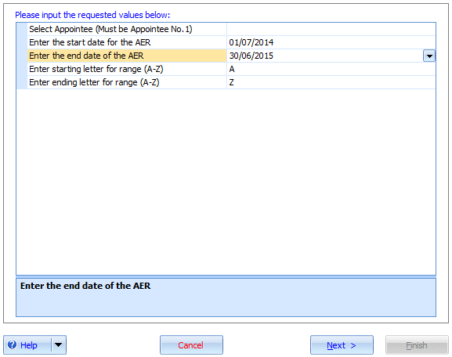

Use the A to Z filter on job name to produce of a range of jobs.

Document Management
A record will be created in document management.
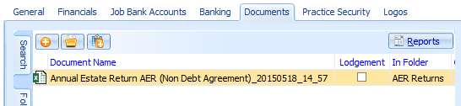

Producing Detail Reports

From personal jobs you may produce the following detail spreadsheets:
- Annual Estate Return AER Payments Detail
- Annual Estate Return AER Receipts Detail

This will allow you to look at the summary figures and determine which entries make up the detail and how the entries are categorised.

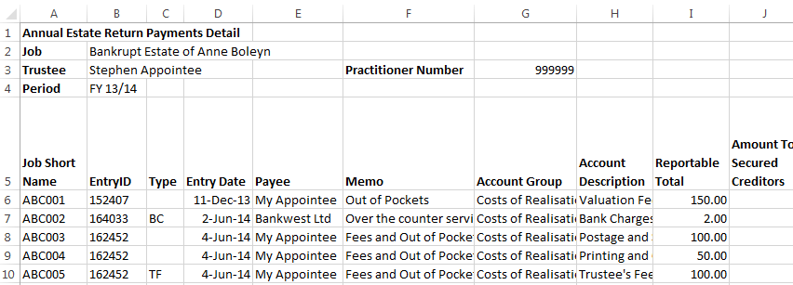

Uploading the spreadsheet

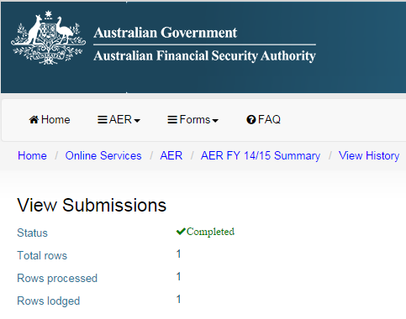

How to populate columns in the AER spreadsheet
The following describes how to include transactions in various columns of the AER.

Admin Details
The admin details include:
- Administration type
AFSA uses a coding system for each type of admin. Here are the ways Insolvency reports the admin type:
ASFA Type | Description
DP | Bankruptcy with Debtors Petition Appointment Method
SEQ | Bankruptcy with Sequestration Order Appointment Method
S188 | Section 188 Authority Appointment Method
DA | Part IX - Debt Agreement Job Type
ASSIGN | Part X - Deed of Assignment Job Type
ARRANGE | Part X - Deed of Arrangement Job Type
COMP | Part X - Composition Job Type
PIA | Execution of PIA Appointment Method or Part X - Personal Insolvency Agreement Job Type
XI | Part XI - Deceased Estate Job Type
This field is validated when uploading files to AFSA.

- Administration state
- Administration number
- Administration year
- Administration check digit
There are entered when the job is first set up, but may be amended. This is what determines how the admin is matched to AFSA records.
You can amend the Administration (matter) details on the personal information tab:
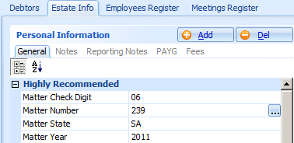
If you have separate jobs entered into the system for joint admins then you may combine the reporting together if you replicate all the same matter details.
- Debtor given name
- Debtor surname
This is the first listed debtor (for joint administrations). The names provided here are irrelevant for electronic submission. It is the matter details that are relevant.

Finalised Admins
Enter the End Date for a job to populate the finalised date on the AER output.

To exclude an Admin from the AER
Set a job to inactive to exclude a job from the AER output.

Selection of Appointee
As each admin is linked to a single appointee’s registration, you need to select the Appointee listed as the Number 1 appointee on a job when producing the spreadsheet.

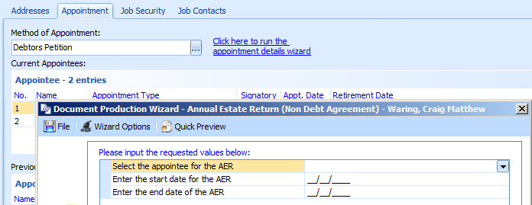

Editing the Appointee Number
You may edit the appointee number in the General > Appointment tab.

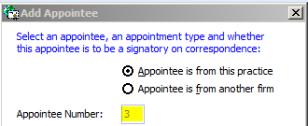

When you set the appointee number to Number 1 the software automatically renumbers all other appointees.

User Details – Liquidator Registration Number
Edit the user record to ensure the registration number is correct.
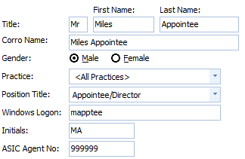

Receipts

An explanation of how to populate the receipt columns.

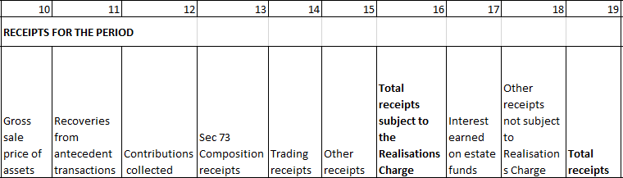

Funds Transferred from another Trustee (9)
Includes transactions (receipts) coded to the Funds Received from Preceding Trustee account.

Gross sale price of assets (10)
The following entries will appear in this column:
- Asset Realisations (realised through the Asset register) plus
- Any net receipts coded to the Asset Realisations account group and allocated to an asset

Recoveries from antecedent transactions (11)

The total of all asset realisations for the asset group “Recovery of Property / Preferences”.
You must realise this asset for amounts to be updated in the AER.
This category of assets is unlikely to belong to the Debtor(s)’ SOA.

Contributions collected (12)

Transactions (receipts) coded to the Debtor Contributions (Mandatory) account.
These transactions will be allocated to a debtor contribution. Entered on the Contribution tab of the Debtor record.

Contributions Voluntary

Transactions (receipts) coded to the Debtor Contributions (Voluntary).

Sec 73 Composition receipts (13)
Includes transactions (receipts) coded to the Composition Funds account.

Other Receipts Realisation charge (15)
Includes other transactions with a realisation charge assigned. Generally entries coded to the Asset Realisations account, where an asset has not been assigned to the entry.

Interest Earned on Estate Funds (17)
Includes transactions (receipts) coded to the Interest Income (Chargeable) account.

Other Receipts not subject to the Realisation charge (18)
Includes other transactions.

Payments

An explanation of how to populate the receipt columns.

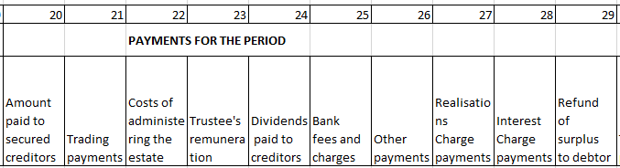

Amount paid to Secured Creditors (20)
Includes transactions (payments) to the Secured Creditors: Claims account.

Also includes costs that are subtracted from realisations (i.e. valid charge. To validly reduce the realisation charge the costs must be incurred in the same AER year as the realisation).

For an amount to be included:
Secured Creditors: must be coded to the Secured Creditors (Fixed): Claims account and allocated to the creditor.
Deductible Expenses: must be coded to an account belonging to the Costs of Realisation account group and be allocated to an asset.

Trading Payments (21)
Includes any entries codes to the trading payments account group.

Costs of administering the estate (22)
Total of all payments to Trustee’s Costs accounts and sub-accounts not allocated to assets (Including paid accounts payable entries on a cash basis) and including GST.

Trustee’s Remuneration (23)
Total of all payments to Trustee’s Fees account and sub-accounts (including paid accounts payable entries on a cash basis) including GST.

Dividends paid to creditors (24)
Total of All Dividends paid.

This excludes petitioner’s costs.

Includes transactions (payments) coded to the Petitioning Creditors Costs account. Note: the taxed costs may have been entered as a Priority creditor. Ensure that the creditor payments have not been double-counted.

Bank Fees and Charges (25)
This includes all bank charges that are deductible from the interest charge.

Other Payments (26)
All other payments that do not fit into any of the previous payment categories.

Realisation Charge Payments (27)
Includes any amounts remitted to ITSA in respect of the Realisation Charge Liability for the period. The remittance relates to the liability arising from transactions in the previous period.

Interest Charge (28)
Includes any amounts remitted to ITSA in respect of the Interest Charge Liability for the period. The remittance relates to the liability arising from transactions in the previous period.

Refund of surplus to Debtor (29)
Includes transactions (payments) coded to the Refund of surplus to Debtor account.

Funds Transferred to another Trustee (31)
Includes transactions (payments) coded to the Funds Paid to Succeeding Trustee account.

Debt Agreement Information

Date proposal lodged with Official Receiver (Realisations charge is only payable if date lodged is on or after 1 July 07)
Enter this field in Job Information.

Total value of creditor claims
Is the calculated field for the total of unsecured creditor claims and only appears if the finalisation date is entered.

Notes on Data Entry

Sale of Assets
Entered in the Asset Register. Processed using Asset Realisation.

Any receipt entered through an Asset Account.

Any receipt to an Asset Realisation account that is allocated to an asset.

Example Entry Screen shot - Receipt
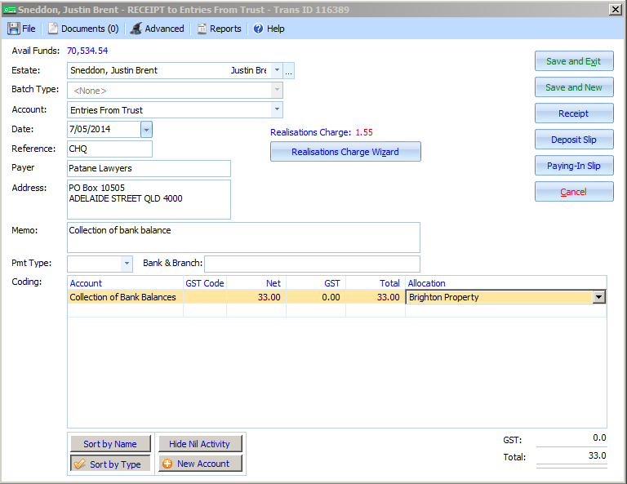

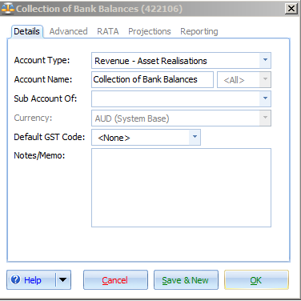

Example Entry Screen shot – Asset Realisation
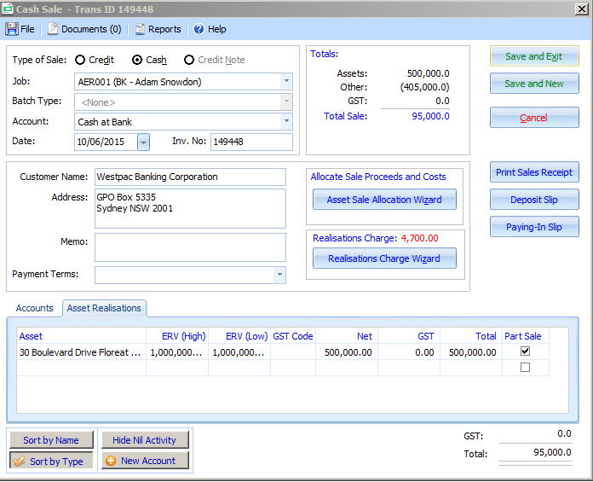
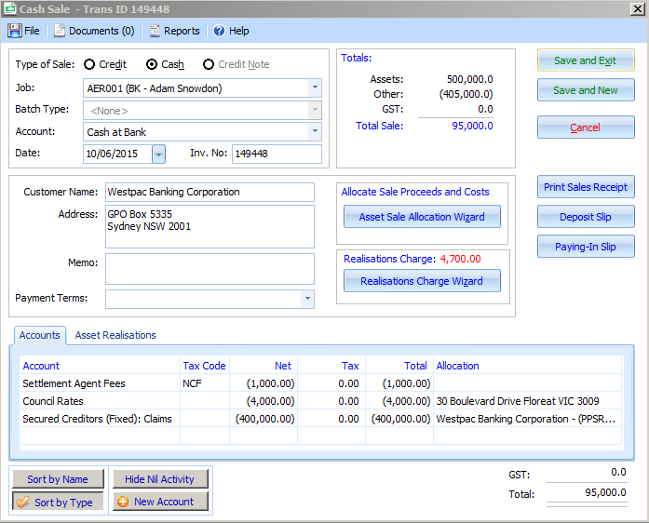

Example Entry Screen shot – Unallocated Asset Realisation
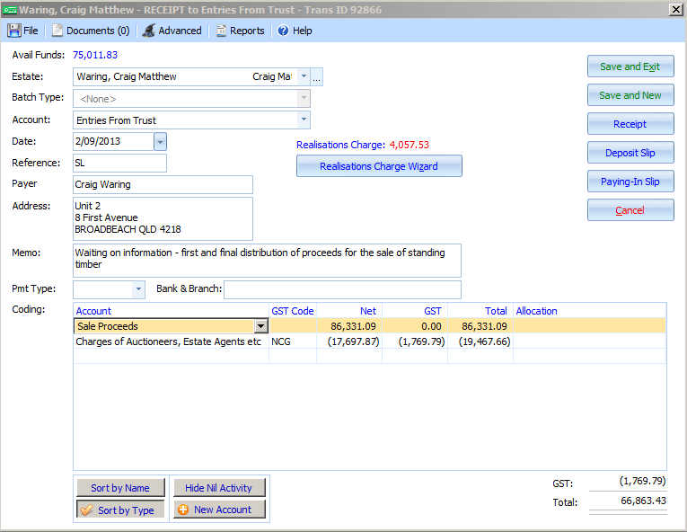
This entry will report as Other recepts but will still be subject to the realisation charge.

Other receipts
Any receipt to an Asset Realisation account not allocated to an asset.

Dividends paid to creditors
Any payments to priority creditors (such as petitioning creditor’s costs) coded to the Priority Creditors: Claims account and allocated to the creditor will appear in dividends.

To exclude petitioning creditor’s costs from dividends, enter as a payment coded to a cost of realisation account.

Example Entry Screen shot – Petitioning creditor’s costs
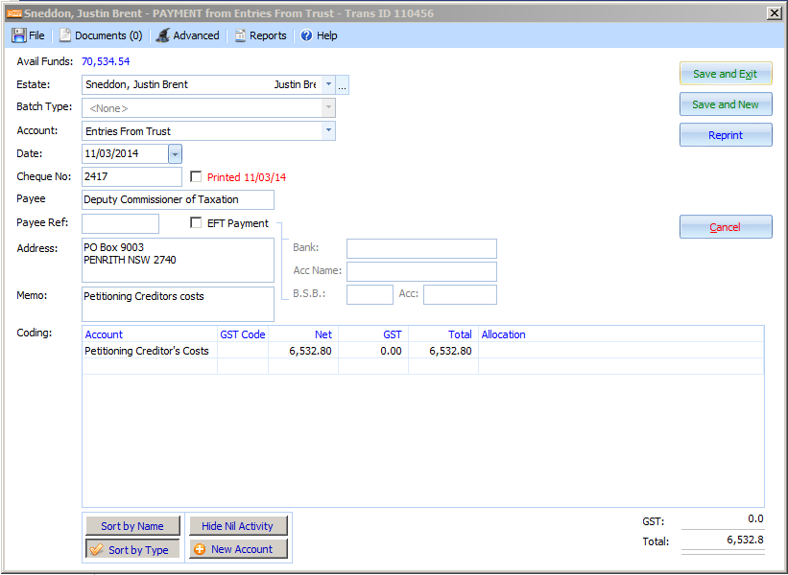

Example Entry Screen shot – Reports as Dividend
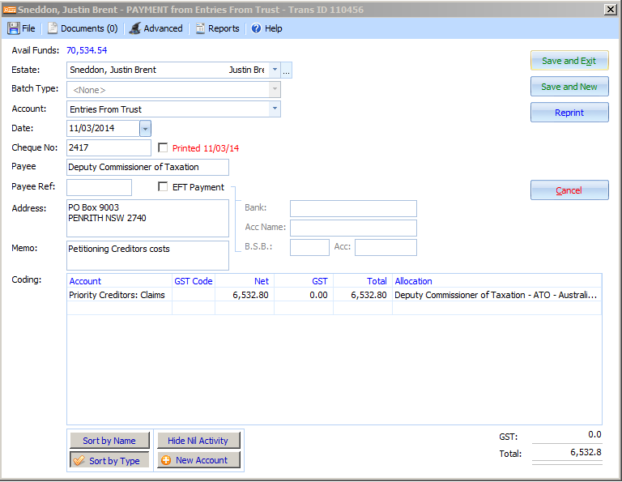

Excluding Accounts from Realisation charge

