MYOB Insolvency
Version 3.1.35
Release Notes
Copyright 2010 MYOB Technology Pty Ltd. All Rights Reserved.
Disclaimer
MYOB Technology Pty Ltd has made every attempt to ensure the accuracy, relevance and completeness of this material but excludes (to the extent allowed by legislation) any warranties regarding it. Furthermore MYOB, its staff and agents shall not be liable for any loss, cost or damage (however incurred including negligence) arising out of errors or omissions in the material, especially if such materials contain information sourced from third parties or the ATO/IRD. In some cases the materials provided contain case studies (applying particular accounting standards or legislation) and anecdotes which may not directly apply to the user's circumstances and are used as representative examples only and should not be considered as authoritative advice regarding any accounting standard, law or industry opinion. MYOB advises that if the user wishes to rely on the case studies contained in the material then it must seek professional advice before doing so. Furthermore reliance on the representative examples in the seminar materials is at the user's own risk.
Copyright
MYOB claims copyright in respect of all published content. None of the material published herein may be copied or altered or distributed in any format without the prior written consent of MYOB.
Trademarks
All trademarks used in this material are owned by MYOB Technology Pty Ltd or the indicated registered owners of the trademarks. Users are forbidden from using, copying or transporting the trademarks without express prior written consent. AppleShare and Macintosh are registered trademarks of Apple Computer, Inc., registered in the United States and other countries. LiveLinks is a trademark of Ceedata Holdings Pty Ltd. Microsoft, MS-DOS, Windows, Windows NT, Windows BackOffice and Outlook are either registered trademarks or trademarks of Microsoft Corporation in the United States and other countries. Novell and Netware are registered trademarks of Novell, Inc.
MYOB Technology Pty Ltd ®
ABN 30 086 760 269
12 Wesley Court
Burwood East VIC 3151
MYOB Insolvency Version 3.1.35 Release Notes
Printed: 2 June 2010

Contents
Release summary 6
Features 8
Task Templates (Checklists) 8
Document Templates (Precedents) 8
Document Production 8
Starting Document Production 8
Locating Document Templates 8
Document output methods 8
Save to file 9
Saving documents outside the job folder 9
Producing documents without merging 10
Merge to MS Word 10
Print documents 10
Merge to Email 10
Attach files 11
Send to Selected Recipients 14
Editing Recipient Addresses 16
Document Management Record 16
Recipient List 17
Letter Packs 17
Maintaining Letter Pack documents 17
Letter Pack attributes 18
Locating letter packs 18
Producing Letter Pack documents 18
Linking letter packs to task templates 19
Document style templates 19
Document template maintenance 20
Document templates maintenance search 20
Types of document templates 21
Importing multiple document templates 21
Maintaining the category for multiple document templates 21
Circulars and Mailing toolbar 21
Filtering standard templates from the toolbar 21
Document template search 22
Defining Merge data source 22
Creditor correspondence method 23
Creditor category 23
Email Merge 24
Document output options 24
Combining documents for letter packs 24
Job contacts records added when merging 25
Other document prompts 25
User prompts 25
User Inputs 25
Replace fields 25
Document Authorisation functionality 26
Document authorisation tasks 26
Document Properties 27
Application document search 27
Workflow changes in Cheque Requisitions 28
Tasks 28
Tasks Display 28
Task Action Status 29
Task templates 29
Editing system task templates (checklists) 29
Open a document template from task templates 30
Task Template Checklist report 30
Task report ordering 30
Task Group Display Order 30
Importing tasks 31
Pay Wages 32
Entering Wages Entries 32
Employee drill down 32
Filtering the Wages 33
Entering Deductions and other income 33
Child Support Payment Example 33
Payroll Deductions 35
Payroll Reimbursements 35
Employee Payment Summaries 35
Registration and digital certificate 36
Enabling jobs for electronic lodgement 36
Online resources and downloading the ECI 36
Producing the Payment Summary Output file 37
Submitting the PAYG Payment Summary annual return 39
Exporting Creditors 40
To export creditors: 40
To view and amend an exported list of creditors. 41
Tab Appearance and Colour 42
To amend the tab style format: 42
ABA File Output file format 43
ABA Output file location 43
Account Details Form 43
Printing Cheques 43
Prepare EFT File Input form 44
Validation 44
ABA application 45
Other enhancements and resolved issues 46
Account Register sort 46
Account Register find 46
Batching 46
ASIC forms 47
Statutory Interest 47
Dividends / Creditors 47
Employee 47
GEERS 48
BAS 48
Tasks 48
Bankruptcy 48
Financials 49
Document Templates 50
Multiple database access 50
Jobs 50
Other 50
Appendix — Merge Templates 52

Release summary
The key changes and enhancements to MYOB Insolvency Version 3.1.35 are:
- Electronic Payments — you can now output payment files in the Australian Bankers’ Association (ABA) format, allowing you to make electronic payments.
- Annual Payment Summaries — you can now use the system to produce paper-based individual employee payment summaries and ETPs. You can lodge annual payment summaries for each job electronically.
- Statutory Interest — calculations are now based on the reducing balance of the creditors’ outstanding claims.
- Standard task templates — are added to provide standard insolvency checklists for the major types of job. The MYOB Standard task templates provide links to the new standard document templates.
- Standard document templates — are included to provide you with a comprehensive set of standard insolvency precedents and updated statutory forms. You may use the templates as is, or copy them and modify to meet your own specific requirements. The new template content has been developed in conjunction with Grant Thornton Australia.
- Document production — simplifies and improves the output of templates. It provides you with a document production system that will improve your workflow, from finding the right template to outputting the final document.
- When used in conjunction with the new standard templates, the document production process is easier and more flexible.
- Document authorisation — to further help in the document production process, the system creates a document review task. A link to the task and a hyperlink to the output document stored on your organisation’s server can be emailed to the authorising user as part of the document production process.
- Letter packs — these are groups of document templates that can be output in one process. Letter packs streamline the document creation process for insolvency practitioners who are often required to produce standard sets of documents for each job.
- Document production options — offer multiple ways to produce documents giving you flexibility to align your use of the software with your preferred method of document production. You can save the output documents to the file system (job folder), output a merge document, combine separate documents into a single document, or create a form letter without the need to create a merge to recipients.
- Document styles — can be linked to all standard and user-defined templates. Styles can be configured for font type, font size and page settings. Styles can be applied to all document templates across the whole organisation, reducing the need to make changes in each individual document.
- Replace fields — can be added direct to MS Word document templates. Just add the replace field to the template and the system automatically prompts you to enter the value.
- Centralised document search — allows you to search for documents across the whole database.
- Multiple database access — allows you to access multiple databases simultaneously from your desktop.
These features are explained in greater detail in the following sections. Other minor enhancements and resolved issues can be found on
page 50.
Features
This section contains specific details on the key features included in this release.

Task Templates (Checklists)
Comprehensive task templates are now available for all major job types. Review Manage Task Templates from the main menu to view the content of the new task templates and print out the new task template checklist report.

Document Templates (Precedents)
Over 500 new standard insolvency precedents have been added to the system. A listing is provided in the Appendix from page 56.

Document Production
A new document production process has been added to the system. The document production process produces documents from the system from document templates.

Starting Document Production

Locating Document Templates
            - Locate the required document template by:
- Searching for the letter pack using the template search from a Job.
- Selecting the letter pack from the Circulars and Mailing toolbar, or
- Selecting it from a task action.

Document output methods
There are many different ways to produce documents. You can output documents using:
- Save to file
- Producing documents without merging
- Merge to MS Word
- Merge to Email
- Print Documents.
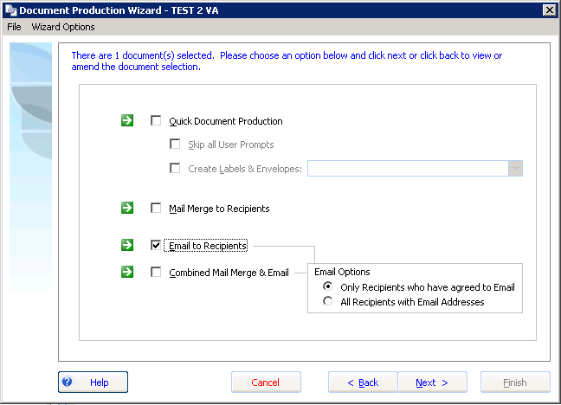

Save to file
This method creates the document and saves it to the save location.
- You have the option to:
- Change the default save location.
You can configure the default output folder and the default letter pack output folder in Manage Document Templates.

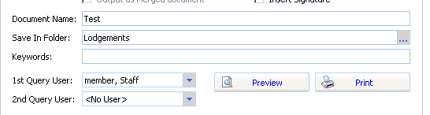

Saving documents outside the job folder
You can now save a document to a folder outside the job folder. This application setting can be activated for clients that use an external Document Management system. If you want to be able to save the document folder outside the job folder, contact MYOB Support for the specific update.

Producing documents without merging
You can now produce merge documents as form letters (without merging a list of recipients or a data source).
When you produce a document as a form letter, the recipient name («CompanyName») will be replaced with the text:
“TO THE RECIPIENT AS ADDRESSED”.
All other merge address fields will be returned as blank.

Merge to MS Word
Merging combines the template with the data source recipients and outputs a merge document. The output document is the pre-merge document. The system opens the document to allow users to start the mail merge process using MS Word.

Print documents
You can print the document output. You can use this option in conjunction with letter packs to print a collection of documents.

Merge to Email
The Document Production process produces a merge to email option.
The email output can be personalised by containing merge codes that populate appropriate values for each recipient.
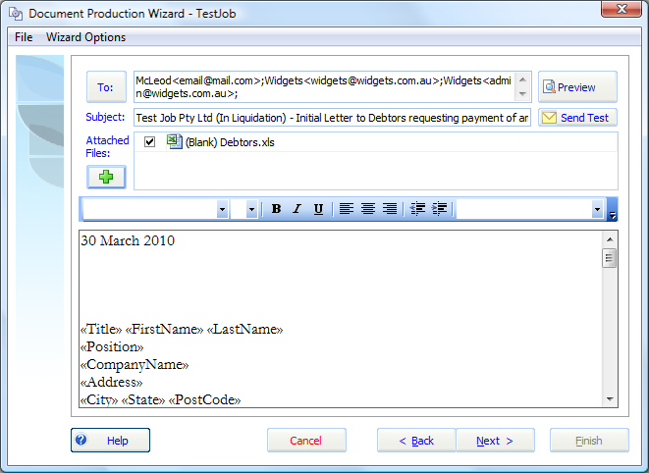
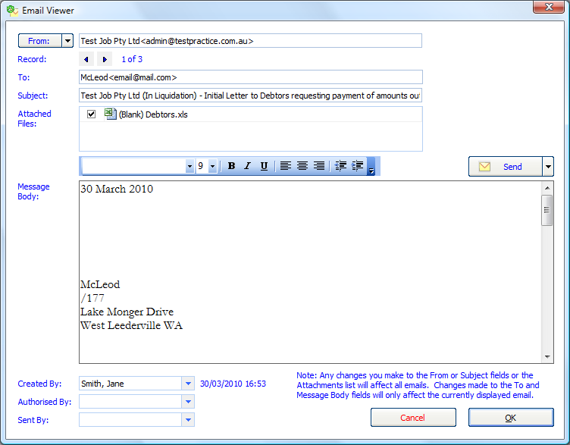

Attach files
You can attach file types such as PDF and MS Excel to the output process. These files can be sent as part of the approval process or as part of an email merge.
This lets you prepare information separately and include it as part of the email merge.

Use replace fields in the body of an email and specify a recipient list with email addresses to receive the merge.

Sending a test email
You can view an example of the email before sending it to the recipients. To send a test email, click ‘Send Test’.
A test email output is sent to the current user’s mail box.
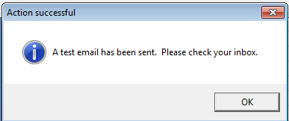
Sending a test email will create an email task for authorisation linked to a document management record. You may review the email from the task or from within the document management tab.

Creating an email in Document Management
When you finish Document Production you have the option of saving the email in document management. If the email is pending authorisation and hasn’t been sent, you can view it using the Email Viewer.
You can open it to edit the text before sending, and to review the recipients. The document authorisation task can have a link to the email task.

Sending the email
When you are ready to send the email, the merge output is generated.
Each individual receives their own individual email message. The system avoids the use of the BCC (blind copy) for addressees and thereby avoids the risk of users reading emails or replies to other recipients.
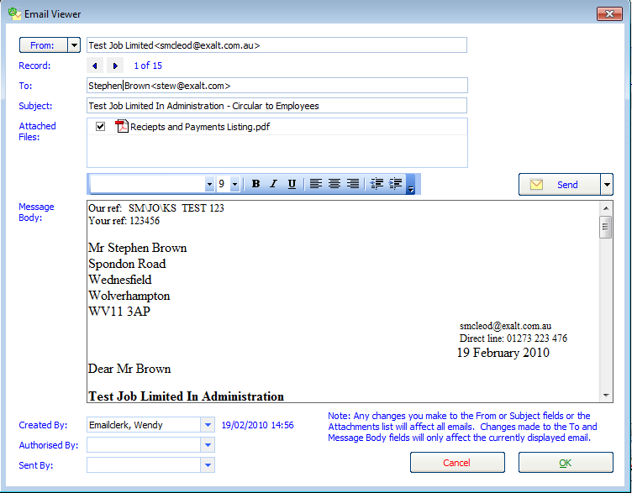

Document authorisation workflow
Users must be granted rights to send emails.
If a user has not been granted rights the user can still create an email to be sent, but the email is placed into document management and an email task pending authorisation is created.
The email task is linked to the email saved in document management.
Once an email is authorised it can be sent.
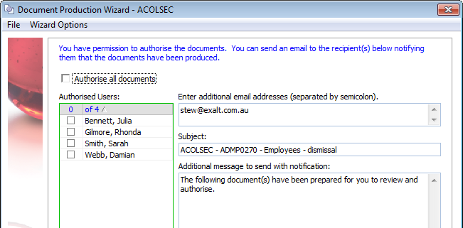

Send to Selected Recipients
To send to selected recipients click the Send button and select Select Recipients.
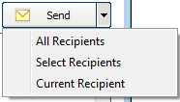
Tick the listed recipients and click OK.
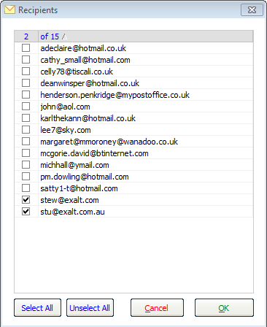
You will be warned if the email has already been sent to one of the recipients.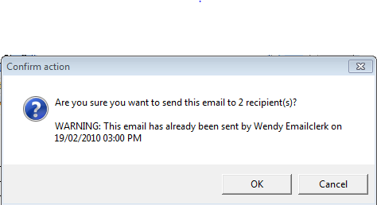
Once you have sent the email the document management record is updated with your user name.


Mailout Address Listing
After you have generated the email record ready for sending, the system creates a PDF report containing all the intended recipients. This report is placed into document management.

Recipients listed in Document Properties of the email
After you have sent an email, a recipient listing is stored with the email.
Right-click the email in document management and select Document Properties. Click the Recipients tab to display the recipient list.

Editing Recipient Addresses
As part of the merge process you are presented with the recipient addresses. You can review and edit the addresses as part of the merge process. Click the recipient list to edit the address.
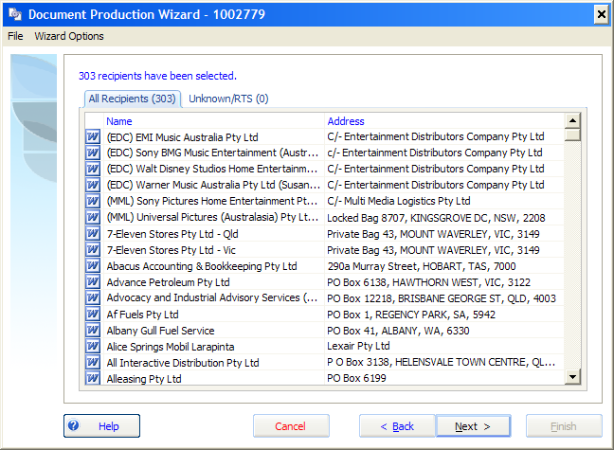

Document Management Record
A document management record is now created with every document created by the system. Each document has a default output file path.

Recipient List
A list of recipients is stored with each output document. When you create a merge document output, the list of recipients is stored in the document properties.
Open the document management record in document management and print a list of the recipients and the addresses at the time the document was produced.
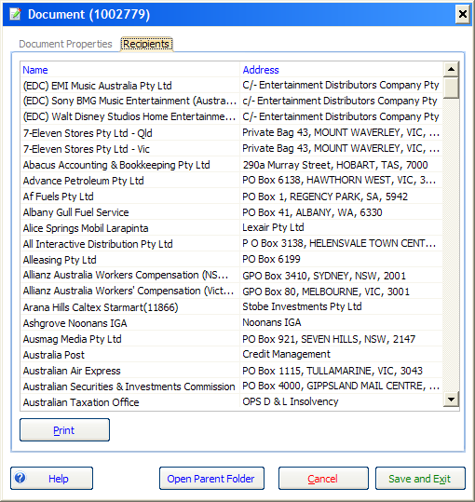

Letter Packs
Letter packs are collections of document templates that can be grouped together.

Maintaining Letter Pack documents
You can link document templates to a letter pack.
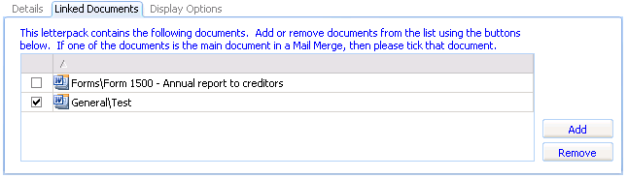

Letter Pack attributes
You can add and edit the following Letter Pack attributes:
- Default save path
You can specify the default job directory to output the letter pack documents.
- Default data source
You can specify the default data source to output the letter pack documents.
- One or more job types (display options)
You can specify the job types for which the letter pack shows.
- Letter Pack categories.
You can separately categorise letter packs.
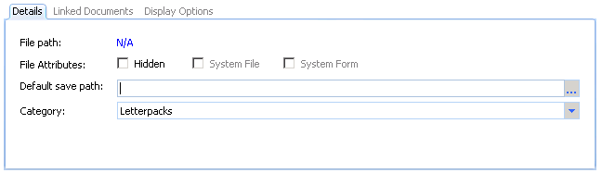
The letter pack attributes display whether the letter pack is a system file or form. You can hide a letter pack from appearing in the job menus.

Locating letter packs
            - Locate the required letter pack by:
- Searching for the letter pack using the template search from a Job
- Selecting the letter pack from the Circulars and Mailing toolbar, or
- Selecting it from a task action.

Producing Letter Pack documents
Once you locate a letter pack, you will be guided through the document production process allowing you to output a collection of documents.
You can add templates on-the-fly (using the document template search) or de-select particular letter pack templates when producing the documents from a letter pack.
Letter Packs will be saved to a new folder unless the folder is specifically configured in Manage Document Templates.

Linking letter packs to task templates
You can use task actions to add a link to a letter pack in a task.
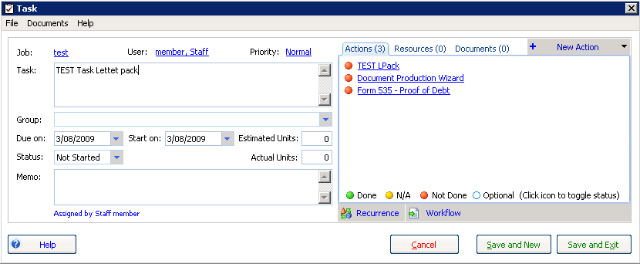

Document style templates
Each document template can be linked to a style template.
A style template defines the formatting of documents produced from a template. Rather than using the styles from the source template, the output document applies the styles, fonts, page setup, page orientation and margins of the style template.
Style documents are stored in the ‘Styles’ directory under the root document templates file-system directory. You cannot maintain document styles through the user-interface.
The contexts of headers and footers contained in the style template appear in the output document. This allows you to place common references in the style template and have these populated in each document which has the style applied.
Replace fields in the style document templates will populate in the output document.
By linking a single style template to many document templates, you can change the style template and automatically update the styles for all linked templates (without having to change each template individually).
Section breaks and separate page numbering (where it is different from the first page) contained in the child document will appear in the output document.

Document template maintenance
Document template maintenance has been improved to enable you to find, add, edit, import, configure and delete document templates.
A new interface allows you to click each template in turn, without having to drill down into the properties of each template individually. This makes it easier to review the properties of each template.

Document templates maintenance search
You can search for or filter document templates in six ways:
- Search and filter document templates based on search criteria
- Search by a text string in the template name
- Filter and sort by category
- Filter by letter pack
- Filter to exclude MYOB standard templates
- Filter by job type.
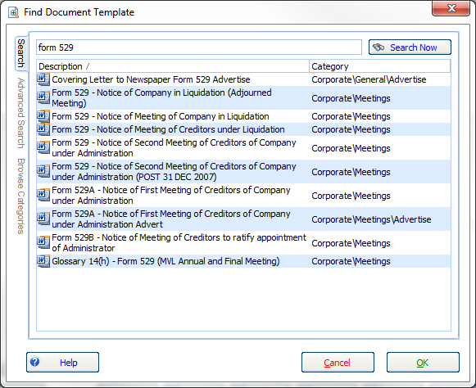
The template category for each document template displays in the template list if the search results belong to different categories.
You can filter the document template search to show different types of templates.

Types of document templates
There are different types of document templates as follows:
- Statutory forms — usually ASIC forms; you can copy and edit, but not delete.
- MYOB standard templates — you can copy, but not edit or delete.
- User-created templates — you can add, import, copy, edit and delete your own templates.
System files are both statutory forms and standard templates.
A warning message will appear if you attempt to edit MYOB standard templates “This is a system template you need to make a copy to edit”.

Importing multiple document templates
If you are a template administrator you can import multiple document templates from the file-system in one action. You can select a file-system directory and import all documents contained within that directory.
The document template options for imported document templates are based on the default document template of the parent import category.

Maintaining the category for multiple document templates
Template administrators can move many document template files to a new category in one action. Use the Shift key to select multiple templates and right-click the selected templates to change the category.

Circulars and Mailing toolbar

Filtering standard templates from the toolbar
Administrators can configure the application to hide (or show) all MYOB standard templates across the application. You may also hide individual templates from appearing on the Circulars and Mailing toolbar.
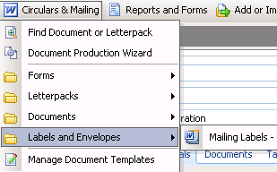
Hide the MYOB standard templates from appearing in the Circulars and Mailing menu using the options in the Document settings in Manage Application Settings.


Document template search
In the document template wizard, you can:
- Filter and sort by category
- Filter by Letter Pack
- Search and add document templates to the selected template list
- Filter to exclude MYOB system templates
- Search for templates for the current job type.
Template administrators can drill down to document template options from the document template search.

Defining Merge data source
Selecting the type of merge data source will determine the data populated in the output.
Types of merge data source include:
- Creditors
- Employees
- Dividends
- Meeting
You can configure the data source options in the Manage Document Templates form on the Datasource Options tab by setting This Datasource.
When performing the merge the merge type defines which recipients you can include in the merge.
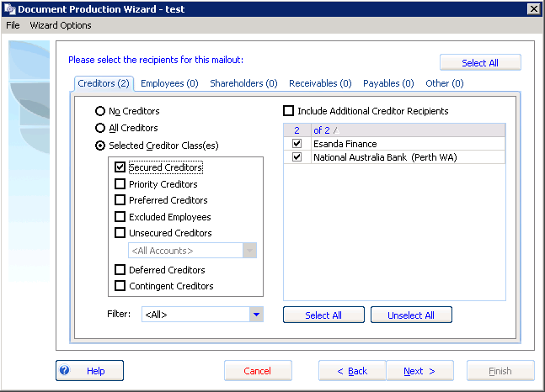

Creditor correspondence method
Each creditor has a default creditor correspondence method (e.g. email, letter). This will allow you to correspond with recipients using different methods.
Using one source output document you can send the same information to recipients using different correspondence methods.
The screen shot below shows the document output methods forming part of document production:


Creditor category
You can filter the creditor recipients list by unsecured creditor category. For example, an unsecured creditor can be created for ‘ROT creditors’ so you can select this group to receive specific correspondence.
You can also filter by creditor category on the Creditor mail out listing.

Email Merge
You can now allocate whether creditors have agreed for notices to be sent to them via email. In the creditor or counterparty record, set the preferred method of correspondence as email in the Numbers grid.
See the green tick below:
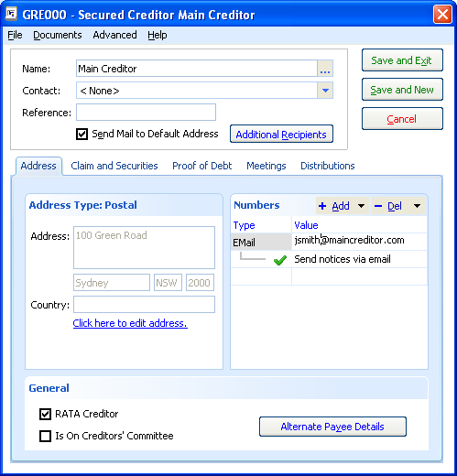

Document output options
Using the document output options available in document production you may:
- Change the document output directory
- rename the output document
- add key words to the document management record
Configure the default save path in the document template options.
When producing letter packs you can select additional documents or exclude some of the documents produced as part of the letter pack.

Combining documents for letter packs
When outputting multiple documents, the document options provide the ability to combine selected document templates into a single document.

Job contacts records added when merging
When you output merged documents and select a contact or counterparty as a recipient that has not already been linked to a job, the system will automatically add a job contact record for the selected contacts or counterparties.

Other document prompts
Existing functionality has been retained, you may:
- insert the appointee’s signature
- specify the 1st User for recipients to ask queries in response
- specify the 2nd User for recipients to ask queries in response


User prompts
You can create prompts for:
- Meetings
- Dividends
- Appointee selections

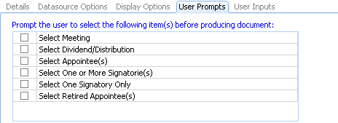

User Inputs
- You can link custom user input fields with job information fields. The system will prompt the user to enter the value for the replace fields and then save the entered value in job information.

Replace fields
As part of document production, the application scans through the text of the selected template(s) and searches for any instance of “[RF_....]” or “[RT_....]”. The application then works out the values and presents a grid of all replace fields involved in the merge.
If you edit the Replace Field values, the updated values will populate in the document output. Hover the mouse pointer over the replace field to see the replace field description.
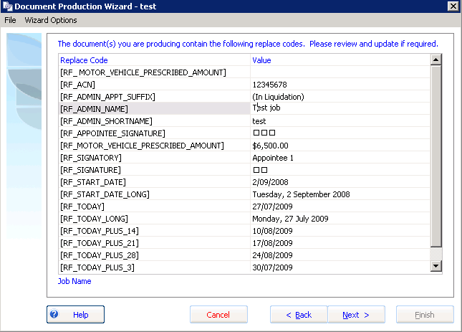
The Replace Field and value that will be populated in the output documents displays.
You only need to type any text starting with “[RF_” into a template for the replace field to display in the above replace field prompt form.

Document Authorisation functionality
When you produce documents in the system you have the option of emailing the document for authorisation.
The email, sent to the authorising user, contains hyperlinks to the output documents and a link to open the application and display the document authorisation tasks.

Document authorisation tasks
When you email document output for authorisation, a document authorisation task is created. These tasks are listed under the <Document Despatch> task group.
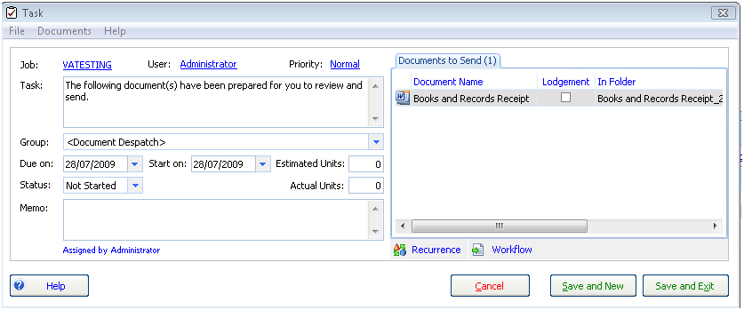
The documents associated with these tasks appear in the ‘Documents to Send’ tab on the despatch task.

Document Properties
Documents can have the status ‘prepared by’, ‘authorised by’ or ‘sent by’.


Application document search
Centralised document searching has been introduced to help you search for documents across all jobs. The document search is available from the main menu.
For example, enter “439A” in the search to bring up a list of all Form 439A reports within the system.
You will need job permissions to view the documents.
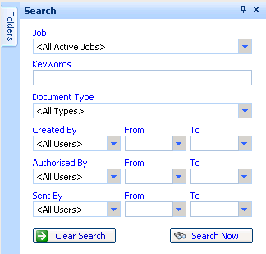
You can search documents using the following criteria:
- A string within document name
- Document type (e.g. BAS 524 etc.)
- Keywords (e.g. Meeting)
- Date range.
A list of documents matching the search criteria will display.
You can open the document from the list of returned document records, provided you have permission to access those documents.

Workflow changes in Cheque Requisitions
Reporting and navigation has been enhanced to improve the workflow for producing cheques and cheque requisitions. You can now produce Payment Requests (formerly called Cheque Requests) and Paying in Slips from all types of transaction screens.
The workflow is more flexible to accommodate many different methods of creating payment requisitions and receipts.

Tasks

Tasks Display
The following changes have been made to the task grid:
- A separate checklist view is available
- The task column refresh is improved
- The reordering display has been improved

Task Action Status
A new feature task action status has been added. You can mark actions as ‘not done’, ‘done’, ‘n/a’ or ‘optional’. A separate view of task actions displays, grouped by task.
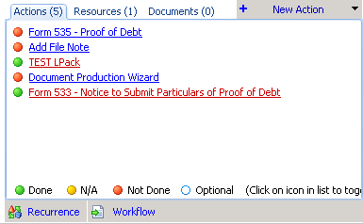

Task templates

Editing system task templates (checklists)
The user interface has been improved to allow easier configuration and updating of task templates.
New Due date and Start date period configurations have been added to the task template maintenance. These automatically assign dates to imported tasks such as end of next quarter, end of financial year and number of business days.
Code | Description
fys | Financial Year Start
fye | Financial Year End
qs | Quarter Start
qe | Quarter End
For example, to have a task due at the end of the first quarter you would enter “0 qe” (which the system changes to QtrEnd) after the Specified Date.
An example of a task due after 1 quarter end is shown below.
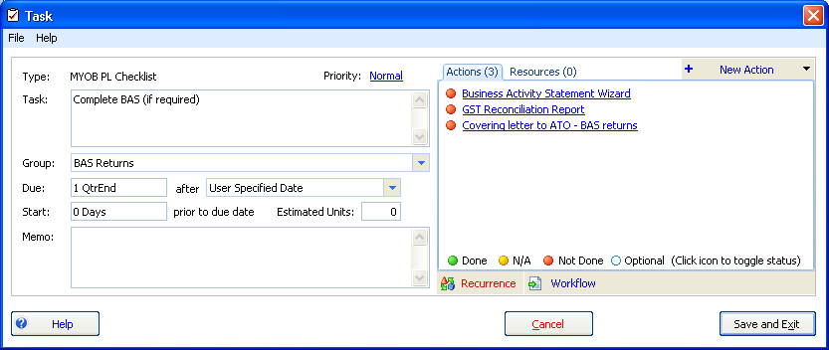
To amend the MYOB standard task templates, copy the task template and change the copy. This is to prevent your changes being overwritten when MYOB sends you updates to the standard task templates.

Open a document template from task templates
A hyperlink has been added to the task template action window, enabling you to drill down to document templates from the task.

Task Template Checklist report
You are now able to produce a report in Task Template Checklist format.
You can group the report by:
- Task Group
- Display Order

Task report ordering
You can also order task reports by:
- Start Date
- Due Date

Task Group Display Order
You can set the display order of task groups in static data.
To amend the display order, go to Static Data > Task Groups and click Task Group Report Order.
The following grid will appear:
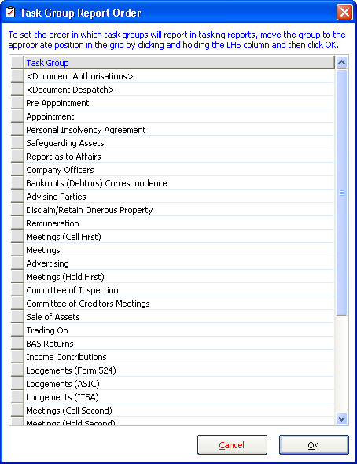
To change the order of the task groups, click the grey box beside each task group and drag up or down until you have the order you want.

Importing tasks
A new Date Planner View has been added to Import Tasks from Template. This provides greater visibility for planning task due dates and supplies a ready reckoner for organising meeting dates and tasks.
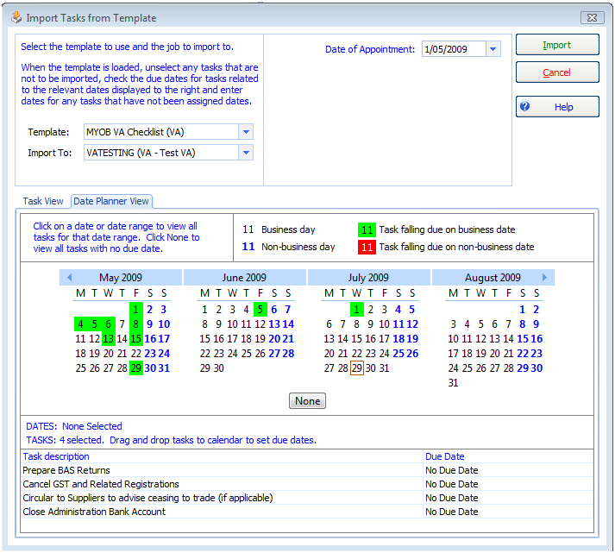
Tasks without specified dates will appear at the bottom of the screen. You can drag these tasks onto the calendar to set their due date.

Pay Wages
Pay Wages functionality is used to generate payroll entries. Although it is not a fully-functional payroll system, you can use it to generate employee payment entries common to insolvent entities.
Open the Pay Wages form from the Transaction > Employees > Pay Wages menu.

Entering Wages Entries
When you enter an Employee’s Weekly wage in the employee details form, the pay amount calculated in the pay wages entry form defaults according to the ‘To’ and ‘From’ wages period you enter.
The PAYG tax deduction is calculated based on the scale of marginal tax rates.

Employee drill down
You can now drill down to each employee to edit their details.

Filtering the Wages
You can now filter the wages grid to separate the payroll into pay runs for separate groups of employees. By entering a Payroll reference in the employee details form, you can filter the list of employees to appear.
Enter payroll reference ‘A001’, ‘A002’ and ‘B001’ into three separate employees. Enter the pay wages reference filter from ‘A’ to ‘A’ to filter the wages form to only display employees with a payroll reference beginning with ‘A’.

Entering Deductions and other income
Here are some specific considerations for entering deductions.
The Pay Wages screen now allows you to:
- Deduct Child Support payments from an employee’s wages
- Make deductions, for example Social Club
- Make reimbursements of expenses.
- Pay Mileage claims
Any employees in one wage period who have different reimbursements or deductions will need to be grouped together and done separately as there is only one place to enter a deduction or reimbursement.
For example, if two employees have child support deductions and two have social club deductions, they should be separated so they can be coded correctly on the Pay Wages window.

Child Support Payment Example
The following details how to process a Child Support deduction:
To withhold child support payments:
- Add an account called “Child Support Liability” to the chart of accounts. The account type should be set to “Other Current Liability”.
The graphic below shows the new account entry form when adding the Child Support Liability account:
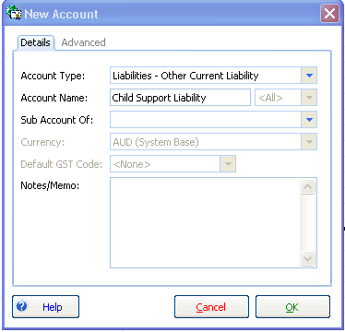
To deduct Child Support payments from an employee’s wage:
            - Select Child Support Liability from the Other Liab Account dropdown and enter the amount under the Other (No Tax) as a negative figure.
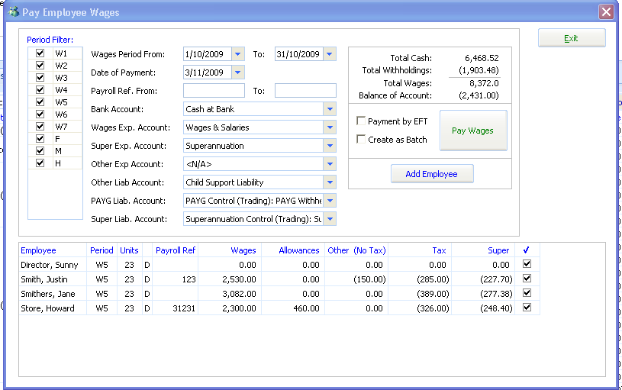
The entry as a result of paying these wages appears as:
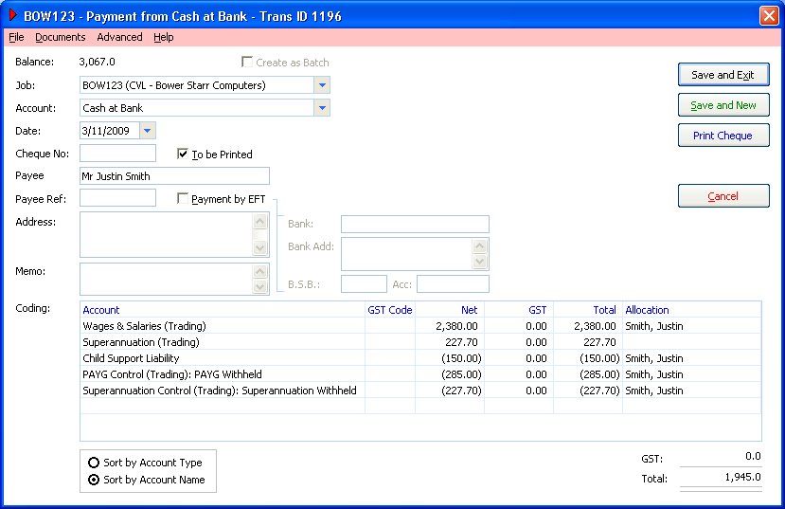

Payroll Deductions
To enter deductions for expenses such as social club, you need to create an expense account, which is a non payroll account, and select the dropdown box in the Pay Wages screen called Other Exp Account and enter a negative amount under the Other (No Tax) column.

Payroll Reimbursements
To enter reimbursement of expenses follow the same steps as entering a deduction, but enter a positive amount under the Other (No Tax) column.
A separate Knowledge Base provides further details about how to use the Pay Wages function.

Employee Payment Summaries
You can now produce paper-based PAYG Payment Summaries for Individuals (employees).
To be able to print individual payment summaries a practice must be registered for electronic lodgement of the Annual Payment Summary Return with the ATO.
The PAYG annual payment summary is a return submitted each financial year per job which details employees and the individual PAYG summaries issued.
You can only submit payment summaries once. The system tracks which employees have had payment summaries lodged. If you amend employee payments you must produce a PAYG Payment Summary Individual (Amendment) and resubmit the annual return for the amended employees.

Registration and digital certificate
It is only necessary to register the practice for electronic lodgement. The ATO will provide a digital certificate that you may use for the lodgement of all annual payment summaries.

Enabling jobs for electronic lodgement
Once you have registered for electronic lodgement of Payment Summaries with the ATO, go to Job > Job Settings window and tick the Enable Electronic Lodgement box.
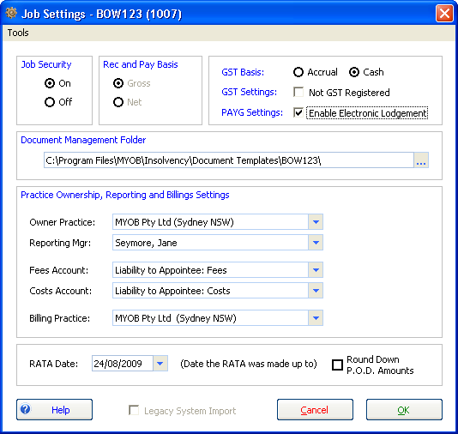

Online resources and downloading the ECI
A general guide for practices on lodging pay as you go (PAYG) payment summary annual reports online is detailed on the ATO’s website at:
http://www.ato.gov.au/onlineservices/content.asp?doc=/content/36036.htm>
To submit electronically you must install the Electronic Commerce Interface (ECI) which is the ATO’s method of submitting electronic files such as BAS and PAYG. You can download and install ECI from:
http://eci.ato.gov.au/Download/download.htm.

Producing the Payment Summary Output file
Produce the electronic output files from the Payment Summary Wizard.
            - Click Transactions > Pay Wages > Payment Summary Wizard.
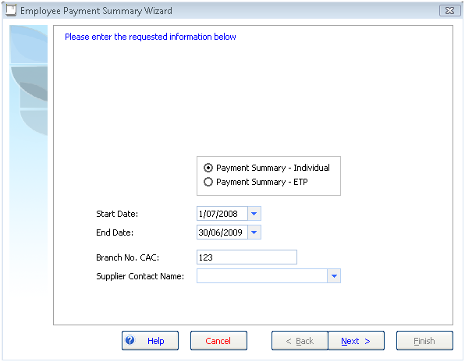
Enter the Branch No. CAC and the supplier contact name. The CAC is saved in Job information.
            - Click Next.
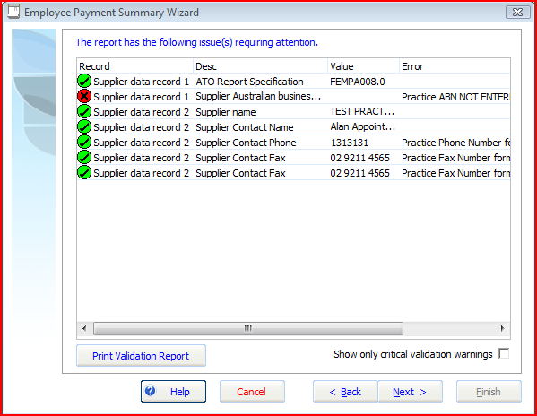
The validation window appears.
Each field used in the output is validated to ensure the data for the Payment Summaries meets the ATO’s validation requirements.
Invalid information will have a cross in a red circle as shown above.
If there is a red validation warning, correct the underlying data.
            - Click Next.
The output file is ready to be produced. This file is used for electronic lodgement of the job’s Annual PAYG Payment Summary.
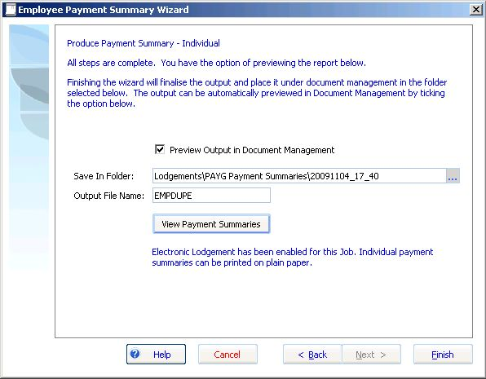
            - You can preview the individual PAYG payment summaries that are issued to employees.
            - Click View Payment Summaries to preview the report.
The preview of the employee’s PAYG individual payment summary appears.
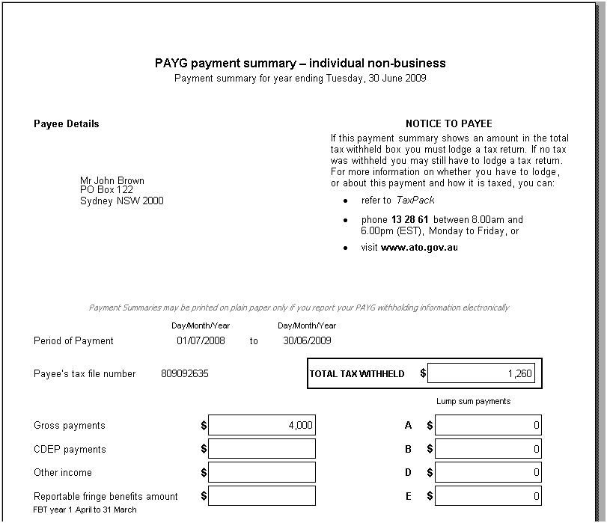
            - Close the Preview screen and click Finish.
The system stores a PDF of the issued Payment Summaries and places the electronic output in document management. Open the job folder to view the output file (you may need to change the file extension to *.txt).
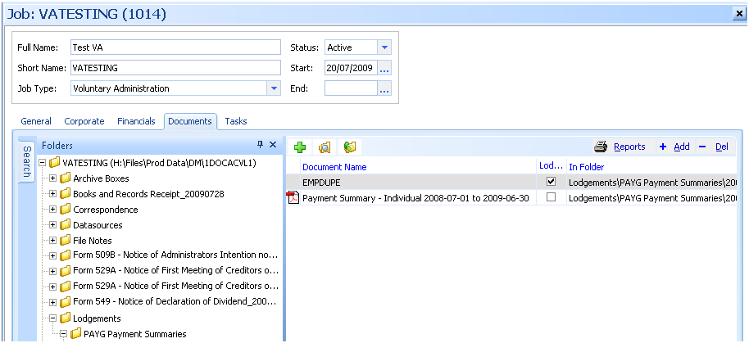
If you amend employee payments after lodging electronically, you must lodge an amended payment summary.

Submitting the PAYG Payment Summary annual return
The following instructions describe how to submit the output file using the ECI.
            - Install the ECI application as per the ECI installation instructions
            - http://eci.ato.gov.au/Download/download.htm.
Navigate to the Payment Summary Report menu in the ECI application.
Business > PAYG Summary Reports > Payment Summary Report
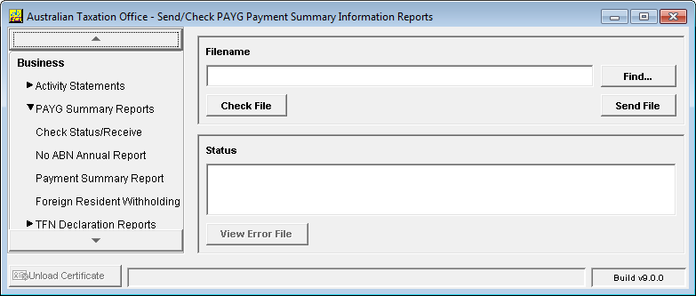
The Send File dialogue appears.
Click Find
Locate the file described as “EMPDUPE” in the section Producing the Payment Summary Output.
Click Check File
The ECI application will provide an output report that checks the contents of the output file and validates the values of the data provided.
Use this file to report any issues to MYOB Support.
Once the file has passed validation, click Send file
The annual payment summary output file is submitted to the ATO.

Exporting Creditors
Creditors can now be exported to MS Excel in the format of the unsecured creditor Import template.
The creditor export format matches the unsecured creditor import format. You cannot presently export employees in a format that can be re-imported.

To export creditors:
            - Navigate to the Creditors tab and double-click the Creditor Class you want to Export. Each creditor class needs to be exported separately.
The Creditor Claims window opens.
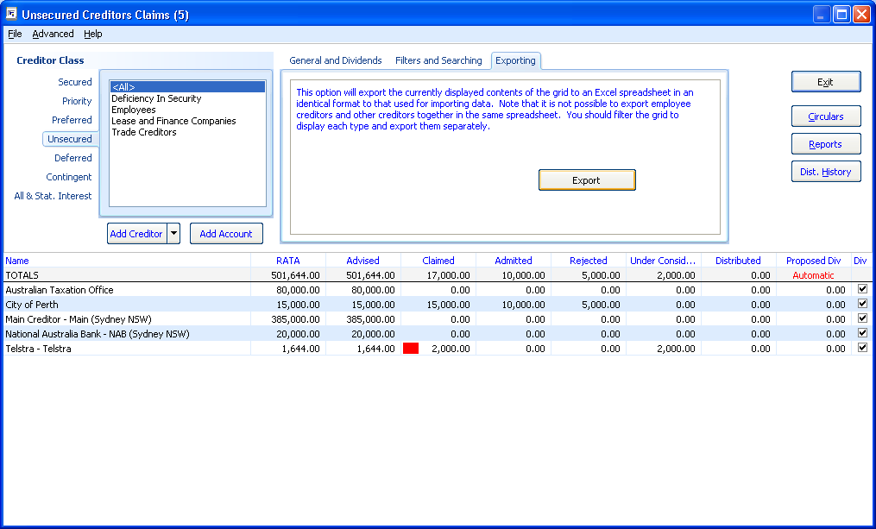
            - Click the Exporting tab.
            - Click the Export button.
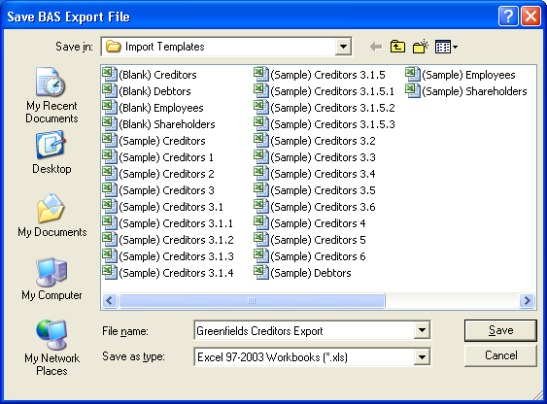
            - Enter the file name and click Save.

To view and amend an exported list of creditors.
Open Excel and:
            - Navigate to the file you saved in the Import directory.
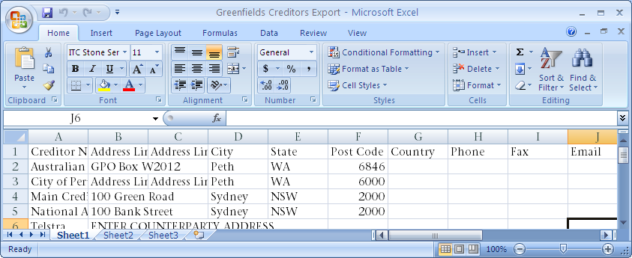
            - Amend and re-import into another job as required.

Tab Appearance and Colour
You can now amend the tab appearance and colour format. This will resolve the disappearing tabs issue some clients have been having, particularly where the application is installed on Citrix.

To amend the tab style format:
            - Click the top tab row (i.e. General, Corporate, Financials, Documents, Tasks) and hold down the Shift key. A Configure Tab Appearance box appears as shown below.
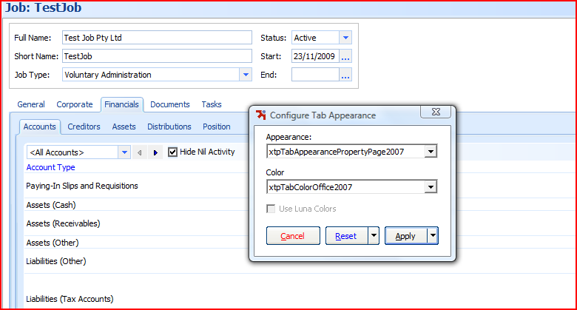
            - The default Appearance is “xtpTabAppearancePropertyPage2007” and Colour is “xtpTabColourOffice2007”.
            - If your tabs disappear, we recommended that you change tab Appearance to “xtpTabAppearancePropertyPage2003”.
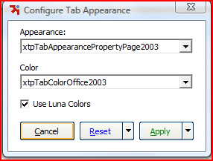
            - If this does not resolve the issue remove the tick for Use Luna Colors as this is just another colour theme type.
            - If the problem is restricted to individual machines, select the Apply this machine only option. If it applies to all machines, select Apply to all machines to change the tab appearance for all.
            - The changes can be reset by clicking the Reset button.

ABA File Output file format
You can now produce file formats that are sent to the bank to make electronic payments. A new ABA tab has been added to the print cheques screen. The bank account details for the payees need to be entered into the banking section or can be entered in the payment screen after ticking the box Payment by EFT.
The system validates the fields which comprise of the data in the output file to ensure the format of the data is correct.

ABA Output file location
The ABA file is created in the data output directory specified in Application Settings > Cheque Printing.

Account Details Form
The bank account details form stores the Payer’s details which are used for the output file.

Printing Cheques
The Print Cheque dialog now displays an ‘ABA’ tab which can be used to output a text file in the ABA format.
Access the Print Cheque dialogue from any payment entry or from the Transactions > Print Cheques menu.
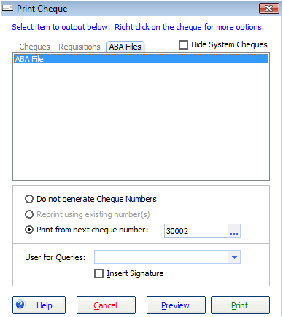

Prepare EFT File Input form
Enter the EFT file information
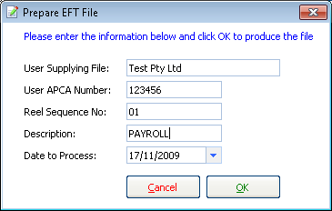
            - The user ACPA number is the User Identification Number allocated by APCA.
            - The user supplying file should match the name registered with ACPA. This value defaults to the Job name.
            - The reel sequence number is the sequential numbering of each output file submitted in one day for each job starting with number ‘01’ then ‘02’, etc.

Validation
Validation is also incorporated in the output process. A validation screen appears and lists any invalid entries.

ABA application
Contact your bank to set up your accounts so you can submit ABA output files for electronic payments.
Description of National Australia Bank Application
The process to enable electronic payments for a job for the National Australia Bank (NAB) is:
- Set up a bank account by completing a NAB Connect application (internet banking form).
- Select the option on the NAB Connect form that requests a Direct Entry ID which will trigger NAB to apply for an APCA number.
- Submit the form to NAB.
- The bank processes your application the form, which includes making a request for APCA to issue an APCA number for the job. The NAB internally calls the APCA number a Direct Entry ID.
- APCA usually advises NAB within about 5 days of the APCA number.
- NAB applies the APCA number to the internet banking setup and advises the customer.
            - The customer can now perform ABA file uploads/transfers.
A new APCA number is required for each entity (can be more than one job if jobs are grouped). If an entity has many accounts, you only need one APCA number.
Other enhancements and resolved issues
The following list summarises additional improvements and resolved issues in this release:

Account Register sort
Click the account register column headers to sort. You can sort by date, reference, transaction ID, payee name and amount.

Account Register find
Enter any value appearing in the account register to search for the details of a transaction. For example enter “Brown” to find the Payee “John Brown”.
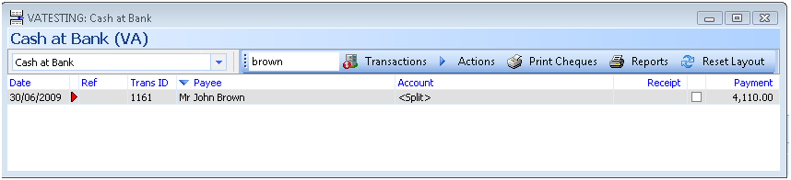

Batching
- Jobs that have un-posted batches are now highlighted on the Transactions > Accounts tab. The number of unposted entries is highlighted in red.

- You no longer receive an error and create a duplicate subentry when you click Save and New in either Make Supplier Payment or Receive Debtor Payment in an unposted batch.
- If a user entered a transaction into a unposted batch while the cashbook operator was posting a transaction within this unposted batch, the new transaction would be marked as posted — even though it is not posted to the bank account. The system now warns you and refreshes the batch before a transaction within an unposted batch is posted.
- The dropdown list in batching is now sorted by date order with the last batch appearing first in the list.

ASIC forms
- Form 524 — now gives you the option to print a summarised receipts and payments annexure.
- Form 524 — can now be produced for a previous job type.
- Form 524 Wizard — line breaks have been inserted into
[RF_ DELAY_CAUSES].
- Form 507 Wizard — Controllership is now automatically selected and the Reason for Report shows Controllership appointment.
- Form 509 — only applies to CVL job types.

Statutory Interest
- There are new calculations for statutory Interest based on the reducing balance of creditors’ outstanding claims.
- You can now combine statutory interest payments with creditor dividends.
- You can enter a specific time period.

Dividends / Creditors
- You can now add unsecured creditor categories (accounts) from the creditor register.
- Alternative counterparty payee details now flow through to dividend payments (Form 549).
- Report grouping by Creditor category is now added to Creditor Claim Type Summary and Creditor Listing by Claim Type.
- The POD Adjudication Form Report now displays the creditor's address.
- Additional fields are available to allow you to define your own dividend description in the Dividend reports. You may now customise dividend report layouts such as the Form 549 report to include the fields "CreditorAdmittedTax", "CreditorAdmittedTotal", "CreditorDividendRate", "CreditorDividendAmount", "CreditorDividendTax".

Employee
- For employees terminated within the wages period, the pay period will now calculate to the termination date.
- Terminated employees no longer appear in Pay Wages for payment dates after the employee has been terminated.
- Employees — Medicare exemption now saves in Employee Register.
- You are now able to add employees in Pay Wages.
- Manual entry employee tax calculations now appear on Payment Summaries.
Employees paid dividends prior to version 3.093 may not appear correctly on Individual Payment Summaries. Make sure you reconcile payments to each employee when preparing payment summaries.
- PAYG Payment Summary — ETP is now populating in bankruptcy jobs.
- When an employee does not claim the tax free threshold, the Medicare exemption now calculates the correct tax amount.
- PAYG marginal tax rates now round down to the dollar.

GEERS
- When you undo a non-approved GEERS distribution, the GEERS wages amount paid is now reset so you can pay wages claims when you redo the distribution.

BAS
- BAS Reports — The Transactions not coded report now excludes accrual transactions from reporting.
- GST is now calculated correctly on imported Post-Appointment (Trading) Accounts Receivables.
- BAS periods now automatically default to the end of the next quarter or month.
- There is now the option to add or maintain Tax codes so they appear in a specific area of the BAS.
- BAS Print Summary Report has been reformatted.
- BAS — Net GST payable was rounding when it should truncate.

Tasks
- You can now mark a task as deleted (setting the status as N/A). This appears on the checklist reports as 'N/A'.
- You can now destroy a task (completely remove it) providing you have permission.
- The start date in a new task template can now be edited.
- The ordering of Task Groups can now be configured.
- When creating or editing task templates you can now open and amend any actions assigned to the task.
- Task actions can now be separately mark/ticked as complete.
- When you complete a task that has a dependent task the date complete is showing correctly.
- A scheduled task will fall due on a day preceding a weekend or public holiday.

Bankruptcy
- Notice of Income Contribution Assessment produced from Circulars and Mailings is now merging.
- The RF code for Motor Vehicle and Tools of Trade Prescribed Amounts, and AITA now uses the correct figures.
- The Invalid input message no longer appears when trying to edit the Personal Actual Income Threshold in Static Data.
- Debtor contributions are now updated when received through a Trust Account.
- You now have the option to add the realisation charge to the deposit of Cash at Bank on Appointment.
- Entering an end date for bankruptcy no longer flags the bankruptcy job for deletion.

Financials
- Cheque requisition now displays the running balance of account.
- Invoice Number is now populating on the Cheque Request Vouchers.
- There is now a button to produce paying-in slips in batch posting and another button to produce deposit slips in Receive Payment and New Cash Sale/Realisation.
- Journal entries now include a total at the bottom of both the Debit (Dr) and Credit (Cr) columns.
- The Chart of Accounts Register now displays Bank Account Name and the BSB and Account Number in brackets.
- Typographical errors "an inter job type transfer" and "cancel to proceeding with making a transfer" have been fixed.
- Updating asset realisation transactions no longer produce an application error.
- The realisation charge for Cash At Bank On Appointment for actual amount received no longer doubles up.
- Creditors' Bank Details such as Bank Names and addresses and BSB/Account numbers can now be imported.
- When manually entering dividend amounts, a blank value in the dividend rate no longer causes an error 13 type mismatch error.
- When previewing a cheque output report, the cheque number now correctly displays when the payment entry is set to “To be Printed”.
- The description “Pre-appointment debtor” now displays instead of “Equity: Opening Balance:” in the account detail listing report and the receipts and payments detail report.
- When you open the BAS Wizard, the BAS period automatically defaults to the end of the next quarter or month.
- Opening balances in the Account Transaction Detailed Listing Report no longer includes unposted batch amounts.
- The Tax code now appears in Cheque Request and Receipt reports if printed immediately after entry.
- When editing an account type if there is no currency type the system will enter the default currency type (AUD).
- The Cheque printing form now orders cheques by date where there are multiple cheques to be printed.
- A Warning message appears when entering an A/P with the same counterparty and invoice number.

Document Templates
- When importing templates, where the template file exists in the target directory, Insolvency no longer rejects the import by saying the file already exists. Instead, it lets you rename the template in the same file-system directory then continue with the import.
- When you add a user prompt with a date format, the system automatically adds the long date format. For example, if you add a prompt called [RF_Date] a code will also appear for [RF_DATE_LONG].
- You can now merge documents for a consultancy job.
- Incorrect document precedent selected when merging a dividend (picks the first precedent in the list not the actual precedent selected).
- Merge and Replace fields now populate in headers and footers, after section breaks and in text boxes.
- The merge field <<DividendDetails>> now rounds the dividend rate to 2 decimal places.
- Amendments have been made to the Style template.

Multiple database access
- New command line switches have been added to the executable.
You can edit the shortcut target to add a command line switch that allows you to specify the database to open, thus allowing you to open different databases simultaneously.

Jobs
- Job information fields now display multi-line entries
- Amending the Job short name now enables the “Save” button.

Other
- The list of public holidays in all states has been updated. When importing tasks using business days, the number of working days is calculated by taking into account public holidays.
- Improvements have been made to query performance to prevent time-out errors
- Email can now be added as a method of Creditor Correspondence
- Additional email recipients can now be added in the Document Production Wizard.
- In Application Settings there are additional maintenance tabs for email settings used for the email notification alerts
- Document merging — merge codes in text boxes are now populating.
- Importing debtors with a zero tax amount now creates the tax code (this is relevant if you want to import the ‘FRE’ code).
- The dropdown Batch combo in batch account registers are now correctly sorted.
- Cheque printing — sort order on data for multiple cheques is fixed.
- The system no longer crashes when previewing cheque reports after closing the parent form before the preview appears.

Appendix — Merge Templates
This section contains a list of new merge templates available with this release.
JOB TYPE: CREDITORS VOLUNTARY LIQUIDATION
Type | Category | Template
ALL | Labels and Envelopes | Mailing Labels
CORP | Accounts Payable | Circular to suppliers
CORP | Accounts Payable: Suppliers | Circular to Suppliers where Company NOT Continuing to Trade
CORP | Accounts Payable: Suppliers | Circular to Suppliers where Company Continuing to Trade
CORP | Accounts Payable: Suppliers | Form Letter to Suppliers where Company Continuing to Trade
CORP | Accounts Payable: Suppliers | Form Letter to Suppliers where Company NOT Continuing to Trade
CORP | Accounts Payable: Suppliers | Circular to Suppliers — Business has been transferred to new owner
CORP | Accounts Payable: Suppliers | Form Letter to Suppliers — Business has been transferred to new owner
CORP | Accounts Receivable | Letter to Debtors advising new bank acccount details
CORP | Accounts Receivable | Initial Letter to Debtors requesting payment of amounts outstanding
CORP | Accounts Receivable | Second and subsequent letters to Debtors requesting payment of amounts outstanding
CORP | Accounts Receivable | Letter referring overdue Debtors to Solicitor or Debt Collector
CORP | Assets | Form 525 — Notice of disclaimer of onerous property
CORP | Assets | Letter to Insurers — Cancellation of Insurance Cover
CORP | Assets | Letter to Agents — Instructions for Asset Valuations
CORP | Assets : Leases | Cover letter to Lessors — disclaim property rights
CORP | Assets : Leases | Continuing to Utilise the Property Subject to the Lease
CORP | Assets : Leases | Covering Letter remittance of payment for continuing lease
CORP | Assets : Leases | Covering Letter Intention not to exercise property rights
CORP | Assets : Leases | Notify Lessors of Appointment
CORP | Assets : Leases | Notify Company Landlords of Appointment
CORP | Assets : Leases | Correspondence to Landlord (continuing to occupy premises)
CORP | Assets : Sale of Business | Draft Confidentiality Agreement for Sale of Company Assets
CORP | Assets : Sale of Business | Advise Interested Party to participate in due diligence process
CORP | Assets : Sale of Business | Covering letter Request for Confidentiality Agreement for the Sale of Business
CORP | Assets : Sale of Business | Advise Interested Party of Unsuccessful Offer for Purchase of Business
CORP | Assets : Sale of Business | Covering letter Confidentiality Agreement for the Sale of Business
CORP | Assets : Sale of Business | Confidentiality Agreement Register
CORP | Creditors | Circular to Creditors Finalisation of Liquidation
CORP | Creditors | Form 535 — Proof of Debt
CORP | Creditors | Form 536 — Formal Proof of Debt or Claim on Behalf of Employees
CORP | Creditors | Form 537 — Rejection of Proof of Debt
CORP | Creditors | Notify Utility Providers of Appointment and Continue Services
CORP | Creditors | Notify Utility Providers of Appointment and Cancel Services
CORP | Creditors | Form Letter to Creditors Finalisation of Liquidation
CORP | Creditors | Request to Continue Telstra Services and Accept Ongoing Personal Liability
CORP | Creditors | Request to Cancel Telstra Services
CORP | Creditors | Request to Change the Lessee for All or Part of the Telstra Services
CORP | Creditors: Committee | Circular to Committee following Appointment of Committee (LIQ)
CORP | Creditors: Preferences | Circular to Creditor Receiving a Preference Payment
CORP | Creditors: Preferences | Circular to Related Party Receiving a Preference Payment
CORP | Creditors: Preferences | Follow up Preference Letter
CORP | Creditors: Preferences | Follow up Preference Letter (No further action)
CORP | Creditors: Reports | Report to ASIC Pursuant to s533(1)
CORP | Creditors: Reports | Supplementary Report to ASIC Pursuant to s533(2)
CORP | Creditors: Retention of Title | Form Letter to Suppliers which may have Retention of Title Claims
CORP | Creditors: Retention of Title | Circular to Suppliers which may have Retention of Title Claims
CORP | Creditors: Retention of Title | Reply to Supplier with Retention of Title claim accepting claim and remittance
CORP | Creditors: Retention of Title | Reply to Supplier with Retention of Title claim seeking settlement
CORP | Creditors: Retention of Title | Reply to Supplier with Retention of Title claim requiring further information
CORP | Creditors: Retention of Title | Reply to Supplier confirming receipt of Retention of Title claim pending assessment
CORP | Dividends | Circular to Creditors — Declaration of Dividend
CORP | Dividends | Notice of GEERS payment (No Cheque)
CORP | Dividends | Notice of Shareholder Dividend
CORP | Dividends | Form 533 — Notice to Submit Particulars of Proof of Debt
CORP | Dividends | Form 534 — Notice to creditors whose claims have not yet been admitted
CORP | Dividends | Circular to Creditors — Notice of Intention to Declare Dividend
CORP | Dividends | Form Letter to Creditors — Notice of Intention to Declare Dividend
CORP | Dividends | Notice to Creditor requiring Further Particulars in Support of Formal Proof of Debt
CORP | Dividends | Form 546 — Advertise intention to declare a dividend
CORP | Dividends | Form 547 — Notice to creditors whose claims have not yet been admitted for interim dividend
CORP | Dividends | Form 548 — Notice to creditors whose claims have not yet been admitted for final dividend
CORP | Dividends | Form 549 — Notice of Declaration of Dividend
CORP | Dividends | Form 550 — Authority to Liquidator to Pay Dividend to a Person Named
CORP | Employees — Directors | Internal Memo PAYG figures to include in next BAS
CORP | Employees — Directors | Letter to GEERS — Notice of Appointment and Termination of Employees
CORP | Employees — Directors | Letter to Centrelink — Notice of Appointment and Termination of Employees
CORP | Employees — Directors | Letter to Employees — Notice of Appointment and Termination
CORP | Employees — Directors | Letter to Employees — Breakdown of Entitlements Distribution
CORP | Employees — Directors | Letter to Employees — Confirming Sufficient Funds to pay Entitlements
CORP | Employees — Directors | Letter to GEERS — Confirming payment to Employees and details of DEWR Claim
CORP | Employees — Directors | Letter to ATO — Advising GEERS PAYG amount
CORP | Employees — Directors | Letter to Employees — Forward GEERS Payment
CORP | Employees — Directors | Letter to GEERS — Employee Entitlements Calculations
CORP | Employees — Directors | Letter to GEERS — Provide Quote to DEWR
CORP | Employees — Directors | Letter to Employees — Advising Claims have been forwards to GEERS
CORP | Employees — Directors | Letter to GEERS — Application to DEWR to meet Professional Costs
CORP | Employees — Directors | Letter to Employee — Calculation of Entitlements
CORP | Employees — Directors | Letter to Employees — Requesting Return of Company Assets
CORP | Employees — Directors | Letter to Employees — Notice of Appointment and Notice of Termination
CORP | Employees — Directors: Affairs | Covering Letter Form 509A — Notice to Director to Deliver Books and Records of Company
CORP | Employees — Directors: Appointment | Advise Directors of responsibilities at Meeting of Creditors for Liquidation of the Company under s497(5)
CORP | Employees — Directors: Appointment | Circular advising Directors resolve to call and meeting placing the company into liquidation
CORP | Employees — Directors: Appointment | Correspondence to Director regarding the proposed winding up of the Company
CORP | Employees — Directors: Appointment | Minutes of a Meeting of Directors
CORP | Employees — Directors: Employee Claims | GEERS Employee Claim Form
CORP | Employees — Directors: Investigation | Investigation checklist for ASIC reports
CORP | Forms | Form 6010 — Application for Voluntary Deregistration of a Company
CORP | Forms | Form 519 — Court Action Relating to Winding Up
CORP | Forms | Form 1500 — Annual report to creditors
CORP | Forms | Form 1501 — Notification of details of pooling determination or order
CORP | Forms | Form 5053 — Notice that Administration of a Company has Ended
CORP | Forms | Form 5056 — Notice that Deed Wholly Effectuated
CORP | Forms | Form 509 — Summary of Affairs of a Company (Blank Template)
CORP | Forms | Form 505 — Appointment or Cessation as External Administrator (Blank Template)
CORP | Forms | Form 911 — Verification or certification of a document
CORP | Forms | Form 507 — Report as To Affairs
CORP | Forms | Form 506 — Notification of change of address of an External Administrator
CORP | Forms | Form 505 — Appointment or Cessation as External Administrator
CORP | Forms | Form 205 — Notification of Resolution
CORP | Forms | Form 524 — Presentation of Accounts and Statement
CORP | Forms | Form 509H — Creditors Statutory Demand for payment of debt
CORP | Forms | Form 507 — Report as To Affairs (Blank Template)
CORP | Forms | Form 507A — Statement Verifying Report as to Affairs
CORP | Forms | Form 505 — Appointment as External Administrator (EXAD)
CORP | General | General Letter
CORP | General | Covering letter to ATO — BAS returns
CORP | General | Covering letter to ASIC Form 505 — Appointment
CORP | General | Request Motor Vehicle Registration Search — RTA
CORP | General | Conflict of Interest checklist
CORP | General | Remuneration Report — Description of Work to be Completed (VA to CVL)
CORP | General | Correspondence to Sheriff advising Appointment and Sheriff's obligations CVL
CORP | General | Onsite First Day Procedures Checklist
CORP | General | Request Motor Vehicle Registration Search — VIC Roads
CORP | General | Request Motor Vehicle Registration Search — Licensing Services WA
CORP | General | Request Motor Vehicle Registration Search — QT QLD
CORP | General | Request Motor Vehicle Registration Search — Transport SA
CORP | General | Request Motor Vehicle Registration Search — MVR NT
CORP | General | Request Motor Vehicle Registration Search — ACT
CORP | General | Request Motor Vehicle Registration Search — Transport DIER TAS
CORP | General | Letter to ATO requesting increasing adjustment dividend unlikely
CORP | General | Job Information
CORP | General | Facsimile Cover Page for the ATO
CORP | General | Scale of Rates
CORP | General | Covering letter to ATO — Final BAS return
CORP | General: Advertise | Form 509D — Advertise Notice of Appointment of Liquidator
CORP | General: Advertise | Advertise Notice of Resolution of EGM
CORP | General: Appointment | Declaration of Independence, Relevant Relationships and Indemnities
CORP | General: Appointment | Advise ATO appointment and debt request
CORP | General: Appointment | Notify Company Accountants of appointment and request books and records
CORP | General: Appointment | Notify Company Auditors of appointment and request books and records
CORP | General: Appointment | Notify Company Solicitors of appointment and request details of any actions
CORP | General: Appointment | Advise Child Support Agency appointment and debt request
CORP | General: Appointment | Advise State Revenue appointment and debt request
CORP | General: Appointment | Advise Workcover appointment and debt request
CORP | General: Appointment | Notify Company Auditors of Appointment
CORP | General: Appointment | Notify Company Solicitors of Appointment
CORP | General: Appointment | Consent to Act as Liquidator
CORP | General: Appointment | Arrange Mail Redirection
CORP | General: Bank | Close Bank Account held by Company and transfer funds to another Account
CORP | General: Bank | Close Bank Account held by the Company and transfer funds to another Bank
CORP | General: Bank | Close Bank Accounts held by Company where account is unknown
CORP | General: Bank | Close Bank Account held in relation to the Appointment
CORP | General: Bank | Advise Bank to set up new account
CORP | General: Books and Records | Books and Records Receipt
CORP | General: Retirement | Application for Consent to destroy Company’s Books and Records
CORP | General: Retirement | Circular to Suppliers ceasing to trade under appointee control
CORP | Meetings | Form 523 — Notification of final meeting convened by liquidator
CORP | Meetings | Form 531A — List of Persons Present at Meeting of Members or Contributories
CORP | Meetings | Form 531B — List of Persons Present at Meeting of Creditors or Debenture Holders
CORP | Meetings | Form 531C — List of Persons Present at Meeting of Committee of Inspection or Creditors
CORP | Meetings | Proof of Debt for Voting Purposes
CORP | Meetings | Form 532 — Appointment of Proxy
CORP | Meetings | Form 530 — Statement in writing of Posting of Notice of Meeting
CORP | Meetings | Delegation of Chairman to chair the meeting
CORP | Meetings: Agenda | Agenda for Meeting of Creditors for Appointment of CVL
CORP | Meetings: Agenda | Draft Agenda Final Meeting of Members and Creditors
CORP | Meetings: Annual | Running Sheet Annual General Meeting of Members and Creditors CVL
CORP | Meetings: Annual | Draft Minutes of Annual General Meeting of Members and Creditors CVL
CORP | Meetings: Annual | Internal Memo Annual Meeting not convened due to insufficient funds
CORP | Meetings: Annual | Circular to Creditors advising that insufficient funds to call AGM
CORP | Meetings: Annual | Form Letter to Creditors advising that insufficient funds to call AGM
CORP | Meetings: Minutes | Draft Minutes of Annual General Meeting of Members and Creditors
CORP | Meetings: Minutes | Minutes of Final Meeting of Members and Creditors
CORP | Meetings: Minutes | Mintues of Final Meeting of Members and Creditors
CORP | Meetings: Minutes | Minutes of Extraordinary General Meeting to Approve Winding Up
CORP | Meetings: Minutes | Draft Minutes of Meeting of Creditors of CVL
CORP | Meetings: Notices | Covering Letter Calling Final Meeting of Creditors proceeding to finalise the Company’s affairs
CORP | Meetings: Notices | Notice to Members of Extraordinary General Meeting
CORP | Meetings: Notices | Notice of Final Meeting
CORP | Meetings: Notices | Form Letter convening First Meetings of Members and Creditors CVL
CORP | Meetings: Notices | Notice of Meeting of Creditors called by Director CVL
CORP | Meetings: Notices | Circular convening First Meetings of Members and Creditors CVL
CORP | Meetings: Notices | Form Letter Calling Final Meeting of Creditors proceeding to finalise the Company’s affairs
CORP | Meetings: Notices | Advertise Final Meeting of CVL
CORP | Meetings: Notices | Advertise Annual General Meeting of CVL
CORP | Meetings: Notices | Circular convening Annual General Meeting of Members and Creditors CVL
CORP | Meetings: Notices | Form Letter convening Annual General Meeting of Members and Creditors CVL

JOB TYPE: PROVISIONAL LIQUIDATION
Type | Category | Template
ALL | Labels and Envelopes | Mailing Labels
CORP | Accounts Payable | Circular to suppliers
CORP | Accounts Payable: Suppliers | Circular to Suppliers where Company NOT Continuing to Trade
CORP | Accounts Payable: Suppliers | Circular to Suppliers where Company Continuing to Trade
CORP | Accounts Payable: Suppliers | Form Letter to Suppliers where Company Continuing to Trade
CORP | Accounts Payable: Suppliers | Form Letter to Suppliers where Company NOT Continuing to Trade
CORP | Accounts Payable: Suppliers | Circular to Suppliers — Business has been transferred to new owner
CORP | Accounts Payable: Suppliers | Form Letter to Suppliers — Business has been transferred to new owner
CORP | Accounts Receivable | Letter to Debtors advising new bank acccount details
CORP | Accounts Receivable | Initial Letter to Debtors requesting payment of amounts outstanding
CORP | Accounts Receivable | Second and subsequent letters to Debtors requesting payment of amounts outstanding
CORP | Accounts Receivable | Letter referring overdue Debtors to Solicitor or Debt Collector
CORP | Assets | Letter to Agents — Instructions for Asset Valuations
CORP | Assets | Letter to Insurers — Cancellation of Insurance Cover
CORP | Assets | Form 525 — Notice of disclaimer of onerous property
CORP | Assets : Leases | Cover letter to Lessors — disclaim property rights
CORP | Assets : Sale of Business | Advise Interested Party to participate in due diligence process
CORP | Assets : Sale of Business | Draft Confidentiality Agreement for Sale of Company Assets
CORP | Assets : Sale of Business | Covering letter Request for Confidentiality Agreement for the Sale of Business
CORP | Assets : Sale of Business | Covering letter Confidentiality Agreement for the Sale of Business
CORP | Assets : Sale of Business | Advise Interested Party of Unsuccessful Offer for Purchase of Business
CORP | Assets : Sale of Business | Confidentiality Agreement Register
CORP | Creditors | Form 535 — Proof of Debt
CORP | Creditors | Form 536 — Formal Proof of Debt or Claim on Behalf of Employees
CORP | Creditors | Discussion Sheet with Petitioning Creditor's Solicitor
CORP | Creditors | Discussion Sheet with Petitioning Creditor
CORP | Creditors | Form Letter to Creditors — Notification of Appointment
CORP | Creditors | Request to Continue Telstra Services and Accept Ongoing Personal Liability
CORP | Creditors | Request to Cancel Telstra Services
CORP | Creditors | Request to Change the Lessee for All or Part of the Telstra Services
CORP | Creditors | Notify Utility Providers of Appointment and Continue Services
CORP | Creditors | Circular to Creditors — Notification of Appointment
CORP | Creditors | Notify Utility Providers of Appointment and Cancel Services
CORP | Creditors: Charge Holders | Request for Books and Records of Company in accordance with Section 530B(2)
CORP | Creditors: Reports | Report to ASIC Pursuant to s476
CORP | Creditors: Reports | Report to ASIC Pursuant to s533(1)
CORP | Creditors: Reports | Supplementary Report to ASIC Pursuant to s533(2)
CORP | Creditors: Retention of Title | Circular to Suppliers which may have Retention of Title Claims
CORP | Creditors: Retention of Title | Form Letter to Suppliers which may have Retention of Title Claims
CORP | Creditors: Retention of Title | Reply to Supplier with Retention of Title claim accepting claim and remittance
CORP | Creditors: Retention of Title | Reply to Supplier confirming receipt of Retention of Title claim pending assessment
CORP | Creditors: Retention of Title | Reply to Supplier with Retention of Title claim requiring further information
CORP | Creditors: Retention of Title | Reply to Supplier with Retention of Title claim seeking settlement
CORP | Employees — Directors | Draft Minutes of board meeting to initiate provisional liquidation and authorise extraordinary general meeting
CORP | Employees — Directors | Letter to Employees — Notice of Appointment and Termination
CORP | Employees — Directors | Letter to Centrelink — Notice of Appointment and Termination of Employees
CORP | Employees — Directors | Letter to GEERS — Notice of Appointment and Termination of Employees
CORP | Employees — Directors | Letter to ATO — Advising GEERS PAYG amount
CORP | Employees — Directors | Letter to GEERS — Confirming payment to Employees and details of DEWR Claim
CORP | Employees — Directors | Letter to Employees — Confirming Sufficient Funds to pay Entitlements
CORP | Employees — Directors | Letter to Employees — Breakdown of Entitlements Distribution
CORP | Employees — Directors | Letter to Employees — Notice of Appointment and Notice of Termination
CORP | Employees — Directors | Letter to Employees — Requesting Return of Company Assets
CORP | Employees — Directors | Letter to Employee — Calculation of Entitlements
CORP | Employees — Directors | Letter to GEERS — Application to DEWR to meet Professional Costs
CORP | Employees — Directors | Letter to Employees — Advising Claims have been forwards to GEERS
CORP | Employees — Directors | Letter to GEERS — Provide Quote to DEWR
CORP | Employees — Directors | Letter to GEERS — Employee Entitlements Calculations
CORP | Employees — Directors | Letter to Employees — Forward GEERS Payment
CORP | Employees — Directors: Affairs | Grant Extension of time requiring Director or Company Officer to submit Report as to Affairs
CORP | Employees — Directors: Affairs | Notice to Director or Company Officer of failure to submit RATA with timeframe
CORP | Employees — Directors: Affairs | Covering Letter Providing copy of RATA to Solicitor
CORP | Employees — Directors: Affairs | Grant Director request for an extension of time to submit RATA
CORP | Employees — Directors: Affairs | Letter to ASIC request received from the directors for extension of time to submit RATA with preliminary
 |  | report
CORP | Employees — Directors: Affairs | Provide Certified copy of RATA to Court
CORP | Employees — Directors: Affairs | Letter to ASIC request received from the directors for extension of time to submit RATA
CORP | Employees — Directors: Affairs | Letter to ASIC yet to receive RATA from Directors
CORP | Employees — Directors: Affairs | Letter to Supreme Court yet to receive RATA from Directors
CORP | Employees — Directors: Affairs | Letter to Federal Court yet to receive RATA from Directors
CORP | Employees — Directors: Appointment | Notification to Director of Requirement to Attend Meeting of Creditors
CORP | Employees — Directors: Appointment | Request Directors for Books and Records
CORP | Employees — Directors: Appointment | Correspondence to Director or Company Officer Advising appointment and responsibilities
CORP | Employees — Directors: Employee Claims | GEERS Employee Claim Form
CORP | Employees — Directors: Investigation | Form Letter to Creditors Summary of RATA and request for information assisting Investigation
CORP | Employees — Directors: Investigation | Circular to Creditors Summary of RATA and request for information assisting Investigation
CORP | Forms | Form 6010 — Application for Voluntary Deregistration of a Company
CORP | Forms | Form 562 — Notice of liquidator extending time to submit report as to affairs
CORP | Forms | Form 511 — Statement verifying report under s430(1) or 475(2)
CORP | Forms | Form 911 — Verification or certification of a document
CORP | Forms | Form 505 — Appointment or Cessation as External Administrator (Blank Template)
CORP | Forms | Form 205 — Notification of Resolution
CORP | Forms | Form 505 — Appointment or Cessation as External Administrator
CORP | Forms | Form 506 — Notification of change of address of an External Administrator
CORP | Forms | Form 507 — Report as To Affairs
CORP | Forms | Form 524 — Presentation of Accounts and Statement
CORP | Forms | Form 505 — Appointment as External Administrator (EXAD)
CORP | Forms | Form 507A — Statement Verifying Report as to Affairs
CORP | Forms | Form 507 — Report as To Affairs (Blank Template)
CORP | Forms | Form 509H — Creditors Statutory Demand for payment of debt
CORP | General | General Letter
CORP | General | Covering letter to ASIC Form 505 — Appointment
CORP | General | Covering letter to ATO — BAS returns
CORP | General | Conflict of Interest checklist
CORP | General | Correspondence to Sheriff advising Appointment and Sheriff's obligations
CORP | General | Request Motor Vehicle Registration Search — RTA
CORP | General | Onsite First Day Procedures Checklist
CORP | General | Request Motor Vehicle Registration Search — VIC Roads
CORP | General | Request Motor Vehicle Registration Search — Licensing Services WA
CORP | General | Request Motor Vehicle Registration Search — QT QLD
CORP | General | Request Motor Vehicle Registration Search — Transport SA
CORP | General | Request Motor Vehicle Registration Search — MVR NT
CORP | General | Request Motor Vehicle Registration Search — ACT
CORP | General | Request Motor Vehicle Registration Search — Transport DIER TAS
CORP | General | Facsimile Cover Page for the ATO
CORP | General | Job Information
CORP | General | Letter to ATO requesting increasing adjustment dividend unlikely
CORP | General | Scale of Rates
CORP | General | Covering letter to ATO — Final BAS return
CORP | General: Advertise | Advertise Appointment of Provisional Liquidator
CORP | General: Appointment | Covering Letter Consent to Act
CORP | General: Appointment | Advise ATO appointment and debt request
CORP | General: Appointment | Form 8 — Consent of Liquidator
CORP | General: Appointment | Declaration of Independence, Relevant Relationships and Indemnities
CORP | General: Appointment | Confirmation Office copy of Order has been Served upon the Company
CORP | General: Appointment | Notify Company Accountants of appointment and request books and records
CORP | General: Appointment | Notify Company Auditors of appointment and request books and records
CORP | General: Appointment | Notify Company Solicitors of appointment and request details of any actions
CORP | General: Appointment | Arrange Mail Redirection
CORP | General: Appointment | Advise Child Support Agency appointment and debt request
CORP | General: Appointment | Advise State Revenue appointment and debt request
CORP | General: Appointment | Advise Workcover appointment and debt request
CORP | General: Bank | Close Bank Accounts held by Company where account is unknown
CORP | General: Bank | Close Bank Account held in relation to the Appointment
CORP | General: Bank | Close Bank Account held by Company
CORP | General: Bank | Advise Bank to set up new account
CORP | General: Books and Records | Books and Records Receipt
CORP | General: Retirement | Acceptance of Final bill of costs
CORP | General: Retirement | Request for final bill of costs Section 466
CORP | Meetings | Form 531A — List of Persons Present at Meeting of Members or Contributories
CORP | Meetings | Form 531B — List of Persons Present at Meeting of Creditors or Debenture Holders
CORP | Meetings | Form 531C — List of Persons Present at Meeting of Committee of Inspection or Creditors
CORP | Meetings | Proof of Debt for Voting Purposes
CORP | Meetings | Form 523 — Notification of final meeting convened by liquidator
CORP | Meetings | Form 530 — Statement in writing of Posting of Notice of Meeting
CORP | Meetings | Form 532 — Appointment of Proxy
CORP | Meetings | Delegation of Chairman to chair the meeting
CORP | Meetings: Minutes | Draft Minutes Blank Template

JOB TYPE: CONSULTING
Type | Category | Template
ALL | Labels and Envelopes | Mailing Labels
CORP | Accounts Payable | Circular to suppliers
CORP | Accounts Payable: Suppliers | Circular to Suppliers where Company NOT Continuing to Trade
CORP | Accounts Payable: Suppliers | Circular to Suppliers where Company Continuing to Trade
CORP | Accounts Payable: Suppliers | Form Letter to Suppliers where Company Continuing to Trade
CORP | Accounts Payable: Suppliers | Form Letter to Suppliers where Company NOT Continuing to Trade
CORP | Accounts Payable: Suppliers | Circular to Suppliers — Business has been transferred to new owner
CORP | Accounts Payable: Suppliers | Form Letter to Suppliers — Business has been transferred to new owner
CORP | Accounts Receivable | Letter to Debtors advising new bank acccount details
CORP | Accounts Receivable | Initial Letter to Debtors requesting payment of amounts outstanding
CORP | Accounts Receivable | Second and subsequent letters to Debtors requesting payment of amounts outstanding
CORP | Accounts Receivable | Letter referring overdue Debtors to Solicitor or Debt Collector
CORP | Assets | Letter to Agents — Instructions for Asset Valuations
CORP | Assets | Letter to Insurers — Cancellation of Insurance Cover
CORP | Assets : Leases | Cover letter to Lessors — disclaim property rights
CORP | Assets : Sale of Business | Draft Confidentiality Agreement for Sale of Company Assets
CORP | Assets : Sale of Business | Advise Interested Party to participate in due diligence process
CORP | Assets : Sale of Business | Covering letter Request for Confidentiality Agreement for the Sale of Business
CORP | Assets : Sale of Business | Advise Interested Party of Unsuccessful Offer for Purchase of Business
CORP | Assets : Sale of Business | Covering letter Confidentiality Agreement for the Sale of Business
CORP | Assets : Sale of Business | Confidentiality Agreement Register
CORP | Creditors | Request to Continue Telstra Services and Accept Ongoing Personal Liability
CORP | Creditors | Request to Cancel Telstra Services
CORP | Creditors | Request to Change the Lessee for All or Part of the Telstra Services
CORP | Creditors | Notify Utility Providers of Appointment and Continue Services
CORP | Creditors | Notify Utility Providers of Appointment and Cancel Services
CORP | Creditors: Retention of Title | Circular to Suppliers which may have Retention of Title Claims
CORP | Creditors: Retention of Title | Form Letter to Suppliers which may have Retention of Title Claims
CORP | Creditors: Retention of Title | Reply to Supplier with Retention of Title claim accepting claim and remittance
CORP | Creditors: Retention of Title | Reply to Supplier with Retention of Title claim seeking settlement
CORP | Creditors: Retention of Title | Reply to Supplier with Retention of Title claim requiring further information
CORP | Creditors: Retention of Title | Reply to Supplier confirming receipt of Retention of Title claim pending assessment
CORP | Dividends | Circular to Creditors — Notice of Intention to Declare Dividend
CORP | Employees — Directors | Letter to GEERS — Notice of Appointment and Termination of Employees
CORP | Employees — Directors | Letter to Centrelink — Notice of Appointment and Termination of Employees
CORP | Employees — Directors | Letter to Employees — Notice of Appointment and Termination
CORP | Employees — Directors | Letter to Employees — Breakdown of Entitlements Distribution
CORP | Employees — Directors | Letter to Employees — Confirming Sufficient Funds to pay Entitlements
CORP | Employees — Directors | Letter to GEERS — Confirming payment to Employees and details of DEWR Claim
CORP | Employees — Directors | Letter to ATO — Advising GEERS PAYG amount
CORP | Employees — Directors | Letter to Employees — Forward GEERS Payment
CORP | Employees — Directors | Letter to GEERS — Employee Entitlements Calculations
CORP | Employees — Directors | Letter to GEERS — Provide Quote to DEWR
CORP | Employees — Directors | Letter to Employees — Advising Claims have been forwards to GEERS
CORP | Employees — Directors | Letter to GEERS — Application to DEWR to meet Professional Costs
CORP | Employees — Directors | Letter to Employee — Calculation of Entitlements
CORP | Employees — Directors | Letter to Employees — Requesting Return of Company Assets
CORP | Employees — Directors | Letter to Employees — Notice of Appointment and Notice of Termination
CORP | Employees — Directors: Employee Claims | GEERS Employee Claim Form
CORP | Forms | Form 505 — Appointment or Cessation as External Administrator (Blank Template)
CORP | Forms | Form 911 — Verification or certification of a document
CORP | Forms | Form 507 — Report as To Affairs
CORP | Forms | Form 506 — Notification of change of address of an External Administrator
CORP | Forms | Form 505 — Appointment or Cessation as External Administrator
CORP | Forms | Form 205 — Notification of Resolution
CORP | Forms | Form 524 — Presentation of Accounts and Statement
CORP | Forms | Form 509H — Creditors Statutory Demand for payment of debt
CORP | Forms | Form 507 — Report as To Affairs (Blank Template)
CORP | Forms | Form 507A — Statement Verifying Report as to Affairs
CORP | Forms | Form 505 — Appointment as External Administrator (EXAD)
CORP | General | General Letter
CORP | General | Covering letter to ATO — BAS returns
CORP | General | Covering letter to ASIC Form 505 — Appointment
CORP | General | Request Motor Vehicle Registration Search — RTA
CORP | General | Request Motor Vehicle Registration Search — VIC Roads
CORP | General | Request Motor Vehicle Registration Search — Licensing Services WA
CORP | General | Request Motor Vehicle Registration Search — QT QLD
CORP | General | Request Motor Vehicle Registration Search — Transport SA
CORP | General | Request Motor Vehicle Registration Search — MVR NT
CORP | General | Request Motor Vehicle Registration Search — ACT
CORP | General | Request Motor Vehicle Registration Search — Transport DIER TAS
CORP | General | Conflict of Interest checklist
CORP | General | Onsite First Day Procedures Checklist
CORP | General | Letter to ATO requesting increasing adjustment dividend unlikely
CORP | General | Job Information
CORP | General | Facsimile Cover Page for the ATO
CORP | General | Scale of Rates
CORP | General | Covering letter to ATO — Final BAS return
CORP | General: Appointment | Arrange Mail Redirection
CORP | General: Appointment | Declaration of Independence, Relevant Relationships and Indemnities
CORP | General: Bank | Close Bank Account held in relation to the Appointment
CORP | General: Bank | Close Bank Account held by Company and transfer funds to another Account
CORP | General: Bank | Close Bank Account held by the Company and transfer funds to another Bank
CORP | General: Bank | Advise Bank to set up new account
CORP | General: Books and Records | Books and Records Receipt
CORP | Meetings | Form 532 — Appointment of Proxy
CORP | Meetings | Form 530 — Statement in writing of Posting of Notice of Meeting
CORP | Meetings | Delegation of Chairman to chair the meeting

JOB TYPE: OTHER
Type | Category | Template
ALL | Labels and Envelopes | Mailing Labels
CORP | Accounts Payable | Circular to suppliers
CORP | Accounts Payable: Suppliers | Circular to Suppliers where Company NOT Continuing to Trade
CORP | Accounts Payable: Suppliers | Circular to Suppliers where Company Continuing to Trade
CORP | Accounts Payable: Suppliers | Form Letter to Suppliers where Company Continuing to Trade
CORP | Accounts Payable: Suppliers | Form Letter to Suppliers where Company NOT Continuing to Trade
CORP | Accounts Payable: Suppliers | Circular to Suppliers — Business has been transferred to new owner
CORP | Accounts Payable: Suppliers | Form Letter to Suppliers — Business has been transferred to new owner
CORP | Accounts Receivable | Letter to Debtors advising new bank acccount details
CORP | Accounts Receivable | Initial Letter to Debtors requesting payment of amounts outstanding
CORP | Accounts Receivable | Second and subsequent letters to Debtors requesting payment of amounts outstanding
CORP | Accounts Receivable | Letter referring overdue Debtors to Solicitor or Debt Collector
CORP | Assets | Letter to Agents — Instructions for Asset Valuations
CORP | Assets | Letter to Insurers — Cancellation of Insurance Cover
CORP | Assets : Leases | Cover letter to Lessors — disclaim property rights
CORP | Assets : Sale of Business | Advise Interested Party to participate in due diligence process
CORP | Assets : Sale of Business | Draft Confidentiality Agreement for Sale of Company Assets
CORP | Assets : Sale of Business | Covering letter Request for Confidentiality Agreement for the Sale of Business
CORP | Assets : Sale of Business | Covering letter Confidentiality Agreement for the Sale of Business
CORP | Assets : Sale of Business | Advise Interested Party of Unsuccessful Offer for Purchase of Business
CORP | Assets : Sale of Business | Confidentiality Agreement Register
CORP | Creditors | Notify Utility Providers of Appointment and Cancel Services
CORP | Creditors | Request to Continue Telstra Services and Accept Ongoing Personal Liability
CORP | Creditors | Request to Cancel Telstra Services
CORP | Creditors | Request to Change the Lessee for All or Part of the Telstra Services
CORP | Creditors | Notify Utility Providers of Appointment and Continue Services
CORP | Creditors: Retention of Title | Form Letter to Suppliers which may have Retention of Title Claims
CORP | Creditors: Retention of Title | Circular to Suppliers which may have Retention of Title Claims
CORP | Creditors: Retention of Title | Reply to Supplier with Retention of Title claim accepting claim and remittance
CORP | Creditors: Retention of Title | Reply to Supplier confirming receipt of Retention of Title claim pending assessment
CORP | Creditors: Retention of Title | Reply to Supplier with Retention of Title claim requiring further information
CORP | Creditors: Retention of Title | Reply to Supplier with Retention of Title claim seeking settlement
CORP | Dividends | Circular to Creditors — Notice of Intention to Declare Dividend
CORP | Employees — Directors | Letter to Employees — Notice of Appointment and Termination
CORP | Employees — Directors | Letter to Centrelink — Notice of Appointment and Termination of Employees
CORP | Employees — Directors | Letter to GEERS — Notice of Appointment and Termination of Employees
CORP | Employees — Directors | Letter to ATO — Advising GEERS PAYG amount
CORP | Employees — Directors | Letter to GEERS — Confirming payment to Employees and details of DEWR Claim
CORP | Employees — Directors | Letter to Employees — Confirming Sufficient Funds to pay Entitlements
CORP | Employees — Directors | Letter to Employees — Breakdown of Entitlements Distribution
CORP | Employees — Directors | Letter to Employees — Notice of Appointment and Notice of Termination
CORP | Employees — Directors | Letter to Employees — Requesting Return of Company Assets
CORP | Employees — Directors | Letter to Employee — Calculation of Entitlements
CORP | Employees — Directors | Letter to GEERS — Application to DEWR to meet Professional Costs
CORP | Employees — Directors | Letter to Employees — Advising Claims have been forwards to GEERS
CORP | Employees — Directors | Letter to GEERS — Provide Quote to DEWR
CORP | Employees — Directors | Letter to GEERS — Employee Entitlements Calculations
CORP | Employees — Directors | Letter to Employees — Forward GEERS Payment
CORP | Employees — Directors: Employee Claims | GEERS Employee Claim Form
CORP | Forms | Form 911 — Verification or certification of a document
CORP | Forms | Form 505 — Appointment or Cessation as External Administrator (Blank Template)
CORP | Forms | Form 205 — Notification of Resolution
CORP | Forms | Form 505 — Appointment or Cessation as External Administrator
CORP | Forms | Form 506 — Notification of change of address of an External Administrator
CORP | Forms | Form 507 — Report as To Affairs
CORP | Forms | Form 524 — Presentation of Accounts and Statement
CORP | Forms | Form 505 — Appointment as External Administrator (EXAD)
CORP | Forms | Form 507A — Statement Verifying Report as to Affairs
CORP | Forms | Form 507 — Report as To Affairs (Blank Template)
CORP | Forms | Form 509H — Creditors Statutory Demand for payment of debt
CORP | General | General Letter
CORP | General | Covering letter to ASIC Form 505 — Appointment
CORP | General | Covering letter to ATO — BAS returns
CORP | General | Request Motor Vehicle Registration Search — RTA
CORP | General | Request Motor Vehicle Registration Search — VIC Roads
CORP | General | Request Motor Vehicle Registration Search — Licensing Services WA
CORP | General | Request Motor Vehicle Registration Search — QT QLD
CORP | General | Request Motor Vehicle Registration Search — Transport SA
CORP | General | Request Motor Vehicle Registration Search — MVR NT
CORP | General | Request Motor Vehicle Registration Search — ACT
CORP | General | Request Motor Vehicle Registration Search — Transport DIER TAS
CORP | General | Conflict of Interest checklist
CORP | General | Onsite First Day Procedures Checklist
CORP | General | Facsimile Cover Page for the ATO
CORP | General | Job Information
CORP | General | Letter to ATO requesting increasing adjustment dividend unlikely
CORP | General | Scale of Rates
CORP | General | Covering letter to ATO — Final BAS return
CORP | General: Appointment | Arrange Mail Redirection
CORP | General: Appointment | Declaration of Independence, Relevant Relationships and Indemnities
CORP | General: Bank | Close Bank Account held in relation to the Appointment
CORP | General: Bank | Close Bank Account held by Company and transfer funds to another Account
CORP | General: Bank | Close Bank Account held by the Company and transfer funds to another Bank
CORP | General: Bank | Advise Bank to set up new account
CORP | General: Books and Records | Books and Records Receipt
CORP | Meetings | Form 530 — Statement in writing of Posting of Notice of Meeting
CORP | Meetings | Form 532 — Appointment of Proxy
CORP | Meetings | Delegation of Chairman to chair the meeting

JOB TYPE: BANKRUPTCY
Type | Category | Template
ALL | Labels and Envelopes | Mailing Labels
CORP | Meetings | Proof of Debt for Voting Purposes
PERS | Accounts Receivable | Letter to Debtors advising Bankrupts new bank account details
PERS | Accounts Receivable | Initial Letter to Debtors requesting payment of outstanding amounts
PERS | Accounts Receivable | Second and Subsequent Letter to Debtors requesting payment of outstanding amounts
PERS | Accounts Receivable | Letter referring overdue Debtors to Solicitor or Debt Collector
PERS | Assets | Letter to Superannuation Fund — Notification of Appointment
PERS | Assets | Letter to Agents — Instructions for Asset Valuations
PERS | Creditors | Discussion Sheet with Petitioning Creditor
PERS | Creditors | Discussion Sheet with Petitioning Creditor's Solicitor
PERS | Creditors | Circular to Creditors — s19 Report
PERS | Creditors | Form Letter to Creditors — s19 Report
PERS | Creditors | Initial Report to Petitioning Creditor and Request for Taxed Bill
PERS | Creditors | Circular to Creditors — Notification of Finalisation of Bankruptcy
PERS | Creditors | Form Letter to Creditors — Notification of Finalisation of Bankruptcy
PERS | Creditors | Circular to Creditors — Notification of Appointment
PERS | Creditors | Form Letter to Creditors — Notification of Appointment
PERS | Creditors | Circular to Secured Creditor — Notification of Appointment
PERS | Creditors | Circular to ATO — Notification of Appointment
PERS | Creditors: Preferences | Circular to Creditor Receiving a Preference Payment
PERS | Creditors: Preferences | Notice for Recovery of Superannuation Payments Pursuant to Section 139ZQ
PERS | Creditors: Preferences | Notice Pursuant to Section 139ZQ
PERS | Debtors | Letter to Debtor — Notice to Attend Creditors Meeting
PERS | Debtors | Letter to Debtor — Collection of Motor Vehicle
PERS | Debtors | Letter to Debtor — Discharge from Bankruptcy
PERS | Debtors | Letter to Debtor — Statement of Income
PERS | Debtors | Business Questionnaire
PERS | Debtors | Letter to Debtor — Notice of Objection to Discharge
PERS | Debtors | Letter to Debtor — Requesting Payment of Outstanding Contributions
PERS | Debtors | Letter to Debtor — Follow up late SOA
PERS | Debtors | Notice of Income Contribution Assessment
PERS | Debtors | Letter Accompanying Sealed Copy of Sequestration Order to Bankrupt
PERS | Debtors | Notice of Requirement to Complete Income Contribution Assessment
PERS | Debtors | Income Assessment Statement
PERS | Debtors | Request Debtor to Complete Income Contribution Assessment
PERS | Debtors | Notice to Deliver Books of Debtor to the Trustee
PERS | Debtors: Appointment | Letter to Debtor — Notification of Bankrupcty and Responsibilities
PERS | Debtors: Notices | Notification of Appointment of PIA and Debtors Responsibilities
PERS | Dividends | Notice of Declaration of Dividend
PERS | Dividends | Notice to Creditors of Intention to Declare Dividend
PERS | Dividends | Advertise Intention to Declare a Dividend
PERS | Dividends | Test
PERS | Dividends | Circular to Creditors Notice of Intention to Declare Final Dividend
PERS | Dividends | Circular to Creditors Notice of Intention to Declare Interim Dividend
PERS | Dividends | Circular to Creditors Notice of Declaration of Dividend
PERS | Dividends | Form Letter to Creditors Notice of Declaration of Dividend
PERS | Dividends | Form Letter to Creditors Notice of Intention to Declare Final Dividend
PERS | Dividends | Proof of Debt Checklist
PERS | Dividends | Notice of Rejection of Formal Proof of Debt or Claim
PERS | Dividends | Request Creditors to Supply More Information Supporting Claim
PERS | Dividends | Form Letter to Creditors Notice of Intention to Declare Interim Dividend
PERS | Employees: Employee Claims | GEERS Employee Claim Form
PERS | Forms | Form 01 — Bankruptcy Notice
PERS | Forms | Form 05 — Declaration of Intention to Present a Debtor's Petition
PERS | Forms | Form 06 — Debtor's Petition
PERS | Forms | Form 02 — Trustees Account of Receipts and Payments (Blank Template)
PERS | Forms | Form 12 — Consent to Act and Trustee Declaration
PERS | Forms | Statement of Affairs (Pro-Forma)
PERS | Forms | Form 16 — Remittance of Realisations Charge (Blank Template)
PERS | Forms | Form 18 — Notice of Special Resolution of Creditors to consider PIA, Scheme or Composition
PERS | Forms | Form 19 — Notice of completion, variation, termination or setting aside of PIA or Composition
PERS | Forms | Form 26 — Application for surrender of registration as a Registered Debt Agreement Administrator
PERS | Forms | Form 03 — Statement of Affairs
PERS | Forms | Form 04 — Statement of Affairs under Part XI
PERS | Forms | Form 07 — Statement of Claim and Proxy
PERS | Forms | Form 08 — Proof of Debt
PERS | Forms | Form 09 — Notice of Demand
PERS | Forms | Form 10 — Application for Registration as a Trustee
PERS | Forms | Form 11 — Application for a Change of Conditions on Registration as a Trustee
PERS | Forms | Form 15 — Remittance Of Interest Charge (Blank Template)
PERS | General | General Letter
PERS | General | Cover Letter to Insurance Advice Form
PERS | General | Shareholdings Registered in the Name of the Bankrupt
PERS | General | Remit Unclaimed Monies
PERS | General | Covering Letter to ITSA- Enclosing completed SOA
PERS | General | Circular to Utility Providers
PERS | General | Circular to State Revenue Authority
PERS | General | Circular to Sheriff's Office
PERS | General | Passport Renewal
PERS | General | Interim Insurance of Debtor's Property
PERS | General | Insurance Advice Form
PERS | General | Notice of Objection of Discharge
PERS | General | Letter to ITSA — Notice of Objection of Discharge
PERS | General | Investigation Procedure
PERS | General | Letter to Solicitor requesting Lodgement of Caveat over Real Property
PERS | General | Books and Records Receipt
PERS | General | Section 139ZL Notice for Income Contributions
PERS | General | Letter to the Child Support Agency
PERS | General | Request Motor Vehicle Registration Search — RTA
PERS | General | Request Motor Vehicle Registration Search — Vic Roads
PERS | General | Request Motor Vehicle Registration Search — ACT
PERS | General | Request Motor Vehicle Registration Search — Licensing Services WA
PERS | General | Request Motor Vehicle Registration Search — MVR NT
PERS | General | Covering letter to ITSA enclosing Notice of Termination of PIA pursuant to s222A
PERS | General | Section 77AA Notice of Authorisation to Access Premises and Books
PERS | General | Section 77C Notice to Provide Information Only (Attendance Not Required)
PERS | General | Section 77C Notice to Give Evidence and Produce Books (Attendance Required)
PERS | General | Letter to Veda Advantage Requesting Debtor File
PERS | General | Declaration of Independence, Relevant Relationships and Indemnities
PERS | General | Remuneration Report
PERS | General | Request Motor Vehicle Registration Search — Transport DIER TAS
PERS | General | Request Motor Vehicle Registration Search — Transport SA
PERS | General | Request Motor Vehicle Registration Search — QT QLD
PERS | General | Statement of Postage
PERS | General | Facsimile Cover Page for the ATO
PERS | General: Bank | Open New Bank Account
PERS | General: Bank | Close Bank Account of a Debtor and transfer funds to another Bank
PERS | General: Bank | Close Bank Account of Trustee
PERS | General: Bank | Cancel Credit Cards
PERS | General: Bank | Close Bank Account of a Debtor and transfer funds to another Account
PERS | General: Retirement | Letter to ITSA — Finalisation of Bankruptcy
PERS | Meetings | Statement in Writing of Posting of Notice of Meeting
PERS | Meetings | Certificate of Resolutions Passed
PERS | Meetings: Minutes | Minutes — Meeting of Creditors
PERS | Meetings: Notices | Advertise Notice of Meeting
PERS | Meetings: Notices | Circular to Creditors — Notice of Meeting
PERS | Meetings: Notices | Form Letter to Creditors — Notice of Meeting

JOB TYPE: PART IX — DEBT AGREEMENT
Type | Category | Template
ALL | Labels and Envelopes | Mailing Labels
CORP | Meetings | Proof of Debt for Voting Purposes
PERS | Debtors | Notice of Income Contribution Assessment
PERS | Debtors | Notice of Requirement to Complete Income Contribution Assessment
PERS | Debtors | Income Assessment Statement
PERS | Debtors | Request Debtor to Complete Income Contribution Assessment
PERS | Debtors: Notices | Notification of Appointment of PIA and Debtors Responsibilities
PERS | Dividends | Notice of Declaration of Dividend
PERS | Dividends | Notice to Creditors of Intention to Declare Dividend
PERS | Dividends | Advertise Intention to Declare a Dividend
PERS | Dividends | Form Letter to Creditors Notice of Intention to Declare Final Dividend
PERS | Dividends | Proof of Debt Checklist
PERS | Dividends | Notice of Rejection of Formal Proof of Debt or Claim
PERS | Dividends | Request Creditors to Supply More Information Supporting Claim
PERS | Dividends | Circular to Creditors Notice of Intention to Declare Final Dividend
PERS | Dividends | Circular to Creditors Notice of Intention to Declare Interim Dividend
PERS | Dividends | Circular to Creditors Notice of Declaration of Dividend
PERS | Dividends | Form Letter to Creditors Notice of Declaration of Dividend
PERS | Dividends | Form Letter to Creditors Notice of Intention to Declare Interim Dividend
PERS | Employees: Employee Claims | GEERS Employee Claim Form
PERS | Forms | Form 17 — Debt Agreement Statement of Affairs and Debt Agreement Proposal
PERS | Forms | Debt Agreement Proposal
PERS | Forms | Debt Agreement Statement of Affairs and Debt Agreement Proposal
PERS | Forms | Form 25 — Application to change registration of a Debt Agreement Administrator
PERS | Forms | Certificate by Debt Agreement Administrator
PERS | Forms | Form 12 — Consent to Act and Trustee Declaration
PERS | Forms | Form 02 — Trustees Account of Receipts and Payments (Blank Template)
PERS | Forms | Form 15 — Remittance Of Interest Charge (Blank Template)
PERS | Forms | Form 11 — Application for a Change of Conditions on Registration as a Trustee
PERS | Forms | Form 10 — Application for Registration as a Trustee
PERS | Forms | Form 09 — Notice of Demand
PERS | Forms | Form 08 — Proof of Debt
PERS | Forms | Form 07 — Statement of Claim and Proxy
PERS | Forms | Form 04 — Statement of Affairs under Part XI
PERS | Forms | Form 03 — Statement of Affairs
PERS | Forms | Form 26 — Application for surrender of registration as a Registered Debt Agreement Administrator
PERS | Forms | Form 19 — Notice of completion, variation, termination or setting aside of PIA or Composition
PERS | Forms | Form 18 — Notice of Special Resolution of Creditors to consider PIA, Scheme or Composition
PERS | Forms | Form 16 — Remittance of Realisations Charge (Blank Template)
PERS | Forms | Statement of Affairs (Pro-Forma)
PERS | General | Cover Letter to Insurance Advice Form
PERS | General | General Letter
PERS | General | Investigation Procedure
PERS | General | Section 139ZL Notice for Income Contributions
PERS | General | Circular to Utility Providers
PERS | General | Interim Insurance of Debtor's Property
PERS | General | Insurance Advice Form
PERS | General | Remit Unclaimed Monies
PERS | General | Covering letter to ITSA enclosing Notice of Termination of PIA pursuant to s222A
PERS | General | Request Motor Vehicle Registration Search — MVR NT
PERS | General | Request Motor Vehicle Registration Search — Licensing Services WA
PERS | General | Request Motor Vehicle Registration Search — ACT
PERS | General | Request Motor Vehicle Registration Search — Vic Roads
PERS | General | Request Motor Vehicle Registration Search — RTA
PERS | General | Section 77AA Notice of Authorisation to Access Premises and Books
PERS | General | Section 77C Notice to Give Evidence and Produce Books (Attendance Required)
PERS | General | Section 77C Notice to Provide Information Only (Attendance Not Required)
PERS | General | Letter to Veda Advantage Requesting Debtor File
PERS | General | Remuneration Report
PERS | General | Declaration of Independence, Relevant Relationships and Indemnities
PERS | General | Statement of Postage
PERS | General | Request Motor Vehicle Registration Search — QT QLD
PERS | General | Request Motor Vehicle Registration Search — Transport SA
PERS | General | Request Motor Vehicle Registration Search — Transport DIER TAS
PERS | General | Facsimile Cover Page for the ATO
PERS | General: Bank | Cancel Credit Cards
PERS | General: Bank | Open New Bank Account
PERS | General: Bank | Close Bank Account of Trustee
PERS | Meetings | Certificate of Resolutions Passed
PERS | Meetings | Statement in Writing of Posting of Notice of Meeting

JOB TYPE: PART X — DEED OF ASSIGNMENT
Type | Category | Template
ALL | Labels and Envelopes | Mailing Labels
CORP | Meetings | Proof of Debt for Voting Purposes
PERS | Debtors: Notices | Notification of Appointment of PIA and Debtors Responsibilities
PERS | Dividends | Notice of Declaration of Dividend
PERS | Dividends | Notice to Creditors of Intention to Declare Dividend
PERS | Dividends | Advertise Intention to Declare a Dividend
PERS | Dividends | Form Letter to Creditors Notice of Intention to Declare Final Dividend
PERS | Dividends | Proof of Debt Checklist
PERS | Dividends | Notice of Rejection of Formal Proof of Debt or Claim
PERS | Dividends | Request Creditors to Supply More Information Supporting Claim
PERS | Dividends | Circular to Creditors Notice of Intention to Declare Final Dividend
PERS | Dividends | Circular to Creditors Notice of Intention to Declare Interim Dividend
PERS | Dividends | Circular to Creditors Notice of Declaration of Dividend
PERS | Dividends | Form Letter to Creditors Notice of Declaration of Dividend
PERS | Dividends | Form Letter to Creditors Notice of Intention to Declare Interim Dividend
PERS | Employees: Employee Claims | GEERS Employee Claim Form
PERS | Forms | Form 12 — Consent to Act and Trustee Declaration
PERS | Forms | Form 02 — Trustees Account of Receipts and Payments (Blank Template)
PERS | Forms | Statement of Affairs (Pro-Forma)
PERS | Forms | Form 16 — Remittance of Realisations Charge (Blank Template)
PERS | Forms | Form 18 — Notice of Special Resolution of Creditors to consider PIA, Scheme or Composition
PERS | Forms | Form 19 — Notice of completion, variation, termination or setting aside of PIA or Composition
PERS | Forms | Form 26 — Application for surrender of registration as a Registered Debt Agreement Administrator
PERS | Forms | Form 03 — Statement of Affairs
PERS | Forms | Form 04 — Statement of Affairs under Part XI
PERS | Forms | Form 07 — Statement of Claim and Proxy
PERS | Forms | Form 08 — Proof of Debt
PERS | Forms | Form 09 — Notice of Demand
PERS | Forms | Form 10 — Application for Registration as a Trustee
PERS | Forms | Form 11 — Application for a Change of Conditions on Registration as a Trustee
PERS | Forms | Form 15 — Remittance Of Interest Charge (Blank Template)
PERS | General | General Letter
PERS | General | Cover Letter to Insurance Advice Form
PERS | General | Section 139ZL Notice for Income Contributions
PERS | General | Remit Unclaimed Monies
PERS | General | Investigation Procedure
PERS | General | Circular to Utility Providers
PERS | General | Interim Insurance of Debtor's Property
PERS | General | Insurance Advice Form
PERS | General | Request Motor Vehicle Registration Search — RTA
PERS | General | Request Motor Vehicle Registration Search — Vic Roads
PERS | General | Request Motor Vehicle Registration Search — ACT
PERS | General | Request Motor Vehicle Registration Search — Licensing Services WA
PERS | General | Request Motor Vehicle Registration Search — MVR NT
PERS | General | Covering letter to ITSA enclosing Notice of Termination of PIA pursuant to s222A
PERS | General | Section 77AA Notice of Authorisation to Access Premises and Books
PERS | General | Section 77C Notice to Provide Information Only (Attendance Not Required)
PERS | General | Section 77C Notice to Give Evidence and Produce Books (Attendance Required)
PERS | General | Letter to Veda Advantage Requesting Debtor File
PERS | General | Declaration of Independence, Relevant Relationships and Indemnities
PERS | General | Remuneration Report
PERS | General | Request Motor Vehicle Registration Search — Transport DIER TAS
PERS | General | Request Motor Vehicle Registration Search — Transport SA
PERS | General | Request Motor Vehicle Registration Search — QT QLD
PERS | General | Statement of Postage
PERS | General | Facsimile Cover Page for the ATO
PERS | General: Bank | Cancel Credit Cards
PERS | General: Bank | Close Bank Account of Trustee
PERS | General: Bank | Open New Bank Account
PERS | Meetings | Statement in Writing of Posting of Notice of Meeting
PERS | Meetings | Certificate of Resolutions Passed

JOB TYPE: PART X — DEED OF ARRANGEMENT
Type | Category | Template
ALL | Labels and Envelopes | Mailing Labels
CORP | Meetings | Proof of Debt for Voting Purposes
PERS | Debtors: Notices | Notification of Appointment of PIA and Debtors Responsibilities
PERS | Dividends | Notice of Declaration of Dividend
PERS | Dividends | Notice to Creditors of Intention to Declare Dividend
PERS | Dividends | Advertise Intention to Declare a Dividend
PERS | Dividends | Form Letter to Creditors Notice of Intention to Declare Final Dividend
PERS | Dividends | Proof of Debt Checklist
PERS | Dividends | Notice of Rejection of Formal Proof of Debt or Claim
PERS | Dividends | Request Creditors to Supply More Information Supporting Claim
PERS | Dividends | Circular to Creditors Notice of Intention to Declare Final Dividend
PERS | Dividends | Circular to Creditors Notice of Intention to Declare Interim Dividend
PERS | Dividends | Circular to Creditors Notice of Declaration of Dividend
PERS | Dividends | Form Letter to Creditors Notice of Declaration of Dividend
PERS | Dividends | Form Letter to Creditors Notice of Intention to Declare Interim Dividend
PERS | Employees: Employee Claims | GEERS Employee Claim Form
PERS | Forms | Form 12 — Consent to Act and Trustee Declaration
PERS | Forms | Form 02 — Trustees Account of Receipts and Payments (Blank Template)
PERS | Forms | Form 15 — Remittance Of Interest Charge (Blank Template)
PERS | Forms | Form 11 — Application for a Change of Conditions on Registration as a Trustee
PERS | Forms | Form 10 — Application for Registration as a Trustee
PERS | Forms | Form 09 — Notice of Demand
PERS | Forms | Form 08 — Proof of Debt
PERS | Forms | Form 07 — Statement of Claim and Proxy
PERS | Forms | Form 04 — Statement of Affairs under Part XI
PERS | Forms | Form 03 — Statement of Affairs
PERS | Forms | Form 26 — Application for surrender of registration as a Registered Debt Agreement Administrator
PERS | Forms | Form 19 — Notice of completion, variation, termination or setting aside of PIA or Composition
PERS | Forms | Form 18 — Notice of Special Resolution of Creditors to consider PIA, Scheme or Composition
PERS | Forms | Form 16 — Remittance of Realisations Charge (Blank Template)
PERS | Forms | Statement of Affairs (Pro-Forma)
PERS | General | Cover Letter to Insurance Advice Form
PERS | General | General Letter
PERS | General | Section 139ZL Notice for Income Contributions
PERS | General | Circular to Utility Providers
PERS | General | Interim Insurance of Debtor's Property
PERS | General | Insurance Advice Form
PERS | General | Investigation Procedure
PERS | General | Remit Unclaimed Monies
PERS | General | Covering letter to ITSA enclosing Notice of Termination of PIA pursuant to s222A
PERS | General | Request Motor Vehicle Registration Search — MVR NT
PERS | General | Request Motor Vehicle Registration Search — Licensing Services WA
PERS | General | Request Motor Vehicle Registration Search — ACT
PERS | General | Request Motor Vehicle Registration Search — Vic Roads
PERS | General | Request Motor Vehicle Registration Search — RTA
PERS | General | Section 77AA Notice of Authorisation to Access Premises and Books
PERS | General | Section 77C Notice to Give Evidence and Produce Books (Attendance Required)
PERS | General | Section 77C Notice to Provide Information Only (Attendance Not Required)
PERS | General | Letter to Veda Advantage Requesting Debtor File
PERS | General | Remuneration Report
PERS | General | Declaration of Independence, Relevant Relationships and Indemnities
PERS | General | Statement of Postage
PERS | General | Request Motor Vehicle Registration Search — QT QLD
PERS | General | Request Motor Vehicle Registration Search — Transport SA
PERS | General | Request Motor Vehicle Registration Search — Transport DIER TAS
PERS | General | Facsimile Cover Page for the ATO
PERS | General: Bank | Cancel Credit Cards
PERS | General: Bank | Open New Bank Account
PERS | General: Bank | Close Bank Account of Trustee
PERS | Meetings | Certificate of Resolutions Passed
PERS | Meetings | Statement in Writing of Posting of Notice of Meeting

JOB TYPE: PART X — COMPOSITION
Type | Category | Template
ALL | Labels and Envelopes | Mailing Labels
CORP | Meetings | Proof of Debt for Voting Purposes
PERS | Debtors: Notices | Notification of Appointment of PIA and Debtors Responsibilities
PERS | Dividends | Notice of Declaration of Dividend
PERS | Dividends | Notice to Creditors of Intention to Declare Dividend
PERS | Dividends | Advertise Intention to Declare a Dividend
PERS | Dividends | Circular to Creditors Notice of Intention to Declare Final Dividend
PERS | Dividends | Circular to Creditors Notice of Intention to Declare Interim Dividend
PERS | Dividends | Circular to Creditors Notice of Declaration of Dividend
PERS | Dividends | Form Letter to Creditors Notice of Declaration of Dividend
PERS | Dividends | Form Letter to Creditors Notice of Intention to Declare Final Dividend
PERS | Dividends | Proof of Debt Checklist
PERS | Dividends | Notice of Rejection of Formal Proof of Debt or Claim
PERS | Dividends | Request Creditors to Supply More Information Supporting Claim
PERS | Dividends | Form Letter to Creditors Notice of Intention to Declare Interim Dividend
PERS | Employees: Employee Claims | GEERS Employee Claim Form
PERS | Forms | Form 12 — Consent to Act and Trustee Declaration
PERS | Forms | Form 02 — Trustees Account of Receipts and Payments (Blank Template)
PERS | Forms | Statement of Affairs (Pro-Forma)
PERS | Forms | Form 16 — Remittance of Realisations Charge (Blank Template)
PERS | Forms | Form 18 — Notice of Special Resolution of Creditors to consider PIA, Scheme or Composition
PERS | Forms | Form 19 — Notice of completion, variation, termination or setting aside of PIA or Composition
PERS | Forms | Form 26 — Application for surrender of registration as a Registered Debt Agreement Administrator
PERS | Forms | Form 03 — Statement of Affairs
PERS | Forms | Form 04 — Statement of Affairs under Part XI
PERS | Forms | Form 07 — Statement of Claim and Proxy
PERS | Forms | Form 08 — Proof of Debt
PERS | Forms | Form 09 — Notice of Demand
PERS | Forms | Form 10 — Application for Registration as a Trustee
PERS | Forms | Form 11 — Application for a Change of Conditions on Registration as a Trustee
PERS | Forms | Form 15 — Remittance Of Interest Charge (Blank Template)
PERS | General | General Letter
PERS | General | Cover Letter to Insurance Advice Form
PERS | General | Section 139ZL Notice for Income Contributions
PERS | General | Investigation Procedure
PERS | General | Remit Unclaimed Monies
PERS | General | Circular to Utility Providers
PERS | General | Interim Insurance of Debtor's Property
PERS | General | Insurance Advice Form
PERS | General | Request Motor Vehicle Registration Search — RTA
PERS | General | Request Motor Vehicle Registration Search — Vic Roads
PERS | General | Request Motor Vehicle Registration Search — ACT
PERS | General | Request Motor Vehicle Registration Search — Licensing Services WA
PERS | General | Request Motor Vehicle Registration Search — MVR NT
PERS | General | Covering letter to ITSA enclosing Notice of Termination of PIA pursuant to s222A
PERS | General | Section 77AA Notice of Authorisation to Access Premises and Books
PERS | General | Section 77C Notice to Provide Information Only (Attendance Not Required)
PERS | General | Section 77C Notice to Give Evidence and Produce Books (Attendance Required)
PERS | General | Letter to Veda Advantage Requesting Debtor File
PERS | General | Declaration of Independence, Relevant Relationships and Indemnities
PERS | General | Remuneration Report
PERS | General | Request Motor Vehicle Registration Search — Transport DIER TAS
PERS | General | Request Motor Vehicle Registration Search — Transport SA
PERS | General | Request Motor Vehicle Registration Search — QT QLD
PERS | General | Statement of Postage
PERS | General | Facsimile Cover Page for the ATO
PERS | General: Bank | Cancel Credit Cards
PERS | General: Bank | Open New Bank Account
PERS | General: Bank | Close Bank Account of Trustee
PERS | Meetings | Statement in Writing of Posting of Notice of Meeting
PERS | Meetings | Certificate of Resolutions Passed

JOB TYPE: PART X — PERSONAL INSOLVENCY AGREEMENT
Type | Category | Template
ALL | Labels and Envelopes | Mailing Labels
PERS | Creditors | Circular to Creditors following meeting PIA
PERS | Creditors | Circular to Creditors of Variation to PIA
PERS | Creditors | Circular to Creditors advising termination of PIA by Resolution of Creditors
PERS | Creditors | Circular to Creditors advising termination of PIA by Creditors consenting to Proposal
PERS | Creditors | Circular to Creditors advising Debtor has failed to meet obligations of PIA
PERS | Creditors | Circular to Creditors Advising no objections to the termination of PIA
PERS | Creditors | Advise Creditors of Court Application to terminate PIA and granting of Sequestration Order
PERS | Creditors | Form Letter to Creditors — Notification of Execution of s188
PERS | Creditors | Form Letter to Creditors following meeting PIA
PERS | Creditors | Form Letter to Creditors of Variation to PIA
PERS | Creditors | Circular to Creditors — PIA Variation Accepted
PERS | Creditors | Form Letter to Creditors — PIA Variation Accepted
PERS | Creditors | Form Letter to Creditors Advising no objections to the termination of PIA
PERS | Debtors | Draft Personal Insolvency Agreement Proposal
PERS | Debtors | Certificate that PIA Obligations Discharged
PERS | Debtors: Appointment | Advise Debtor that Request for Variation of PIA has been accepted
PERS | Debtors: Appointment | Advise Debtor of Court Application to terminate PIA and granting of Sequestration Order
PERS | Debtors: Appointment | Circular to ITSA enclosing certificate issued to Debtor pursuant to s232
PERS | Debtors: Appointment | Advise Debtor that notice of termination of PIA has been sent to Creditors
PERS | Debtors: Appointment | Advise Debtor that Request for Variation of PIA has been sent to Creditors
PERS | Debtors: Appointment | Request for Certification to Debtor pursuant to s232
PERS | Debtors: Notices | Notification of Appointment of PIA and Debtors Responsibilities
PERS | Dividends | Notice of Declaration of Dividend
PERS | Dividends | Advertise Intention to Declare a Dividend
PERS | Dividends | Circular to Creditors Notice of Dividend (PIA)
PERS | Dividends | Form Letter to Creditors Notice of Intention to Declare Final Dividend
PERS | Dividends | Proof of Debt Checklist
PERS | Dividends | Notice of Rejection of Formal Proof of Debt or Claim
PERS | Dividends | Request Creditors to Supply More Information Supporting Claim
PERS | Dividends | Form Letter to Creditors Notice of Dividend (PIA)
PERS | Dividends | Circular to Creditors Notice of Intention to Declare Final Dividend
PERS | Dividends | Circular to Creditors Notice of Intention to Declare Interim Dividend
PERS | Dividends | Circular to Creditors Notice of Declaration of Dividend
PERS | Dividends | Form Letter to Creditors Notice of Declaration of Dividend
PERS | Dividends | Form Letter to Creditors Notice of Intention to Declare Interim Dividend
PERS | Employees: Employee Claims | GEERS Employee Claim Form
PERS | Forms | Form 19 — Notice of Variation of PIA
PERS | Forms | Form 13 — Controlling Trustee Authority and Trustee Declaration
PERS | Forms | Form 12 — Consent to Act and Trustee Declaration (Blank Template)
PERS | Forms | Form 13 — Controlling Trustee Authority and Trustee Declaration (Blank Template)
PERS | Forms | Form 12 — Consent to Act and Trustee Declaration
PERS | Forms | Form 02 — Trustees Account of Receipts and Payments (Blank Template)
PERS | Forms | Form 15 — Remittance Of Interest Charge (Blank Template)
PERS | Forms | Form 11 — Application for a Change of Conditions on Registration as a Trustee
PERS | Forms | Form 10 — Application for Registration as a Trustee
PERS | Forms | Form 09 — Notice of Demand
PERS | Forms | Form 08 — Proof of Debt
PERS | Forms | Form 07 — Statement of Claim and Proxy
PERS | Forms | Form 04 — Statement of Affairs under Part XI
PERS | Forms | Form 03 — Statement of Affairs
PERS | Forms | Form 26 — Application for surrender of registration as a Registered Debt Agreement Administrator
PERS | Forms | Form 19 — Notice of completion, variation, termination or setting aside of PIA or Composition
PERS | Forms | Form 18 — Notice of Special Resolution of Creditors to consider PIA, Scheme or Composition
PERS | Forms | Form 16 — Remittance of Realisations Charge (Blank Template)
PERS | Forms | Statement of Affairs (Pro-Forma)
PERS | General | Cover Letter to Insurance Advice Form
PERS | General | General Letter
PERS | General | Covering Letter to ITSA Re Execution of PIA
PERS | General | Remit Unclaimed Monies
PERS | General | Circular to Utility Providers
PERS | General | Interim Insurance of Debtor's Property
PERS | General | Insurance Advice Form
PERS | General | Notify ITSA Variation of PIA accepted by Creditors
PERS | General | Advise ITSA of Termination of PIA by Resolution of Creditors
PERS | General | Covering Letter to ITSA — Enclosing Form 13, Form 3 and PIA Proposal
PERS | General | Investigation Procedure
PERS | General | Section 139ZL Notice for Income Contributions
PERS | General | Covering Letter to ITSA — Enclosing Executed PIA, Form 12 and Resolutions
PERS | General | Covering letter to ITSA enclosing Notice of Termination of PIA pursuant to s222A
PERS | General | Request Motor Vehicle Registration Search — MVR NT
PERS | General | Request Motor Vehicle Registration Search — Licensing Services WA
PERS | General | Request Motor Vehicle Registration Search — ACT
PERS | General | Request Motor Vehicle Registration Search — Vic Roads
PERS | General | Request Motor Vehicle Registration Search — RTA
PERS | General | Section 77AA Notice of Authorisation to Access Premises and Books
PERS | General | Section 77C Notice to Give Evidence and Produce Books (Attendance Required)
PERS | General | Section 77C Notice to Provide Information Only (Attendance Not Required)
PERS | General | Letter to Veda Advantage Requesting Debtor File
PERS | General | Remuneration Report
PERS | General | Declaration of Independence, Relevant Relationships and Indemnities
PERS | General | Statement of Postage
PERS | General | Request Motor Vehicle Registration Search — QT QLD
PERS | General | Request Motor Vehicle Registration Search — Transport SA
PERS | General | Request Motor Vehicle Registration Search — Transport DIER TAS
PERS | General | Facsimile Cover Page for the ATO
PERS | General: Bank | Open New Bank Account
PERS | General: Bank | Close Bank Account of Trustee
PERS | General: Bank | Cancel Credit Cards
PERS | General: Retirement | Advise ITSA of Finalisation of PIA
PERS | General: Retirement | Advise OL of termination of PIA by Court and Sequestration Order made
PERS | Meetings | Circular to Creditors Following Meeting of Creditors (Controlling Trustee)
PERS | Meetings | Certificate of Resolutions Passed
PERS | Meetings | Statement in Writing of Posting of Notice of Meeting
PERS | Meetings: Agenda | Agenda of Meeting of Creditors for Termination of PIA
PERS | Meetings: Minutes | Minutes — Meeting of Creditors Termination of PIA
PERS | Meetings: Notices | Form Letter to Creditors Notice of Meeting resulting from the failure of Debtor to Satisfy PIA
PERS | Meetings: Notices | Circular to Creditors Notice of Meeting resulting from the failure of Debtor to Satisfy PIA
PERS | Meetings: Notices | Advertise Notice of Meeting of Creditors for Termination of PIA

JOB TYPE: PART X — CONTROLLING TRUSTEE
Type | Category | Template
ALL | Labels and Envelopes | Mailing Labels
PERS | Creditors | Circular to Creditors — Notification of Execution of s188
PERS | Creditors | Form Letter to Creditors — Notification of Execution of s188
PERS | Creditors | Circular to Creditors — Report Pursuant to s189A
PERS | Creditors | Form Letter to Creditors — Report Pursuant to s189A
PERS | Debtors | Draft Personal Insolvency Agreement Proposal
PERS | Debtors | Personal Insolvency Agreement Checklist
PERS | Debtors: Notices | Notification of Appointment of PIA and Debtors Responsibilities
PERS | Dividends | Form Letter to Creditors Notice of Intention to Declare Interim Dividend
PERS | Employees: Employee Claims | GEERS Employee Claim Form
PERS | Forms | Form 13 — Controlling Trustee Authority and Trustee Declaration
PERS | Forms | Form 12 — Consent to Act and Trustee Declaration (Blank Template)
PERS | Forms | Form 13 — Controlling Trustee Authority and Trustee Declaration (Blank Template)
PERS | Forms | Form 12 — Consent to Act and Trustee Declaration
PERS | Forms | Form 02 — Trustees Account of Receipts and Payments (Blank Template)
PERS | Forms | Statement of Affairs (Pro-Forma)
PERS | Forms | Form 16 — Remittance of Realisations Charge (Blank Template)
PERS | Forms | Form 18 — Notice of Special Resolution of Creditors to consider PIA, Scheme or Composition
PERS | Forms | Form 19 — Notice of completion, variation, termination or setting aside of PIA or Composition
PERS | Forms | Form 26 — Application for surrender of registration as a Registered Debt Agreement Administrator
PERS | Forms | Form 03 — Statement of Affairs
PERS | Forms | Form 04 — Statement of Affairs under Part XI
PERS | Forms | Form 07 — Statement of Claim and Proxy
PERS | Forms | Form 08 — Proof of Debt
PERS | Forms | Form 09 — Notice of Demand
PERS | Forms | Form 10 — Application for Registration as a Trustee
PERS | Forms | Form 11 — Application for a Change of Conditions on Registration as a Trustee
PERS | Forms | Form 15 — Remittance Of Interest Charge (Blank Template)
PERS | General | General Letter
PERS | General | Cover Letter to Insurance Advice Form
PERS | General | Covering Letter to ITSA — Enclosing Form 13, Form 3 and PIA Proposal
PERS | General | Request ITSA to Issue an Estate Number
PERS | General | Report by Controlling Trustee Pursuant to Section 189A
PERS | General | Seizure Under Authority of a Writ of Fieri Facias
PERS | General | Covering Letter Consent to Act as Trustee of PIA
PERS | General | Covering Letter to ITSA — Enclosing Meeting Notices
PERS | General | Request Motor Vehicle Registration Search — RTA
PERS | General | Request Motor Vehicle Registration Search — Vic Roads
PERS | General | Request Motor Vehicle Registration Search — ACT
PERS | General | Request Motor Vehicle Registration Search — Licensing Services WA
PERS | General | Request Motor Vehicle Registration Search — MVR NT
PERS | General | Covering letter to ITSA enclosing Notice of Termination of PIA pursuant to s222A
PERS | General | Section 77AA Notice of Authorisation to Access Premises and Books
PERS | General | Section 77C Notice to Provide Information Only (Attendance Not Required)
PERS | General | Section 77C Notice to Give Evidence and Produce Books (Attendance Required)
PERS | General | Letter to Veda Advantage Requesting Debtor File
PERS | General | Declaration of Independence, Relevant Relationships and Indemnities
PERS | General | Remuneration Report
PERS | General | Request Motor Vehicle Registration Search — Transport DIER TAS
PERS | General | Request Motor Vehicle Registration Search — Transport SA
PERS | General | Request Motor Vehicle Registration Search — QT QLD
PERS | General | Statement of Postage
PERS | General | Facsimile Cover Page for the ATO
PERS | Meetings | Circular to Creditors Following Meeting of Creditors (Controlling Trustee)
PERS | Meetings | Statement in Writing of Posting of Notice of Meeting
PERS | Meetings | Certificate of Resolutions Passed
PERS | Meetings: Minutes | Minutes — Meeting of Creditors (Controlling Trustee)
PERS | Meetings: Notices | Notice of Meeting of Creditors (Controlling Trustee)
PERS | Meetings: Notices | Section 189B Notice
PERS | Meetings: Notices | Advertise Notice of Meeting (Controlling Trustee)

JOB TYPE: PART XI — DECEASED ESTATE
Type | Category | Template
ALL | Labels and Envelopes | Mailing Labels
PERS | Assets | Letter to Agents — Instructions for Asset Valuations
PERS | Debtors: Notices | Notification of Appointment of PIA and Debtors Responsibilities
PERS | Dividends | Circular to Creditors Notice of Intention to Declare Final Dividend
PERS | Dividends | Circular to Creditors Notice of Intention to Declare Interim Dividend
PERS | Dividends | Circular to Creditors Notice of Declaration of Dividend
PERS | Dividends | Form Letter to Creditors Notice of Declaration of Dividend
PERS | Dividends | Notice of Declaration of Dividend
PERS | Dividends | Notice to Creditors of Intention to Declare Dividend
PERS | Dividends | Advertise Intention to Declare a Dividend
PERS | Dividends | Form Letter to Creditors Notice of Intention to Declare Final Dividend
PERS | Dividends | Proof of Debt Checklist
PERS | Dividends | Notice of Rejection of Formal Proof of Debt or Claim
PERS | Dividends | Request Creditors to Supply More Information Supporting Claim
PERS | Dividends | Form Letter to Creditors Notice of Intention to Declare Interim Dividend
PERS | Employees: Employee Claims | GEERS Employee Claim Form
PERS | Forms | Form 01 — Bankruptcy Notice
PERS | Forms | Form 12 — Consent to Act and Trustee Declaration
PERS | Forms | Form 02 — Trustees Account of Receipts and Payments (Blank Template)
PERS | Forms | Form 15 — Remittance Of Interest Charge (Blank Template)
PERS | Forms | Form 11 — Application for a Change of Conditions on Registration as a Trustee
PERS | Forms | Form 10 — Application for Registration as a Trustee
PERS | Forms | Form 09 — Notice of Demand
PERS | Forms | Form 08 — Proof of Debt
PERS | Forms | Form 07 — Statement of Claim and Proxy
PERS | Forms | Form 04 — Statement of Affairs under Part XI
PERS | Forms | Form 03 — Statement of Affairs
PERS | Forms | Form 26 — Application for surrender of registration as a Registered Debt Agreement Administrator
PERS | Forms | Form 19 — Notice of completion, variation, termination or setting aside of PIA or Composition
PERS | Forms | Form 18 — Notice of Special Resolution of Creditors to consider PIA, Scheme or Composition
PERS | Forms | Form 16 — Remittance of Realisations Charge (Blank Template)
PERS | Forms | Statement of Affairs (Pro-Forma)
PERS | General | Remit Unclaimed Monies
PERS | General | Cover Letter to Insurance Advice Form
PERS | General | General Letter
PERS | General | Investigation Procedure
PERS | General | Section 139ZL Notice for Income Contributions
PERS | General | Circular to Utility Providers
PERS | General | Interim Insurance of Debtor's Property
PERS | General | Insurance Advice Form
PERS | General | Covering letter to ITSA enclosing Notice of Termination of PIA pursuant to s222A
PERS | General | Request Motor Vehicle Registration Search — MVR NT
PERS | General | Request Motor Vehicle Registration Search — Licensing Services WA
PERS | General | Request Motor Vehicle Registration Search — ACT
PERS | General | Request Motor Vehicle Registration Search — Vic Roads
PERS | General | Request Motor Vehicle Registration Search — RTA
PERS | General | Section 77AA Notice of Authorisation to Access Premises and Books
PERS | General | Section 77C Notice to Give Evidence and Produce Books (Attendance Required)
PERS | General | Section 77C Notice to Provide Information Only (Attendance Not Required)
PERS | General | Letter to Veda Advantage Requesting Debtor File
PERS | General | Remuneration Report
PERS | General | Declaration of Independence, Relevant Relationships and Indemnities
PERS | General | Statement of Postage
PERS | General | Request Motor Vehicle Registration Search — QT QLD
PERS | General | Request Motor Vehicle Registration Search — Transport SA
PERS | General | Request Motor Vehicle Registration Search — Transport DIER TAS
PERS | General | Facsimile Cover Page for the ATO
PERS | General: Bank | Cancel Credit Cards
PERS | General: Bank | Open New Bank Account
PERS | General: Bank | Close Bank Account of Trustee
PERS | Meetings | Certificate of Resolutions Passed
PERS | Meetings | Statement in Writing of Posting of Notice of Meeting
pf

