.35

Copyright 2010 MYOB Technology Pty Ltd. All Rights Reserved.

Disclaimer

MYOB Technology Pty Ltd has made every attempt to ensure the accuracy, relevance and completeness of this material but excludes (to the extent allowed by legislation) any warranties regarding it. Furthermore MYOB, its staff and agents shall not be liable for any loss, cost or damage (however incurred including negligence) arising out of errors or omissions in the material, especially if such materials contain information sourced from third parties or the ATO/IRD. In some cases the materials provided contain case studies (applying particular accounting standards or legislation) and anecdotes which may not directly apply to the user's circumstances and are used as representative examples only and should not be considered as authoritative advice regarding any accounting standard, law or industry opinion. MYOB advises that if the user wishes to rely on the case studies contained in the material then it must seek professional advice before doing so. Furthermore reliance on the representative examples in the seminar materials is at the user's own risk.

Copyright

MYOB claims copyright in respect of all published content. None of the material published herein may be copied or altered or distributed in any format without the prior written consent of MYOB.

Trademarks

All trademarks used in this material are owned by MYOB Technology Pty Ltd or the indicated registered owners of the trademarks. Users are forbidden from using, copying or transporting the trademarks without express prior written consent. AppleShare and Macintosh are registered trademarks of Apple Computer, Inc., registered in the United States and other countries. LiveLinks is a trademark of Ceedata Holdings Pty Ltd. Microsoft, MS-DOS, Windows, Windows NT, Windows BackOffice and Outlook are either registered trademarks or trademarks of Microsoft Corporation in the United States and other countries. Novell and Netware are registered trademarks of Novell, Inc.

MYOB Technology Pty Ltd ®  
ABN 30 086 760 269  
12 Wesley Court  
Burwood East VIC 3151

.35   
  
Printed: 2 June 2010

Contents

Release summary 6

Features 8

Task Templates (Checklists) 8

Document Templates (Precedents) 8

Document Production 8

Starting Document Production 8

Locating Document Templates 8

Document output methods 8

Save to file 9

Saving documents outside the job folder 9

Producing documents without merging 10

Merge to MS Word 10

Print documents 10

Merge to Email 10

Attach files 11

Send to Selected Recipients 14

Editing Recipient Addresses 16

Document Management Record 16

Recipient List 17

Letter Packs 17

Maintaining Letter Pack documents 17

Letter Pack attributes 18

Locating letter packs 18

Producing Letter Pack documents 18

Linking letter packs to task templates 19

Document style templates 19

Document template maintenance 20

Document templates maintenance search 20

Types of document templates 21

Importing multiple document templates 21

Maintaining the category for multiple document templates 21

Circulars and Mailing toolbar 21

Filtering standard templates from the toolbar 21

Document template search 22

Defining Merge data source 22

Creditor correspondence method 23

Creditor category 23

Email Merge 24

Document output options 24

Combining documents for letter packs 24

Job contacts records added when merging 25

Other document prompts 25

User prompts 25

User Inputs 25

Replace fields 25

Document Authorisation functionality 26

Document authorisation tasks 26

Document Properties 27

Application document search 27

Workflow changes in Cheque Requisitions 28

Tasks 28

Tasks Display 28

Task Action Status 29

Task templates 29

Editing system task templates (checklists) 29

Open a document template from task templates 30

Task Template Checklist report 30

Task report ordering 30

Task Group Display Order 30

Importing tasks 31

Pay Wages 32

Entering Wages Entries 32

Employee drill down 32

Filtering the Wages 33

Entering Deductions and other income 33

Child Support Payment Example 33

Payroll Deductions 35

Payroll Reimbursements 35

Employee Payment Summaries 35

Registration and digital certificate 36

Enabling jobs for electronic lodgement 36

Online resources and downloading the ECI 36

Producing the Payment Summary Output file 37

Submitting the PAYG Payment Summary annual return 39

Exporting Creditors 40

To export creditors: 40

To view and amend an exported list of creditors. 41

Tab Appearance and Colour 42

To amend the tab style format: 42

ABA File Output file format 43

ABA Output file location 43

Account Details Form 43

Printing Cheques 43

Prepare EFT File Input form 44

Validation 44

ABA application 45

Other enhancements and resolved issues 46

Account Register sort 46

Account Register find 46

Batching 46

ASIC forms 47

Statutory Interest 47

Dividends / Creditors 47

Employee 47

GEERS 48

BAS 48

Tasks 48

Bankruptcy 48

Financials 49

Document Templates 50

Multiple database access 50

Jobs 50

Other 50

Appendix — Merge Templates 52

Release summary

The key changes and enhancements to MYOB **.35** are:

* Electronic Payments — you can now output payment files in the Australian Bankers’ Association (ABA) format, allowing you to make electronic payments.
* Annual Payment Summaries — you can now use the system to produce paper-based individual employee payment summaries and ETPs. You can lodge annual payment summaries for each job electronically.
* **Statutory Interest** — calculations are now based on the reducing balance of the creditors’ outstanding claims.
* Standard task templates — are added to provide standard insolvency checklists for the major types of job. The MYOB Standard task templates provide links to the new standard document templates.
* Standard document templates — are included to provide you with a comprehensive set of standard insolvency precedents and updated statutory forms. You may use the templates as is, or copy them and modify to meet your own specific requirements. The new template content has been developed in conjunction with [Grant Thornton Australia](http://www.grantthornton.com.au/About-us/index.asp).
* Document production — simplifies and improves the output of templates. It provides you with a document production system that will improve your workflow, from finding the right template to outputting the final document.
* When used in conjunction with the new standard templates, the document production process is easier and more flexible.
* Document authorisation — to further help in the document production process, the system creates a document review task. A link to the task and a hyperlink to the output document stored on your organisation’s server can be emailed to the authorising user as part of the document production process.
* Letter packs — these are groups of document templates that can be output in one process. Letter packs streamline the document creation process for insolvency practitioners who are often required to produce standard sets of documents for each job.
* Document production options — offer multiple ways to produce documents giving you flexibility to align your use of the software with your preferred method of document production. You can save the output documents to the file system (job folder), output a merge document, combine separate documents into a single document, or create a form letter without the need to create a merge to recipients.
* Document styles — can be linked to all standard and user-defined templates. Styles can be configured for font type, font size and page settings. Styles can be applied to all document templates across the whole organisation, reducing the need to make changes in each individual document.
* Replace fields — can be added direct to MS Word document templates. Just add the replace field to the template and the system automatically prompts you to enter the value.
* Centralised document search — allows you to search for documents across the whole database.
* Multiple database access — allows you to access multiple databases simultaneously from your desktop.

1. These features are explained in greater detail in the following sections. Other minor enhancements and resolved issues can be found on   
   page 50.

Features

This section contains specific details on the key features included in this release.

# Task Templates (Checklists)

Comprehensive task templates are now available for all major job types. Review **Manage Task Templates** from the main menu to view the content of the new task templates and print out the new **task template checklist** report.

# Document Templates (Precedents)

Over 500 new standard insolvency precedents have been added to the system. A listing is provided in the Appendix from page 56.

# Document Production

A new document production process has been added to the system. The document production process produces documents from the system from document templates.

## Starting Document Production

### Locating Document Templates

Locate the required document template by:

* Searching for the letter pack using the template search from a Job.
* Selecting the letter pack from the Circulars and Mailing toolbar, or
* Selecting it from a task action.

## Document output methods

There are many different ways to produce documents. You can output documents using:

* Save to file
* Producing documents without merging
* Merge to MS Word
* Merge to Email
* Print Documents.

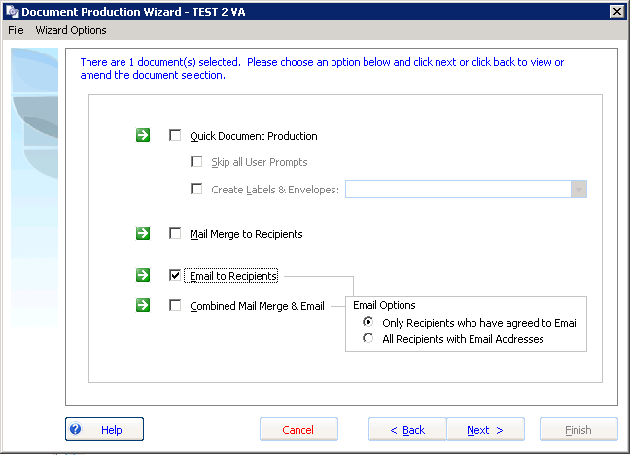

### Save to file

This method creates the document and saves it to the save location.

* You have the option to:
* Change the default save location.

1. You can configure the default output folder and the default letter pack output folder in Manage Document Templates.

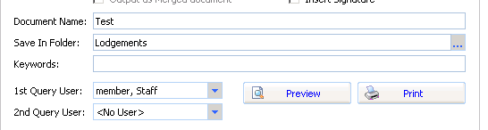

### Saving documents outside the job folder

You can now save a document to a folder outside the job folder. This application setting can be activated for clients that use an external Document Management system. If you want to be able to save the document folder outside the job folder, contact MYOB Support for the specific update.

### Producing documents without merging

You can now produce merge documents as form letters (without merging a list of recipients or a data source).

When you produce a document as a form letter, the recipient name («CompanyName») will be replaced with the text:

“TO THE RECIPIENT AS ADDRESSED”.

All other merge address fields will be returned as blank.

### Merge to MS Word

Merging combines the template with the data source recipients and outputs a merge document. The output document is the pre-merge document. The system opens the document to allow users to start the mail merge process using MS Word.

### Print documents

You can print the document output. You can use this option in conjunction with letter packs to print a collection of documents.

### Merge to Email

The Document Production process produces a merge to email option.

The email output can be personalised by containing merge codes that populate appropriate values for each recipient.

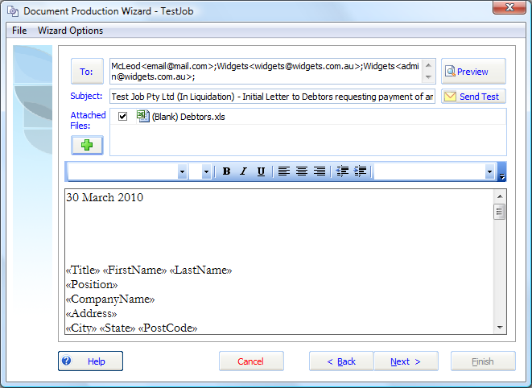

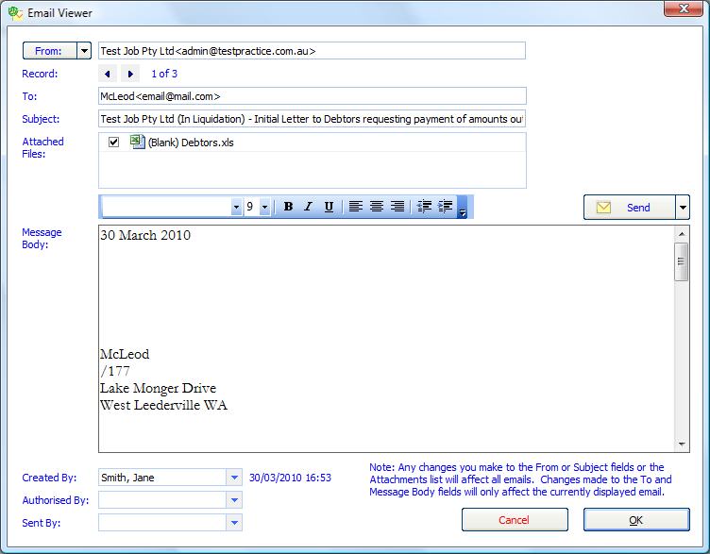

### Attach files

You can attach file types such as PDF and MS Excel to the output process. These files can be sent as part of the approval process or as part of an email merge.

This lets you prepare information separately and include it as part of the email merge.



Use replace fields in the body of an email and specify a recipient list with email addresses to receive the merge.

#### Sending a test email

You can view an example of the email before sending it to the recipients. To send a test email, click ‘Send Test’.

A test email output is sent to the current user’s mail box.

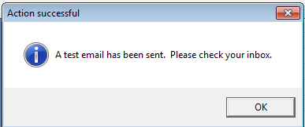

Sending a test email will create an **email task** for authorisation linked to a document management record. You may review the email from the task or from within the **document management** tab.

#### Creating an email in Document Management

When you finish **Document Production** you have the option of saving the email in document management. If the email is pending authorisation and hasn’t been sent, you can view it using the **Email Viewer**.

You can open it to edit the text before sending, and to review the recipients. The document authorisation task can have a link to the email task.

#### Sending the email

When you are ready to send the email, the merge output is generated.

Each individual receives their own individual email message. The system avoids the use of the BCC (blind copy) for addressees and thereby avoids the risk of users reading emails or replies to other recipients.

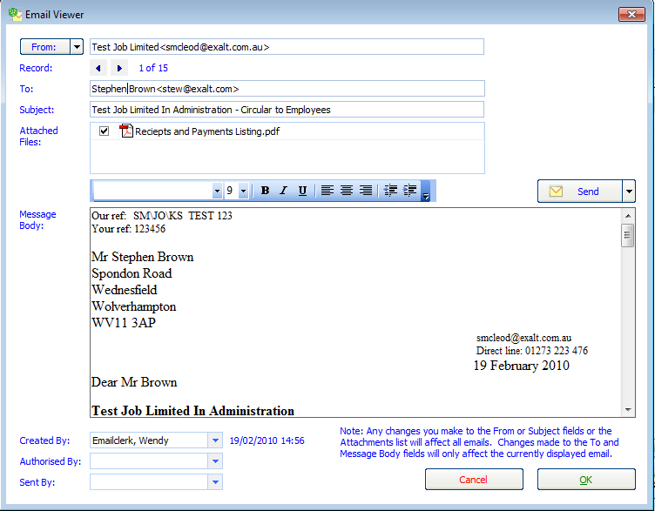

#### Document authorisation workflow

Users must be granted rights to send emails.

If a user has not been granted rights the user can still create an email to be sent, but the email is placed into document management and an email task pending authorisation is created.

The email task is linked to the email saved in document management.

Once an email is authorised it can be sent.

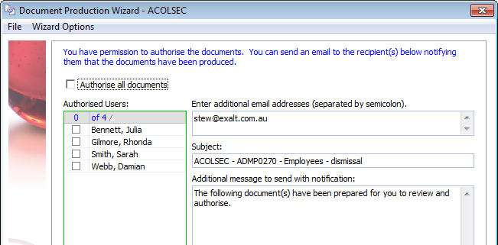

### Send to Selected Recipients

To send to selected recipients click the **Send** button and select **Select Recipients**.

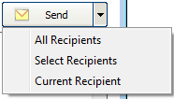

Tick the listed recipients and click **OK**.

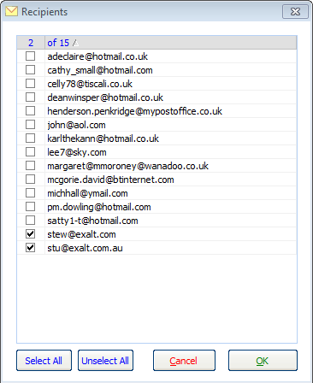

You will be warned if the email has already been sent to one of the recipients.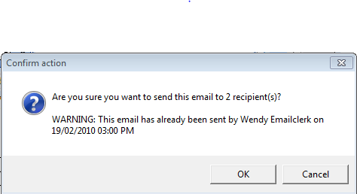

Once you have sent the email the document management record is updated with your user name.

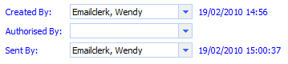

#### Mailout Address Listing

After you have generated the email record ready for sending, the system creates a PDF report containing all the intended recipients. This report is placed into document management.

#### Recipients listed in Document Properties of the email

After you have sent an email, a recipient listing is stored with the email.

Right-click the email in document management and select **Document Properties**. Click the **Recipients** tab to display the recipient list.

## Editing Recipient Addresses

As part of the merge process you are presented with the recipient addresses. You can review and edit the addresses as part of the merge process. Click the recipient list to edit the address.

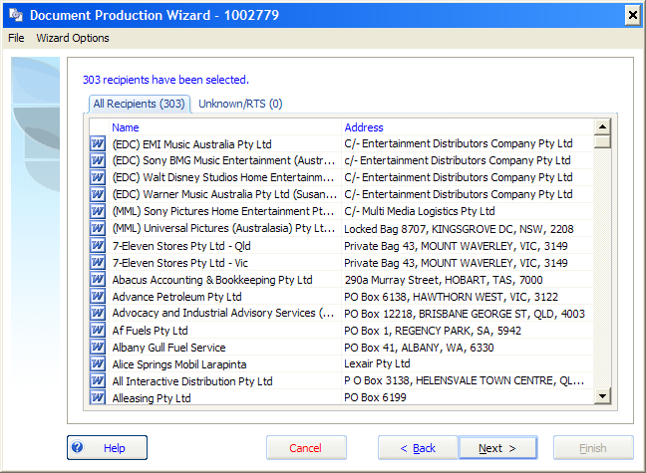

## Document Management Record

A document management record is now created with every document created by the system. Each document has a default output file path.

## Recipient List

A list of recipients is stored with each output document. When you create a merge document output, the list of recipients is stored in the document properties.

Open the document management record in document management and print a list of the recipients and the addresses at the time the document was produced.

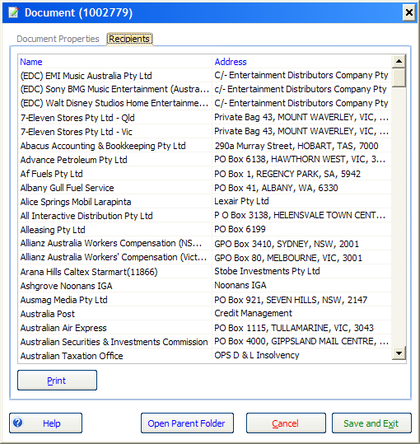

# Letter Packs

Letter packs are collections of document templates that can be grouped together.

## Maintaining Letter Pack documents

You can link document templates to a letter pack.

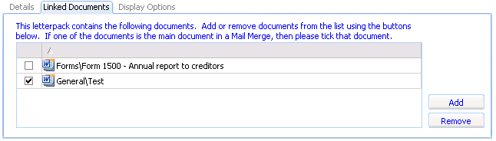

### Letter Pack attributes

You can add and edit the following Letter Pack attributes:

* Default save path

You can specify the default job directory to output the letter pack documents.

* Default data source

You can specify the default data source to output the letter pack documents.

* One or more job types (display options)

You can specify the job types for which the letter pack shows.

* Letter Pack categories.

You can separately categorise letter packs.

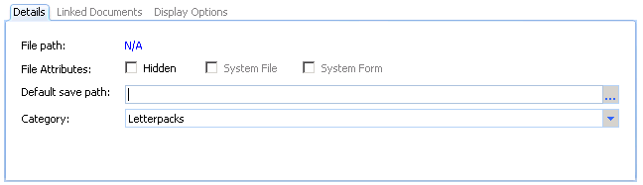

The letter pack attributes display whether the letter pack is a system file or form. You can hide a letter pack from appearing in the job menus.

### Locating letter packs

Locate the required letter pack by:

* Searching for the letter pack using the template search from a Job
* Selecting the letter pack from the Circulars and Mailing toolbar, or
* Selecting it from a task action.

## Producing Letter Pack documents

Once you locate a letter pack, you will be guided through the document production process allowing you to output a collection of documents.

You can add templates on-the-fly (using the document template search) or de-select particular letter pack templates when producing the documents from a letter pack.

1. Letter Packs will be saved to a new folder unless the folder is specifically configured in Manage Document Templates.

### Linking letter packs to task templates

You can use task actions to add a link to a letter pack in a task.

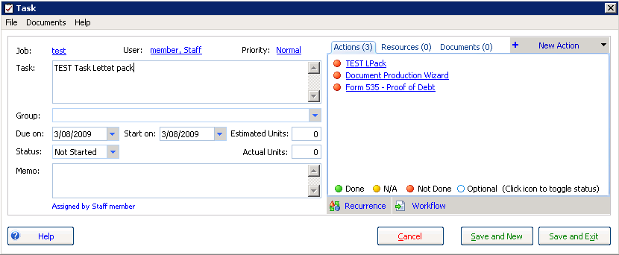

## Document style templates

Each document template can be linked to a style template.

A style template defines the formatting of documents produced from a template. Rather than using the styles from the source template, the output document applies the styles, fonts, page setup, page orientation and margins of the style template.

Style documents are stored in the ‘Styles’ directory under the root document templates file-system directory. You cannot maintain document styles through the user-interface.

The contexts of headers and footers contained in the style template appear in the output document. This allows you to place common references in the style template and have these populated in each document which has the style applied.

Replace fields in the style document templates will populate in the output document.

By linking a single style template to many document templates, you can change the style template and automatically update the styles for all linked templates (without having to change each template individually).

Section breaks and separate page numbering (where it is different from the first page) contained in the child document will appear in the output document.

## Document template maintenance

Document template maintenance has been improved to enable you to find, add, edit, import, configure and delete document templates.

A new interface allows you to click each template in turn, without having to drill down into the properties of each template individually. This makes it easier to review the properties of each template.

### Document templates maintenance search

You can search for or filter document templates in six ways:

* Search and filter document templates based on search criteria
* Search by a text string in the template name
* Filter and sort by category
* Filter by letter pack
* Filter to exclude MYOB standard templates
* Filter by job type.

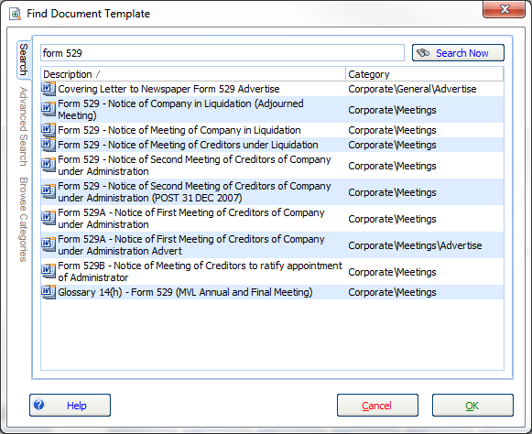

The template category for each document template displays in the template list if the search results belong to different categories.

You can filter the document template search to show different types of templates.

### Types of document templates

There are different types of document templates as follows:

* Statutory forms — usually ASIC forms; you can copy and edit, but not delete.
* MYOB standard templates — you can copy, but not edit or delete.
* User-created templates — you can add, import, copy, edit and delete your own templates.

**System files** are both statutory forms and standard templates.

A warning message will appear if you attempt to edit MYOB standard templates “This is a system template you need to make a copy to edit”.

### Importing multiple document templates

If you are a template administrator you can import multiple document templates from the file-system in one action. You can select a file-system directory and import all documents contained within that directory.

The document template options for imported document templates are based on the default document template of the parent import category.

### Maintaining the category for multiple document templates

Template administrators can move many document template files to a new category in one action. Use the Shift key to select multiple templates and right-click the selected templates to change the category.

## Circulars and Mailing toolbar

### Filtering standard templates from the toolbar

Administrators can configure the application to hide (or show) all MYOB standard templates across the application. You may also hide individual templates from appearing on the Circulars and Mailing toolbar.

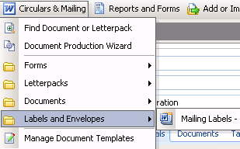

Hide the MYOB standard templates from appearing in the Circulars and Mailing menu using the options in the **Document settings** in **Manage Application Settings**.



## Document template search

In the document template wizard, you can:

* Filter and sort by category
* Filter by Letter Pack
* Search and add document templates to the selected template list
* Filter to exclude MYOB system templates
* Search for templates for the current job type.

Template administrators can drill down to document template options from the document template search.

## Defining Merge data source

Selecting the type of merge data source will determine the data populated in the output.

Types of merge data source include:

* Creditors
* Employees
* Dividends
* Meeting

You can configure the data source options in the **Manage Document Templates** form on the **Datasource Options** tab by setting **This Datasource**.

When performing the merge the merge type defines which recipients you can include in the merge.

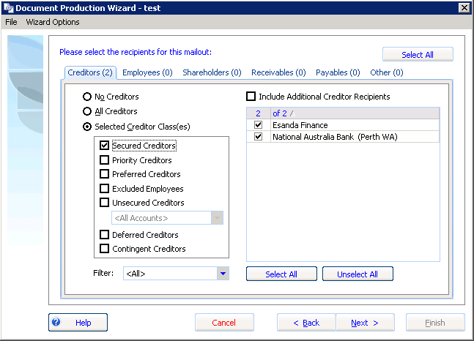

### Creditor correspondence method

Each creditor has a default creditor correspondence method (e.g. email, letter). This will allow you to correspond with recipients using different methods.

Using one source output document you can send the same information to recipients using different correspondence methods.

The screen shot below shows the document output methods forming part of document production:

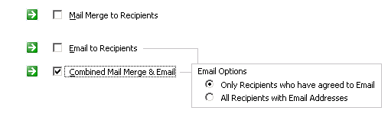

### Creditor category

You can filter the creditor recipients list by unsecured creditor category. For example, an unsecured creditor can be created for ‘ROT creditors’ so you can select this group to receive specific correspondence.

You can also filter by creditor category on the **Creditor mail out listing**.

### Email Merge

You can now allocate whether creditors have agreed for notices to be sent to them via email. In the **creditor** or **counterparty** record, set the preferred method of correspondence as email in the **Numbers** grid.

See the green tick below:

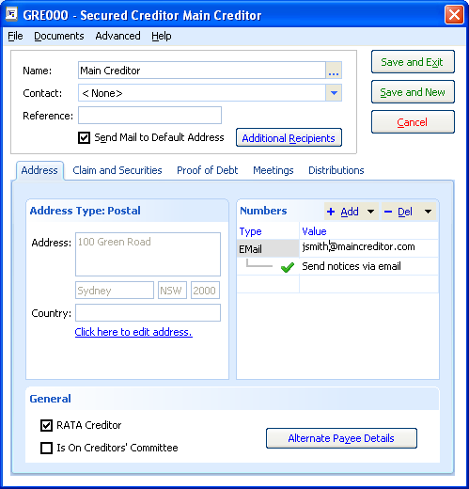

## Document output options

Using the document output options available in **document production** you may:

* Change the document output directory
* rename the output document
* add key words to the document management record

Configure the default save path in the document template options.

When producing letter packs you can select additional documents or exclude some of the documents produced as part of the letter pack.

### Combining documents for letter packs

When outputting multiple documents, the document options provide the ability to combine selected document templates into a single document.

### Job contacts records added when merging

When you output merged documents and select a contact or counterparty as a recipient that has not already been linked to a job, the system will automatically add a job contact record for the selected contacts or counterparties.

### Other document prompts

Existing functionality has been retained, you may:

* insert the appointee’s signature
* specify the 1st User for recipients to ask queries in response
* specify the 2nd User for recipients to ask queries in response



### User prompts

You can create prompts for:

* Meetings
* Dividends
* Appointee selections

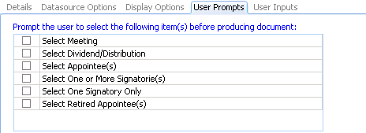

### User Inputs

* You can link custom user input fields with **job information** fields. The system will prompt the user to enter the value for the replace fields and then save the entered value in **job information**.

## Replace fields

As part of document production, the application scans through the text of the selected template(s) and searches for any instance of “[RF_....]” or “[RT_....]”. The application then works out the values and presents a grid of all replace fields involved in the merge.

If you edit the Replace Field values, the updated values will populate in the document output. Hover the mouse pointer over the replace field to see the replace field description.

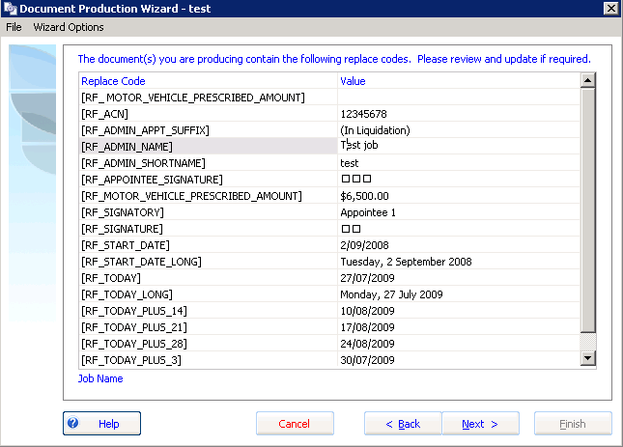

The Replace Field and value that will be populated in the output documents displays.

1. You only need to type any text starting with “[RF_” into a template for the replace field to display in the above replace field prompt form.

# Document Authorisation functionality

When you produce documents in the system you have the option of emailing the document for authorisation.

The email, sent to the authorising user, contains hyperlinks to the output documents and a link to open the application and display the document authorisation tasks.

### Document authorisation tasks

When you email document output for authorisation, a document authorisation task is created. These tasks are listed under the <Document Despatch> task group.

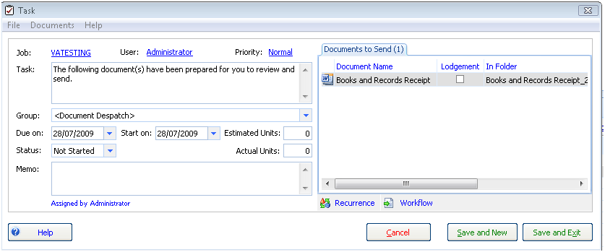

The documents associated with these tasks appear in the ‘Documents to Send’ tab on the despatch task.

### Document Properties

Documents can have the status ‘prepared by’, ‘authorised by’ or ‘sent by’.

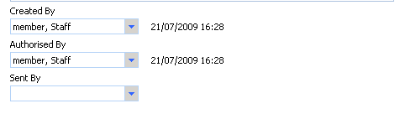

# Application document search

Centralised document searching has been introduced to help you search for documents across all jobs. The document search is available from the main menu.

For example, enter “439A” in the search to bring up a list of all Form 439A reports within the system.

1. You will need job permissions to view the documents.

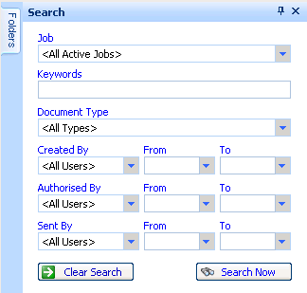

You can search documents using the following criteria:

* A string within document name
* Document type (e.g. BAS 524 etc.)
* Keywords (e.g. Meeting)
* Date range.

A list of documents matching the search criteria will display.

You can open the document from the list of returned document records, provided you have permission to access those documents.

# Workflow changes in Cheque Requisitions

Reporting and navigation has been enhanced to improve the workflow for producing cheques and cheque requisitions. You can now produce Payment Requests (formerly called Cheque Requests) and Paying in Slips from all types of transaction screens.

The workflow is more flexible to accommodate many different methods of creating payment requisitions and receipts.

# Tasks

## Tasks Display

The following changes have been made to the task grid:

* A separate checklist view is available
* The task column refresh is improved
* The reordering display has been improved

## Task Action Status

A new feature task action status has been added. You can mark actions as ‘not done’, ‘done’, ‘n/a’ or ‘optional’. A separate view of task actions displays, grouped by task.

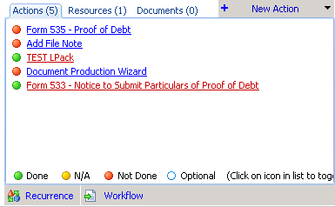

# Task templates

## Editing system task templates (checklists)

The user interface has been improved to allow easier configuration and updating of task templates.

New **Due date** and **Start date** period configurations have been added to the task template maintenance. These automatically assign dates to imported tasks such as end of next quarter, end of financial year and number of business days.

|  |  |
| --- | --- |
| Code | Description |
| fys | Financial Year Start |
| fye | Financial Year End |
| qs | Quarter Start |
| qe | Quarter End |

For example, to have a task due at the end of the first quarter you would enter **“**0 qe” (which the system changes to QtrEnd) after the Specified Date.

An example of a task due after 1 quarter end is shown below.

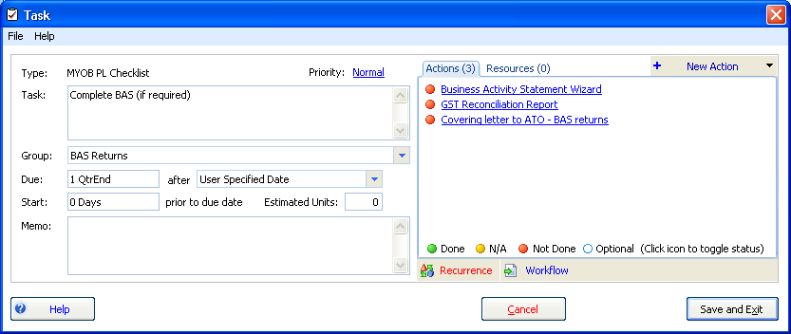

To amend the MYOB standard task templates, copy the task template and change the copy. This is to prevent your changes being overwritten when MYOB sends you updates to the standard task templates.

## Open a document template from task templates

A hyperlink has been added to the task template action window, enabling you to drill down to **document templates** from the task.

## Task Template Checklist report

You are now able to produce a report in Task Template Checklist format.

You can group the report by:

* Task Group
* Display Order

## Task report ordering

You can also order task reports by:

* Start Date
* Due Date

## Task Group Display Order

You can set the display order of task groups in **static data**.

To amend the display order, go to Static Data > Task Groups and click Task Group Report Order.

The following grid will appear:

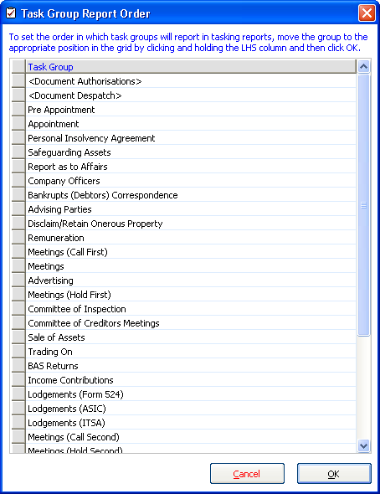

To change the order of the task groups, click the grey box beside each task group and drag up or down until you have the order you want.

## Importing tasks

A new Date Planner View has been added to Import Tasks from Template. This provides greater visibility for planning task due dates and supplies a ready reckoner for organising meeting dates and tasks.

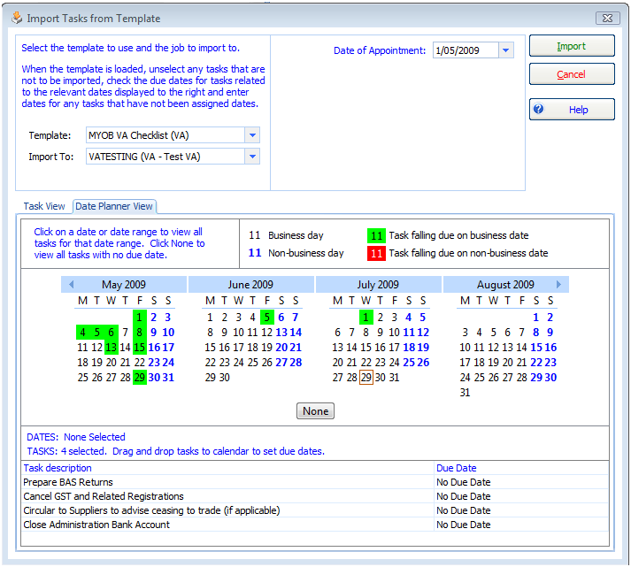

Tasks without specified dates will appear at the bottom of the screen. You can drag these tasks onto the calendar to set their due date.

# Pay Wages

Pay Wages functionality is used to generate payroll entries. Although it is not a fully-functional payroll system, you can use it to generate employee payment entries common to insolvent entities.

Open the **Pay Wages** form from the Transaction > Employees > **Pay Wages** menu.

### Entering Wages Entries

When you enter an Employee’s Weekly wage in the **employee details** form, the pay amount calculated in the **pay wages entry** form defaults according to the ‘To’ and ‘From’ wages period you enter.

The PAYG tax deduction is calculated based on the scale of marginal tax rates.

### Employee drill down

You can now drill down to each employee to edit their details.

### Filtering the Wages

You can now filter the wages grid to separate the payroll into pay runs for separate groups of employees. By entering a Payroll reference in the employee details form, you can filter the list of employees to appear.

Enter payroll reference ‘A001’, ‘A002’ and ‘B001’ into three separate employees. Enter the pay wages **reference** filter from ‘A’ to ‘A’ to filter the wages form to only display employees with a payroll reference beginning with ‘A’.

### Entering Deductions and other income

Here are some specific considerations for entering deductions.

The Pay Wages screen now allows you to:

* Deduct Child Support payments from an employee’s wages
* Make deductions, for example Social Club
* Make reimbursements of expenses.
* Pay Mileage claims

Any employees in one wage period who have different reimbursements or deductions will need to be grouped together and done separately as there is only one place to enter a deduction or reimbursement.

For example, if two employees have child support deductions and two have social club deductions, they should be separated so they can be coded correctly on the Pay Wages window.

### Child Support Payment Example

The following details how to process a Child Support deduction:

To withhold child support payments:

* Add an account called “Child Support Liability” to the chart of accounts. The account type should be set to “Other Current Liability”.

The graphic below shows the new account entry form when adding the Child Support Liability account:

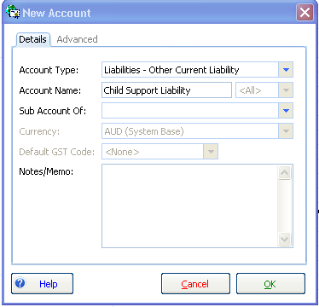

To deduct Child Support payments from an employee’s wage:

Select Child Support Liability from the Other Liab Account dropdown and enter the amount under the Other (No Tax) as a negative figure.

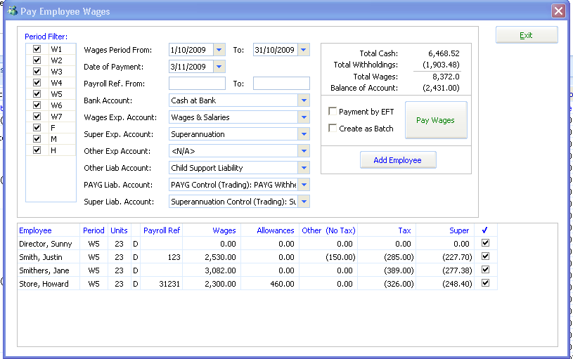

The entry as a result of paying these wages appears as:

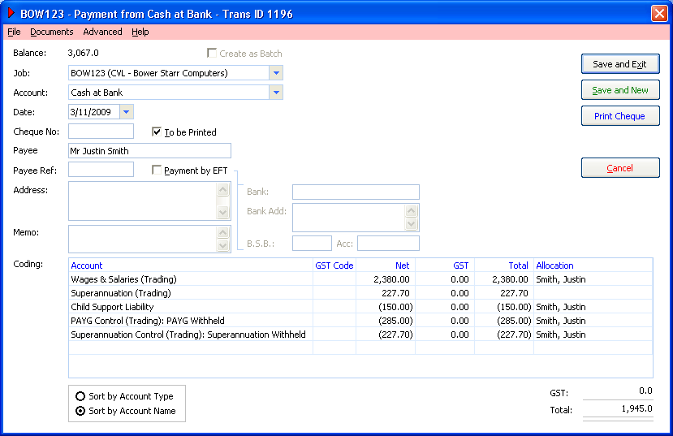

### Payroll Deductions

To enter deductions for expenses such as social club, you need to create an expense account, which is a non payroll account, and select the dropdown box in the Pay Wages screen called **Other Exp Account** and enter a negative amount under the Other (No Tax) column.

### Payroll Reimbursements

To enter reimbursement of expenses follow the same steps as entering a deduction, but enter a **positive** amount under the Other (No Tax) column.

1. A separate Knowledge Base provides further details about how to use the Pay Wages function.

# Employee Payment Summaries

You can now produce paper-based PAYG Payment Summaries for Individuals (employees).

1. To be able to print individual payment summaries a practice must be registered for electronic lodgement of the Annual Payment Summary Return with the ATO.

The PAYG annual payment summary is a return submitted each financial year per job which details employees and the individual PAYG summaries issued.

You can only submit payment summaries once. The system tracks which employees have had payment summaries lodged. If you amend employee payments you must produce a PAYG Payment Summary Individual (Amendment) and resubmit the annual return for the amended employees.

### Registration and digital certificate

It is only necessary to register the practice for electronic lodgement. The ATO will provide a digital certificate that you may use for the lodgement of all annual payment summaries.

### Enabling jobs for electronic lodgement

Once you have registered for electronic lodgement of Payment Summaries with the ATO, go to Job > Job Settings window and tick the Enable Electronic Lodgement box.

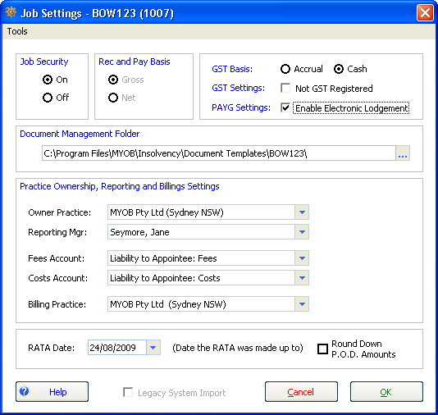

### Online resources and downloading the ECI

A general guide for practices on lodging pay as you go (PAYG) payment summary annual reports online is detailed on the ATO’s website at:

<http://www.ato.gov.au/onlineservices/content.asp?doc=/content/36036.htm>>

To submit electronically you must install the Electronic Commerce Interface (ECI) which is the ATO’s method of submitting electronic files such as BAS and PAYG. You can download and install ECI from:

<http://eci.ato.gov.au/Download/download.htm>.

## Producing the Payment Summary Output file

Produce the electronic output files from the Payment Summary Wizard.

Click Transactions > Pay Wages > Payment Summary Wizard.

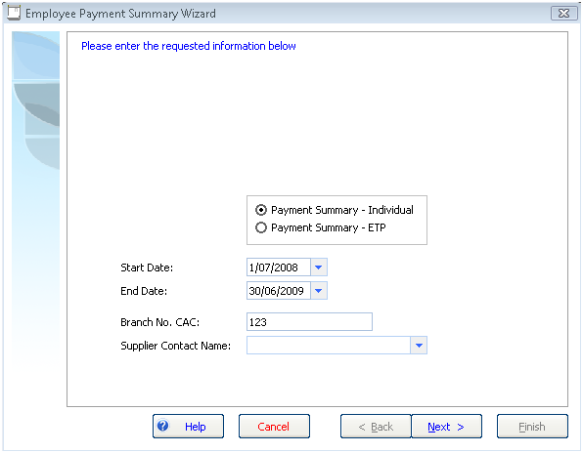

Enter the Branch No. CAC and the supplier contact name. The CAC is saved in Job information.

Click Next.

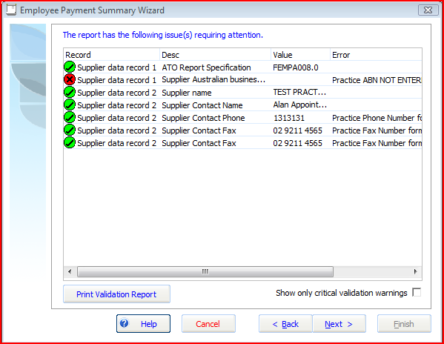

The validation window appears.

Each field used in the output is validated to ensure the data for the Payment Summaries meets the ATO’s validation requirements.

Invalid information will have a cross in a red circle as shown above.

1. If there is a red validation warning, correct the underlying data.

Click Next.

The output file is ready to be produced. This file is used for electronic lodgement of the job’s Annual PAYG Payment Summary.

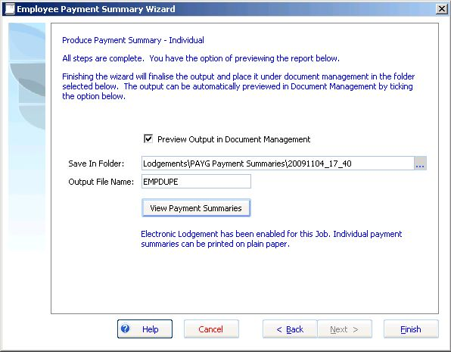

You can preview the individual PAYG payment summaries that are issued to employees.

Click View Payment Summaries to preview the report.

The preview of the employee’s PAYG individual payment summary appears.

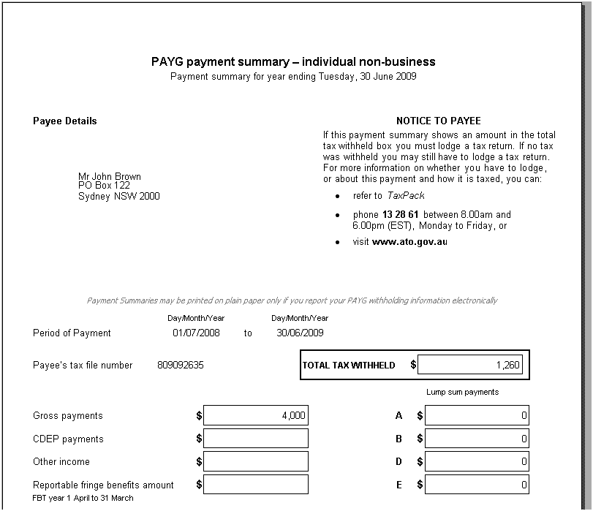

Close the Preview screen and click Finish.

The system stores a PDF of the issued Payment Summaries and places the electronic output in **document management**. Open the job folder to view the output file (you may need to change the file extension to *.txt).

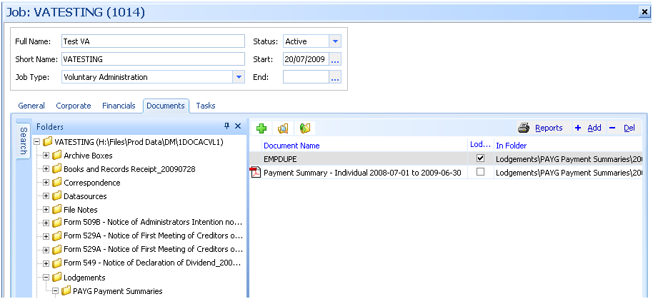

1. If you amend employee payments after lodging electronically, you must lodge an amended payment summary.

# Submitting the PAYG Payment Summary annual return

The following instructions describe how to submit the output file using the ECI.

Install the ECI application as per the ECI installation instructions

<http://eci.ato.gov.au/Download/download.htm>.

Navigate to the Payment Summary Report menu in the ECI application.

Business > PAYG Summary Reports > **Payment Summary Report**

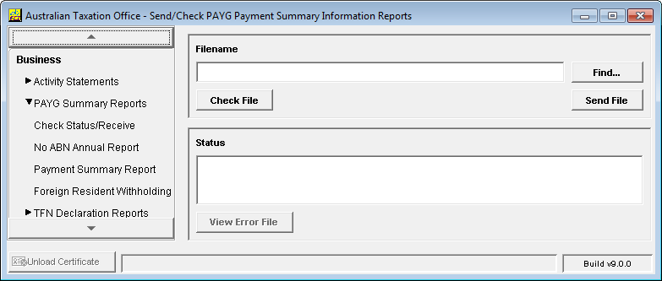

The **Send File** dialogue appears.

Click **Find**

Locate the file described as “EMPDUPE” in the section Producing the Payment Summary Output.

Click **Check File**

The ECI application will provide an output report that checks the contents of the output file and validates the values of the data provided.

Use this file to report any issues to MYOB Support.

Once the file has passed validation, click **Send file**

The annual payment summary output file is submitted to the ATO.

# Exporting Creditors

Creditors can now be exported to MS Excel in the format of the unsecured creditor Import template.

1. The creditor export format matches the **unsecured creditor** import format. You cannot presently export employees in a format that can be re-imported.

### To export creditors:

Navigate to the Creditors tab and double-click the Creditor Class you want to Export. Each creditor class needs to be exported separately.

The Creditor Claims window opens.

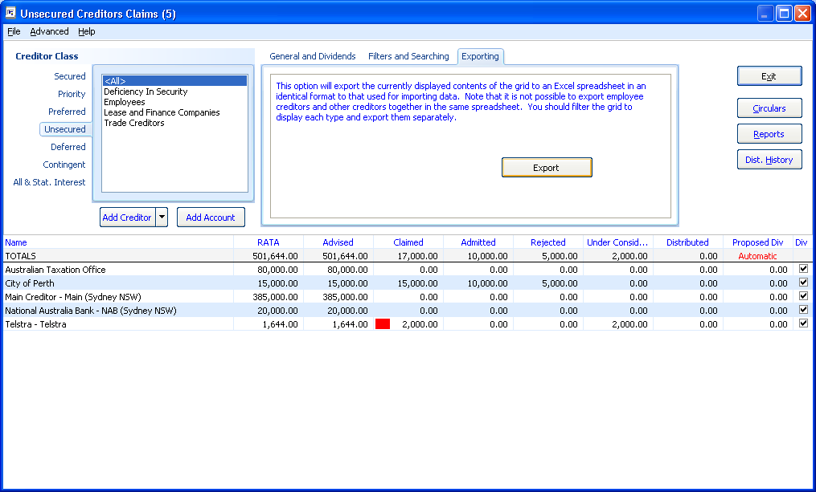

Click the Exporting tab.

Click the Export button.

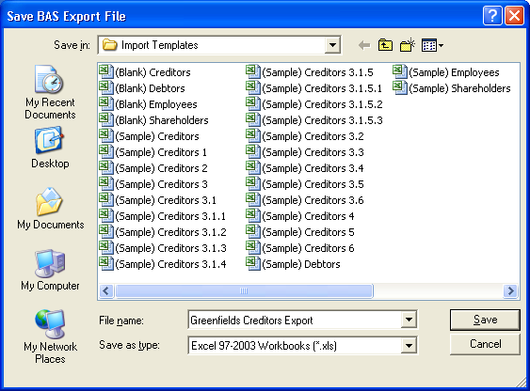

Enter the file name and click Save.

### To view and amend an exported list of creditors.

Open Excel and:

Navigate to the file you saved in the Import directory.

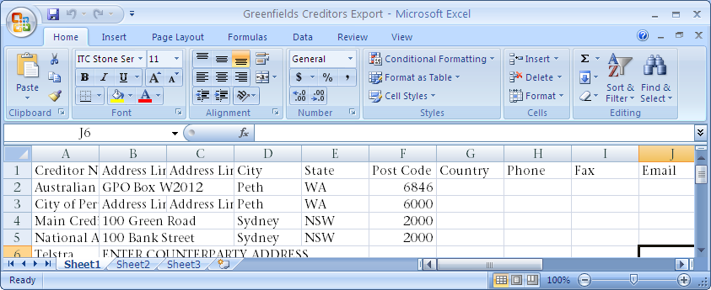

Amend and re-import into another job as required.

# Tab Appearance and Colour

You can now amend the tab appearance and colour format. This will resolve the disappearing tabs issue some clients have been having, particularly where the application is installed on Citrix.

### To amend the tab style format:

Click the top tab row (i.e. General, Corporate, Financials, Documents, Tasks) and hold down the **Shift** key. A **Configure Tab Appearance** box appears as shown below.

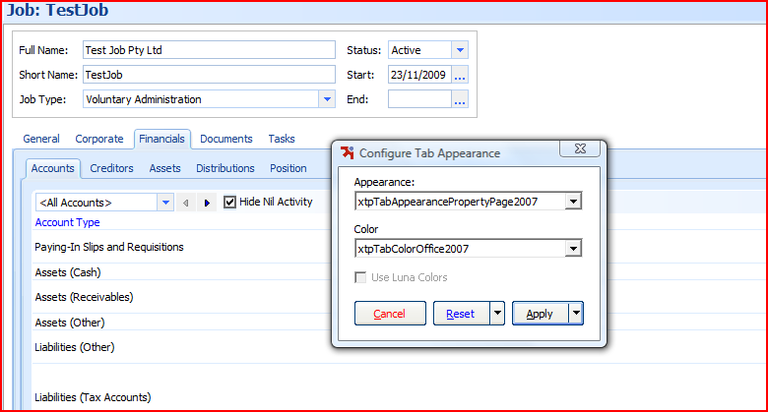

The default **Appearance** is “xtpTabAppearancePropertyPage2007” and **Colour** is “xtpTabColourOffice2007”.

If your tabs disappear, we recommended that you change tab **Appearance** to “xtpTabAppearancePropertyPage2003”.

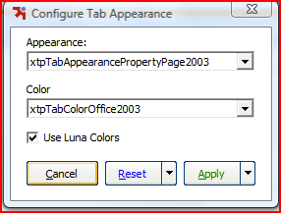

If this does not resolve the issue remove the tick for **Use Luna Colors** as this is just another colour theme type.

If the problem is restricted to individual machines, select the **Apply this machine only** option. If it applies to all machines, select **Apply to all machines** to change the tab appearance for all.

The changes can be reset by clicking the **Reset** button.

# ABA File Output file format

You can now produce file formats that are sent to the bank to make electronic payments. A new ABA tab has been added to the print cheques screen. The bank account details for the payees need to be entered into the banking section or can be entered in the payment screen after ticking the box Payment by EFT.

The system validates the fields which comprise of the data in the output file to ensure the format of the data is correct.

### ABA Output file location

The ABA file is created in the data output directory specified in Application Settings > **Cheque Printing**.

### Account Details Form

The bank account details form stores the Payer’s details which are used for the output file.

### Printing Cheques

The **Print Cheque** dialog now displays an ‘ABA’ tab which can be used to output a text file in the ABA format.

Access the Print Cheque dialogue from any payment entry or from the Transactions > **Print Cheques menu.**

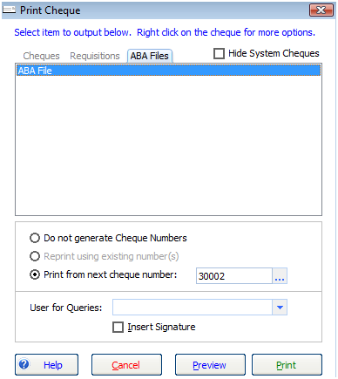

### Prepare EFT File Input form

Enter the EFT file information

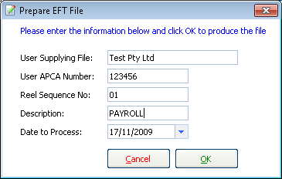

The **user ACPA number** is the User Identification Number allocated by APCA.

The **user supplying file** should match the name registered with ACPA. This value defaults to the Job name.

The **reel sequence number** is the sequential numbering of each output file submitted in one day for each job starting with number ‘01’ then ‘02’, etc.

### Validation

Validation is also incorporated in the output process. A validation screen appears and lists any invalid entries.

### ABA application

Contact your bank to set up your accounts so you can submit ABA output files for electronic payments.   
  
Description of National Australia Bank Application  
The process to enable electronic payments for a job for the National Australia Bank (NAB) is:

1. Set up a bank account by completing a NAB Connect application (internet banking form).
2. Select the option on the NAB Connect form that requests a Direct Entry ID which will trigger NAB to apply for an APCA number.
3. Submit the form to NAB.
4. The bank processes your application the form, which includes making a request for APCA to issue an **APCA number** for the job. The NAB internally calls the APCA number a Direct Entry ID.
5. APCA usually advises NAB within about 5 days of the APCA number.
6. NAB applies the APCA number to the internet banking setup and advises the customer.

The customer can now perform ABA file uploads/transfers.

1. A new APCA number is required for each entity (can be more than one job if jobs are grouped). If an entity has many accounts, you only need one APCA number.

Other enhancements and resolved issues

The following list summarises additional improvements and resolved issues in this release:

## Account Register sort

Click the account register column headers to sort. You can sort by date, reference, transaction ID, payee name and amount.

## Account Register find

Enter any value appearing in the account register to search for the details of a transaction. For example enter “Brown” to find the Payee “John Brown”.

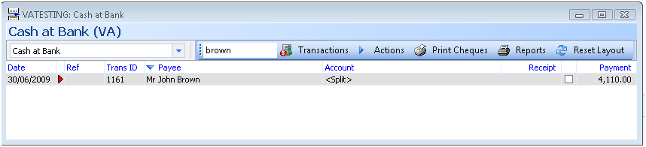

## Batching

* Jobs that have un-posted batches are now highlighted on the Transactions > Accounts tab. The number of unposted entries is highlighted in red.



* You no longer receive an error and create a duplicate subentry when you click **Save** and **New** in either Make Supplier Payment or Receive Debtor Payment in an unposted batch.
* If a user entered a transaction into a unposted batch while the cashbook operator was posting a transaction within this unposted batch, the new transaction would be marked as posted — even though it is not posted to the bank account. The system now warns you and refreshes the batch before a transaction within an unposted batch is posted.
* The dropdown list in batching is now sorted by date order with the last batch appearing first in the list.

## ASIC forms

* Form 524 — now gives you the option to print a summarised receipts and payments annexure.
* Form 524 — can now be produced for a previous job type.
* Form 524 Wizard — line breaks have been inserted into

[RF_ DELAY_CAUSES].

* Form 507 Wizard — Controllership is now automatically selected and the Reason for Report shows Controllership appointment.
* Form 509 — only applies to CVL job types.

## Statutory Interest

* There are new calculations for statutory Interest based on the reducing balance of creditors’ outstanding claims.
* You can now combine statutory interest payments with creditor dividends.
* You can enter a specific time period.

## Dividends / Creditors

* You can now add unsecured creditor categories (accounts) from the creditor register.
* Alternative counterparty **payee** details now flow through to dividend payments (Form 549).
* Report grouping by Creditor category is now added to Creditor Claim Type Summary and Creditor Listing by Claim Type.
* The POD Adjudication Form Report now displays the creditor's address.
* Additional fields are available to allow you to define your own dividend description in the Dividend reports. You may now customise dividend report layouts such as the Form 549 report to include the fields "CreditorAdmittedTax", "CreditorAdmittedTotal", "CreditorDividendRate", "CreditorDividendAmount", "CreditorDividendTax".

## Employee

* For employees terminated within the wages period, the pay period will now calculate to the termination date.
* Terminated employees no longer appear in Pay Wages for payment dates after the employee has been terminated.
* Employees — Medicare exemption now saves in Employee Register.
* You are now able to add employees in Pay Wages.
* Manual entry employee tax calculations now appear on Payment Summaries.

1. Employees paid dividends prior to version 3.093 may not appear correctly on Individual Payment Summaries. Make sure you reconcile payments to each employee when preparing payment summaries.

* PAYG Payment Summary — ETP is now populating in bankruptcy jobs.
* When an employee does not claim the tax free threshold, the Medicare exemption now calculates the correct tax amount.
* PAYG marginal tax rates now round down to the dollar.

## GEERS

* When you undo a non-approved GEERS distribution, the GEERS wages amount paid is now reset so you can pay wages claims when you redo the distribution.

## BAS

* BAS Reports — The Transactions not coded report now excludes accrual transactions from reporting.
* GST is now calculated correctly on imported Post-Appointment (Trading) Accounts Receivables.
* BAS periods now automatically default to the end of the next quarter or month.
* There is now the option to add or maintain Tax codes so they appear in a specific area of the BAS.
* BAS Print Summary Report has been reformatted.
* BAS — Net GST payable was rounding when it should truncate.

## Tasks

* You can now mark a task as deleted (setting the status as N/A). This appears on the checklist reports as 'N/A'.
* You can now destroy a task (completely remove it) providing you have permission.
* The start date in a new task template can now be edited.
* The ordering of Task Groups can now be configured.
* When creating or editing task templates you can now open and amend any actions assigned to the task.
* Task actions can now be separately mark/ticked as complete.
* When you complete a task that has a dependent task the date complete is showing correctly.
* A scheduled task will fall due on a day preceding a weekend or public holiday.

## Bankruptcy

* Notice of Income Contribution Assessment produced from Circulars and Mailings is now merging.
* The RF code for Motor Vehicle and Tools of Trade Prescribed Amounts, and AITA now uses the correct figures.
* The Invalid input message no longer appears when trying to edit the Personal Actual Income Threshold in Static Data.
* Debtor contributions are now updated when received through a Trust Account.
* You now have the option to add the realisation charge to the deposit of Cash at Bank on Appointment.
* Entering an end date for bankruptcy no longer flags the bankruptcy job for deletion.

## Financials

* Cheque requisition now displays the running balance of account.
* Invoice Number is now populating on the Cheque Request Vouchers.
* There is now a button to produce paying-in slips in batch posting and another button to produce deposit slips in Receive Payment and New Cash Sale/Realisation.
* Journal entries now include a total at the bottom of both the Debit (Dr) and Credit (Cr) columns.
* The Chart of Accounts Register now displays Bank Account Name and the BSB and Account Number in brackets.
* Typographical errors "an inter job type transfer" and "cancel to proceeding with making a transfer" have been fixed.
* Updating asset realisation transactions no longer produce an application error.
* The realisation charge for Cash At Bank On Appointment for actual amount received no longer doubles up.
* Creditors' Bank Details such as Bank Names and addresses and BSB/Account numbers can now be imported.
* When manually entering dividend amounts, a blank value in the dividend rate no longer causes an error 13 type mismatch error.
* When previewing a cheque output report, the cheque number now correctly displays when the payment entry is set to “To be Printed”.
* The description “Pre-appointment debtor” now displays instead of “Equity: Opening Balance:” in the account detail listing report and the receipts and payments detail report.
* When you open the BAS Wizard, the BAS period automatically defaults to the end of the next quarter or month.
* Opening balances in the Account Transaction Detailed Listing Report no longer includes unposted batch amounts.
* The Tax code now appears in Cheque Request and Receipt reports if printed immediately after entry.
* When editing an account type if there is no currency type the system will enter the default currency type (AUD).
* The Cheque printing form now orders cheques by date where there are multiple cheques to be printed.
* A Warning message appears when entering an A/P with the same counterparty and invoice number.

## Document Templates

* When importing templates, where the template file exists in the target directory, **Insolvency** no longer rejects the import by saying the file already exists. Instead, it lets you rename the template in the same file-system directory then continue with the import.
* When you add a user prompt with a date format, the system automatically adds the long date format. For example, if you add a prompt called [RF_Date] a code will also appear for [RF_DATE_LONG].
* You can now merge documents for a consultancy job.
* Incorrect document precedent selected when merging a dividend (picks the first precedent in the list not the actual precedent selected).
* Merge and Replace fields now populate in headers and footers, after section breaks and in text boxes.
* The merge field <<DividendDetails>> now rounds the dividend rate to 2 decimal places.
* Amendments have been made to the Style template.

## Multiple database access

* New command line switches have been added to the executable.

You can edit the shortcut target to add a command line switch that allows you to specify the database to open, thus allowing you to open different databases simultaneously.

## Jobs

* Job information fields now display multi-line entries
* Amending the Job short name now enables the “Save” button.

## Other

* The list of public holidays in all states has been updated. When importing tasks using business days, the number of working days is calculated by taking into account public holidays.
* Improvements have been made to query performance to prevent time-out errors
* Email can now be added as a method of Creditor Correspondence
* Additional email recipients can now be added in the Document Production Wizard.
* In Application Settings there are additional maintenance tabs for email settings used for the email notification alerts
* Document merging — merge codes in text boxes are now populating.
* Importing debtors with a zero tax amount now creates the tax code (this is relevant if you want to import the ‘FRE’ code).
* The dropdown Batch combo in batch account registers are now correctly sorted.
* Cheque printing — sort order on data for multiple cheques is fixed.
* The system no longer crashes when previewing cheque reports after closing the parent form before the preview appears.

Appendix — Merge Templates

This section contains a list of new merge templates available with this release.

| **JOB TYPE: CREDITORS VOLUNTARY LIQUIDATION** | | |
| --- | --- | --- |
| **Type** | **Category** | **Template** |
| ALL | Labels and Envelopes | Mailing Labels |
| CORP | Accounts Payable | Circular to suppliers |
| CORP | Accounts Payable: Suppliers | Circular to Suppliers where Company NOT Continuing to Trade |
| CORP | Accounts Payable: Suppliers | Circular to Suppliers where Company Continuing to Trade |
| CORP | Accounts Payable: Suppliers | Form Letter to Suppliers where Company Continuing to Trade |
| CORP | Accounts Payable: Suppliers | Form Letter to Suppliers where Company NOT Continuing to Trade |
| CORP | Accounts Payable: Suppliers | Circular to Suppliers — Business has been transferred to new owner |
| CORP | Accounts Payable: Suppliers | Form Letter to Suppliers — Business has been transferred to new owner |
| CORP | Accounts Receivable | Letter to Debtors advising new bank acccount details |
| CORP | Accounts Receivable | Initial Letter to Debtors requesting payment of amounts outstanding |
| CORP | Accounts Receivable | Second and subsequent letters to Debtors requesting payment of amounts outstanding |
| CORP | Accounts Receivable | Letter referring overdue Debtors to Solicitor or Debt Collector |
| CORP | Assets | Form 525 — Notice of disclaimer of onerous property |
| CORP | Assets | Letter to Insurers — Cancellation of Insurance Cover |
| CORP | Assets | Letter to Agents — Instructions for Asset Valuations |
| CORP | Assets : Leases | Cover letter to Lessors — disclaim property rights |
| CORP | Assets : Leases | Continuing to Utilise the Property Subject to the Lease |
| CORP | Assets : Leases | Covering Letter remittance of payment for continuing lease |
| CORP | Assets : Leases | Covering Letter Intention not to exercise property rights |
| CORP | Assets : Leases | Notify Lessors of Appointment |
| CORP | Assets : Leases | Notify Company Landlords of Appointment |
| CORP | Assets : Leases | Correspondence to Landlord (continuing to occupy premises) |
| CORP | Assets : Sale of Business | Draft Confidentiality Agreement for Sale of Company Assets |
| CORP | Assets : Sale of Business | Advise Interested Party to participate in due diligence process |
| CORP | Assets : Sale of Business | Covering letter Request for Confidentiality Agreement for the Sale of Business |
| CORP | Assets : Sale of Business | Advise Interested Party of Unsuccessful Offer for Purchase of Business |
| CORP | Assets : Sale of Business | Covering letter Confidentiality Agreement for the Sale of Business |
| CORP | Assets : Sale of Business | Confidentiality Agreement Register |
| CORP | Creditors | Circular to Creditors Finalisation of Liquidation |
| CORP | Creditors | Form 535 — Proof of Debt |
| CORP | Creditors | Form 536 — Formal Proof of Debt or Claim on Behalf of Employees |
| CORP | Creditors | Form 537 — Rejection of Proof of Debt |
| CORP | Creditors | Notify Utility Providers of Appointment and Continue Services |
| CORP | Creditors | Notify Utility Providers of Appointment and Cancel Services |
| CORP | Creditors | Form Letter to Creditors Finalisation of Liquidation |
| CORP | Creditors | Request to Continue Telstra Services and Accept Ongoing Personal Liability |
| CORP | Creditors | Request to Cancel Telstra Services |
| CORP | Creditors | Request to Change the Lessee for All or Part of the Telstra Services |
| CORP | Creditors: Committee | Circular to Committee following Appointment of Committee (LIQ) |
| CORP | Creditors: Preferences | Circular to Creditor Receiving a Preference Payment |
| CORP | Creditors: Preferences | Circular to Related Party Receiving a Preference Payment |
| CORP | Creditors: Preferences | Follow up Preference Letter |
| CORP | Creditors: Preferences | Follow up Preference Letter (No further action) |
| CORP | Creditors: Reports | Report to ASIC Pursuant to s533(1) |
| CORP | Creditors: Reports | Supplementary Report to ASIC Pursuant to s533(2) |
| CORP | Creditors: Retention of Title | Form Letter to Suppliers which may have Retention of Title Claims |
| CORP | Creditors: Retention of Title | Circular to Suppliers which may have Retention of Title Claims |
| CORP | Creditors: Retention of Title | Reply to Supplier with Retention of Title claim accepting claim and remittance |
| CORP | Creditors: Retention of Title | Reply to Supplier with Retention of Title claim seeking settlement |
| CORP | Creditors: Retention of Title | Reply to Supplier with Retention of Title claim requiring further information |
| CORP | Creditors: Retention of Title | Reply to Supplier confirming receipt of Retention of Title claim pending assessment |
| CORP | Dividends | Circular to Creditors — Declaration of Dividend |
| CORP | Dividends | Notice of GEERS payment (No Cheque) |
| CORP | Dividends | Notice of Shareholder Dividend |
| CORP | Dividends | Form 533 — Notice to Submit Particulars of Proof of Debt |
| CORP | Dividends | Form 534 — Notice to creditors whose claims have not yet been admitted |
| CORP | Dividends | Circular to Creditors — Notice of Intention to Declare Dividend |
| CORP | Dividends | Form Letter to Creditors — Notice of Intention to Declare Dividend |
| CORP | Dividends | Notice to Creditor requiring Further Particulars in Support of Formal Proof of Debt |
| CORP | Dividends | Form 546 — Advertise intention to declare a dividend |
| CORP | Dividends | Form 547 — Notice to creditors whose claims have not yet been admitted for interim dividend |
| CORP | Dividends | Form 548 — Notice to creditors whose claims have not yet been admitted for final dividend |
| CORP | Dividends | Form 549 — Notice of Declaration of Dividend |
| CORP | Dividends | Form 550 — Authority to Liquidator to Pay Dividend to a Person Named |
| CORP | Employees — Directors | Internal Memo PAYG figures to include in next BAS |
| CORP | Employees — Directors | Letter to GEERS — Notice of Appointment and Termination of Employees |
| CORP | Employees — Directors | Letter to Centrelink — Notice of Appointment and Termination of Employees |
| CORP | Employees — Directors | Letter to Employees — Notice of Appointment and Termination |
| CORP | Employees — Directors | Letter to Employees — Breakdown of Entitlements Distribution |
| CORP | Employees — Directors | Letter to Employees — Confirming Sufficient Funds to pay Entitlements |
| CORP | Employees — Directors | Letter to GEERS — Confirming payment to Employees and details of DEWR Claim |
| CORP | Employees — Directors | Letter to ATO — Advising GEERS PAYG amount |
| CORP | Employees — Directors | Letter to Employees — Forward GEERS Payment |
| CORP | Employees — Directors | Letter to GEERS — Employee Entitlements Calculations |
| CORP | Employees — Directors | Letter to GEERS — Provide Quote to DEWR |
| CORP | Employees — Directors | Letter to Employees — Advising Claims have been forwards to GEERS |
| CORP | Employees — Directors | Letter to GEERS — Application to DEWR to meet Professional Costs |
| CORP | Employees — Directors | Letter to Employee — Calculation of Entitlements |
| CORP | Employees — Directors | Letter to Employees — Requesting Return of Company Assets |
| CORP | Employees — Directors | Letter to Employees — Notice of Appointment and Notice of Termination |
| CORP | Employees — Directors: Affairs | Covering Letter Form 509A — Notice to Director to Deliver Books and Records of Company |
| CORP | Employees — Directors: Appointment | Advise Directors of responsibilities at Meeting of Creditors for Liquidation of the Company under s497(5) |
| CORP | Employees — Directors: Appointment | Circular advising Directors resolve to call and meeting placing the company into liquidation |
| CORP | Employees — Directors: Appointment | Correspondence to Director regarding the proposed winding up of the Company |
| CORP | Employees — Directors: Appointment | Minutes of a Meeting of Directors |
| CORP | Employees — Directors: Employee Claims | GEERS Employee Claim Form |
| CORP | Employees — Directors: Investigation | Investigation checklist for ASIC reports |
| CORP | Forms | Form 6010 — Application for Voluntary Deregistration of a Company |
| CORP | Forms | Form 519 — Court Action Relating to Winding Up |
| CORP | Forms | Form 1500 — Annual report to creditors |
| CORP | Forms | Form 1501 — Notification of details of pooling determination or order |
| CORP | Forms | Form 5053 — Notice that Administration of a Company has Ended |
| CORP | Forms | Form 5056 — Notice that Deed Wholly Effectuated |
| CORP | Forms | Form 509 — Summary of Affairs of a Company (Blank Template) |
| CORP | Forms | Form 505 — Appointment or Cessation as External Administrator (Blank Template) |
| CORP | Forms | Form 911 — Verification or certification of a document |
| CORP | Forms | Form 507 — Report as To Affairs |
| CORP | Forms | Form 506 — Notification of change of address of an External Administrator |
| CORP | Forms | Form 505 — Appointment or Cessation as External Administrator |
| CORP | Forms | Form 205 — Notification of Resolution |
| CORP | Forms | Form 524 — Presentation of Accounts and Statement |
| CORP | Forms | Form 509H — Creditors Statutory Demand for payment of debt |
| CORP | Forms | Form 507 — Report as To Affairs (Blank Template) |
| CORP | Forms | Form 507A — Statement Verifying Report as to Affairs |
| CORP | Forms | Form 505 — Appointment as External Administrator (EXAD) |
| CORP | General | General Letter |
| CORP | General | Covering letter to ATO — BAS returns |
| CORP | General | Covering letter to ASIC Form 505 — Appointment |
| CORP | General | Request Motor Vehicle Registration Search — RTA |
| CORP | General | Conflict of Interest checklist |
| CORP | General | Remuneration Report — Description of Work to be Completed (VA to CVL) |
| CORP | General | Correspondence to Sheriff advising Appointment and Sheriff's obligations CVL |
| CORP | General | Onsite First Day Procedures Checklist |
| CORP | General | Request Motor Vehicle Registration Search — VIC Roads |
| CORP | General | Request Motor Vehicle Registration Search — Licensing Services WA |
| CORP | General | Request Motor Vehicle Registration Search — QT QLD |
| CORP | General | Request Motor Vehicle Registration Search — Transport SA |
| CORP | General | Request Motor Vehicle Registration Search — MVR NT |
| CORP | General | Request Motor Vehicle Registration Search — ACT |
| CORP | General | Request Motor Vehicle Registration Search — Transport DIER TAS |
| CORP | General | Letter to ATO requesting increasing adjustment dividend unlikely |
| CORP | General | Job Information |
| CORP | General | Facsimile Cover Page for the ATO |
| CORP | General | Scale of Rates |
| CORP | General | Covering letter to ATO — Final BAS return |
| CORP | General: Advertise | Form 509D — Advertise Notice of Appointment of Liquidator |
| CORP | General: Advertise | Advertise Notice of Resolution of EGM |
| CORP | General: Appointment | Declaration of Independence, Relevant Relationships and Indemnities |
| CORP | General: Appointment | Advise ATO appointment and debt request |
| CORP | General: Appointment | Notify Company Accountants of appointment and request books and records |
| CORP | General: Appointment | Notify Company Auditors of appointment and request books and records |
| CORP | General: Appointment | Notify Company Solicitors of appointment and request details of any actions |
| CORP | General: Appointment | Advise Child Support Agency appointment and debt request |
| CORP | General: Appointment | Advise State Revenue appointment and debt request |
| CORP | General: Appointment | Advise Workcover appointment and debt request |
| CORP | General: Appointment | Notify Company Auditors of Appointment |
| CORP | General: Appointment | Notify Company Solicitors of Appointment |
| CORP | General: Appointment | Consent to Act as Liquidator |
| CORP | General: Appointment | Arrange Mail Redirection |
| CORP | General: Bank | Close Bank Account held by Company and transfer funds to another Account |
| CORP | General: Bank | Close Bank Account held by the Company and transfer funds to another Bank |
| CORP | General: Bank | Close Bank Accounts held by Company where account is unknown |
| CORP | General: Bank | Close Bank Account held in relation to the Appointment |
| CORP | General: Bank | Advise Bank to set up new account |
| CORP | General: Books and Records | Books and Records Receipt |
| CORP | General: Retirement | Application for Consent to destroy Company’s Books and Records |
| CORP | General: Retirement | Circular to Suppliers ceasing to trade under appointee control |
| CORP | Meetings | Form 523 — Notification of final meeting convened by liquidator |
| CORP | Meetings | Form 531A — List of Persons Present at Meeting of Members or Contributories |
| CORP | Meetings | Form 531B — List of Persons Present at Meeting of Creditors or Debenture Holders |
| CORP | Meetings | Form 531C — List of Persons Present at Meeting of Committee of Inspection or Creditors |
| CORP | Meetings | Proof of Debt for Voting Purposes |
| CORP | Meetings | Form 532 — Appointment of Proxy |
| CORP | Meetings | Form 530 — Statement in writing of Posting of Notice of Meeting |
| CORP | Meetings | Delegation of Chairman to chair the meeting |
| CORP | Meetings: Agenda | Agenda for Meeting of Creditors for Appointment of CVL |
| CORP | Meetings: Agenda | Draft Agenda Final Meeting of Members and Creditors |
| CORP | Meetings: Annual | Running Sheet Annual General Meeting of Members and Creditors CVL |
| CORP | Meetings: Annual | Draft Minutes of Annual General Meeting of Members and Creditors CVL |
| CORP | Meetings: Annual | Internal Memo Annual Meeting not convened due to insufficient funds |
| CORP | Meetings: Annual | Circular to Creditors advising that insufficient funds to call AGM |
| CORP | Meetings: Annual | Form Letter to Creditors advising that insufficient funds to call AGM |
| CORP | Meetings: Minutes | Draft Minutes of Annual General Meeting of Members and Creditors |
| CORP | Meetings: Minutes | Minutes of Final Meeting of Members and Creditors |
| CORP | Meetings: Minutes | Mintues of Final Meeting of Members and Creditors |
| CORP | Meetings: Minutes | Minutes of Extraordinary General Meeting to Approve Winding Up |
| CORP | Meetings: Minutes | Draft Minutes of Meeting of Creditors of CVL |
| CORP | Meetings: Notices | Covering Letter Calling Final Meeting of Creditors proceeding to finalise the Company’s affairs |
| CORP | Meetings: Notices | Notice to Members of Extraordinary General Meeting |
| CORP | Meetings: Notices | Notice of Final Meeting |
| CORP | Meetings: Notices | Form Letter convening First Meetings of Members and Creditors CVL |
| CORP | Meetings: Notices | Notice of Meeting of Creditors called by Director CVL |
| CORP | Meetings: Notices | Circular convening First Meetings of Members and Creditors CVL |
| CORP | Meetings: Notices | Form Letter Calling Final Meeting of Creditors proceeding to finalise the Company’s affairs |
| CORP | Meetings: Notices | Advertise Final Meeting of CVL |
| CORP | Meetings: Notices | Advertise Annual General Meeting of CVL |
| CORP | Meetings: Notices | Circular convening Annual General Meeting of Members and Creditors CVL |
| CORP | Meetings: Notices | Form Letter convening Annual General Meeting of Members and Creditors CVL |

| **JOB TYPE: PROVISIONAL LIQUIDATION** | | |
| --- | --- | --- |
| **Type** | **Category** | **Template** |
| ALL | Labels and Envelopes | Mailing Labels |
| CORP | Accounts Payable | Circular to suppliers |
| CORP | Accounts Payable: Suppliers | Circular to Suppliers where Company NOT Continuing to Trade |
| CORP | Accounts Payable: Suppliers | Circular to Suppliers where Company Continuing to Trade |
| CORP | Accounts Payable: Suppliers | Form Letter to Suppliers where Company Continuing to Trade |
| CORP | Accounts Payable: Suppliers | Form Letter to Suppliers where Company NOT Continuing to Trade |
| CORP | Accounts Payable: Suppliers | Circular to Suppliers — Business has been transferred to new owner |
| CORP | Accounts Payable: Suppliers | Form Letter to Suppliers — Business has been transferred to new owner |
| CORP | Accounts Receivable | Letter to Debtors advising new bank acccount details |
| CORP | Accounts Receivable | Initial Letter to Debtors requesting payment of amounts outstanding |
| CORP | Accounts Receivable | Second and subsequent letters to Debtors requesting payment of amounts outstanding |
| CORP | Accounts Receivable | Letter referring overdue Debtors to Solicitor or Debt Collector |
| CORP | Assets | Letter to Agents — Instructions for Asset Valuations |
| CORP | Assets | Letter to Insurers — Cancellation of Insurance Cover |
| CORP | Assets | Form 525 — Notice of disclaimer of onerous property |
| CORP | Assets : Leases | Cover letter to Lessors — disclaim property rights |
| CORP | Assets : Sale of Business | Advise Interested Party to participate in due diligence process |
| CORP | Assets : Sale of Business | Draft Confidentiality Agreement for Sale of Company Assets |
| CORP | Assets : Sale of Business | Covering letter Request for Confidentiality Agreement for the Sale of Business |
| CORP | Assets : Sale of Business | Covering letter Confidentiality Agreement for the Sale of Business |
| CORP | Assets : Sale of Business | Advise Interested Party of Unsuccessful Offer for Purchase of Business |
| CORP | Assets : Sale of Business | Confidentiality Agreement Register |
| CORP | Creditors | Form 535 — Proof of Debt |
| CORP | Creditors | Form 536 — Formal Proof of Debt or Claim on Behalf of Employees |
| CORP | Creditors | Discussion Sheet with Petitioning Creditor's Solicitor |
| CORP | Creditors | Discussion Sheet with Petitioning Creditor |
| CORP | Creditors | Form Letter to Creditors — Notification of Appointment |
| CORP | Creditors | Request to Continue Telstra Services and Accept Ongoing Personal Liability |
| CORP | Creditors | Request to Cancel Telstra Services |
| CORP | Creditors | Request to Change the Lessee for All or Part of the Telstra Services |
| CORP | Creditors | Notify Utility Providers of Appointment and Continue Services |
| CORP | Creditors | Circular to Creditors — Notification of Appointment |
| CORP | Creditors | Notify Utility Providers of Appointment and Cancel Services |
| CORP | Creditors: Charge Holders | Request for Books and Records of Company in accordance with Section 530B(2) |
| CORP | Creditors: Reports | Report to ASIC Pursuant to s476 |
| CORP | Creditors: Reports | Report to ASIC Pursuant to s533(1) |
| CORP | Creditors: Reports | Supplementary Report to ASIC Pursuant to s533(2) |
| CORP | Creditors: Retention of Title | Circular to Suppliers which may have Retention of Title Claims |
| CORP | Creditors: Retention of Title | Form Letter to Suppliers which may have Retention of Title Claims |
| CORP | Creditors: Retention of Title | Reply to Supplier with Retention of Title claim accepting claim and remittance |
| CORP | Creditors: Retention of Title | Reply to Supplier confirming receipt of Retention of Title claim pending assessment |
| CORP | Creditors: Retention of Title | Reply to Supplier with Retention of Title claim requiring further information |
| CORP | Creditors: Retention of Title | Reply to Supplier with Retention of Title claim seeking settlement |
| CORP | Employees — Directors | Draft Minutes of board meeting to initiate provisional liquidation and authorise extraordinary general meeting |
| CORP | Employees — Directors | Letter to Employees — Notice of Appointment and Termination |
| CORP | Employees — Directors | Letter to Centrelink — Notice of Appointment and Termination of Employees |
| CORP | Employees — Directors | Letter to GEERS — Notice of Appointment and Termination of Employees |
| CORP | Employees — Directors | Letter to ATO — Advising GEERS PAYG amount |
| CORP | Employees — Directors | Letter to GEERS — Confirming payment to Employees and details of DEWR Claim |
| CORP | Employees — Directors | Letter to Employees — Confirming Sufficient Funds to pay Entitlements |
| CORP | Employees — Directors | Letter to Employees — Breakdown of Entitlements Distribution |
| CORP | Employees — Directors | Letter to Employees — Notice of Appointment and Notice of Termination |
| CORP | Employees — Directors | Letter to Employees — Requesting Return of Company Assets |
| CORP | Employees — Directors | Letter to Employee — Calculation of Entitlements |
| CORP | Employees — Directors | Letter to GEERS — Application to DEWR to meet Professional Costs |
| CORP | Employees — Directors | Letter to Employees — Advising Claims have been forwards to GEERS |
| CORP | Employees — Directors | Letter to GEERS — Provide Quote to DEWR |
| CORP | Employees — Directors | Letter to GEERS — Employee Entitlements Calculations |
| CORP | Employees — Directors | Letter to Employees — Forward GEERS Payment |
| CORP | Employees — Directors: Affairs | Grant Extension of time requiring Director or Company Officer to submit Report as to Affairs |
| CORP | Employees — Directors: Affairs | Notice to Director or Company Officer of failure to submit RATA with timeframe |
| CORP | Employees — Directors: Affairs | Covering Letter Providing copy of RATA to Solicitor |
| CORP | Employees — Directors: Affairs | Grant Director request for an extension of time to submit RATA |
| CORP | Employees — Directors: Affairs | Letter to ASIC request received from the directors for extension of time to submit RATA with preliminary |
|  |  | report |
| CORP | Employees — Directors: Affairs | Provide Certified copy of RATA to Court |
| CORP | Employees — Directors: Affairs | Letter to ASIC request received from the directors for extension of time to submit RATA |
| CORP | Employees — Directors: Affairs | Letter to ASIC yet to receive RATA from Directors |
| CORP | Employees — Directors: Affairs | Letter to Supreme Court yet to receive RATA from Directors |
| CORP | Employees — Directors: Affairs | Letter to Federal Court yet to receive RATA from Directors |
| CORP | Employees — Directors: Appointment | Notification to Director of Requirement to Attend Meeting of Creditors |
| CORP | Employees — Directors: Appointment | Request Directors for Books and Records |
| CORP | Employees — Directors: Appointment | Correspondence to Director or Company Officer Advising appointment and responsibilities |
| CORP | Employees — Directors: Employee Claims | GEERS Employee Claim Form |
| CORP | Employees — Directors: Investigation | Form Letter to Creditors Summary of RATA and request for information assisting Investigation |
| CORP | Employees — Directors: Investigation | Circular to Creditors Summary of RATA and request for information assisting Investigation |
| CORP | Forms | Form 6010 — Application for Voluntary Deregistration of a Company |
| CORP | Forms | Form 562 — Notice of liquidator extending time to submit report as to affairs |
| CORP | Forms | Form 511 — Statement verifying report under s430(1) or 475(2) |
| CORP | Forms | Form 911 — Verification or certification of a document |
| CORP | Forms | Form 505 — Appointment or Cessation as External Administrator (Blank Template) |
| CORP | Forms | Form 205 — Notification of Resolution |
| CORP | Forms | Form 505 — Appointment or Cessation as External Administrator |
| CORP | Forms | Form 506 — Notification of change of address of an External Administrator |
| CORP | Forms | Form 507 — Report as To Affairs |
| CORP | Forms | Form 524 — Presentation of Accounts and Statement |
| CORP | Forms | Form 505 — Appointment as External Administrator (EXAD) |
| CORP | Forms | Form 507A — Statement Verifying Report as to Affairs |
| CORP | Forms | Form 507 — Report as To Affairs (Blank Template) |
| CORP | Forms | Form 509H — Creditors Statutory Demand for payment of debt |
| CORP | General | General Letter |
| CORP | General | Covering letter to ASIC Form 505 — Appointment |
| CORP | General | Covering letter to ATO — BAS returns |
| CORP | General | Conflict of Interest checklist |
| CORP | General | Correspondence to Sheriff advising Appointment and Sheriff's obligations |
| CORP | General | Request Motor Vehicle Registration Search — RTA |
| CORP | General | Onsite First Day Procedures Checklist |
| CORP | General | Request Motor Vehicle Registration Search — VIC Roads |
| CORP | General | Request Motor Vehicle Registration Search — Licensing Services WA |
| CORP | General | Request Motor Vehicle Registration Search — QT QLD |
| CORP | General | Request Motor Vehicle Registration Search — Transport SA |
| CORP | General | Request Motor Vehicle Registration Search — MVR NT |
| CORP | General | Request Motor Vehicle Registration Search — ACT |
| CORP | General | Request Motor Vehicle Registration Search — Transport DIER TAS |
| CORP | General | Facsimile Cover Page for the ATO |
| CORP | General | Job Information |
| CORP | General | Letter to ATO requesting increasing adjustment dividend unlikely |
| CORP | General | Scale of Rates |
| CORP | General | Covering letter to ATO — Final BAS return |
| CORP | General: Advertise | Advertise Appointment of Provisional Liquidator |
| CORP | General: Appointment | Covering Letter Consent to Act |
| CORP | General: Appointment | Advise ATO appointment and debt request |
| CORP | General: Appointment | Form 8 — Consent of Liquidator |
| CORP | General: Appointment | Declaration of Independence, Relevant Relationships and Indemnities |
| CORP | General: Appointment | Confirmation Office copy of Order has been Served upon the Company |
| CORP | General: Appointment | Notify Company Accountants of appointment and request books and records |
| CORP | General: Appointment | Notify Company Auditors of appointment and request books and records |
| CORP | General: Appointment | Notify Company Solicitors of appointment and request details of any actions |
| CORP | General: Appointment | Arrange Mail Redirection |
| CORP | General: Appointment | Advise Child Support Agency appointment and debt request |
| CORP | General: Appointment | Advise State Revenue appointment and debt request |
| CORP | General: Appointment | Advise Workcover appointment and debt request |
| CORP | General: Bank | Close Bank Accounts held by Company where account is unknown |
| CORP | General: Bank | Close Bank Account held in relation to the Appointment |
| CORP | General: Bank | Close Bank Account held by Company |
| CORP | General: Bank | Advise Bank to set up new account |
| CORP | General: Books and Records | Books and Records Receipt |
| CORP | General: Retirement | Acceptance of Final bill of costs |
| CORP | General: Retirement | Request for final bill of costs Section 466 |
| CORP | Meetings | Form 531A — List of Persons Present at Meeting of Members or Contributories |
| CORP | Meetings | Form 531B — List of Persons Present at Meeting of Creditors or Debenture Holders |
| CORP | Meetings | Form 531C — List of Persons Present at Meeting of Committee of Inspection or Creditors |
| CORP | Meetings | Proof of Debt for Voting Purposes |
| CORP | Meetings | Form 523 — Notification of final meeting convened by liquidator |
| CORP | Meetings | Form 530 — Statement in writing of Posting of Notice of Meeting |
| CORP | Meetings | Form 532 — Appointment of Proxy |
| CORP | Meetings | Delegation of Chairman to chair the meeting |
| CORP | Meetings: Minutes | Draft Minutes Blank Template |

| **JOB TYPE: CONSULTING** | | |
| --- | --- | --- |
| **Type** | **Category** | **Template** |
| ALL | Labels and Envelopes | Mailing Labels |
| CORP | Accounts Payable | Circular to suppliers |
| CORP | Accounts Payable: Suppliers | Circular to Suppliers where Company NOT Continuing to Trade |
| CORP | Accounts Payable: Suppliers | Circular to Suppliers where Company Continuing to Trade |
| CORP | Accounts Payable: Suppliers | Form Letter to Suppliers where Company Continuing to Trade |
| CORP | Accounts Payable: Suppliers | Form Letter to Suppliers where Company NOT Continuing to Trade |
| CORP | Accounts Payable: Suppliers | Circular to Suppliers — Business has been transferred to new owner |
| CORP | Accounts Payable: Suppliers | Form Letter to Suppliers — Business has been transferred to new owner |
| CORP | Accounts Receivable | Letter to Debtors advising new bank acccount details |
| CORP | Accounts Receivable | Initial Letter to Debtors requesting payment of amounts outstanding |
| CORP | Accounts Receivable | Second and subsequent letters to Debtors requesting payment of amounts outstanding |
| CORP | Accounts Receivable | Letter referring overdue Debtors to Solicitor or Debt Collector |
| CORP | Assets | Letter to Agents — Instructions for Asset Valuations |
| CORP | Assets | Letter to Insurers — Cancellation of Insurance Cover |
| CORP | Assets : Leases | Cover letter to Lessors — disclaim property rights |
| CORP | Assets : Sale of Business | Draft Confidentiality Agreement for Sale of Company Assets |
| CORP | Assets : Sale of Business | Advise Interested Party to participate in due diligence process |
| CORP | Assets : Sale of Business | Covering letter Request for Confidentiality Agreement for the Sale of Business |
| CORP | Assets : Sale of Business | Advise Interested Party of Unsuccessful Offer for Purchase of Business |
| CORP | Assets : Sale of Business | Covering letter Confidentiality Agreement for the Sale of Business |
| CORP | Assets : Sale of Business | Confidentiality Agreement Register |
| CORP | Creditors | Request to Continue Telstra Services and Accept Ongoing Personal Liability |
| CORP | Creditors | Request to Cancel Telstra Services |
| CORP | Creditors | Request to Change the Lessee for All or Part of the Telstra Services |
| CORP | Creditors | Notify Utility Providers of Appointment and Continue Services |
| CORP | Creditors | Notify Utility Providers of Appointment and Cancel Services |
| CORP | Creditors: Retention of Title | Circular to Suppliers which may have Retention of Title Claims |
| CORP | Creditors: Retention of Title | Form Letter to Suppliers which may have Retention of Title Claims |
| CORP | Creditors: Retention of Title | Reply to Supplier with Retention of Title claim accepting claim and remittance |
| CORP | Creditors: Retention of Title | Reply to Supplier with Retention of Title claim seeking settlement |
| CORP | Creditors: Retention of Title | Reply to Supplier with Retention of Title claim requiring further information |
| CORP | Creditors: Retention of Title | Reply to Supplier confirming receipt of Retention of Title claim pending assessment |
| CORP | Dividends | Circular to Creditors — Notice of Intention to Declare Dividend |
| CORP | Employees — Directors | Letter to GEERS — Notice of Appointment and Termination of Employees |
| CORP | Employees — Directors | Letter to Centrelink — Notice of Appointment and Termination of Employees |
| CORP | Employees — Directors | Letter to Employees — Notice of Appointment and Termination |
| CORP | Employees — Directors | Letter to Employees — Breakdown of Entitlements Distribution |
| CORP | Employees — Directors | Letter to Employees — Confirming Sufficient Funds to pay Entitlements |
| CORP | Employees — Directors | Letter to GEERS — Confirming payment to Employees and details of DEWR Claim |
| CORP | Employees — Directors | Letter to ATO — Advising GEERS PAYG amount |
| CORP | Employees — Directors | Letter to Employees — Forward GEERS Payment |
| CORP | Employees — Directors | Letter to GEERS — Employee Entitlements Calculations |
| CORP | Employees — Directors | Letter to GEERS — Provide Quote to DEWR |
| CORP | Employees — Directors | Letter to Employees — Advising Claims have been forwards to GEERS |
| CORP | Employees — Directors | Letter to GEERS — Application to DEWR to meet Professional Costs |
| CORP | Employees — Directors | Letter to Employee — Calculation of Entitlements |
| CORP | Employees — Directors | Letter to Employees — Requesting Return of Company Assets |
| CORP | Employees — Directors | Letter to Employees — Notice of Appointment and Notice of Termination |
| CORP | Employees — Directors: Employee Claims | GEERS Employee Claim Form |
| CORP | Forms | Form 505 — Appointment or Cessation as External Administrator (Blank Template) |
| CORP | Forms | Form 911 — Verification or certification of a document |
| CORP | Forms | Form 507 — Report as To Affairs |
| CORP | Forms | Form 506 — Notification of change of address of an External Administrator |
| CORP | Forms | Form 505 — Appointment or Cessation as External Administrator |
| CORP | Forms | Form 205 — Notification of Resolution |
| CORP | Forms | Form 524 — Presentation of Accounts and Statement |
| CORP | Forms | Form 509H — Creditors Statutory Demand for payment of debt |
| CORP | Forms | Form 507 — Report as To Affairs (Blank Template) |
| CORP | Forms | Form 507A — Statement Verifying Report as to Affairs |
| CORP | Forms | Form 505 — Appointment as External Administrator (EXAD) |
| CORP | General | General Letter |
| CORP | General | Covering letter to ATO — BAS returns |
| CORP | General | Covering letter to ASIC Form 505 — Appointment |
| CORP | General | Request Motor Vehicle Registration Search — RTA |
| CORP | General | Request Motor Vehicle Registration Search — VIC Roads |
| CORP | General | Request Motor Vehicle Registration Search — Licensing Services WA |
| CORP | General | Request Motor Vehicle Registration Search — QT QLD |
| CORP | General | Request Motor Vehicle Registration Search — Transport SA |
| CORP | General | Request Motor Vehicle Registration Search — MVR NT |
| CORP | General | Request Motor Vehicle Registration Search — ACT |
| CORP | General | Request Motor Vehicle Registration Search — Transport DIER TAS |
| CORP | General | Conflict of Interest checklist |
| CORP | General | Onsite First Day Procedures Checklist |
| CORP | General | Letter to ATO requesting increasing adjustment dividend unlikely |
| CORP | General | Job Information |
| CORP | General | Facsimile Cover Page for the ATO |
| CORP | General | Scale of Rates |
| CORP | General | Covering letter to ATO — Final BAS return |
| CORP | General: Appointment | Arrange Mail Redirection |
| CORP | General: Appointment | Declaration of Independence, Relevant Relationships and Indemnities |
| CORP | General: Bank | Close Bank Account held in relation to the Appointment |
| CORP | General: Bank | Close Bank Account held by Company and transfer funds to another Account |
| CORP | General: Bank | Close Bank Account held by the Company and transfer funds to another Bank |
| CORP | General: Bank | Advise Bank to set up new account |
| CORP | General: Books and Records | Books and Records Receipt |
| CORP | Meetings | Form 532 — Appointment of Proxy |
| CORP | Meetings | Form 530 — Statement in writing of Posting of Notice of Meeting |
| CORP | Meetings | Delegation of Chairman to chair the meeting |

| **JOB TYPE: OTHER** | | |
| --- | --- | --- |
| **Type** | **Category** | **Template** |
| ALL | Labels and Envelopes | Mailing Labels |
| CORP | Accounts Payable | Circular to suppliers |
| CORP | Accounts Payable: Suppliers | Circular to Suppliers where Company NOT Continuing to Trade |
| CORP | Accounts Payable: Suppliers | Circular to Suppliers where Company Continuing to Trade |
| CORP | Accounts Payable: Suppliers | Form Letter to Suppliers where Company Continuing to Trade |
| CORP | Accounts Payable: Suppliers | Form Letter to Suppliers where Company NOT Continuing to Trade |
| CORP | Accounts Payable: Suppliers | Circular to Suppliers — Business has been transferred to new owner |
| CORP | Accounts Payable: Suppliers | Form Letter to Suppliers — Business has been transferred to new owner |
| CORP | Accounts Receivable | Letter to Debtors advising new bank acccount details |
| CORP | Accounts Receivable | Initial Letter to Debtors requesting payment of amounts outstanding |
| CORP | Accounts Receivable | Second and subsequent letters to Debtors requesting payment of amounts outstanding |
| CORP | Accounts Receivable | Letter referring overdue Debtors to Solicitor or Debt Collector |
| CORP | Assets | Letter to Agents — Instructions for Asset Valuations |
| CORP | Assets | Letter to Insurers — Cancellation of Insurance Cover |
| CORP | Assets : Leases | Cover letter to Lessors — disclaim property rights |
| CORP | Assets : Sale of Business | Advise Interested Party to participate in due diligence process |
| CORP | Assets : Sale of Business | Draft Confidentiality Agreement for Sale of Company Assets |
| CORP | Assets : Sale of Business | Covering letter Request for Confidentiality Agreement for the Sale of Business |
| CORP | Assets : Sale of Business | Covering letter Confidentiality Agreement for the Sale of Business |
| CORP | Assets : Sale of Business | Advise Interested Party of Unsuccessful Offer for Purchase of Business |
| CORP | Assets : Sale of Business | Confidentiality Agreement Register |
| CORP | Creditors | Notify Utility Providers of Appointment and Cancel Services |
| CORP | Creditors | Request to Continue Telstra Services and Accept Ongoing Personal Liability |
| CORP | Creditors | Request to Cancel Telstra Services |
| CORP | Creditors | Request to Change the Lessee for All or Part of the Telstra Services |
| CORP | Creditors | Notify Utility Providers of Appointment and Continue Services |
| CORP | Creditors: Retention of Title | Form Letter to Suppliers which may have Retention of Title Claims |
| CORP | Creditors: Retention of Title | Circular to Suppliers which may have Retention of Title Claims |
| CORP | Creditors: Retention of Title | Reply to Supplier with Retention of Title claim accepting claim and remittance |
| CORP | Creditors: Retention of Title | Reply to Supplier confirming receipt of Retention of Title claim pending assessment |
| CORP | Creditors: Retention of Title | Reply to Supplier with Retention of Title claim requiring further information |
| CORP | Creditors: Retention of Title | Reply to Supplier with Retention of Title claim seeking settlement |
| CORP | Dividends | Circular to Creditors — Notice of Intention to Declare Dividend |
| CORP | Employees — Directors | Letter to Employees — Notice of Appointment and Termination |
| CORP | Employees — Directors | Letter to Centrelink — Notice of Appointment and Termination of Employees |
| CORP | Employees — Directors | Letter to GEERS — Notice of Appointment and Termination of Employees |
| CORP | Employees — Directors | Letter to ATO — Advising GEERS PAYG amount |
| CORP | Employees — Directors | Letter to GEERS — Confirming payment to Employees and details of DEWR Claim |
| CORP | Employees — Directors | Letter to Employees — Confirming Sufficient Funds to pay Entitlements |
| CORP | Employees — Directors | Letter to Employees — Breakdown of Entitlements Distribution |
| CORP | Employees — Directors | Letter to Employees — Notice of Appointment and Notice of Termination |
| CORP | Employees — Directors | Letter to Employees — Requesting Return of Company Assets |
| CORP | Employees — Directors | Letter to Employee — Calculation of Entitlements |
| CORP | Employees — Directors | Letter to GEERS — Application to DEWR to meet Professional Costs |
| CORP | Employees — Directors | Letter to Employees — Advising Claims have been forwards to GEERS |
| CORP | Employees — Directors | Letter to GEERS — Provide Quote to DEWR |
| CORP | Employees — Directors | Letter to GEERS — Employee Entitlements Calculations |
| CORP | Employees — Directors | Letter to Employees — Forward GEERS Payment |
| CORP | Employees — Directors: Employee Claims | GEERS Employee Claim Form |
| CORP | Forms | Form 911 — Verification or certification of a document |
| CORP | Forms | Form 505 — Appointment or Cessation as External Administrator (Blank Template) |
| CORP | Forms | Form 205 — Notification of Resolution |
| CORP | Forms | Form 505 — Appointment or Cessation as External Administrator |
| CORP | Forms | Form 506 — Notification of change of address of an External Administrator |
| CORP | Forms | Form 507 — Report as To Affairs |
| CORP | Forms | Form 524 — Presentation of Accounts and Statement |
| CORP | Forms | Form 505 — Appointment as External Administrator (EXAD) |
| CORP | Forms | Form 507A — Statement Verifying Report as to Affairs |
| CORP | Forms | Form 507 — Report as To Affairs (Blank Template) |
| CORP | Forms | Form 509H — Creditors Statutory Demand for payment of debt |
| CORP | General | General Letter |
| CORP | General | Covering letter to ASIC Form 505 — Appointment |
| CORP | General | Covering letter to ATO — BAS returns |
| CORP | General | Request Motor Vehicle Registration Search — RTA |
| CORP | General | Request Motor Vehicle Registration Search — VIC Roads |
| CORP | General | Request Motor Vehicle Registration Search — Licensing Services WA |
| CORP | General | Request Motor Vehicle Registration Search — QT QLD |
| CORP | General | Request Motor Vehicle Registration Search — Transport SA |
| CORP | General | Request Motor Vehicle Registration Search — MVR NT |
| CORP | General | Request Motor Vehicle Registration Search — ACT |
| CORP | General | Request Motor Vehicle Registration Search — Transport DIER TAS |
| CORP | General | Conflict of Interest checklist |
| CORP | General | Onsite First Day Procedures Checklist |
| CORP | General | Facsimile Cover Page for the ATO |
| CORP | General | Job Information |
| CORP | General | Letter to ATO requesting increasing adjustment dividend unlikely |
| CORP | General | Scale of Rates |
| CORP | General | Covering letter to ATO — Final BAS return |
| CORP | General: Appointment | Arrange Mail Redirection |
| CORP | General: Appointment | Declaration of Independence, Relevant Relationships and Indemnities |
| CORP | General: Bank | Close Bank Account held in relation to the Appointment |
| CORP | General: Bank | Close Bank Account held by Company and transfer funds to another Account |
| CORP | General: Bank | Close Bank Account held by the Company and transfer funds to another Bank |
| CORP | General: Bank | Advise Bank to set up new account |
| CORP | General: Books and Records | Books and Records Receipt |
| CORP | Meetings | Form 530 — Statement in writing of Posting of Notice of Meeting |
| CORP | Meetings | Form 532 — Appointment of Proxy |
| CORP | Meetings | Delegation of Chairman to chair the meeting |

| **JOB TYPE: BANKRUPTCY** | | |
| --- | --- | --- |
| **Type** | **Category** | **Template** |
| ALL | Labels and Envelopes | Mailing Labels |
| CORP | Meetings | Proof of Debt for Voting Purposes |
| PERS | Accounts Receivable | Letter to Debtors advising Bankrupts new bank account details |
| PERS | Accounts Receivable | Initial Letter to Debtors requesting payment of outstanding amounts |
| PERS | Accounts Receivable | Second and Subsequent Letter to Debtors requesting payment of outstanding amounts |
| PERS | Accounts Receivable | Letter referring overdue Debtors to Solicitor or Debt Collector |
| PERS | Assets | Letter to Superannuation Fund — Notification of Appointment |
| PERS | Assets | Letter to Agents — Instructions for Asset Valuations |
| PERS | Creditors | Discussion Sheet with Petitioning Creditor |
| PERS | Creditors | Discussion Sheet with Petitioning Creditor's Solicitor |
| PERS | Creditors | Circular to Creditors — s19 Report |
| PERS | Creditors | Form Letter to Creditors — s19 Report |
| PERS | Creditors | Initial Report to Petitioning Creditor and Request for Taxed Bill |
| PERS | Creditors | Circular to Creditors — Notification of Finalisation of Bankruptcy |
| PERS | Creditors | Form Letter to Creditors — Notification of Finalisation of Bankruptcy |
| PERS | Creditors | Circular to Creditors — Notification of Appointment |
| PERS | Creditors | Form Letter to Creditors — Notification of Appointment |
| PERS | Creditors | Circular to Secured Creditor — Notification of Appointment |
| PERS | Creditors | Circular to ATO — Notification of Appointment |
| PERS | Creditors: Preferences | Circular to Creditor Receiving a Preference Payment |
| PERS | Creditors: Preferences | Notice for Recovery of Superannuation Payments Pursuant to Section 139ZQ |
| PERS | Creditors: Preferences | Notice Pursuant to Section 139ZQ |
| PERS | Debtors | Letter to Debtor — Notice to Attend Creditors Meeting |
| PERS | Debtors | Letter to Debtor — Collection of Motor Vehicle |
| PERS | Debtors | Letter to Debtor — Discharge from Bankruptcy |
| PERS | Debtors | Letter to Debtor — Statement of Income |
| PERS | Debtors | Business Questionnaire |
| PERS | Debtors | Letter to Debtor — Notice of Objection to Discharge |
| PERS | Debtors | Letter to Debtor — Requesting Payment of Outstanding Contributions |
| PERS | Debtors | Letter to Debtor — Follow up late SOA |
| PERS | Debtors | Notice of Income Contribution Assessment |
| PERS | Debtors | Letter Accompanying Sealed Copy of Sequestration Order to Bankrupt |
| PERS | Debtors | Notice of Requirement to Complete Income Contribution Assessment |
| PERS | Debtors | Income Assessment Statement |
| PERS | Debtors | Request Debtor to Complete Income Contribution Assessment |
| PERS | Debtors | Notice to Deliver Books of Debtor to the Trustee |
| PERS | Debtors: Appointment | Letter to Debtor — Notification of Bankrupcty and Responsibilities |
| PERS | Debtors: Notices | Notification of Appointment of PIA and Debtors Responsibilities |
| PERS | Dividends | Notice of Declaration of Dividend |
| PERS | Dividends | Notice to Creditors of Intention to Declare Dividend |
| PERS | Dividends | Advertise Intention to Declare a Dividend |
| PERS | Dividends | Test |
| PERS | Dividends | Circular to Creditors Notice of Intention to Declare Final Dividend |
| PERS | Dividends | Circular to Creditors Notice of Intention to Declare Interim Dividend |
| PERS | Dividends | Circular to Creditors Notice of Declaration of Dividend |
| PERS | Dividends | Form Letter to Creditors Notice of Declaration of Dividend |
| PERS | Dividends | Form Letter to Creditors Notice of Intention to Declare Final Dividend |
| PERS | Dividends | Proof of Debt Checklist |
| PERS | Dividends | Notice of Rejection of Formal Proof of Debt or Claim |
| PERS | Dividends | Request Creditors to Supply More Information Supporting Claim |
| PERS | Dividends | Form Letter to Creditors Notice of Intention to Declare Interim Dividend |
| PERS | Employees: Employee Claims | GEERS Employee Claim Form |
| PERS | Forms | Form 01 — Bankruptcy Notice |
| PERS | Forms | Form 05 — Declaration of Intention to Present a Debtor's Petition |
| PERS | Forms | Form 06 — Debtor's Petition |
| PERS | Forms | Form 02 — Trustees Account of Receipts and Payments (Blank Template) |
| PERS | Forms | Form 12 — Consent to Act and Trustee Declaration |
| PERS | Forms | Statement of Affairs (Pro-Forma) |
| PERS | Forms | Form 16 — Remittance of Realisations Charge (Blank Template) |
| PERS | Forms | Form 18 — Notice of Special Resolution of Creditors to consider PIA, Scheme or Composition |
| PERS | Forms | Form 19 — Notice of completion, variation, termination or setting aside of PIA or Composition |
| PERS | Forms | Form 26 — Application for surrender of registration as a Registered Debt Agreement Administrator |
| PERS | Forms | Form 03 — Statement of Affairs |
| PERS | Forms | Form 04 — Statement of Affairs under Part XI |
| PERS | Forms | Form 07 — Statement of Claim and Proxy |
| PERS | Forms | Form 08 — Proof of Debt |
| PERS | Forms | Form 09 — Notice of Demand |
| PERS | Forms | Form 10 — Application for Registration as a Trustee |
| PERS | Forms | Form 11 — Application for a Change of Conditions on Registration as a Trustee |
| PERS | Forms | Form 15 — Remittance Of Interest Charge (Blank Template) |
| PERS | General | General Letter |
| PERS | General | Cover Letter to Insurance Advice Form |
| PERS | General | Shareholdings Registered in the Name of the Bankrupt |
| PERS | General | Remit Unclaimed Monies |
| PERS | General | Covering Letter to ITSA- Enclosing completed SOA |
| PERS | General | Circular to Utility Providers |
| PERS | General | Circular to State Revenue Authority |
| PERS | General | Circular to Sheriff's Office |
| PERS | General | Passport Renewal |
| PERS | General | Interim Insurance of Debtor's Property |
| PERS | General | Insurance Advice Form |
| PERS | General | Notice of Objection of Discharge |
| PERS | General | Letter to ITSA — Notice of Objection of Discharge |
| PERS | General | Investigation Procedure |
| PERS | General | Letter to Solicitor requesting Lodgement of Caveat over Real Property |
| PERS | General | Books and Records Receipt |
| PERS | General | Section 139ZL Notice for Income Contributions |
| PERS | General | Letter to the Child Support Agency |
| PERS | General | Request Motor Vehicle Registration Search — RTA |
| PERS | General | Request Motor Vehicle Registration Search — Vic Roads |
| PERS | General | Request Motor Vehicle Registration Search — ACT |
| PERS | General | Request Motor Vehicle Registration Search — Licensing Services WA |
| PERS | General | Request Motor Vehicle Registration Search — MVR NT |
| PERS | General | Covering letter to ITSA enclosing Notice of Termination of PIA pursuant to s222A |
| PERS | General | Section 77AA Notice of Authorisation to Access Premises and Books |
| PERS | General | Section 77C Notice to Provide Information Only (Attendance Not Required) |
| PERS | General | Section 77C Notice to Give Evidence and Produce Books (Attendance Required) |
| PERS | General | Letter to Veda Advantage Requesting Debtor File |
| PERS | General | Declaration of Independence, Relevant Relationships and Indemnities |
| PERS | General | Remuneration Report |
| PERS | General | Request Motor Vehicle Registration Search — Transport DIER TAS |
| PERS | General | Request Motor Vehicle Registration Search — Transport SA |
| PERS | General | Request Motor Vehicle Registration Search — QT QLD |
| PERS | General | Statement of Postage |
| PERS | General | Facsimile Cover Page for the ATO |
| PERS | General: Bank | Open New Bank Account |
| PERS | General: Bank | Close Bank Account of a Debtor and transfer funds to another Bank |
| PERS | General: Bank | Close Bank Account of Trustee |
| PERS | General: Bank | Cancel Credit Cards |
| PERS | General: Bank | Close Bank Account of a Debtor and transfer funds to another Account |
| PERS | General: Retirement | Letter to ITSA — Finalisation of Bankruptcy |
| PERS | Meetings | Statement in Writing of Posting of Notice of Meeting |
| PERS | Meetings | Certificate of Resolutions Passed |
| PERS | Meetings: Minutes | Minutes — Meeting of Creditors |
| PERS | Meetings: Notices | Advertise Notice of Meeting |
| PERS | Meetings: Notices | Circular to Creditors — Notice of Meeting |
| PERS | Meetings: Notices | Form Letter to Creditors — Notice of Meeting |

| **JOB TYPE: PART IX — DEBT AGREEMENT** | | |
| --- | --- | --- |
| **Type** | **Category** | **Template** |
| ALL | Labels and Envelopes | Mailing Labels |
| CORP | Meetings | Proof of Debt for Voting Purposes |
| PERS | Debtors | Notice of Income Contribution Assessment |
| PERS | Debtors | Notice of Requirement to Complete Income Contribution Assessment |
| PERS | Debtors | Income Assessment Statement |
| PERS | Debtors | Request Debtor to Complete Income Contribution Assessment |
| PERS | Debtors: Notices | Notification of Appointment of PIA and Debtors Responsibilities |
| PERS | Dividends | Notice of Declaration of Dividend |
| PERS | Dividends | Notice to Creditors of Intention to Declare Dividend |
| PERS | Dividends | Advertise Intention to Declare a Dividend |
| PERS | Dividends | Form Letter to Creditors Notice of Intention to Declare Final Dividend |
| PERS | Dividends | Proof of Debt Checklist |
| PERS | Dividends | Notice of Rejection of Formal Proof of Debt or Claim |
| PERS | Dividends | Request Creditors to Supply More Information Supporting Claim |
| PERS | Dividends | Circular to Creditors Notice of Intention to Declare Final Dividend |
| PERS | Dividends | Circular to Creditors Notice of Intention to Declare Interim Dividend |
| PERS | Dividends | Circular to Creditors Notice of Declaration of Dividend |
| PERS | Dividends | Form Letter to Creditors Notice of Declaration of Dividend |
| PERS | Dividends | Form Letter to Creditors Notice of Intention to Declare Interim Dividend |
| PERS | Employees: Employee Claims | GEERS Employee Claim Form |
| PERS | Forms | Form 17 — Debt Agreement Statement of Affairs and Debt Agreement Proposal |
| PERS | Forms | Debt Agreement Proposal |
| PERS | Forms | Debt Agreement Statement of Affairs and Debt Agreement Proposal |
| PERS | Forms | Form 25 — Application to change registration of a Debt Agreement Administrator |
| PERS | Forms | Certificate by Debt Agreement Administrator |
| PERS | Forms | Form 12 — Consent to Act and Trustee Declaration |
| PERS | Forms | Form 02 — Trustees Account of Receipts and Payments (Blank Template) |
| PERS | Forms | Form 15 — Remittance Of Interest Charge (Blank Template) |
| PERS | Forms | Form 11 — Application for a Change of Conditions on Registration as a Trustee |
| PERS | Forms | Form 10 — Application for Registration as a Trustee |
| PERS | Forms | Form 09 — Notice of Demand |
| PERS | Forms | Form 08 — Proof of Debt |
| PERS | Forms | Form 07 — Statement of Claim and Proxy |
| PERS | Forms | Form 04 — Statement of Affairs under Part XI |
| PERS | Forms | Form 03 — Statement of Affairs |
| PERS | Forms | Form 26 — Application for surrender of registration as a Registered Debt Agreement Administrator |
| PERS | Forms | Form 19 — Notice of completion, variation, termination or setting aside of PIA or Composition |
| PERS | Forms | Form 18 — Notice of Special Resolution of Creditors to consider PIA, Scheme or Composition |
| PERS | Forms | Form 16 — Remittance of Realisations Charge (Blank Template) |
| PERS | Forms | Statement of Affairs (Pro-Forma) |
| PERS | General | Cover Letter to Insurance Advice Form |
| PERS | General | General Letter |
| PERS | General | Investigation Procedure |
| PERS | General | Section 139ZL Notice for Income Contributions |
| PERS | General | Circular to Utility Providers |
| PERS | General | Interim Insurance of Debtor's Property |
| PERS | General | Insurance Advice Form |
| PERS | General | Remit Unclaimed Monies |
| PERS | General | Covering letter to ITSA enclosing Notice of Termination of PIA pursuant to s222A |
| PERS | General | Request Motor Vehicle Registration Search — MVR NT |
| PERS | General | Request Motor Vehicle Registration Search — Licensing Services WA |
| PERS | General | Request Motor Vehicle Registration Search — ACT |
| PERS | General | Request Motor Vehicle Registration Search — Vic Roads |
| PERS | General | Request Motor Vehicle Registration Search — RTA |
| PERS | General | Section 77AA Notice of Authorisation to Access Premises and Books |
| PERS | General | Section 77C Notice to Give Evidence and Produce Books (Attendance Required) |
| PERS | General | Section 77C Notice to Provide Information Only (Attendance Not Required) |
| PERS | General | Letter to Veda Advantage Requesting Debtor File |
| PERS | General | Remuneration Report |
| PERS | General | Declaration of Independence, Relevant Relationships and Indemnities |
| PERS | General | Statement of Postage |
| PERS | General | Request Motor Vehicle Registration Search — QT QLD |
| PERS | General | Request Motor Vehicle Registration Search — Transport SA |
| PERS | General | Request Motor Vehicle Registration Search — Transport DIER TAS |
| PERS | General | Facsimile Cover Page for the ATO |
| PERS | General: Bank | Cancel Credit Cards |
| PERS | General: Bank | Open New Bank Account |
| PERS | General: Bank | Close Bank Account of Trustee |
| PERS | Meetings | Certificate of Resolutions Passed |
| PERS | Meetings | Statement in Writing of Posting of Notice of Meeting |

| **JOB TYPE: PART X — DEED OF ASSIGNMENT** | | |
| --- | --- | --- |
| **Type** | **Category** | **Template** |
| ALL | Labels and Envelopes | Mailing Labels |
| CORP | Meetings | Proof of Debt for Voting Purposes |
| PERS | Debtors: Notices | Notification of Appointment of PIA and Debtors Responsibilities |
| PERS | Dividends | Notice of Declaration of Dividend |
| PERS | Dividends | Notice to Creditors of Intention to Declare Dividend |
| PERS | Dividends | Advertise Intention to Declare a Dividend |
| PERS | Dividends | Form Letter to Creditors Notice of Intention to Declare Final Dividend |
| PERS | Dividends | Proof of Debt Checklist |
| PERS | Dividends | Notice of Rejection of Formal Proof of Debt or Claim |
| PERS | Dividends | Request Creditors to Supply More Information Supporting Claim |
| PERS | Dividends | Circular to Creditors Notice of Intention to Declare Final Dividend |
| PERS | Dividends | Circular to Creditors Notice of Intention to Declare Interim Dividend |
| PERS | Dividends | Circular to Creditors Notice of Declaration of Dividend |
| PERS | Dividends | Form Letter to Creditors Notice of Declaration of Dividend |
| PERS | Dividends | Form Letter to Creditors Notice of Intention to Declare Interim Dividend |
| PERS | Employees: Employee Claims | GEERS Employee Claim Form |
| PERS | Forms | Form 12 — Consent to Act and Trustee Declaration |
| PERS | Forms | Form 02 — Trustees Account of Receipts and Payments (Blank Template) |
| PERS | Forms | Statement of Affairs (Pro-Forma) |
| PERS | Forms | Form 16 — Remittance of Realisations Charge (Blank Template) |
| PERS | Forms | Form 18 — Notice of Special Resolution of Creditors to consider PIA, Scheme or Composition |
| PERS | Forms | Form 19 — Notice of completion, variation, termination or setting aside of PIA or Composition |
| PERS | Forms | Form 26 — Application for surrender of registration as a Registered Debt Agreement Administrator |
| PERS | Forms | Form 03 — Statement of Affairs |
| PERS | Forms | Form 04 — Statement of Affairs under Part XI |
| PERS | Forms | Form 07 — Statement of Claim and Proxy |
| PERS | Forms | Form 08 — Proof of Debt |
| PERS | Forms | Form 09 — Notice of Demand |
| PERS | Forms | Form 10 — Application for Registration as a Trustee |
| PERS | Forms | Form 11 — Application for a Change of Conditions on Registration as a Trustee |
| PERS | Forms | Form 15 — Remittance Of Interest Charge (Blank Template) |
| PERS | General | General Letter |
| PERS | General | Cover Letter to Insurance Advice Form |
| PERS | General | Section 139ZL Notice for Income Contributions |
| PERS | General | Remit Unclaimed Monies |
| PERS | General | Investigation Procedure |
| PERS | General | Circular to Utility Providers |
| PERS | General | Interim Insurance of Debtor's Property |
| PERS | General | Insurance Advice Form |
| PERS | General | Request Motor Vehicle Registration Search — RTA |
| PERS | General | Request Motor Vehicle Registration Search — Vic Roads |
| PERS | General | Request Motor Vehicle Registration Search — ACT |
| PERS | General | Request Motor Vehicle Registration Search — Licensing Services WA |
| PERS | General | Request Motor Vehicle Registration Search — MVR NT |
| PERS | General | Covering letter to ITSA enclosing Notice of Termination of PIA pursuant to s222A |
| PERS | General | Section 77AA Notice of Authorisation to Access Premises and Books |
| PERS | General | Section 77C Notice to Provide Information Only (Attendance Not Required) |
| PERS | General | Section 77C Notice to Give Evidence and Produce Books (Attendance Required) |
| PERS | General | Letter to Veda Advantage Requesting Debtor File |
| PERS | General | Declaration of Independence, Relevant Relationships and Indemnities |
| PERS | General | Remuneration Report |
| PERS | General | Request Motor Vehicle Registration Search — Transport DIER TAS |
| PERS | General | Request Motor Vehicle Registration Search — Transport SA |
| PERS | General | Request Motor Vehicle Registration Search — QT QLD |
| PERS | General | Statement of Postage |
| PERS | General | Facsimile Cover Page for the ATO |
| PERS | General: Bank | Cancel Credit Cards |
| PERS | General: Bank | Close Bank Account of Trustee |
| PERS | General: Bank | Open New Bank Account |
| PERS | Meetings | Statement in Writing of Posting of Notice of Meeting |
| PERS | Meetings | Certificate of Resolutions Passed |

| **JOB TYPE: PART X — DEED OF ARRANGEMENT** | | |
| --- | --- | --- |
| **Type** | **Category** | **Template** |
| ALL | Labels and Envelopes | Mailing Labels |
| CORP | Meetings | Proof of Debt for Voting Purposes |
| PERS | Debtors: Notices | Notification of Appointment of PIA and Debtors Responsibilities |
| PERS | Dividends | Notice of Declaration of Dividend |
| PERS | Dividends | Notice to Creditors of Intention to Declare Dividend |
| PERS | Dividends | Advertise Intention to Declare a Dividend |
| PERS | Dividends | Form Letter to Creditors Notice of Intention to Declare Final Dividend |
| PERS | Dividends | Proof of Debt Checklist |
| PERS | Dividends | Notice of Rejection of Formal Proof of Debt or Claim |
| PERS | Dividends | Request Creditors to Supply More Information Supporting Claim |
| PERS | Dividends | Circular to Creditors Notice of Intention to Declare Final Dividend |
| PERS | Dividends | Circular to Creditors Notice of Intention to Declare Interim Dividend |
| PERS | Dividends | Circular to Creditors Notice of Declaration of Dividend |
| PERS | Dividends | Form Letter to Creditors Notice of Declaration of Dividend |
| PERS | Dividends | Form Letter to Creditors Notice of Intention to Declare Interim Dividend |
| PERS | Employees: Employee Claims | GEERS Employee Claim Form |
| PERS | Forms | Form 12 — Consent to Act and Trustee Declaration |
| PERS | Forms | Form 02 — Trustees Account of Receipts and Payments (Blank Template) |
| PERS | Forms | Form 15 — Remittance Of Interest Charge (Blank Template) |
| PERS | Forms | Form 11 — Application for a Change of Conditions on Registration as a Trustee |
| PERS | Forms | Form 10 — Application for Registration as a Trustee |
| PERS | Forms | Form 09 — Notice of Demand |
| PERS | Forms | Form 08 — Proof of Debt |
| PERS | Forms | Form 07 — Statement of Claim and Proxy |
| PERS | Forms | Form 04 — Statement of Affairs under Part XI |
| PERS | Forms | Form 03 — Statement of Affairs |
| PERS | Forms | Form 26 — Application for surrender of registration as a Registered Debt Agreement Administrator |
| PERS | Forms | Form 19 — Notice of completion, variation, termination or setting aside of PIA or Composition |
| PERS | Forms | Form 18 — Notice of Special Resolution of Creditors to consider PIA, Scheme or Composition |
| PERS | Forms | Form 16 — Remittance of Realisations Charge (Blank Template) |
| PERS | Forms | Statement of Affairs (Pro-Forma) |
| PERS | General | Cover Letter to Insurance Advice Form |
| PERS | General | General Letter |
| PERS | General | Section 139ZL Notice for Income Contributions |
| PERS | General | Circular to Utility Providers |
| PERS | General | Interim Insurance of Debtor's Property |
| PERS | General | Insurance Advice Form |
| PERS | General | Investigation Procedure |
| PERS | General | Remit Unclaimed Monies |
| PERS | General | Covering letter to ITSA enclosing Notice of Termination of PIA pursuant to s222A |
| PERS | General | Request Motor Vehicle Registration Search — MVR NT |
| PERS | General | Request Motor Vehicle Registration Search — Licensing Services WA |
| PERS | General | Request Motor Vehicle Registration Search — ACT |
| PERS | General | Request Motor Vehicle Registration Search — Vic Roads |
| PERS | General | Request Motor Vehicle Registration Search — RTA |
| PERS | General | Section 77AA Notice of Authorisation to Access Premises and Books |
| PERS | General | Section 77C Notice to Give Evidence and Produce Books (Attendance Required) |
| PERS | General | Section 77C Notice to Provide Information Only (Attendance Not Required) |
| PERS | General | Letter to Veda Advantage Requesting Debtor File |
| PERS | General | Remuneration Report |
| PERS | General | Declaration of Independence, Relevant Relationships and Indemnities |
| PERS | General | Statement of Postage |
| PERS | General | Request Motor Vehicle Registration Search — QT QLD |
| PERS | General | Request Motor Vehicle Registration Search — Transport SA |
| PERS | General | Request Motor Vehicle Registration Search — Transport DIER TAS |
| PERS | General | Facsimile Cover Page for the ATO |
| PERS | General: Bank | Cancel Credit Cards |
| PERS | General: Bank | Open New Bank Account |
| PERS | General: Bank | Close Bank Account of Trustee |
| PERS | Meetings | Certificate of Resolutions Passed |
| PERS | Meetings | Statement in Writing of Posting of Notice of Meeting |

| **JOB TYPE: PART X — COMPOSITION** | | |
| --- | --- | --- |
| **Type** | **Category** | **Template** |
| ALL | Labels and Envelopes | Mailing Labels |
| CORP | Meetings | Proof of Debt for Voting Purposes |
| PERS | Debtors: Notices | Notification of Appointment of PIA and Debtors Responsibilities |
| PERS | Dividends | Notice of Declaration of Dividend |
| PERS | Dividends | Notice to Creditors of Intention to Declare Dividend |
| PERS | Dividends | Advertise Intention to Declare a Dividend |
| PERS | Dividends | Circular to Creditors Notice of Intention to Declare Final Dividend |
| PERS | Dividends | Circular to Creditors Notice of Intention to Declare Interim Dividend |
| PERS | Dividends | Circular to Creditors Notice of Declaration of Dividend |
| PERS | Dividends | Form Letter to Creditors Notice of Declaration of Dividend |
| PERS | Dividends | Form Letter to Creditors Notice of Intention to Declare Final Dividend |
| PERS | Dividends | Proof of Debt Checklist |
| PERS | Dividends | Notice of Rejection of Formal Proof of Debt or Claim |
| PERS | Dividends | Request Creditors to Supply More Information Supporting Claim |
| PERS | Dividends | Form Letter to Creditors Notice of Intention to Declare Interim Dividend |
| PERS | Employees: Employee Claims | GEERS Employee Claim Form |
| PERS | Forms | Form 12 — Consent to Act and Trustee Declaration |
| PERS | Forms | Form 02 — Trustees Account of Receipts and Payments (Blank Template) |
| PERS | Forms | Statement of Affairs (Pro-Forma) |
| PERS | Forms | Form 16 — Remittance of Realisations Charge (Blank Template) |
| PERS | Forms | Form 18 — Notice of Special Resolution of Creditors to consider PIA, Scheme or Composition |
| PERS | Forms | Form 19 — Notice of completion, variation, termination or setting aside of PIA or Composition |
| PERS | Forms | Form 26 — Application for surrender of registration as a Registered Debt Agreement Administrator |
| PERS | Forms | Form 03 — Statement of Affairs |
| PERS | Forms | Form 04 — Statement of Affairs under Part XI |
| PERS | Forms | Form 07 — Statement of Claim and Proxy |
| PERS | Forms | Form 08 — Proof of Debt |
| PERS | Forms | Form 09 — Notice of Demand |
| PERS | Forms | Form 10 — Application for Registration as a Trustee |
| PERS | Forms | Form 11 — Application for a Change of Conditions on Registration as a Trustee |
| PERS | Forms | Form 15 — Remittance Of Interest Charge (Blank Template) |
| PERS | General | General Letter |
| PERS | General | Cover Letter to Insurance Advice Form |
| PERS | General | Section 139ZL Notice for Income Contributions |
| PERS | General | Investigation Procedure |
| PERS | General | Remit Unclaimed Monies |
| PERS | General | Circular to Utility Providers |
| PERS | General | Interim Insurance of Debtor's Property |
| PERS | General | Insurance Advice Form |
| PERS | General | Request Motor Vehicle Registration Search — RTA |
| PERS | General | Request Motor Vehicle Registration Search — Vic Roads |
| PERS | General | Request Motor Vehicle Registration Search — ACT |
| PERS | General | Request Motor Vehicle Registration Search — Licensing Services WA |
| PERS | General | Request Motor Vehicle Registration Search — MVR NT |
| PERS | General | Covering letter to ITSA enclosing Notice of Termination of PIA pursuant to s222A |
| PERS | General | Section 77AA Notice of Authorisation to Access Premises and Books |
| PERS | General | Section 77C Notice to Provide Information Only (Attendance Not Required) |
| PERS | General | Section 77C Notice to Give Evidence and Produce Books (Attendance Required) |
| PERS | General | Letter to Veda Advantage Requesting Debtor File |
| PERS | General | Declaration of Independence, Relevant Relationships and Indemnities |
| PERS | General | Remuneration Report |
| PERS | General | Request Motor Vehicle Registration Search — Transport DIER TAS |
| PERS | General | Request Motor Vehicle Registration Search — Transport SA |
| PERS | General | Request Motor Vehicle Registration Search — QT QLD |
| PERS | General | Statement of Postage |
| PERS | General | Facsimile Cover Page for the ATO |
| PERS | General: Bank | Cancel Credit Cards |
| PERS | General: Bank | Open New Bank Account |
| PERS | General: Bank | Close Bank Account of Trustee |
| PERS | Meetings | Statement in Writing of Posting of Notice of Meeting |
| PERS | Meetings | Certificate of Resolutions Passed |

| **JOB TYPE: PART X — PERSONAL INSOLVENCY AGREEMENT** | | |
| --- | --- | --- |
| **Type** | **Category** | **Template** |
| ALL | Labels and Envelopes | Mailing Labels |
| PERS | Creditors | Circular to Creditors following meeting PIA |
| PERS | Creditors | Circular to Creditors of Variation to PIA |
| PERS | Creditors | Circular to Creditors advising termination of PIA by Resolution of Creditors |
| PERS | Creditors | Circular to Creditors advising termination of PIA by Creditors consenting to Proposal |
| PERS | Creditors | Circular to Creditors advising Debtor has failed to meet obligations of PIA |
| PERS | Creditors | Circular to Creditors Advising no objections to the termination of PIA |
| PERS | Creditors | Advise Creditors of Court Application to terminate PIA and granting of Sequestration Order |
| PERS | Creditors | Form Letter to Creditors — Notification of Execution of s188 |
| PERS | Creditors | Form Letter to Creditors following meeting PIA |
| PERS | Creditors | Form Letter to Creditors of Variation to PIA |
| PERS | Creditors | Circular to Creditors — PIA Variation Accepted |
| PERS | Creditors | Form Letter to Creditors — PIA Variation Accepted |
| PERS | Creditors | Form Letter to Creditors Advising no objections to the termination of PIA |
| PERS | Debtors | Draft Personal Insolvency Agreement Proposal |
| PERS | Debtors | Certificate that PIA Obligations Discharged |
| PERS | Debtors: Appointment | Advise Debtor that Request for Variation of PIA has been accepted |
| PERS | Debtors: Appointment | Advise Debtor of Court Application to terminate PIA and granting of Sequestration Order |
| PERS | Debtors: Appointment | Circular to ITSA enclosing certificate issued to Debtor pursuant to s232 |
| PERS | Debtors: Appointment | Advise Debtor that notice of termination of PIA has been sent to Creditors |
| PERS | Debtors: Appointment | Advise Debtor that Request for Variation of PIA has been sent to Creditors |
| PERS | Debtors: Appointment | Request for Certification to Debtor pursuant to s232 |
| PERS | Debtors: Notices | Notification of Appointment of PIA and Debtors Responsibilities |
| PERS | Dividends | Notice of Declaration of Dividend |
| PERS | Dividends | Advertise Intention to Declare a Dividend |
| PERS | Dividends | Circular to Creditors Notice of Dividend (PIA) |
| PERS | Dividends | Form Letter to Creditors Notice of Intention to Declare Final Dividend |
| PERS | Dividends | Proof of Debt Checklist |
| PERS | Dividends | Notice of Rejection of Formal Proof of Debt or Claim |
| PERS | Dividends | Request Creditors to Supply More Information Supporting Claim |
| PERS | Dividends | Form Letter to Creditors Notice of Dividend (PIA) |
| PERS | Dividends | Circular to Creditors Notice of Intention to Declare Final Dividend |
| PERS | Dividends | Circular to Creditors Notice of Intention to Declare Interim Dividend |
| PERS | Dividends | Circular to Creditors Notice of Declaration of Dividend |
| PERS | Dividends | Form Letter to Creditors Notice of Declaration of Dividend |
| PERS | Dividends | Form Letter to Creditors Notice of Intention to Declare Interim Dividend |
| PERS | Employees: Employee Claims | GEERS Employee Claim Form |
| PERS | Forms | Form 19 — Notice of Variation of PIA |
| PERS | Forms | Form 13 — Controlling Trustee Authority and Trustee Declaration |
| PERS | Forms | Form 12 — Consent to Act and Trustee Declaration (Blank Template) |
| PERS | Forms | Form 13 — Controlling Trustee Authority and Trustee Declaration (Blank Template) |
| PERS | Forms | Form 12 — Consent to Act and Trustee Declaration |
| PERS | Forms | Form 02 — Trustees Account of Receipts and Payments (Blank Template) |
| PERS | Forms | Form 15 — Remittance Of Interest Charge (Blank Template) |
| PERS | Forms | Form 11 — Application for a Change of Conditions on Registration as a Trustee |
| PERS | Forms | Form 10 — Application for Registration as a Trustee |
| PERS | Forms | Form 09 — Notice of Demand |
| PERS | Forms | Form 08 — Proof of Debt |
| PERS | Forms | Form 07 — Statement of Claim and Proxy |
| PERS | Forms | Form 04 — Statement of Affairs under Part XI |
| PERS | Forms | Form 03 — Statement of Affairs |
| PERS | Forms | Form 26 — Application for surrender of registration as a Registered Debt Agreement Administrator |
| PERS | Forms | Form 19 — Notice of completion, variation, termination or setting aside of PIA or Composition |
| PERS | Forms | Form 18 — Notice of Special Resolution of Creditors to consider PIA, Scheme or Composition |
| PERS | Forms | Form 16 — Remittance of Realisations Charge (Blank Template) |
| PERS | Forms | Statement of Affairs (Pro-Forma) |
| PERS | General | Cover Letter to Insurance Advice Form |
| PERS | General | General Letter |
| PERS | General | Covering Letter to ITSA Re Execution of PIA |
| PERS | General | Remit Unclaimed Monies |
| PERS | General | Circular to Utility Providers |
| PERS | General | Interim Insurance of Debtor's Property |
| PERS | General | Insurance Advice Form |
| PERS | General | Notify ITSA Variation of PIA accepted by Creditors |
| PERS | General | Advise ITSA of Termination of PIA by Resolution of Creditors |
| PERS | General | Covering Letter to ITSA — Enclosing Form 13, Form 3 and PIA Proposal |
| PERS | General | Investigation Procedure |
| PERS | General | Section 139ZL Notice for Income Contributions |
| PERS | General | Covering Letter to ITSA — Enclosing Executed PIA, Form 12 and Resolutions |
| PERS | General | Covering letter to ITSA enclosing Notice of Termination of PIA pursuant to s222A |
| PERS | General | Request Motor Vehicle Registration Search — MVR NT |
| PERS | General | Request Motor Vehicle Registration Search — Licensing Services WA |
| PERS | General | Request Motor Vehicle Registration Search — ACT |
| PERS | General | Request Motor Vehicle Registration Search — Vic Roads |
| PERS | General | Request Motor Vehicle Registration Search — RTA |
| PERS | General | Section 77AA Notice of Authorisation to Access Premises and Books |
| PERS | General | Section 77C Notice to Give Evidence and Produce Books (Attendance Required) |
| PERS | General | Section 77C Notice to Provide Information Only (Attendance Not Required) |
| PERS | General | Letter to Veda Advantage Requesting Debtor File |
| PERS | General | Remuneration Report |
| PERS | General | Declaration of Independence, Relevant Relationships and Indemnities |
| PERS | General | Statement of Postage |
| PERS | General | Request Motor Vehicle Registration Search — QT QLD |
| PERS | General | Request Motor Vehicle Registration Search — Transport SA |
| PERS | General | Request Motor Vehicle Registration Search — Transport DIER TAS |
| PERS | General | Facsimile Cover Page for the ATO |
| PERS | General: Bank | Open New Bank Account |
| PERS | General: Bank | Close Bank Account of Trustee |
| PERS | General: Bank | Cancel Credit Cards |
| PERS | General: Retirement | Advise ITSA of Finalisation of PIA |
| PERS | General: Retirement | Advise OL of termination of PIA by Court and Sequestration Order made |
| PERS | Meetings | Circular to Creditors Following Meeting of Creditors (Controlling Trustee) |
| PERS | Meetings | Certificate of Resolutions Passed |
| PERS | Meetings | Statement in Writing of Posting of Notice of Meeting |
| PERS | Meetings: Agenda | Agenda of Meeting of Creditors for Termination of PIA |
| PERS | Meetings: Minutes | Minutes — Meeting of Creditors Termination of PIA |
| PERS | Meetings: Notices | Form Letter to Creditors Notice of Meeting resulting from the failure of Debtor to Satisfy PIA |
| PERS | Meetings: Notices | Circular to Creditors Notice of Meeting resulting from the failure of Debtor to Satisfy PIA |
| PERS | Meetings: Notices | Advertise Notice of Meeting of Creditors for Termination of PIA |

| **JOB TYPE: PART X — CONTROLLING TRUSTEE** | | |
| --- | --- | --- |
| **Type** | **Category** | **Template** |
| ALL | Labels and Envelopes | Mailing Labels |
| PERS | Creditors | Circular to Creditors — Notification of Execution of s188 |
| PERS | Creditors | Form Letter to Creditors — Notification of Execution of s188 |
| PERS | Creditors | Circular to Creditors — Report Pursuant to s189A |
| PERS | Creditors | Form Letter to Creditors — Report Pursuant to s189A |
| PERS | Debtors | Draft Personal Insolvency Agreement Proposal |
| PERS | Debtors | Personal Insolvency Agreement Checklist |
| PERS | Debtors: Notices | Notification of Appointment of PIA and Debtors Responsibilities |
| PERS | Dividends | Form Letter to Creditors Notice of Intention to Declare Interim Dividend |
| PERS | Employees: Employee Claims | GEERS Employee Claim Form |
| PERS | Forms | Form 13 — Controlling Trustee Authority and Trustee Declaration |
| PERS | Forms | Form 12 — Consent to Act and Trustee Declaration (Blank Template) |
| PERS | Forms | Form 13 — Controlling Trustee Authority and Trustee Declaration (Blank Template) |
| PERS | Forms | Form 12 — Consent to Act and Trustee Declaration |
| PERS | Forms | Form 02 — Trustees Account of Receipts and Payments (Blank Template) |
| PERS | Forms | Statement of Affairs (Pro-Forma) |
| PERS | Forms | Form 16 — Remittance of Realisations Charge (Blank Template) |
| PERS | Forms | Form 18 — Notice of Special Resolution of Creditors to consider PIA, Scheme or Composition |
| PERS | Forms | Form 19 — Notice of completion, variation, termination or setting aside of PIA or Composition |
| PERS | Forms | Form 26 — Application for surrender of registration as a Registered Debt Agreement Administrator |
| PERS | Forms | Form 03 — Statement of Affairs |
| PERS | Forms | Form 04 — Statement of Affairs under Part XI |
| PERS | Forms | Form 07 — Statement of Claim and Proxy |
| PERS | Forms | Form 08 — Proof of Debt |
| PERS | Forms | Form 09 — Notice of Demand |
| PERS | Forms | Form 10 — Application for Registration as a Trustee |
| PERS | Forms | Form 11 — Application for a Change of Conditions on Registration as a Trustee |
| PERS | Forms | Form 15 — Remittance Of Interest Charge (Blank Template) |
| PERS | General | General Letter |
| PERS | General | Cover Letter to Insurance Advice Form |
| PERS | General | Covering Letter to ITSA — Enclosing Form 13, Form 3 and PIA Proposal |
| PERS | General | Request ITSA to Issue an Estate Number |
| PERS | General | Report by Controlling Trustee Pursuant to Section 189A |
| PERS | General | Seizure Under Authority of a Writ of Fieri Facias |
| PERS | General | Covering Letter Consent to Act as Trustee of PIA |
| PERS | General | Covering Letter to ITSA — Enclosing Meeting Notices |
| PERS | General | Request Motor Vehicle Registration Search — RTA |
| PERS | General | Request Motor Vehicle Registration Search — Vic Roads |
| PERS | General | Request Motor Vehicle Registration Search — ACT |
| PERS | General | Request Motor Vehicle Registration Search — Licensing Services WA |
| PERS | General | Request Motor Vehicle Registration Search — MVR NT |
| PERS | General | Covering letter to ITSA enclosing Notice of Termination of PIA pursuant to s222A |
| PERS | General | Section 77AA Notice of Authorisation to Access Premises and Books |
| PERS | General | Section 77C Notice to Provide Information Only (Attendance Not Required) |
| PERS | General | Section 77C Notice to Give Evidence and Produce Books (Attendance Required) |
| PERS | General | Letter to Veda Advantage Requesting Debtor File |
| PERS | General | Declaration of Independence, Relevant Relationships and Indemnities |
| PERS | General | Remuneration Report |
| PERS | General | Request Motor Vehicle Registration Search — Transport DIER TAS |
| PERS | General | Request Motor Vehicle Registration Search — Transport SA |
| PERS | General | Request Motor Vehicle Registration Search — QT QLD |
| PERS | General | Statement of Postage |
| PERS | General | Facsimile Cover Page for the ATO |
| PERS | Meetings | Circular to Creditors Following Meeting of Creditors (Controlling Trustee) |
| PERS | Meetings | Statement in Writing of Posting of Notice of Meeting |
| PERS | Meetings | Certificate of Resolutions Passed |
| PERS | Meetings: Minutes | Minutes — Meeting of Creditors (Controlling Trustee) |
| PERS | Meetings: Notices | Notice of Meeting of Creditors (Controlling Trustee) |
| PERS | Meetings: Notices | Section 189B Notice |
| PERS | Meetings: Notices | Advertise Notice of Meeting (Controlling Trustee) |

| **JOB TYPE: PART XI — DECEASED ESTATE** | | |
| --- | --- | --- |
| **Type** | **Category** | **Template** |
| ALL | Labels and Envelopes | Mailing Labels |
| PERS | Assets | Letter to Agents — Instructions for Asset Valuations |
| PERS | Debtors: Notices | Notification of Appointment of PIA and Debtors Responsibilities |
| PERS | Dividends | Circular to Creditors Notice of Intention to Declare Final Dividend |
| PERS | Dividends | Circular to Creditors Notice of Intention to Declare Interim Dividend |
| PERS | Dividends | Circular to Creditors Notice of Declaration of Dividend |
| PERS | Dividends | Form Letter to Creditors Notice of Declaration of Dividend |
| PERS | Dividends | Notice of Declaration of Dividend |
| PERS | Dividends | Notice to Creditors of Intention to Declare Dividend |
| PERS | Dividends | Advertise Intention to Declare a Dividend |
| PERS | Dividends | Form Letter to Creditors Notice of Intention to Declare Final Dividend |
| PERS | Dividends | Proof of Debt Checklist |
| PERS | Dividends | Notice of Rejection of Formal Proof of Debt or Claim |
| PERS | Dividends | Request Creditors to Supply More Information Supporting Claim |
| PERS | Dividends | Form Letter to Creditors Notice of Intention to Declare Interim Dividend |
| PERS | Employees: Employee Claims | GEERS Employee Claim Form |
| PERS | Forms | Form 01 — Bankruptcy Notice |
| PERS | Forms | Form 12 — Consent to Act and Trustee Declaration |
| PERS | Forms | Form 02 — Trustees Account of Receipts and Payments (Blank Template) |
| PERS | Forms | Form 15 — Remittance Of Interest Charge (Blank Template) |
| PERS | Forms | Form 11 — Application for a Change of Conditions on Registration as a Trustee |
| PERS | Forms | Form 10 — Application for Registration as a Trustee |
| PERS | Forms | Form 09 — Notice of Demand |
| PERS | Forms | Form 08 — Proof of Debt |
| PERS | Forms | Form 07 — Statement of Claim and Proxy |
| PERS | Forms | Form 04 — Statement of Affairs under Part XI |
| PERS | Forms | Form 03 — Statement of Affairs |
| PERS | Forms | Form 26 — Application for surrender of registration as a Registered Debt Agreement Administrator |
| PERS | Forms | Form 19 — Notice of completion, variation, termination or setting aside of PIA or Composition |
| PERS | Forms | Form 18 — Notice of Special Resolution of Creditors to consider PIA, Scheme or Composition |
| PERS | Forms | Form 16 — Remittance of Realisations Charge (Blank Template) |
| PERS | Forms | Statement of Affairs (Pro-Forma) |
| PERS | General | Remit Unclaimed Monies |
| PERS | General | Cover Letter to Insurance Advice Form |
| PERS | General | General Letter |
| PERS | General | Investigation Procedure |
| PERS | General | Section 139ZL Notice for Income Contributions |
| PERS | General | Circular to Utility Providers |
| PERS | General | Interim Insurance of Debtor's Property |
| PERS | General | Insurance Advice Form |
| PERS | General | Covering letter to ITSA enclosing Notice of Termination of PIA pursuant to s222A |
| PERS | General | Request Motor Vehicle Registration Search — MVR NT |
| PERS | General | Request Motor Vehicle Registration Search — Licensing Services WA |
| PERS | General | Request Motor Vehicle Registration Search — ACT |
| PERS | General | Request Motor Vehicle Registration Search — Vic Roads |
| PERS | General | Request Motor Vehicle Registration Search — RTA |
| PERS | General | Section 77AA Notice of Authorisation to Access Premises and Books |
| PERS | General | Section 77C Notice to Give Evidence and Produce Books (Attendance Required) |
| PERS | General | Section 77C Notice to Provide Information Only (Attendance Not Required) |
| PERS | General | Letter to Veda Advantage Requesting Debtor File |
| PERS | General | Remuneration Report |
| PERS | General | Declaration of Independence, Relevant Relationships and Indemnities |
| PERS | General | Statement of Postage |
| PERS | General | Request Motor Vehicle Registration Search — QT QLD |
| PERS | General | Request Motor Vehicle Registration Search — Transport SA |
| PERS | General | Request Motor Vehicle Registration Search — Transport DIER TAS |
| PERS | General | Facsimile Cover Page for the ATO |
| PERS | General: Bank | Cancel Credit Cards |
| PERS | General: Bank | Open New Bank Account |
| PERS | General: Bank | Close Bank Account of Trustee |
| PERS | Meetings | Certificate of Resolutions Passed |
| PERS | Meetings | Statement in Writing of Posting of Notice of Meeting |

pf