Other Product/Module not listed above but present in RNT
<Insolvency>

Module Version:
<V4.1.45>

Article Title:
<How do you specify the default file directory structure for a job.>

Summary:
<Discussed the job folder structure.>

Detail:
<When you add a job, the software creates a directory with the job shortname under the Document Management Root Folder. The structure of the subdirectories of the job folder can be configured.

The default file directory structure is specified in Application Settings > Document Settings. Enter the Document Management Default Folder.

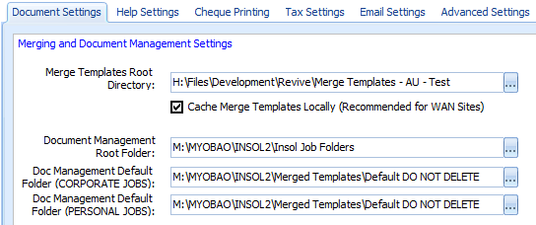

You may change the structure by opening the directory structure in the file system (using Windows explorer). You may set up any directory structure you want, except for consideration of the follow factors:

- Any new jobs will adopt the new folder structure, but, existing jobs will remain with their current structure.
- Document templates may have been configured to output in a specific default save path, if you delete this folder from the default set of folders then the folder will be recreated when the document is produced. The default save path configuration for a document template shows below:
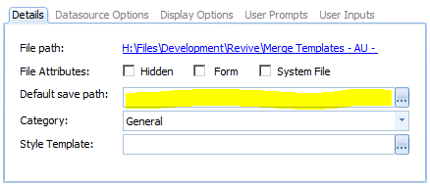
- Particular templates are created in system locations such as lodgements, BAS and PAYG outputs, if these directories do not exist the software will recreate the folder.

Note: scan document folders (the feature that creates document records from the content of a job folders) does not import documents that exist in the root directory of the job folder).

You may also have separate folder structures for personal and corporate job types.

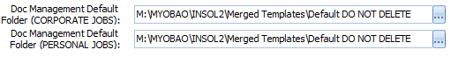

>

Related Articles:
<type>

Related Links:
<type>

Internal Notes:
<type>

Keywords:
<documents, default, directory, folder>

