Other Product/Module not listed above but present in RNT
<Insolvency>

Module Version:
<V4.1.32>

Article Title:
<Task Display Ordering>

Summary:
<This explains how task ordering is configured>

Detail:
<
Task Ordering

Task Template Tasks have a display order. The task ordering is configured by moving tasks up and down.

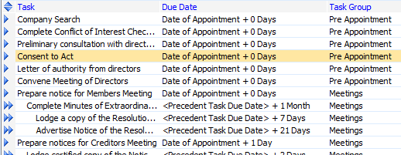

Click and drag the arrow icon to move a task up or down.

The Task Move dialogue appears.

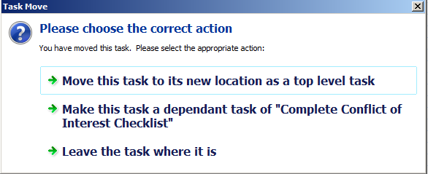

Select “Move this task to its new location” and the task ordering has been reconfigured.

Importing Tasks

First time import:
When importing tasks into a job that doesn’t have any tasks, the task ordering which is set in the task template is inherited by the tasks imported into the job.

Subsequent times importing:
If there are existing tasks in a job, any newly imported tasks are ordered at the end of the task list, but retain the task ordering from the template within the imported block of tasks. You need to reorder tasks if this ordering is not appropriate.

Ordering tasks in the job

To reorder tasks, switch to the task checklist view and tasks appear in Task Group Order.

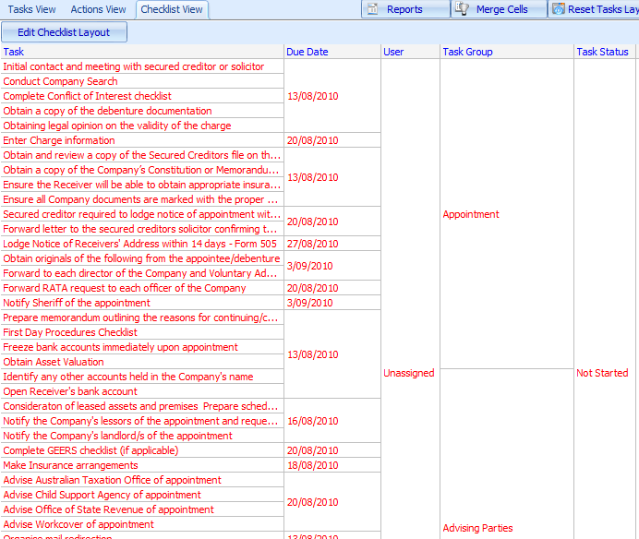

To re-order tasks in the job, click the Edit Checklist Layout button.

The task reorder column appears.

By clicking and dragging on the reorder column you may reorder tasks.

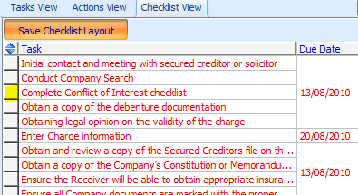

Reporting:

Task Checklist Reports

Task Checklist reports are grouped by Task Group. The primary sort order for Task Group is the Task Group Display Order, which you may configure in Static Data > Task Group.

The secondary task sorting is by Task Display Order.

Task Reports

The display order can be determined by choosing the type of report and setting the report display order in the report wizard.

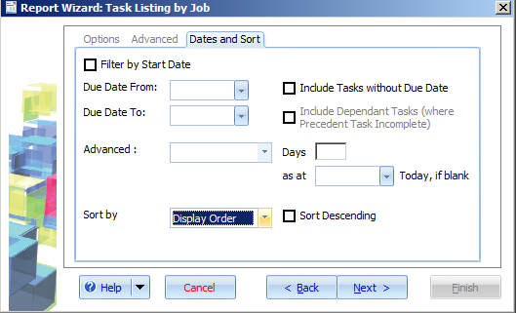
>

Related Articles:
<type>

Related Links:
<type>

Internal Notes:
<type>

Keywords:
<tasks, display order>

