Other Product/Module not listed above but present in RNT

<Insolvency>

Module Version:

<V4.0.53>

Article Title:

<How to Use the Report Designer>

Summary:

<type>

Detail:

<

To design a report

1. Open the Report Wizard and view the report list for the report you want to design  
     
   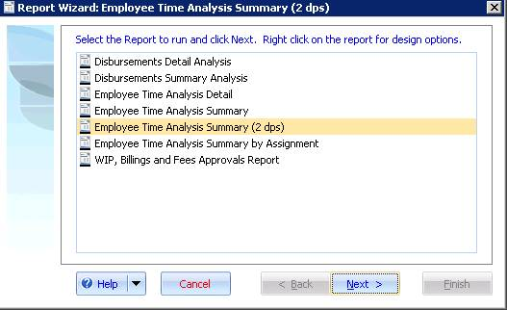  
     
   Note: Some reports you may need to click the ‘Back’ button to view the report list.
2. Right click on the report and select “New Report based on ‘My Report’”  
     
   Enter a new report name and click **OK**.  
   A new report has been added based on the existing report.
3. Right click on the report and select “Design ‘My Report’”  
     
   The report designer appears.

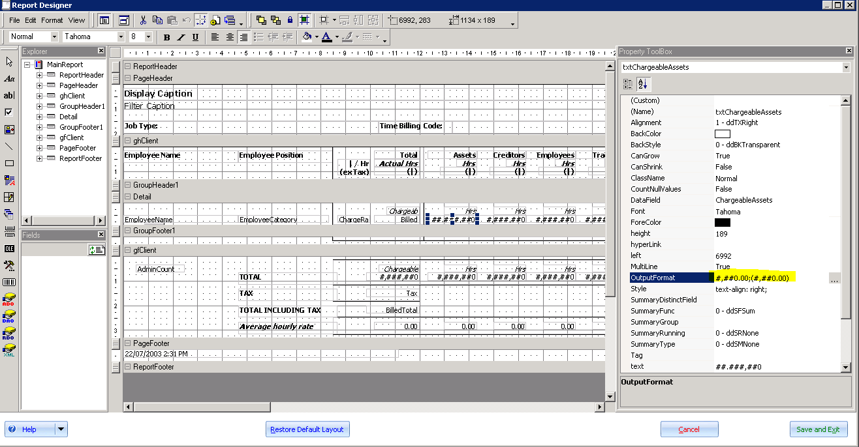

1. Adding fields to the report.  
     
   To add a field, either copy an existing field or create a new field by dragging a control from the toolbox (for example add a text box).

Each report has its own data source which is a collection of fields (much like a spreadsheet with row headers). Set the Datafield property of the field (located in the property toolbox) to the name of the datafield available in the data source.

Contact support for information on the datafields available.  
  
Note: On some reports, fields are positioned on the report, but, are hidden. If you want to show a hidden field set the field’s **Visible** property to True.

>

Related Articles:

<type>

Related Links:

<type>

Internal Notes:

<type>

Keywords:

<type>