MYOB Insolvency
Specification– Australian Banking Association
ABA bank payment file format

Prepared By: Stewart McLeod
Exalt Technologies

MYOB Insolvency (v3.1) Specification– Australian Banking Association ABA bank payment file format 1
Introduction 1
ABA Text File Location 2
Account Details Form 2
Printing Cheques 3
Prepare EFT File Input form 3
Validation 4
Output File specification 5
Output File Validation 10

Introduction
Enclosed is the ABA output file specification. Produce the output file by following the commentary described in the ‘Testing Description’ column.

ABA Text File Location
The ABA file is created in the data output directory specified in Application Settings:
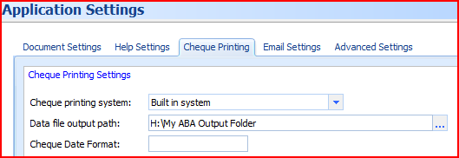

Account Details Form
Each account stores the Payer’s details which are used for the output file
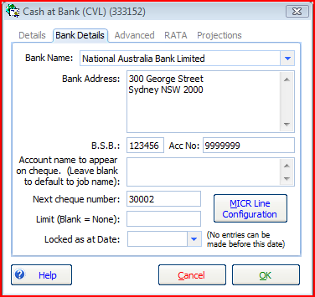

Printing Cheques
The Print Cheque dialogue displays a ‘DE Entry’ (previously ‘ABA’) tab which can be used to output a text file in the ABA format
Access the Print Cheque dialogue from any payment entry or from the Transactions > Print Cheques menu.
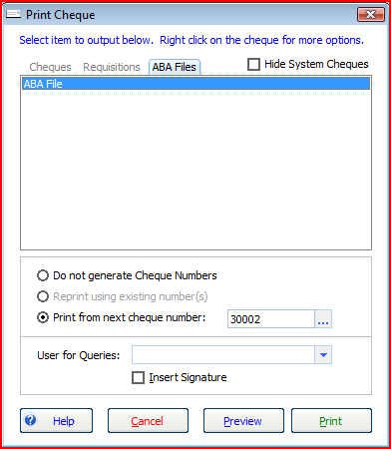
Click on the ABA or DE file output and click Print.

Prepare EFT File Input form
Enter the EFT file information:
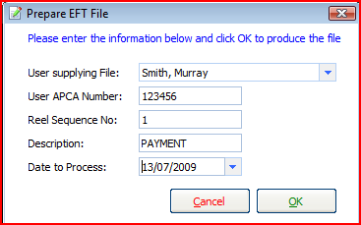
User APCA Number defaults to the last entered.
Reel Number is the sequential number for each date (if you are producing an EFT file for the same date then the first file will be ‘1’ then ‘2’ etc.

Validation
Validation is also incorporated in the output process.
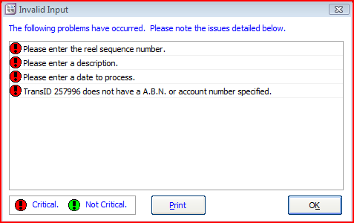
For all fields in the ABA output, ensure you cannot either:
- add incorrect values in the UI, or
- an incorrect value causes a validation warning
The validation warnings are set out in the Output File Validation section below.

Payments to Creditors and Employees
You are also able to pay creditors and employees electronically using the ABA output format.

Unsecured Creditors
Enter the Counterparty banking details and this will default onto the dividend payment provided you select the EFT payment option when creating the dividend.

Employees
Enter the Counterparty banking details and this will default onto the dividend payment provided you select the EFT payment option when creating the dividend.

Output File specification
Char Position | Field size | Field description | Specification | Testing Description | Test Validation  Blank or invalid entry
Header Record Definition ('0' record) (first line):
1 | 1 | Record Type 0 | Must be '0'
2-18 | 17 | Blank | Must be blank filled.
19-20 | 2 | Reel Sequence Number | Must be numeric  commencing at 01. Right justified. Zero filled | Field entered into ‘Prepare EFT File’ Input form
21-23 | 3 | Name of User's Financial  Institution | Must be approved  Financial Institution abbreviation. Westpac's abbreviation is "WBC". | Relates to the Bank Set for the Bank Account.  Three letter abbrev. set up in Static Data > Banks  Importing
24-30 | 7 | Blank | Must be blank filled.
31-56 | 26 | Name of User supplying file | Must be User Preferred  Specification as advised in Application. Left justified, blank filled. All  coded character set valid. Must not be all blanks. | Field entered into ‘Prepare EFT File’ Input form
57-62 | 6 | Number of User supplying  file | Must be User  Identification Number which is allocated by APCA. Must be numeric, right  justified, zero filled. | Field entered into ‘Prepare EFT File’ Input form
63-74 | 12 | Description of entries on  file e.g. "PAYROLL" | All coded character set  valid. Must not be all blanks. Left justified, blank filled. | Field entered into ‘Prepare EFT File’ Input form
75-80 | 6 | Date to be processed  (i.e. the date transactions are released to all Financial Institutions) | Must be numeric in the  format of DDMMYY. Must be a valid date. Zero filled. | Field entered into ‘Prepare EFT File’ Input form
81-120 | 40 | Blank | Must be blank filled.
Detail Record ('1' record)
1 | 1 | Record Type 1 | Must be '1'
2-8 | 7 | Bank/State/Branch Number | Must be numeric with a hyphen in character position 5. Character positions 2 and 3 must equal valid Financial Institution number. Character position 4 must equal a valid State number (0-9). | Value retuned: “123-456”  Payee’s BSB entered in the payment
9-17 | 9 | Account number to be credited/debited | Numeric, hyphens and blanks only are valid. Must not contain all blanks or zeros. Leading zeros which are part of a valid account number must be shown, e.g. 00-1234. Westpac recommends that (except in the above example), ALL hyphens are edited out. Where account number exceeds nine characters, edit out hyphens. Right justified, blank filled. | Value: “123456789”  Payee’s account number entered in the payment
18 | 1 | Indicator | "N" -for new or varied Bank (FI)/State/Branch number or name details, otherwise blank filled. Withholding Tax Indicators: "W" -dividend paid to a resident of a country where a double tax agreement is in force. "X" -dividend paid to a resident of any other country. "Y" -interest paid to all non-residents The amount of withholding tax is to appear in character positions113-120. Note: Where withholding tax has been deducted the appropriate Indicator as shown above is to be used and will override the normal indicator. | Value: “N”
19-20 | 2 | Transaction Code | Must only be valid industry standard tran codes (see list). Only numeric valid. | Set to ‘13’ Externally initiated debit items
21-30 | 10 | Amount | Only numeric valid. Must be greater than zero. Shown in cents without punctuations. Right justified, zero filled. Unsigned. | Amount of Payment
31-62 | 32 | Title of Account to be credited/debited | All coded character set valid. Must not be all blanks. Left justified, blank filled. Desirable format: - surname (period) blank  - given names with blank between each name | Payee Name  Check validation if > 32 characters
63-80 | 18 | Lodgement Reference | All coded character set valid. Reference as submitted by the User indicating details of the origin of the entry e.g. Payroll number, invoice, contract number. Left justified, blank filled. Must not contain all blanks. | Payee Reference field (Entry.Reference2)  Entered in Payment  Check for Supplier Payment on Account and Make Payment
81-96 (81-87) | 16  7 | Trace Record (-BSB Number  in format XXX-XXX) | Bank (FI)/State/Branch and  Account number of User to enable retracing of the entry to its source if  necessary. Only numeric and hyphens valid. Character positions 81 & 82  must equal a valid Financial Institution number. Character position 83  must equal a valid State number (0-9). Character position 84 must be a  hyphen. | Payer’s details.  BSB Value retuned: “123-456”  Entered in Account Details Form.  Check validation of format.  State number (0-9) validated by virtue of the fact that the field is validated as numeric.
(88-96) | 9 | (-Account Number) | Right justified, blank  filled. | Payer’s details.  BSB Value retuned: “123-456”  Entered in Account Details Form.
97-112 | 16 | Name of Remitter | Name of originator of the entry. This may vary from Name of the User. All coded character set valid. Must not contain all blanks. Left justified, blank filled. | Job Name
113-120 | 8 | Amount of Withholding Tax | Numeric only valid. Show in cents without punctuation. Right justified, zero filled. Unsigned. | Value “00000000”
Total Record ‘7’ (Trailer)
1 | 1 | Record Type 7 | Must be '7'.
2-8 | 7 | BSB Format Filler | Must be '999-999'. | Value '999-999'
9-20 | 12 | Blank | Must be blank filled.
21-30 | 10 | File (User) Net Total Amount | Numeric only valid. Must equal the difference between File Credit & File Debit Total Amounts. Show in cents without punctuation. Right justified, zero filled. Unsigned.
31-40 | 10 | File (User) Credit Total Amount | Numeric only valid. Must equal the accumulated total of credit Detail Record amounts. Show in cents without punctuation. Right justified, zero filled. Unsigned.
41-50 | 10 | File (User) Debit Total Amount | Numeric only valid. Must equal the accumulated total of debit Detail Record amounts. Show in cents without punctuation. Right justified, zero filled. Unsigned.
51-74 | 24 | Blank | Must be blank filled.
75-80 | 6 | File (User) count of Records Type 1 | Numeric only valid. Must equal accumulated number of Record Type 1 items on the file. Right justified, zero filled.
81-120 | 40 | Blank | Must be blank filled.

Output File Validation
POS | Warning description | Type
EFT Input | Please enter the user APCA number. | Critical
EFT Input | The APCA user name is greater than 26 characters and will be truncated. | Warning
EFT Input | Please enter the reel sequence number. This the sequential number of output files produced. First output file sequence 1, second output 2 etc." | Critical
EFT Input | The reel sequence number should be a number between 1 and 99. | Critical
EFT Input | Please enter a payment description. | Critical
EFT Input | Please enter a date to process. | Critical
Transaction | TransID [EntryID] does not have an account number specified for payee. | Critical
Transaction | TransID [EntryID] does not have BSB specified for payee. | Critical
Transaction | The account number specified in transID [EntryID] has an account number > 9 characters. | Critical
Transaction | TransID [EntryID] has BSB > than 7 characters '999-999' | Critical
Transaction | The Payee Ref. for TransID [EntryID] is greater than 18 characters. The field will be truncated. | Critical
Transaction | TransID [EntryID] does not have a Payee entered. | Warning
Transaction | The Payee field for TransID [EntryID] is greater than 32 characters. The field will be truncated", | Warning
Account | The Account does not have BSB specified. | Critical
Account | The Account does not have an Account specified. | Critical

