Entering a net sale of a property asset where the secured creditor has received the funds directly.

The following example records the situation where a liquidator receives the net proceeds from an asset sale.

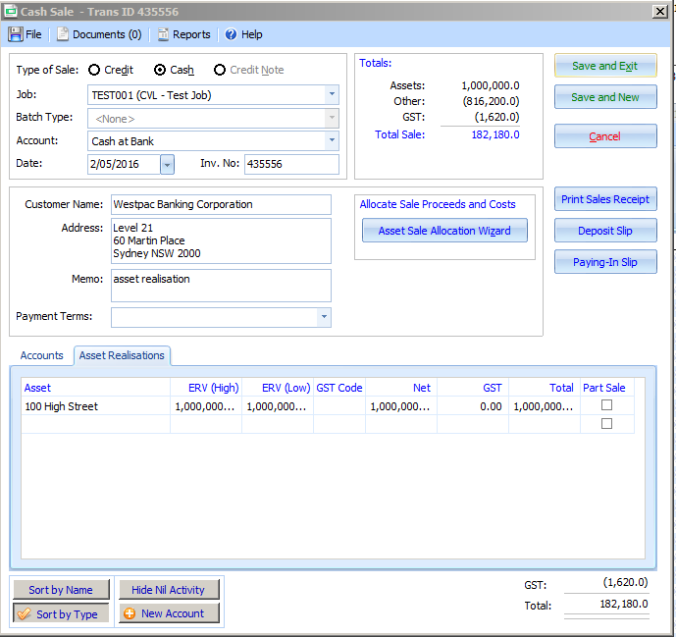

There isn’t any GST entered in this example, assuming the Liquidator isn’t running a business for the purpose of completing the buciness activity statement. Seek advise as to whether the asset sale transaction attracts GST.

The accounts tab over the page records costs and the secured creditor amount, where the net proceeds are paid to the Liquidator.

