MYOB Insolvency (UK)
Foreign Currency

Introduction 2
Adding FC Bank Accounts 3
Adding FC Assets 4
FC Asset Holding Accounts 4
FC Pre Appointment Debtors 4
Other FC Assets 5
Managing XR 6
Entering Rates 7
FC Transactions 8
Entering FC transactions 8
Make FC Payments 9
Receive FC Payments 10
Receipts for FC Assets 10
Receive FC Payments for Pre Appointment Debtors 10
Receive FC Payments for Post Appointment Debtors 13
Receiving FC Payments on Account 15
Realising FC Assets 16
Realising FC Assets in FC Bank Accounts. 16
Realising FC Assets in HC Bank Accounts. 17
Revaluing FC Assets 17
FC Transfers 18
FC Journal entries 20
Exchange Rate Gains (Losses) 20
Processing a Foreign Currency Gain (Loss) entry 21
Asset Adjustments 21
Creditors 22
Reporting 22
Bank Account Reconciliation 23
Deposit Slip 23
Account Register 23
Asset Register 23
Detailed Transaction Reports 23
Receipts and Payments Detail Reports 24
Receipts and Payments Summary Reports 24
Balance Sheet reports 24
Debtor Reports 24
Profit and Loss 24

Version: Draft

Dated: 20 December 2005

Introduction

United Kingdom:

SSAP 20 describes the basic principles governing accounting for foreign currency (“FC”) transactions as applicable to insolvency controllerships.

According to SSAP 20, each transaction should be translated into the home currency (“HC”) using the exchange rate (“XR”) in operation at the date of the transaction.

This method of accounting for FC transactions is commonly known as the temporal method. From an accounting point of view, system follows this method for recording transactions.

Australia:

The temporal method is also used in Australia. See: Statement of Accounting Standards AAS 20A.

General:

From a display and reporting point of view, the system, where appropriate, presents the user with the value of FC Assets converted at current XRs. By using this method we assume an insolvent practitioner’s primary concern when considering FC is the current value of assets in HC (i.e. the most accurate assessment of the remaining value of the assets).

Additionally, typical receipts and payments abstracts used for statutory reporting in the UK reconcile the total receipts and payments represented by balance sheet accounts (mainly bank accounts).

An example might be:

Receipts and Payments: | Total
Receipts | £10,000
Payments | £5,000
Represented By:
Cash at Bank | £5,000

When amounts are held in FC bank accounts, and XR variations occur, the system reports adjustments for any unrealised XR gains (losses) which would otherwise cause the balance sheet to be out of balance.

All FC transactions record the amount of the transaction both in FC and in HC. In this way the system can simultaneously (in a single entry) post transactions to accounts which are denominated in different currencies. Additionally, the system may report amounts in the appropriate currency (FC or HC) depending upon the reporting requirements.

Reporting for consolidated entities with separate foreign reporting entities are outside the scope of consideration.

Adding Foreign Currency (FC) Bank Accounts

When adding a bank account, you may specify a currency.

To add a FC bank account (Financials > Accounts > Add Account) select a currency in the Add New Account form.

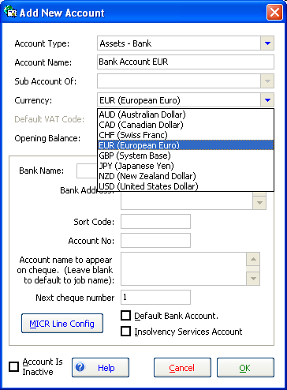

Once a FC account is entered, the Ccy column appears in the Accounts List.

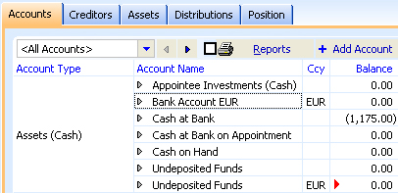

When entering transactions to FC bank accounts you must enter the amounts in FC denominations. A transaction records the XR, the amount(s) in FC and the amount(s) in HC.

Adding Foreign Currency (FC) Assets

FC Asset Holding Accounts

Each asset has a general ledger holding account. The holding account is used to record entries for capturing the value of asset, processing adjustments and realising assets. Any entry that affects the asset value will be coded against the asset holding account and have an allocation to the asset.

The asset holding account determines the asset’s currency. You may specify a currency for any general ledger account which belongs to an asset class (Debtors, Plant and Equipment, Land, Other Assets, Bank etc.).

To add a FC Asset holding account, in the Add New Account form (Financials > Accounts > Add Account) select an Account type which relates to an asset class and select the currency. You may also add an account “on-the-fly” when adding an asset.

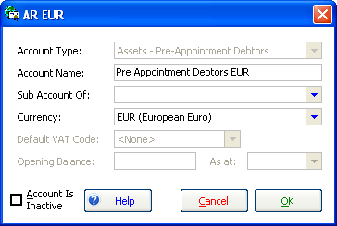

FC Pre Appointment Debtors

You may record and collect Debtors denominated in FC.

Firstly, add the FC Asset holding account (as described above) and then add the Debtor (Financials > Assets > Add Asset > Accounts Receivable (Pre-Appointment)).

Enter the FC Pre Appointment Debtor details:

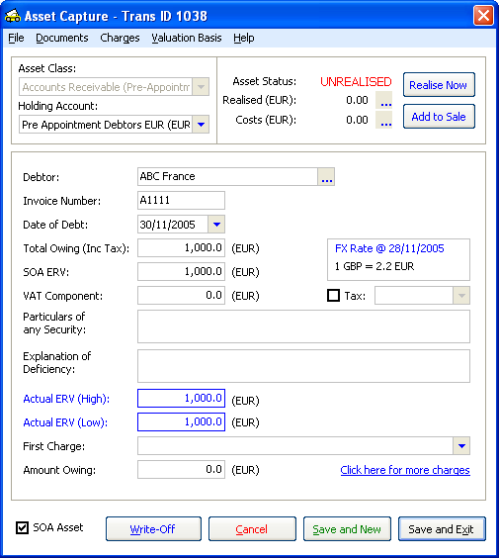

Note: The Date of Debt is automatically set as the Job’s Start Date.
The XR defaults to the most current system XR as at the Date of Debt.
The Holding Account is an asset account denominated in FC.

Note: The entry of a FC Pre Appointment Debtor crystallises any valuation for the purposes of pre appointment corporation tax. If you wish to subsequently recognise any income arising from the collection debtors you will have to enter separate journal entries.

Other Foreign Currency (FC) Assets

All asset classes available in the system may be captured and realised in FC.

To add the asset select Financials > Assets > Add Asset > Select the asset class, add the asset holding account on-the-fly by selecting <New Account> from the Holding Account dropdown list, enter the Account Name and select a FC.
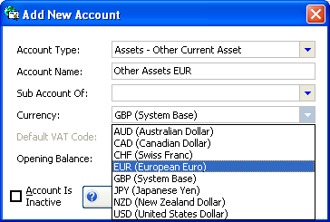

Enter the FC asset details:

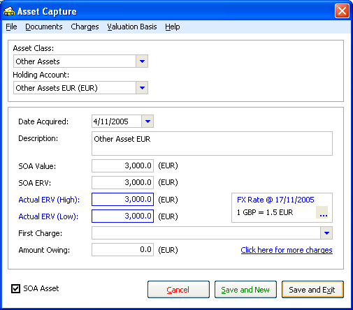

Managing Exchange Rates (XR)

Rule 4.91(2) - Debt in foreign currency of the Insolvency Rules 1986 specifies the official exchange rate as:

4.91(2) ["The official exchange rate"] "The official exchange rate" is the middle market rate at the Bank of England, as published for the date in question. In the absence of any such published rate, it is such rate as the court determines.

Accordingly, only one exchange rate per currency for each date is used as the basis for currency calculations across all jobs.

The system uses a base system currency or home currency, which in the United Kingdom is GBP. All currencies are entered in relation to 1 (one) unit of HC.

Entering Rates

You can maintain the system XR in Static Data > Foreign Currency Exchange Rates. System default rates may be added for each currency for each date.

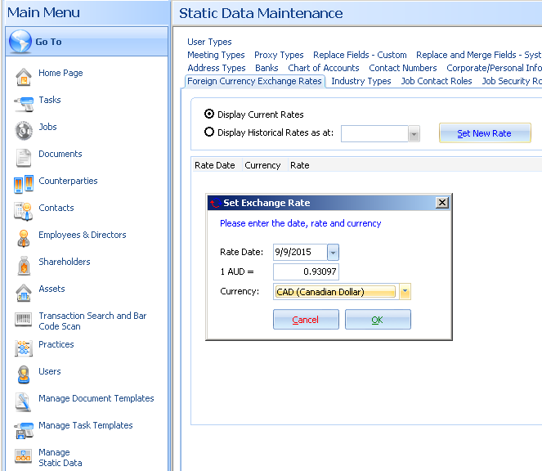

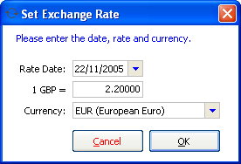

System XRs
FC transactions by default will use the most recent XR (“System Rate”).

To avoid changing the HC values of FC transactions using the System Rate, the XR is locked (i.e. the rate cannot be changed) once a transaction uses the System Rate.

When you add a new System Rate, the pre-existing System Rate will be changed to a “Previous System Rate”. If the date of a transaction is before the current System Rate then the system uses the most recent Previous System Rate as the default rate of the transaction.

When you add a System Rate, any Previous System Rates which are not used by transactions and are more than one-year old are deleted.

Custom XRs entered in transactions
In addition to System Rates, you may specify a custom rate for each transaction. When you add a FC transaction the Exchange Rate box appears. To specify a custom rate in a transaction, click the ellipsis in the Exchange Rate box:



Enter the XR,

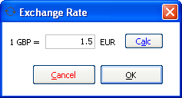

Or, enter the amounts of each currency by clicking the Calc button, to calculate the rate.

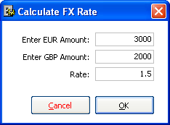

FC Transactions

Entering Foreign Currency (FC) transactions

The system always requires you to enter FC transactions in FC denominations. A transaction records only one XR, so therefore, all entry lines in a transaction are recorded at the same rate.

Although all FC transactions display in FC, the transaction records amounts in both FC and in HC. The HC amount is calculated by XR x FC Amount, where the XR may be the System Rate or a custom rate.

You may perform the following types of transactions:

- Make FC Payments
- Receive FC Payments
- Receipts for FC Assets
  - Receive FC Payments for Pre Appointment Debtors
  - Receive FC Payments for Post Appointment Debtors
  - Receive FC Payments on Account
- Realise FC Assets
- FC Transfers
- FC Journal Entries
- XR Gains (Losses)

You may not enter Accounts Payable (Liabilities) in FC.

Make Foreign Currency (FC) Payments

You may Make FC Payments from HC or FC bank accounts.

Make FC Payments from FC bank accounts by selecting a FC denominated bank account from the Account dropdown (in the transaction).

The following example shows a Payment by selecting Transactions > Make Payment:

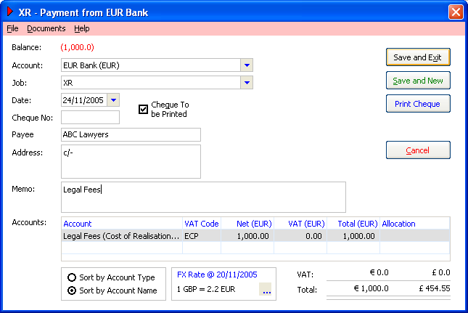

Note: the Account selected above is a FC Bank Account.

You may also make FC Payments from HC bank accounts, however, this only occurs if you code an entry line to a FC Asset account. Generally, you wouldn’t be required to purchase FC Assets, as you would usually add FC assets via the Asset Register.

Note: In a bank account denominated in foreign currency you may toggle the values between home currency and foreign currency.

Receive Foreign Currency (FC) Payments

You may Receive FC Payments to either FC or HC bank accounts.

To Receive FC Payments to FC bank accounts select a FC denominated bank account in the receipt’s Account drop down (menu: Transactions > Receive Payment).

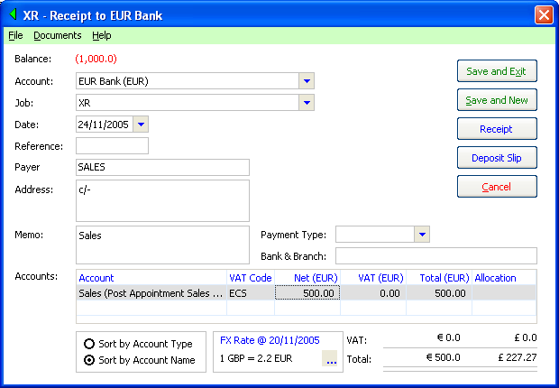

Generally, FC receipts (other than collections of FC Debtors or realisations of FC assets) would be coded to a Sales account.

Receipts for Foreign Currency (FC) Assets

FC transactions relating to FC assets generally fit into the following categories:

- Receive FC Payments for Pre Appointment Debtors
- Receive FC Payments for Post Appointment Debtors
- Receive FC Payments on Account
- Realise FC Assets

Receive FC Payments for Pre Appointment Debtors

When Receiving FC Payments for Pre-Appointment Debtors, the system records amounts owing both in FC and in HC (defaulting to the XR as at the date of appointment).

Receipts of FC Debtor amounts owing may be banked into either a FC or HC bank accounts.

Entering FC Pre Appointment Debtors is highlighted in the Adding FC Assets section, above.

Foreign Currency (FC) Bank Accounts
To Receive a Pre Appointment Debt in a FC denominated bank account, from the menu select Transactions > Receive Payments.

Firstly, select a FC bank account from the Account drop-down. Adding a FC bank account is described in the Adding FC Bank Accounts, above.

Secondly, select the FC Accounts Receivable account and allocate the transaction entry line to the appropriate invoice.

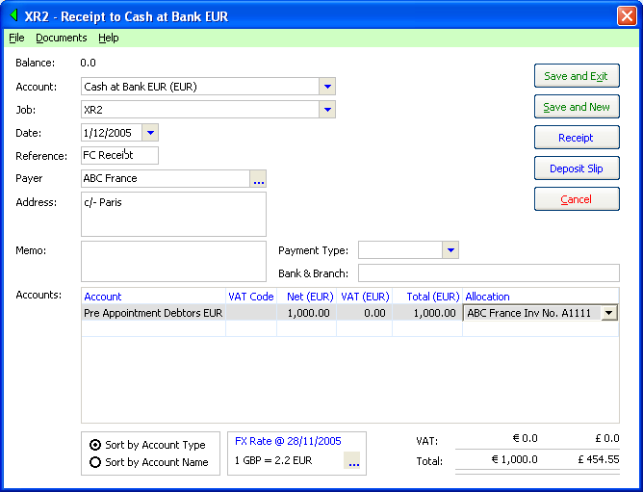

You may receive an amount that represents a part payment on the FC Debt.

The amount of the receipt is also recorded in the HC at the XR and both the FC amount and the HC equivalent for the realisation amount are recorded for the asset.

You may also add receipts of FC Debtors to FC bank accounts using Receive Payment on Account.

Home Currency (HC) Bank Accounts
When you receive FC payments to a HC bank account select a HC bank account from the Account drop-down option.

The transaction is still entered in FC amounts, however, the transaction will display in HC in the bank account register. The transaction is entered in FC because the Asset is denominated in this currency. This is consistent for all FC transactions.

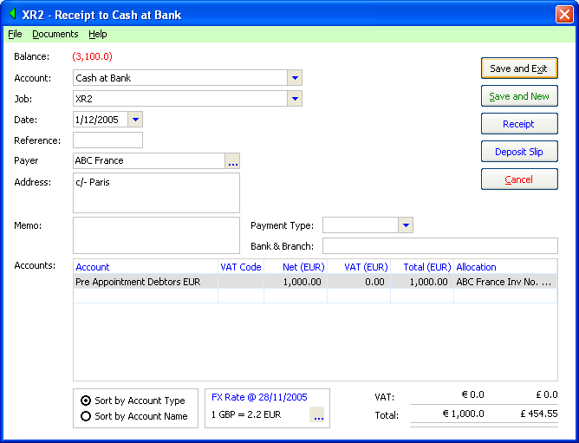

Once you have saved the transaction, open the Asset and view the transactions (In the Asset Detail form click on the ellipsis next to the amount Realised (EUR).

Note: The account register (filtered by the asset) displays in FC.

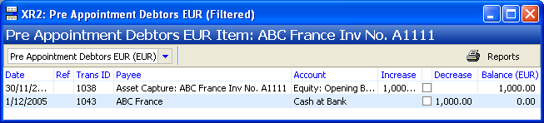

As the FC asset account register displays amounts in FC, and any FC Gains (Losses) are in HC, these entries will not appear in the register. You can see adjustment entries in the separate ledger account, Foreign Currency Gain (Loss). See below for more on FC Gains (Losses).

Receive Foreign Currency (FC) Payments for Post Appointment Debtors

Firstly, enter a FC Post Appointment Debtor Transaction (Financials > Assets > Add Asset > Accounts Receivable (Post-Appointment)).

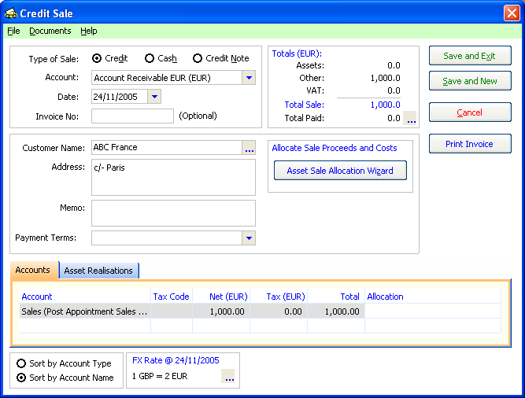

Note: the Account selected is a FC denominated account

Receiving FC payments for Post Appointment Debtors is similar to receiving FC payments for Pre Appointment Debtors, so for this example we will look at receiving part of the amount owing.

Part Receipts
You may enter a series of debtor collection entries that makes up only part of the amount owing. To illustrate receiving debtors in different currencies, we’ll look at this example by receiving a part payment in a FC bank account and a part payment in a HC bank account.

Foreign Currency (FC) Bank Accounts
You may receive FC receipts into a FC bank account of the same currency. Record receipts using either Receive Payment or Receive Payment on Account.

The amount received will be entered in the FC and the amount of the receipt will be converted into the HC (at the default system rate or at a custom rate).

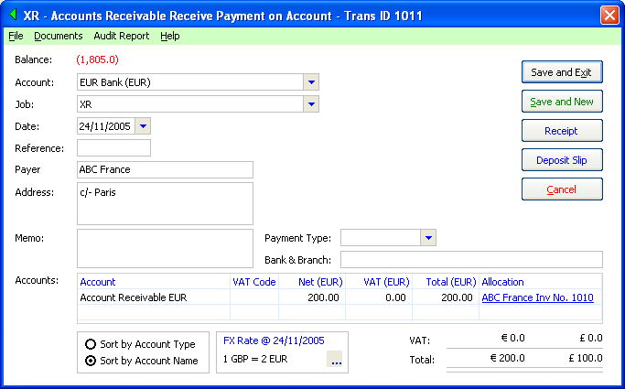

Home Currency (HC) Bank Accounts
Entering a debtor receipt for a HC bank account is the same as for a FC bank account, except a HC bank account is selected from the Account drop-down (in this example Cash at Bank). Even though the transaction belongs to a HC bank account the entry is denominated in FC, which again is consistent with the way the system handles all FC transactions.

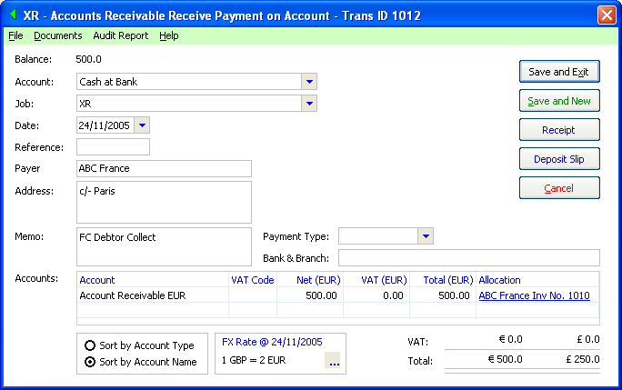

When you view the above entry in the bank account register it displays in HC, however, when you view the same transaction in Asset account register it displays in FC.

If you edit the original Credit Sale entry (the accounts receivable invoice) the Totals Summary displays in FC (where a FC accounts receivable account is used).

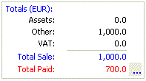

Drill down on the Total Paid to display the transactions in the Asset’s account register. The amounts are denominated in FC.

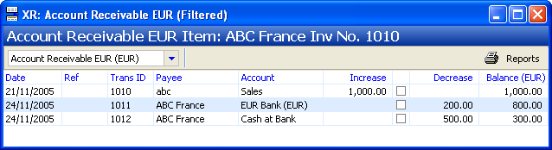

Also see: XR Gains (Losses) against an Asset.

Note: You cannot receive HC Debtors in a FC bank account.
You may not select FC Debtors when processing Receive Payments on Account using a HC bank account.

Receiving Foreign Currency (FC) Payments on Account

Receive Payment on Account (Transactions > Receive Payment on Account) may be used to receive both Pre and Post Appointment Debtors. You may only receive: FC Debtors in FC denominated bank accounts.

If you want to receive FC Debtors in HC you must use the Receive Payment option.

Realising Foreign Currency (FC) Assets
The following attributes apply to FC Asset realisations.

- You may realise FC Assets with more than one currency in one transaction (i.e. Assets denominated in EUR, GBP, and USD).
- You may only realise FC Assets in either the same FC (i.e. EUR Asset into EUR bank accounts) or in HC bank accounts.
- When you realise FC Assets in HC, FC Assets must be realised in full.
- You cannot realise HC Assets in FC.

Realising FC Assets in FC Bank Accounts.

Realising FC Assets in a FC bank account is similar to realising HC Assets in HC, except the transaction is denominated in FC (when you specify a FC bank account). You can only realise FC Assets in a bank account of the same currency (i.e. you can only realise EUR Assets to a EUR denominated bank account.

The transaction is also recorded in HC at the selected XR. The system doesn’t process any FC Gains (Losses) when realising FC Assets to FC bank accounts.

An example of the Cash Receipt is illustrated:

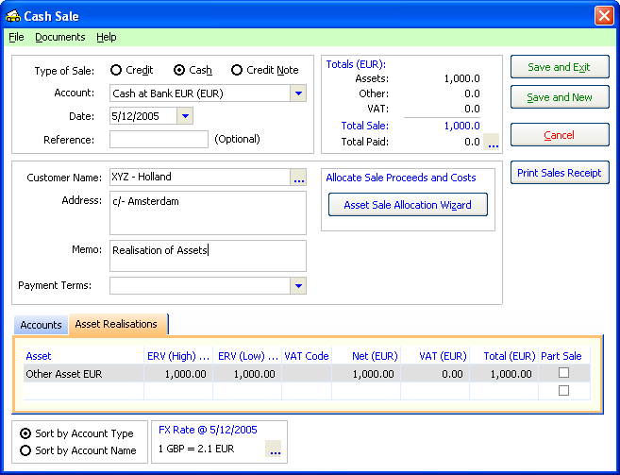

You may also partly realise FC Assets in FC bank accounts.

Realising FC Assets in HC Bank Accounts.

You may realise FC Assets (of all currencies) into a HC bank account provided you fully realise the FC Assets.

HC Assets may be partly realised.

Revaluing Foreign Currency (FC) Assets
Adjustments to the value of FC Assets are made in both FC and HC equivalents.

You may adjust the FC value of an asset by editing the asset (in the Asset Capture form) and entering a new ERV (Low) value in FC.

The system creates an adjustment journal in both FC and HC amounts as at the specified date.

The XR of the original asset capture will be used to calculate the amount of the HC adjustment.

You may also process an adjustment solely in the HC. This won’t have any effect on the balance of the Asset in FC or the amount realised against the asset. It may not be important to adjust the balance of the Asset in HC as most of the reports convert the FC Asset values into HC at current rates, and when fully realised the HC balance of the asset is written off.

FC Transfers

Any receipt or payment from one bank account to another is recorded as a transfer. As such, it is excluded from receipts and payments reporting.

To record a transfer, either Make and/or Receive Payments denominated in FC where the accounts entries are coded to/from a FC bank account .

The following is an example of a Payment from a HC bank account to a FC bank account.

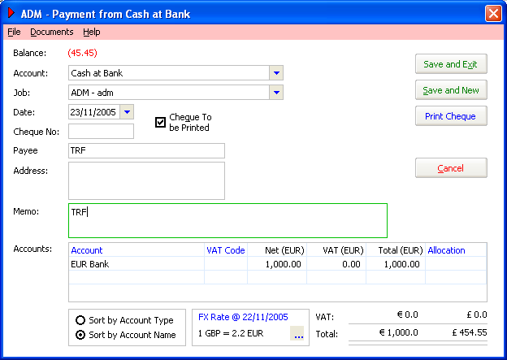

Note: The Account selected above is a HC Bank Account.
Amounts are entered in FC.

The above entry transfers a FC amount to the FC bank account from the HC bank account.

The transaction records the amount of the transfer in the HC for the HC bank account (i.e. the system processes the entry both in HC and FC).

The above entry transfers a FC amount from the FC bank account to the HC bank account. The transaction records the amount of the transfer in the HC for the HC bank account.

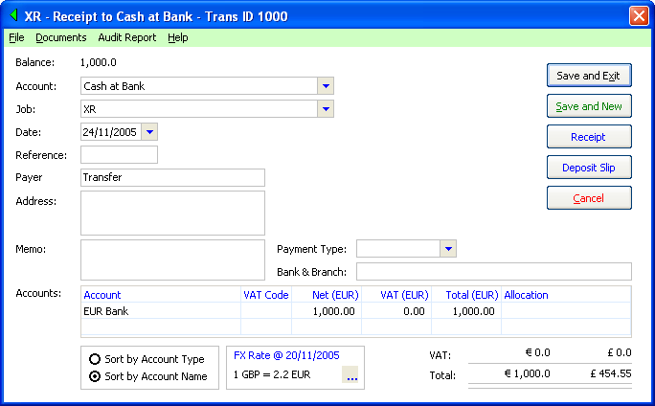

Note: the Account selected above is a HC Bank Account.

FC Journal entries

You may also enter FC journal entries. If a journal entry containing an entry for either a FC Asset Account or FC bank account, the entry will be denominated in FC.

Journal Entries may only belong to one FC. You cannot mix currencies other than one FC and the HC.

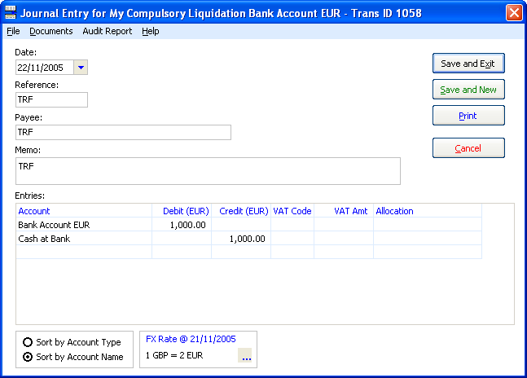

The system processes the entry both in HC and FC. As a result, you may enter a transfer between HC and FC accounts in a single entry.

Where an entry is coded against an HC bank account, the amount displays in the HC bank account register at the specified XR.

Exchange Rate Gains (Losses)

XR Gains (Losses) arise when a FC Asset is realised in HC at an XR which differs from the XR at which it was recorded.

For example, you record a FC debtor valued at €10,000 at 2EUR : 1GBP totalling £5,000. When you receive payment of €10,000 in HC the XR is 2.5EUR : 1GBP. The FC Loss totals £1,000 as the amount received in HC (£) will be equivalent to £4,000.

The system doesn’t automatically generate FC Gains (Losses).

To bring these variations to account you have to process a journal entry.

Processing a Foreign Currency Gain (Loss) entry

You may process a journal entry to bring to account a FC Gain (Loss) by coding one side of an entry to the Exchange Rate Gain (Loss) account.

An example of a Foreign Currency Gain e.g.

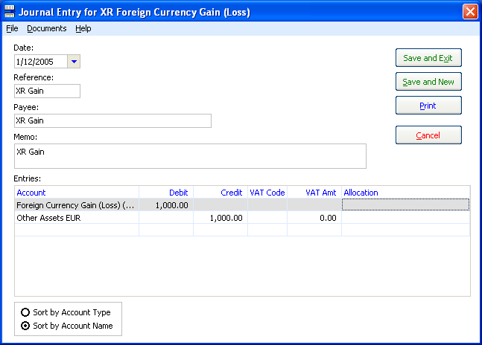

Note: The transaction is always processed in the HC and doesn’t have any effect on FC balances.

Asset Adjustments

Adjustments to the value of an asset value may occur in the following circumstances:

- Realising an asset for more that the ERV (Low).
- Changing an asset’s ERV (Low).
- Writing off an asset.

For the FC asset value, changes to the FC value are recorded the same way as a HC asset is handled. The system validates any change to the value of an asset to ensure the ERV (Low) of an asset is always greater than or equal to the sum of all amounts realised for the asset.

So, if an asset realisation is recorded which results in the sum of the totals realised against the asset the system will increase the Asset’s ERV (Low).

Changing an asset’s ERV (Low) is discussed above, in Revaluing FC Assets.

When an Asset is Written Off the ERV (Low) will be reduced to the sum total of amounts realised. E.g. if an asset is valued at €1,000 (ERV (Low)) and the amounts realised total €600, writing off the asset will reduce the ERV (Low) to €1,000.

For the HC asset value, the HC amount of each entries are processed entries at the exchange rate of the original asset capture. The same validation rule applies to the ERV (Low) compared with the sum total of realisation entries in HC as in FC.

Creditors
Rule 4.91 - Debt in foreign currency of the Insolvency Rules 1986 states the following:

4.91(1) [Conversion into sterling] For the purpose of proving a debt incurred or payable in a currency other than sterling, the amount of the debt shall be converted into sterling at the official exchange rate prevailing on the date when the company went into liquidation.

Creditor claims are entered in HC denomination. Creditors which have claims denominated in FC will have to be manually converted at the prevailing XR at the date of appointment. The system doesn’t provide an interface to converting a FC Creditor into the HC amount.

Although the Rules promote conversion of creditor claims to the HC at the date of appointment, a FC asset may be subject to a FC charge and accordingly a creditor may need to be paid in FC. In these cases you will need to adjust the amount of the claims based on the HC equivalent.

Reporting
The following reports have been designed to cater for FC transactions

- Bank Account Reconciliation
- Deposit Slip
- Pre-printed Cheque Summary
- Pre-printed Cheque Detail
- MICR Cheque Summary
- MICR Cheque Detail
- Requisition for Cheque
- Summary Cheque Listing
- General Receipt
- Detailed Receipt
- Invoice Detail
- Invoice Summary
- Accounts Payable
- Accounts Transaction Detail Listing
- Accounts Transaction Listing
- Balance Sheet
- Chart of Accounts
- Current Position
- Profit and Loss
- R&P Detail
- R&P Summary
- R&P Summary By Account
- Trial Balance
- Aged Receivables Detail
- Aged Receivables Summary
- Asset Listing By Asset Class
- Asset Listing By Holding Account
- Asset Listing By Security Charge
- Debtor Collection Status Detail
- Debtor Transaction Detail
- Pre App Debtor GST Summary
- Deleted Transaction Audit Report

Some of the main reports are described below:

Bank Account Reconciliation
The Bank Reconciliation functionality allows you to reconcile a FC bank account in its own currency.

Deposit Slip
Deposit amounts for FC bank accounts are denominated in FC.

Account Register
Once an FC account is added, a Ccy column will appear in the Accounts Register, showing the currency of any accounts denominated in FC.

If you drill down into the Account Register, transactions display in the currency of the account, that is FC accounts display FC amounts and HC accounts display HC amounts.

Asset Register
When displaying lists of assets grouped with other HC Assets, FC Asset ERV’s display at current exchange rates.

Detailed Transaction Reports
Detailed Transaction Reports display transactions in the HC at historical rates (i.e. the XR applicable to the transaction.

Receipts and Payments Detail Reports
All FC transactions, reported on receipts and payments reports, display at their historical HC value.

Receipts and Payments Summary Reports
Receipts and payments abstract reports (e.g. Receipts and Payments Summary By Account) summarise accounts which make up the total of receipts and payments. In some instances the receipts and payments reports are represented by the totals of balance sheet accounts (mainly bank accounts).

When FC transactions are reported, the system calculates a FC adjustment for any unrealised XR gains (losses) which cause the bank accounts to be out of balance.

A nominal XR Gain (Loss) will be calculated by the report. The amount of the Gain (Loss) is calculated based on the total of each currency’s receipts and payments when compared to the current XR (i.e. this is not just calculated as a balancing item).
This only applies where FC bank accounts have a remaining balance at the reporting date.

Balance Sheet reports (PL, BS, Trial Balance)
The system reports account totals based on all entries recorded at historical values in HC. As a consequence any Foreign Currency Gains (Losses) will not be reflected in the totals.

As a result, the value of FC bank accounts will be out of balance (where a XR variation has occurred) in comparison to their current value.

Where you record an asset (e.g. a debtor) at a particular value and receive full payment for the asset at a different XR, there will be outstanding balances in asset accounts due to the Foreign Currency Gains (Losses) despite the asset being fully realised in the FC amounts.

Debtor / Receivables Reports
Amounts owing display in HC translated at the most recent exchange rate.

Profit and Loss
Amounts are reported at historical values.

