Transaction approval workflow
The software provides for different options for Transaction Approval Workflow.

Payment workflow
Clients may consider different ways to set up their payment workflow which determines at what point in the payment cycle you enter invoices, produce payment requests and produce cheques.
The choices you make affect at what point you produce cheque requisitions and approve payments and as a result the information that is presented on reports at those points in time. Some of the alternative methods are described, below, as well as a description of the systems recommended workflow process.

Payment workflow process with batching and authorisation
The workflow of the payments process has been designed in this way:
Enter a purchase order. | Optional | Recognises an expectation of a future expense.  Entries do not affect the accounts.  You may convert the purchase order into an accounts payable entry.
Enter an Accounts Payable. | Optional | Keep a register of amounts owed.  Items only are entered as accounts payable when goods are received or services provided.
Enter and submit a Batch Payment or Accounts Payable Payment. |  | Coding is entered with batch entry, so you need to determine the account used for the entry.  Produce the payment requisition from the payment entry.  As you enter the payment you know the bank account at this time, therefore the bank account is pre-selected.
Payment Authorisation process. |  | Send emails to authorised users to approve payments.
Post the Entry. |  | The entry is now recorded.

Payment workflow process without batching
Enter a purchase order. | Optional | Recognises an expectation of a future expense.  Entries do not affect the accounts.  You may convert the purchase order into an accounts payable entry.
Enter an Accounts Payable. | Optional | Keep a register of amounts owed.  Items only are entered as accounts payable when goods are received or services provided.
Enter a Payment or Accounts Payable Payment. |  | Coding is entered with batch entry.  Produce the payment requisition from the payment entry.  The entry is now recorded.

Alternative workflow process
Clients may have predominately paper-based payment workflows. An example of an alternative workflow is listed below:
Enter an Accounts Payable. | Optional | Keep a register of amounts owed.  Items only are entered as accounts payable when goods are received or services provided.  Produce the cheque requisition from the Accounts Payable entry form.
Enter a Payment or Accounts Payable Payment. |  | Coding is entered with batch entry.  Produce the payment requisition from the payment entry.  The entry is now recorded.

Receipts and payments approval functionality
The software incorporates a process of approving cheque requisitions (payments) and paying-in slips (receipts). The process is described below in the context of cheque requisitions, but the same process also applies to paying in slips.
The software provides electronic approval of cheque requisitions and paying in slips. Once enabled, this creates a workflow process where transactions can be approved using the system. This process incorporates user-defined workflow steps (if required) and approval limits.

Setting up payment authorisation workflow

Enabling the payment authorisation workflow
Enable payment authorisation workflow via Manage Application Settings > Approval Workflow. Tick the ‘Enable payment authorisation workflow’ checkbox to turn it on.
If this option is enabled, users will no longer be able to produce cheque requests from the accounts payable form. All cheque requests must be entered as a cheque requisition batch item and entered into the approval process.
To enter a posted payment directly so it appears in the accounts you need to enable the security role Payments Add. To activate approval workflow you need to untick this permission for all system security roles.

Configure custom approval stages
Configure custom approval stages by adding descriptions to each payment approval stage. In the example below, two custom stages have been configured for the approval process, in addition to the final mandatory stage.

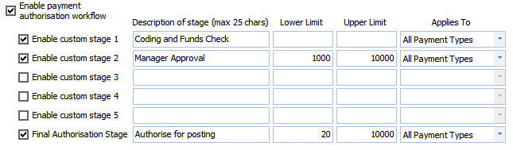
The first custom stage is defined as ‘Coding and Funds check’. Once a custom stage is defined it will appear in the Job Security Settings in Static Data. You may enable the authorisation step for defined user roles, as shown below:
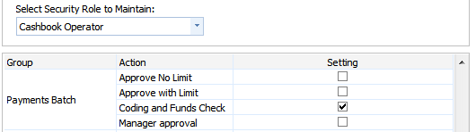
In this example, the cashbook operator role has been granted permission to perform the ‘Coding and Funds check’ stage. Since a limit has not been defined for this stage all payments entered into the workflow will enter this stage. Each approval stage can be configured to apply to all payment types, cheque payments only or EFT payments only.
As a lower limit has been entered for the second approval stage, this stage will only be applicable for payments that exceed the lower limit of $1,000 and are under the upper limit of $10,000. Only a Job Security role with this action enabled may approve items in this stage:

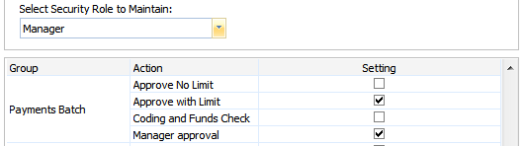
Once a batch is approved at each stage it moves to the next defined stage. Once it reaches the final stage and is approved by the appropriate Job Security role the batch appears as an unposted batch.
You may optionally configure the final authorisation stage. This stage is linked with two Job Security role actions, ‘Approve With Limit’ and ‘Approve no limit’. The limit for the first action is defined by the upper limit in the final authorisation stage. In this example, a security role with the ‘Approve With Limit’ action enabled will be able to approve anything under $10,000. Anything over that amount would require a security role with the ‘Approve No Limit’ action enabled. Note that the lower limit of $20 that has been set for this stage means that payments under that amount will not enter this final stage.

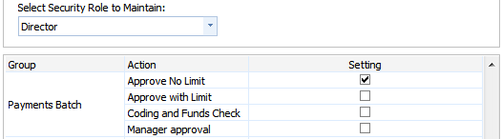
It is not necessary to any define custom stages, however, they can be setup to ensure that batches enter mandatory checking stages before final approval. The limits for each stage are mutually exclusive. This allows you to define limits for each stage and the batch will not enter a stage unless it meets the limits. If a batch does not meet the limits for a stage it will automatically be routed to the next stage.
As each stage is approved, the batch is updated with details of the approving user, is time stamped, optional comments entered and routed to the next stage.
Batches can be rejected at any stage. If this happens, they revert to the previous approval stage and the owner of the previous stage will be notified of the rejection via email.
During the approval process, batches can be viewed on screen and details of amounts, transaction coding and documents linked to the transactions can be viewed without having to open the transaction entry screen.
Once a batch has passed the final approval stage, it is authorised for posting and any users with the security role batch post enabled are notified.
Batches cannot be changed once they are submitted. This ensures that what is submitted, authorised and posted remains unchanged through those stages. Once a payment has been posted then it can be changed depending on permission settings.

Practical example of payment authorisation: Example 1

Batch preparation and submission
Payment entries are entered into a batch for submission. For example, a cheque requestions batch is created via Transactions > New Cheque Requisitions Batch. An optional description of the batch is entered:
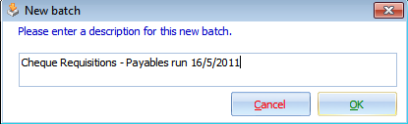
The cheque requisitions batch then appears and payments can be entered using the normal Make Payment, Make Supplier Payment and memorised transaction options. All payments entered will belong to this batch until such time that the user submits the batch and/or creates a new one. Note that each user owns their own batch and would not ordinarily post in to batches owned by other users (although this can be done if required).
In this example, the user has used the Make Supplier Payment functionality to create a payment entry for an outstanding accounts payable invoice.
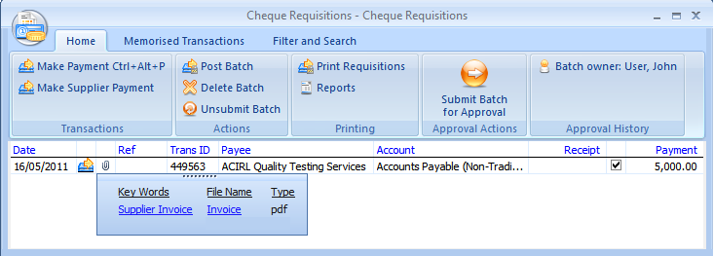

Payments show accounts receivable invoices
The software displays documents linked to the accounts payable source entry. In this way you can view the payment entry and display the original invoice entered in relation to the payment.

Creating batches
Batches can be created and submitted from functional areas of the system. You may create a batch from
- Employee Pay Wages
- Creditor Distributions
- Make Payment
- Make Supplier Payment.

Batch authorisation
Once a batch is submitted, it is presented to any users who have permissions to authorise the next stage in the batch. In this example, the batch enters the ‘Coding and Funds check’ stage:
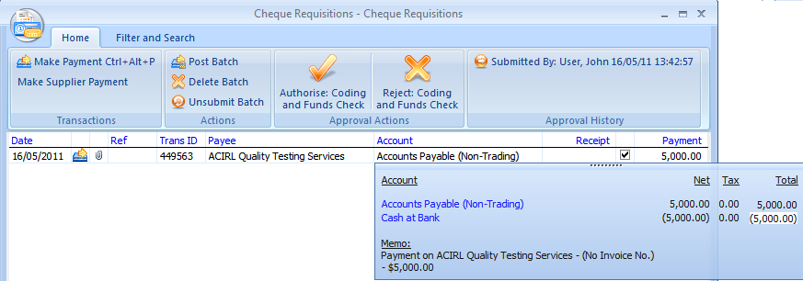
The approving user can then authorise or reject the stage.

Viewing the transaction coding
The user may view the coding of the transaction without having to open the transaction detail. Once the batch is approved, it moves to the next stage in the approval process.

Posting batches
Once the batch has received final approval, users with Batch - Post Job Security permissions can post the batch to the ledger.
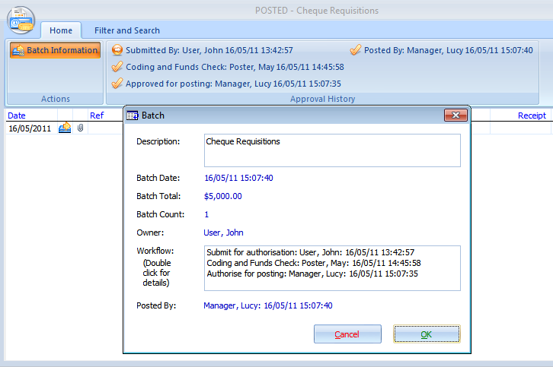
At any time you may view the Batch Information by opening the batch detail and clicking on the Batch Information button. Information is displayed relating to the approval steps, the user authorising the batch and the dates authorised. You may also perform actions such as printing cheques and producing relevant output such as dividend circulars.

Notification of batch approval
The software alerts users to the existence of payment batches requiring authorisation in several ways.

Home page view
The application home page provides a practice wide view of batches and batch authorisations.
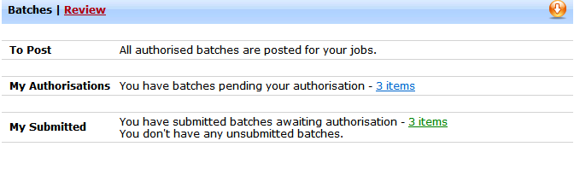
Depending on your permissions you will be presented with a list of relevant batches. Drill-down via the batches register and submit, authorise or post batches.

Email processing at each stage
At the time each stage of the batch is submitted, the user is prompted to generate a notification email to one of the users having authority to approve the next batch payment stage.
When you Submit or Authorise the batch the following dialog appears.
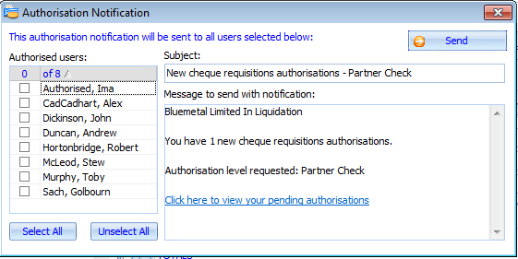
Users will appear in the Authorised User list if they have been given authorisation to approve documents. This may be configured in the security matrix Static Data Maintenance > Job Security Settings > Select a Role > Select Documents – Authorise.

Batches register
Batches can be viewed, submitted, approved and posted via the batches register. This allows users to perform actions across multiple batches. For example, it is not necessary to go into a batch to submit, approve or post it. The user can select multiple batches and submit, authorise or post all batches in one action.
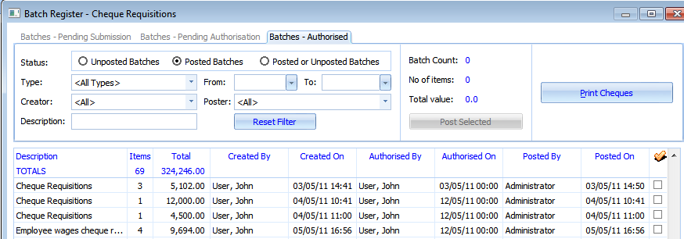

Listing by bank account
At all stages prior to posting, the batch register also provides a view of batches by bank account giving details of the effect of the unposted batches on the ledger balance of the bank accounts.
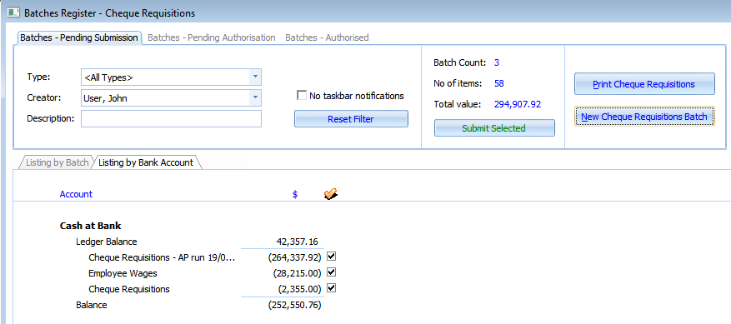

Practical example of payment authorisation: Example 2

Configure custom approval stages
In this example there are two potential payment approval paths.

Configure custom approval stages by adding descriptions to each payment approval stage. In the example below, two custom stages have been configured for the approval process, in addition to the final mandatory stage.

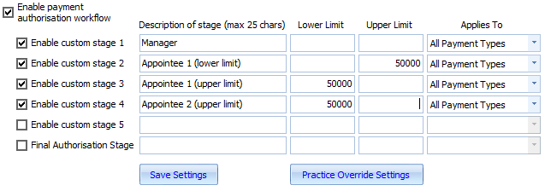

Assign Job Security Roles to custom approval stages

Assign Users to Job Security Settings
A user may be assigned to a standalone role for a job or the user may be added to a work team role.

