# How Documents are used within Insolvency

Contents

How Documents are used within Insolvency 1

Examples of document relationships 2

Task Production (Linked to Forms via Actions) 2

Task Production (Linked to Documents via Actions) 2

Lodgements 2

Form 524 (Electronic Output) 3

Merging to Email 3

Attaching files to emails 4

Creating an email in Document Management 4

Sending the email 4

Document authorisation workflow (Emails) 5

Send to Selected Recipients 5

Creditor documents 7

Creditor documents (web submission, under development) 7

Creditor Register (under development) 7

Creditor Circulars (under development) 7

Recipient List 7

Mailout Address Listing 8

Meeting Documents 8

Shareholder Documents 8

Attaching documents to transactions 8

Approving transaction in a batch 9

Payment Approvals on the Web (under development) 9

Payment Documents 9

Bank Reconciliations 10

Application document search 10

Batch Header Documents 11

Document authorisation functionality 11

Document authorisation tasks 11

Document authorisation properties 11

Email Merge 12

Help Resources 12

Considerations for using an external document management system 13

Removing documents from the file system 13

Saving documents outside the job folder 13

# Examples of document relationships

Below are examples of the types of features referred to as document integration within Insolvency.

### Task Production (Linked to Forms via Actions)

A document is created when you perform an Action to produce a document form a task. In the example below there is an action to create a Form.

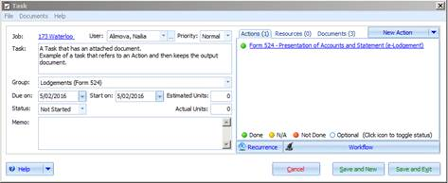

When you click on this action the software creates documents.

The output documents are available from within the task and show the results of the user completing the task by creating the document.

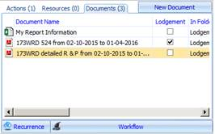

### Task Production (Linked to Documents via Actions)

The same process occurs when you produce document from tasks. You can see whether the tasks complete and whether the document has been produced.

## Lodgements

The Insolvency software creates the following documents as lodgement outputs:

* Business Activity Statements
* Form 524 (Document Output)
* Report as to Affairs
* SuperStream Outputs
* Annual Estate Return Outputs
* Employee Payment Summaries
* Annual Employee Payment Summaries file output

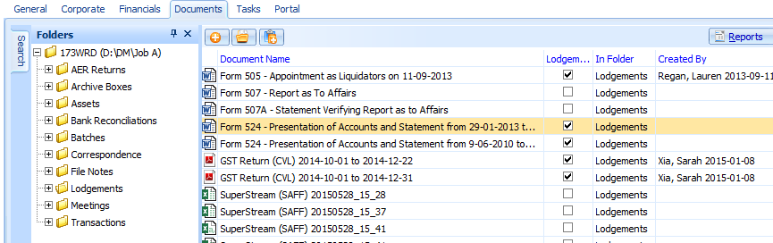

## Form 524 (Electronic Output)

Document outputs are created in PDF format that provide supporting information for the electronic Form 524 lodgement. The lodgement document record in the database stores the XML file and there is a process to create this file when required for lodging.

This way the XML file is always kept synchronised with the PDF document output (that cannot be editing using a PDF reader.

## Merging to Email

Document Production has the option to merge to email.

The email output can be personalised by containing merge codes that populate appropriate values for each recipient. Use merge codes and replace fields in the body of an email and specify a recipient list with email addresses to receive the merge.

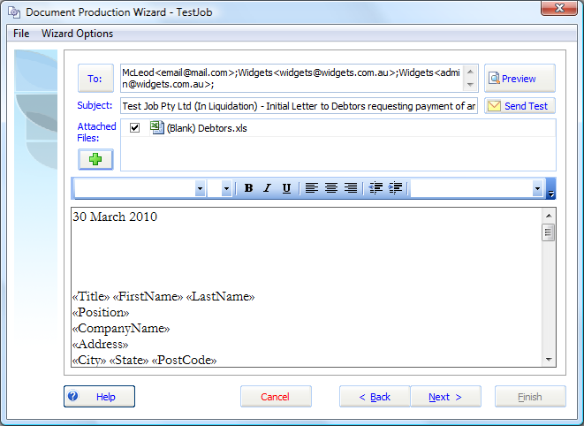

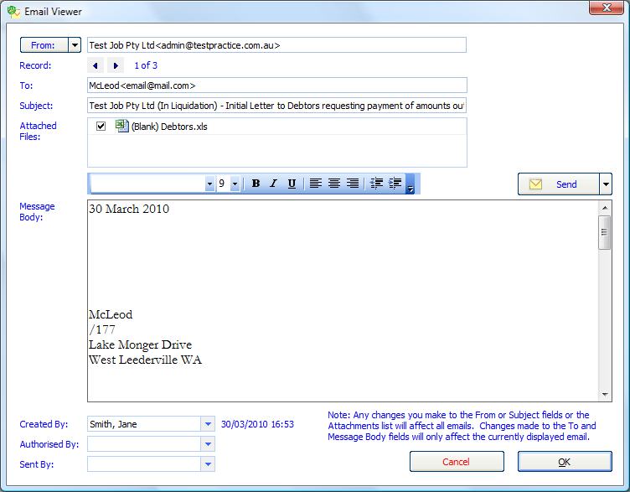

### Attaching files to emails

Any documents can be attached to the email including MS Word documents, PDF documents and MS Excel documents. These files can be sent as part of the approval process or as part of an email merge. This allows you to prepare documents separately and include it as part of the email merge.

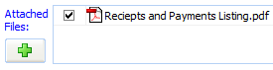

When the email is sent the attachments are sent with the email.

### Creating an email in Document Management

When you finish Document Production you have the option of saving the email in document management. If the email is pending authorisation and hasn’t been sent, you can view it using the Email Viewer.

You can open it to edit the text before sending, and to review the recipients. The document authorisation task can have a link to the email task.

### Sending the email

When you are ready to send the email, the merge output is generated and any attachments sent with the email.

Each individual receives their own individual email message. The system avoids the use of the BCC (blind copy) for addressees and thereby avoids the risk of users reading emails or replies to other recipients.

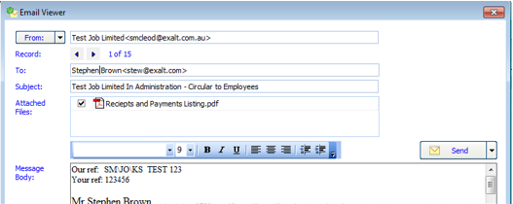

## Document authorisation workflow (Emails)

Users may be granted rights to send emails.

If a user has not been granted rights the user can still create an email to be sent, but the email is placed into document management and an email task pending authorisation is created.

The email task is linked to the email saved in document management.Once an email is authorised it can be sent.

### Send to Selected Recipients

To send to selected recipients click the **Send** button and select Select Recipients.

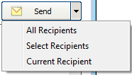

Tick the listed recipients and click **OK**.

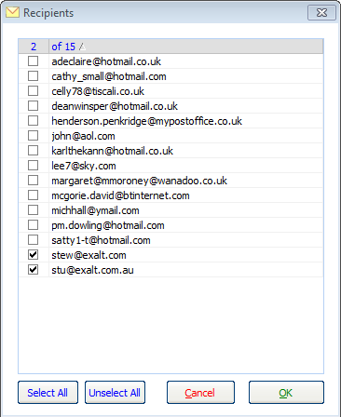

You will be warned if the email has already been sent to one of the recipients.

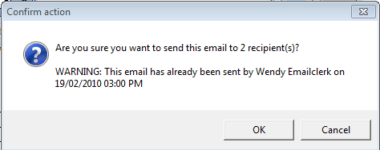

Once you have sent the email the document management record is updated with your user name.

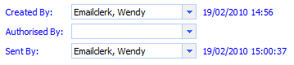

## Creditor documents

You can attached documents to a creditor. Documents may involve information relating to the adjudication of a claim, the proof of debt form or supporting information submitted by the creditor

## Creditor documents (web submission, under development)

When creditors submit claim from the creditors’ portal a copy of the electronically generated Proof of Debt and well as any documents uploaded by the creditor are attached as documents to the creditors records

You may view the read history of a document.

## Creditor Register (under development)

You may now access documents from the main creditor register, rather than drilling down to the creditor details form.

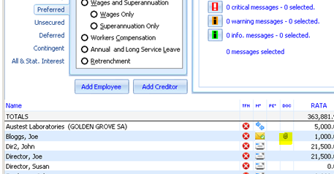

## Creditor Circulars (under development)

From within the Creditor record you can view whether the creditor has participated in a mail out. email, web or standard mail. The documents are available from the creditor record so you can see what circulars a creditor has received.

You can see whether the creditor has received a dividend notification, you can view that notification and resend it.

## Recipient List

A list of recipients is stored with each output document. When you create a merge document output, the list of recipients is stored in the document properties.

Open the document management record in document management and print a list of the recipients and the addresses at the time the document was produced.

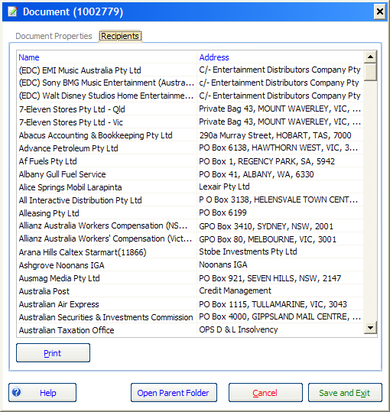

### Mailout Address Listing

After you have generated the email record ready for sending, the system creates a PDF report containing all the intended recipients. This report is placed into document management.

## Meeting Documents

You may attach documents to meetings, such as the attendance register.

## Shareholder Documents

## Attaching documents to transactions

You may attach documents to transactions. The documents represent supporting information for payments. The document attachments are displayed as a paper clip in the account register.

When you add file attachments to a purchase order, that document is also displayed in the resultant invoice as well as the resultant payment.

## Approving transaction in a batch

When you attach a document to a transaction and this transaction is submitted as a batch for approval, the attachment is visible when approving the batch.

Email approval notifications allow you to hyperlink straight to the approval and view documents associated with the approval.

## Payment Approvals on the Web (under development)

When you enable web authorisations any batch approvals are post onto the web and accompanying documents are posted to a secure web store.

You may use the web portal-to approve payments via the internet or a mobile device without the need to log onto the software. Approvers may view pdfs of invoices and approve payments from their mobile phone remotely.

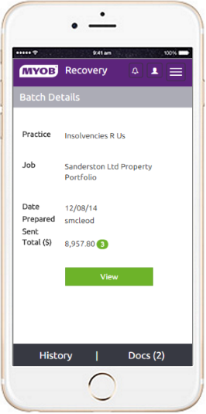

### Payment Documents

If a payment or batch header has any document attachments, these documents are securely posted to the approval websites and may be viewed from the web approval.

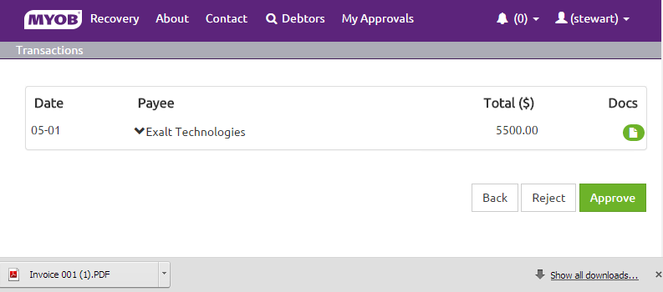

## Bank Reconciliations

You may attach the bank statement to a reconciliation, you can create a PDF output of the reconciliation performed in the software to evidence the reconciliation that was done at that time.

## Application document search

Centralised document searching has been introduced to help you search for documents across all jobs. The document search is available from the main menu.

For example, enter “**439A”** in the search to bring up a list of all Form 439A reports within the system.

1. You will need job permissions to view the documents.

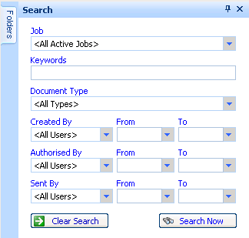

You can search documents using the following criteria:

* A string within document name
* Document type (e.g. ‘BAS’ or ‘524‘ etc.)
* Keywords (e.g. ‘Meeting’)
* Date range.

A list of documents matching the search criteria will display.

You can open the document from the list of returned document records, provided you have permission to access those documents.

## Batch Header Documents

You may attach documents to a batch that relates to a series of transactions (i.e. the transactions entered into the batch). An example may be a listing

## Document authorisation functionality

When you produce documents in the system you have the option of emailing the document for authorisation.

The email, sent to the authorising user, contains hyperlinks to the output documents and a link to open the application and display the document authorisation tasks.

### Document authorisation tasks

When you email document output for authorisation, a document authorisation task is created. These tasks are listed under the <Document Despatch> task group.

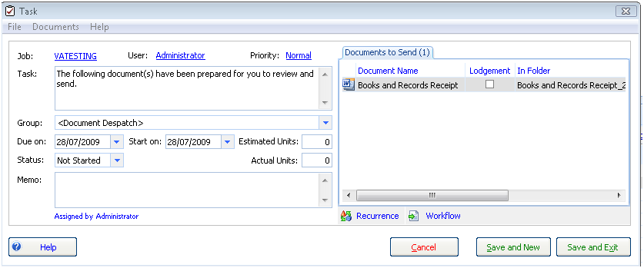

The documents associated with these tasks appear in the ‘Documents to Send’ tab on the despatch task.

### Document authorisation properties

Documents can have the status ‘prepared by’, ‘authorised by’ or ‘sent by’.

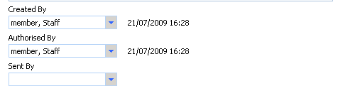

## Email Merge

You may allocate whether creditors have agreed for notices to be sent to them via email. In the creditor or counterparty record, set the preferred method of correspondence as email in the Numbers grid.

See the green tick below:

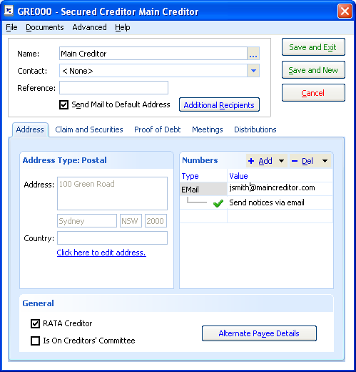

## Help Resources

Users may add Help resources that may be linked to documents in the file-system.

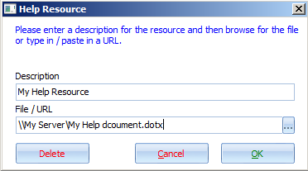

# Considerations for using an external document management system

There are over 50 features within the Insolvency software that link to documents stored outside the software.

If you have an automated approach to adding documents to DM and you want to retain some of the linking features then an integrated approach to document management integration is recommended.

If you want to retain any of these features you are advised to consider an integrated approach and avoid an implementation that stores document in that exist in two places, either in the file-system or in a document management system.

The software is moving forward with online creditor claim submission, web creditor documents, web document approvals, and web payment approvals. All of these features involve document attachments. An integrated approach will retain these features. A disconnected approach will not.

## Removing documents from the file system

If you remove documents form the file system and place them under document management. Does this effect the operation of the system?

There is little impact on the operation of the software if documents are removed from the file-system locations, particularly if you remove on the output documents created form Document Templates.

The only impact is that if documents are relocated, and, not accessible from within the software, certain features cannot be used and the software becomes less able to enhance workflow efficiencies.

## Saving documents outside the job folder

You can save documents to a folder outside the job folder. This application setting can be activated for clients that use an external Document Management system. If you want to be able to save the document folder outside the job folder, contact MYOB Support for the specific update.