MYOB Insolvency

Varying a debtor contribution

A contribution is displayed below:

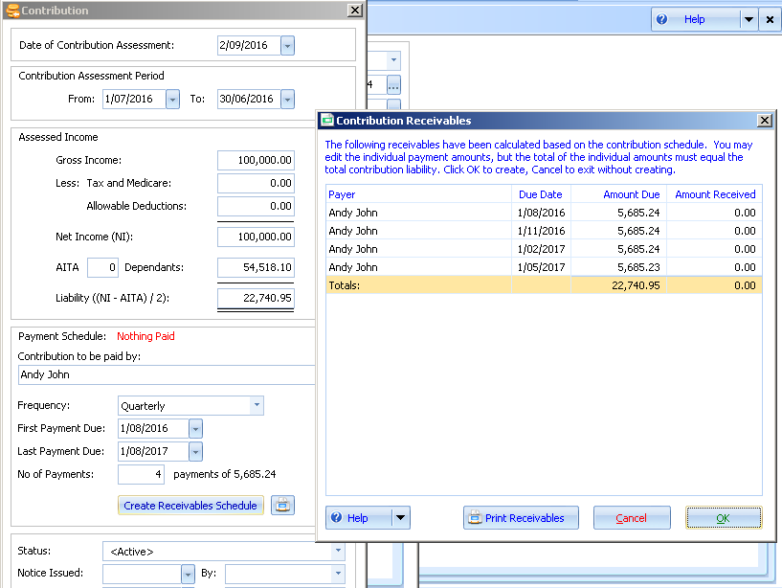

After contributions have been received, the debtor reports his/her income has changed.

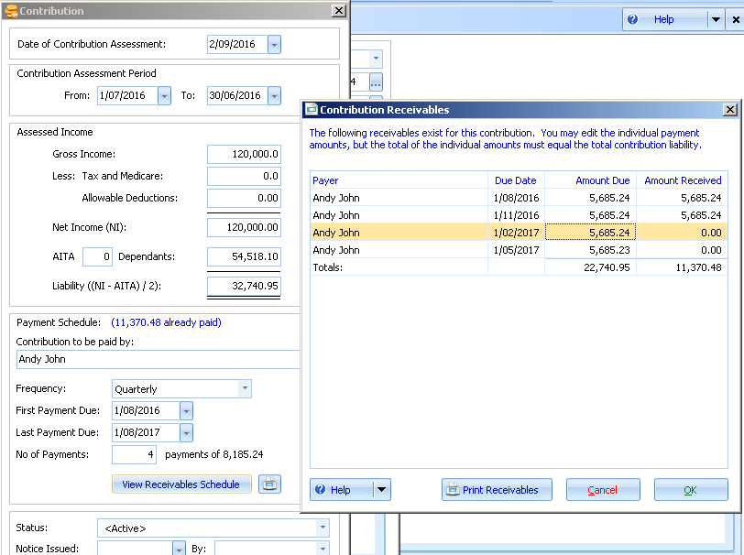

Vary the contribution by changing the Gross Amount and the Liability total changes.

However, when you try to save this contribution a warning will appear:

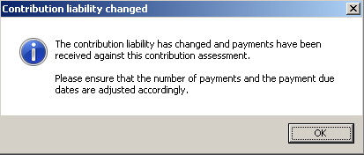

To save the contribution, view the receivables schedule and update the Amount Due column for the unpaid accounts receivable.

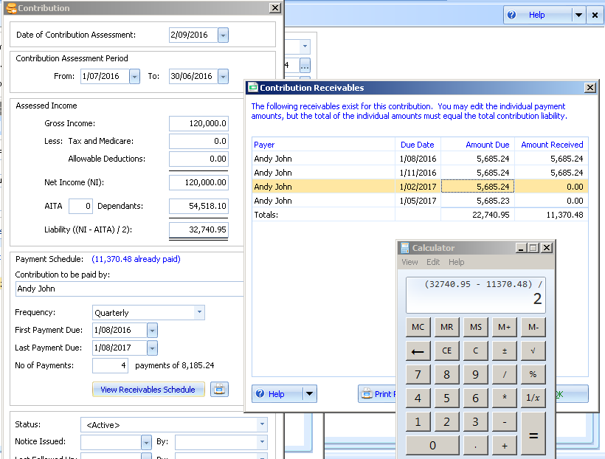

You will have to calculate the amount due for each remaining period:

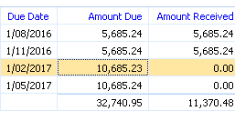

Enter the remaining amounts and Click OK.

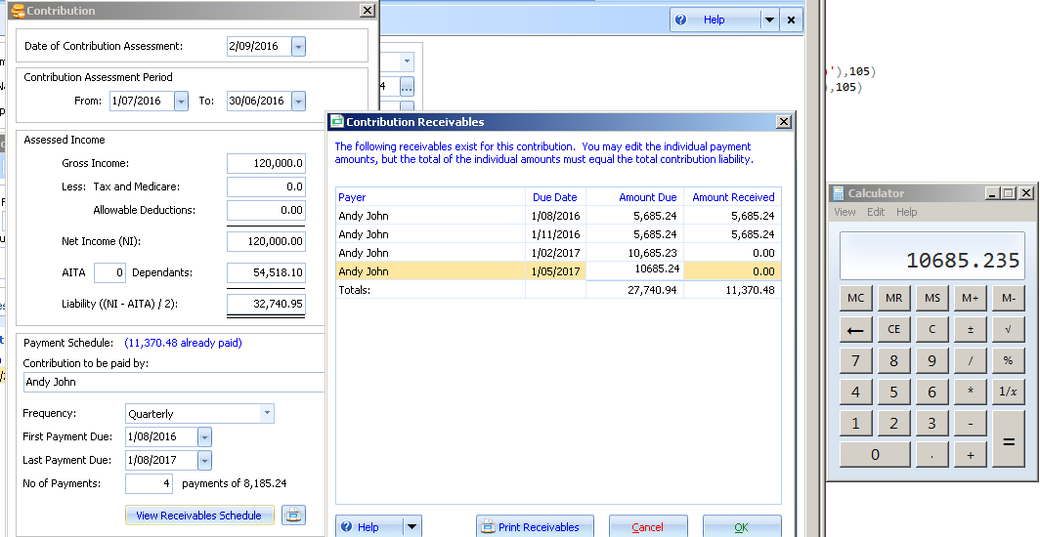

When you save the new contribution schedule the accounts payable invoices will be updated with the new amounts.

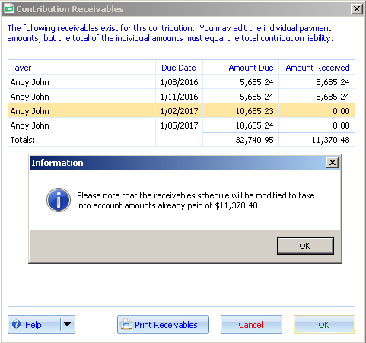

The contribution details have been updated

