CREATE AN EMAIL TEMPLATE

You can create an email template with standard wording that is editable however you cannot use RF or merge codes as they will not populate.

You would be using this method in the event you are not using electronic signatures and thus need to scan the signed document before sending. You are also not using the Creditors portal.

Using this method you:

* Cannot insert a scanned signature into the body of the email
* Cannot use RF codes or merge fields in the body of the email
* Can attach documents to be sent via email
* Can create labels for hard copy recipients at the same time as creating the email
* Can edit the category, Message Subject, and body of the email.
* The job name is auto populated in the Message subject box along with the template name, which you may want to remove or edit.

# To create a custom Email Template

1. Open outlook
2. Click on New Email
3. In the open email Click on File-> Save as
4. Name the File and save it somewhere on your computer. This file name will be produced in the subject line of the email during the creation of the message. You can either remove it once the email wizard has completed or you may want to name the template something like Creditors Report so the Message subject line reads for example. Test Job CL (In Liquidation) – Creditors Report

NB If you are creating the email template your email signature will be on the bottom. You can remove that now and enter whatever sign off you will want to use for these emails. The sign off can be edited during the wizard also

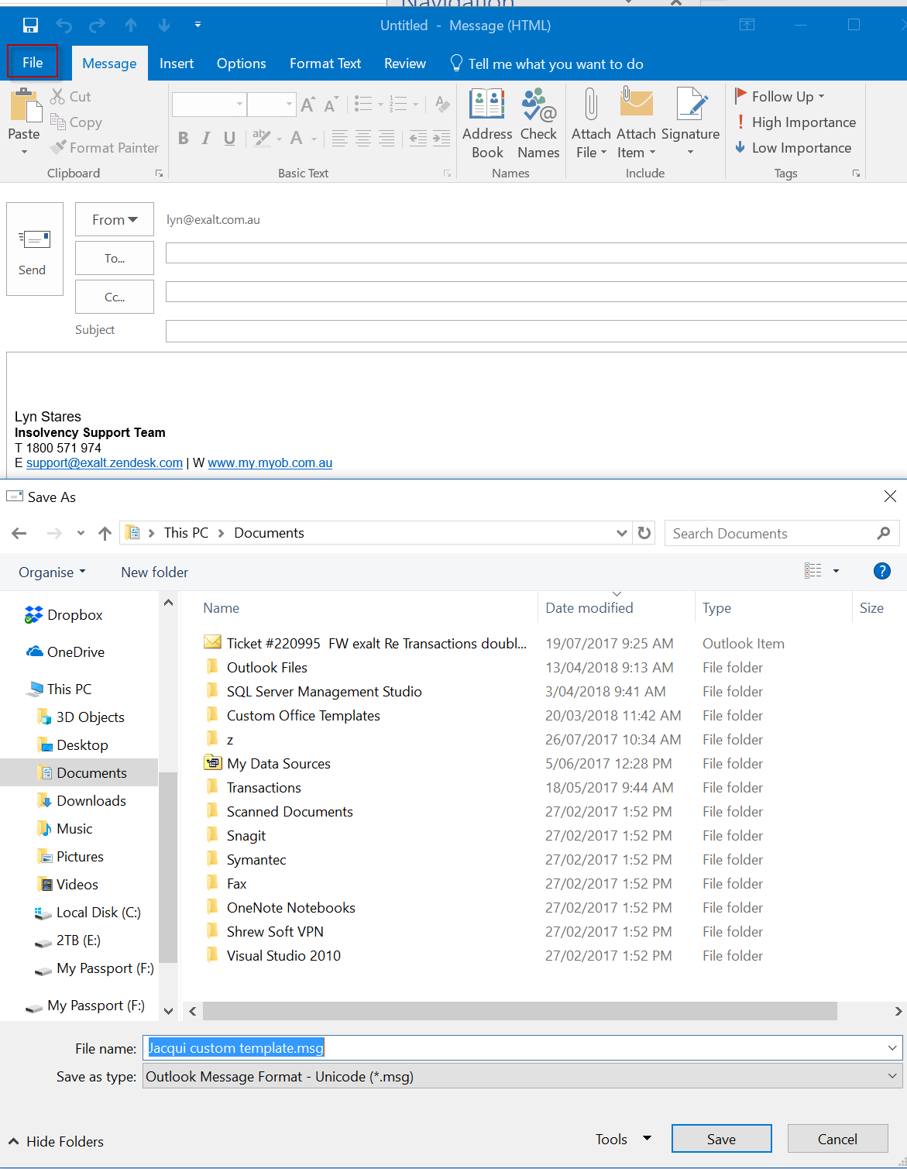

1. Open Insolvency and select Manage Document Templates from the Main Menu
2. Click into the category you want to save the template in.
3. Click New File. Navigate to the folder you saved the email in
4. Click on the email template and click open

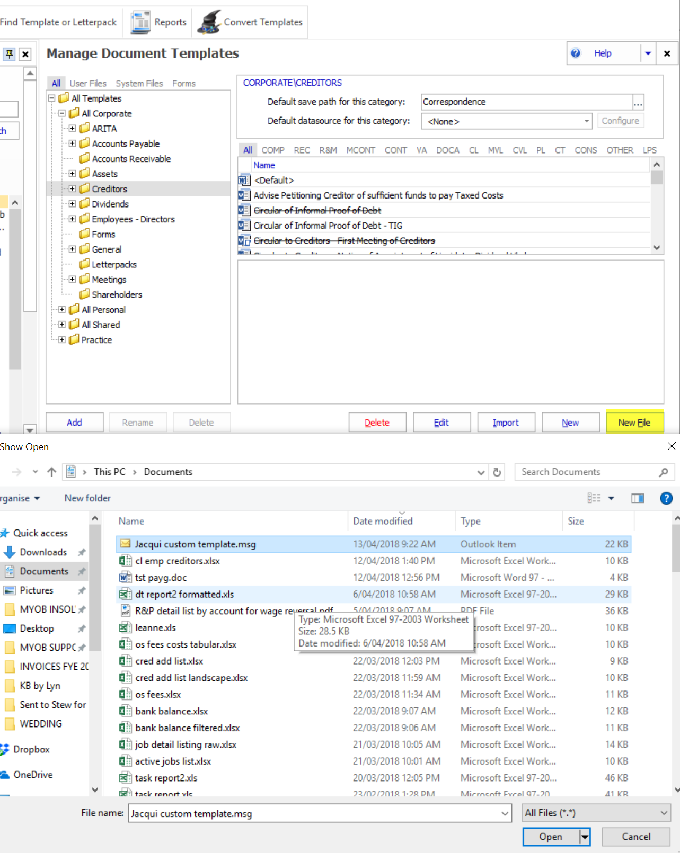

1. At the Invalid Action pop up click OK

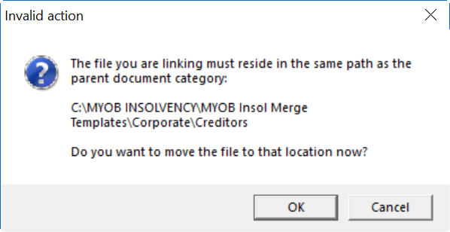

1. You may want to set the Details and Display options. There are no data sources or user input/prompts.
2. You can edit the template by right hand clicking on the template and selecting edit. The template will open.

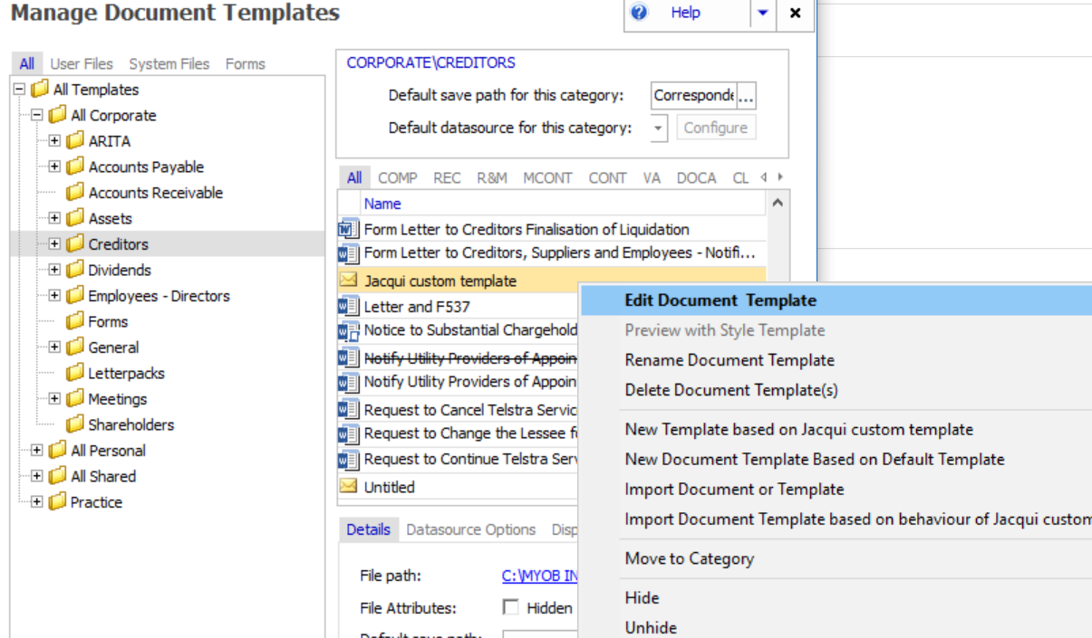

1. Edit the body of the email. NB the subject line will auto fill with the job name and template name so leave it blank. When finished click File->Save

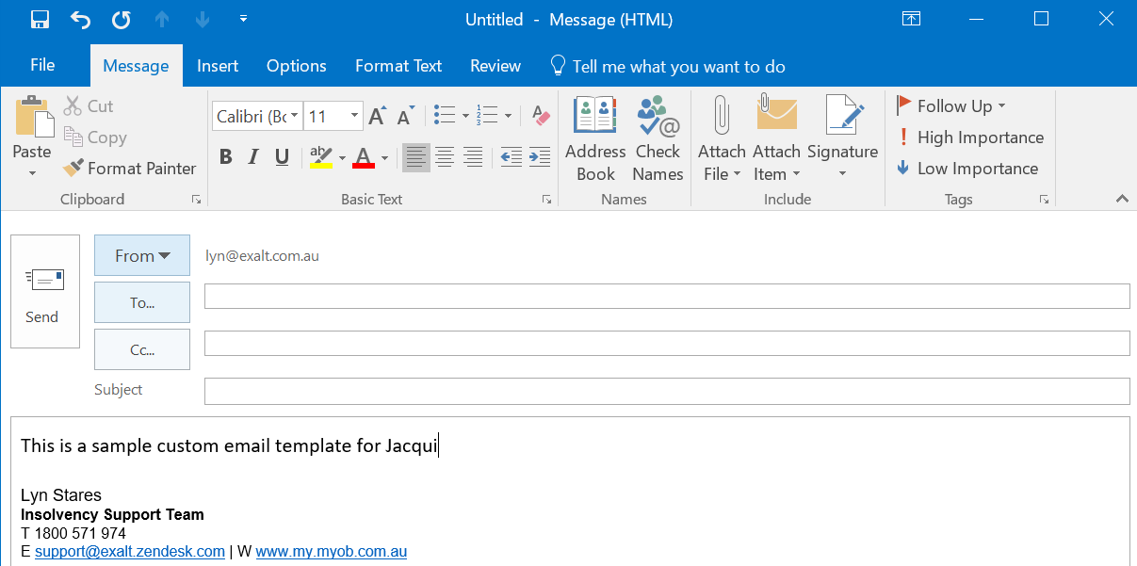

# Use a Custom Template

1. From the job click Circulars and Mailing -> Electronic Message wizard -> Message from Template

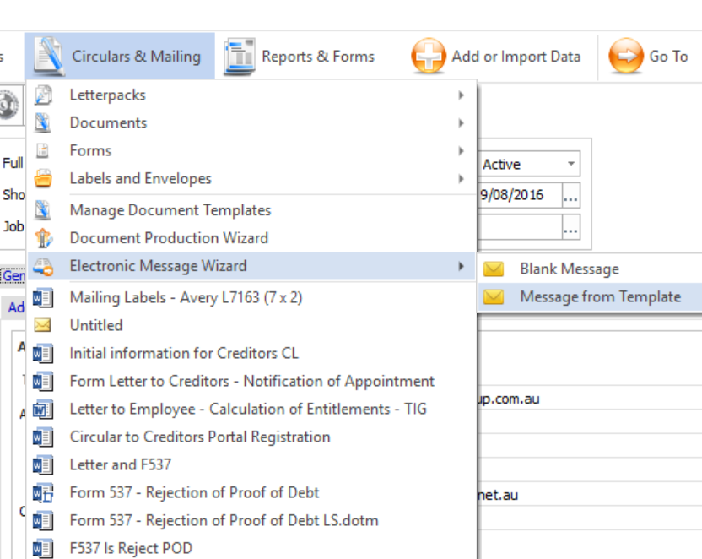

1. Using the Search tab click on the drop down as highlighted and select **Email Template**.
2. You will be given a list of templates you have created. Double click on the template you wish to use so it appears in the selected templates area below. Click next

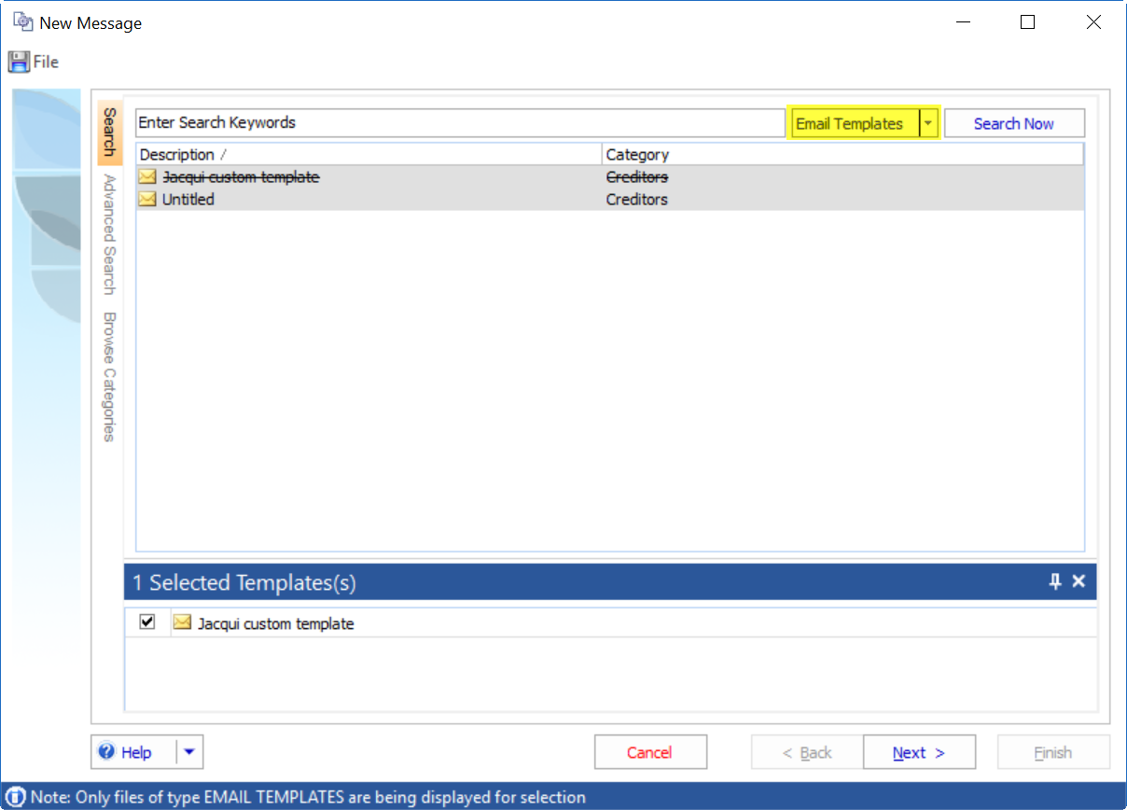

1. At this stage you can also prepare labels for any recipients that will be receiving a hard copy. You will need to make you selections in this order if you want to prepare labels too.
2. Click on Combined Circular to recipients -> All recipients agreed to electronic message
3. Tick labels and envelopes
4. Click on the drop down next to create labels and select the label format

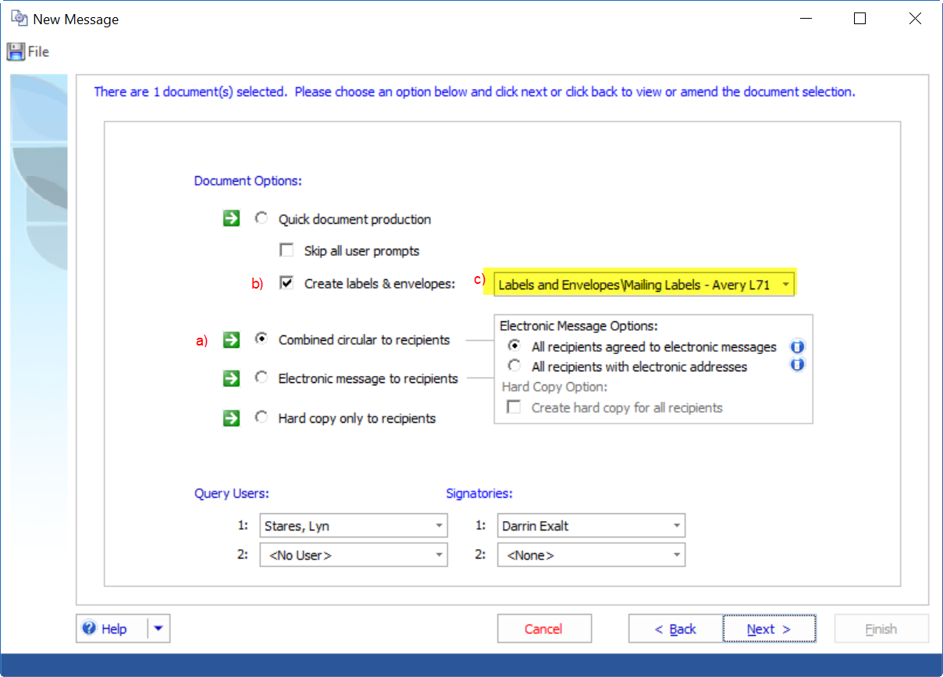

Click Next

1. Select the recipients. NB you do not need to select the hard copy recipient separately. The system will decide this based on the criteria you selected in step 4. Click next.

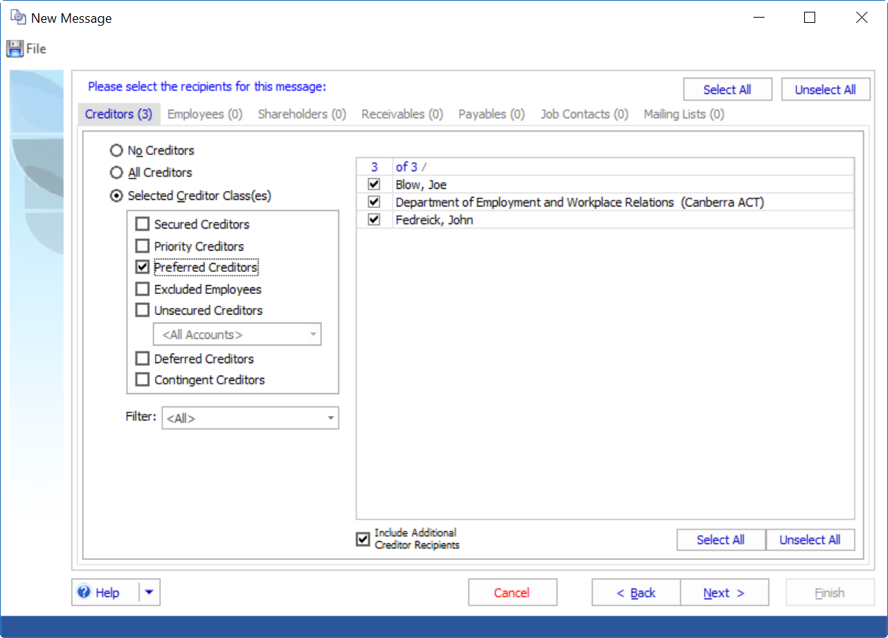

1. The next screen will display a list of recipients. The yellow envelope with a green tick denotes an email recipient. The white envelope denotes hard copy recipients. In my example below you can see Joe Blow is receiving by email and the remaining creditors by post. The report also details the number of label recipients and email recipients. Click next

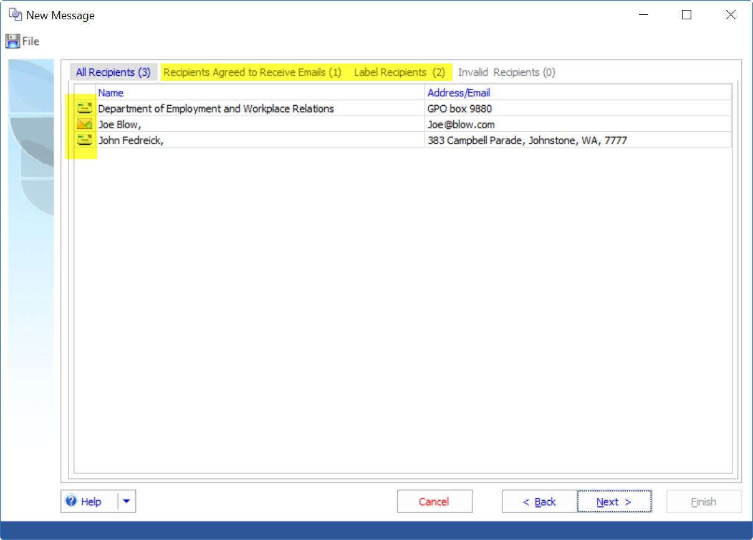

1. This page will be blank as there are no RF codes in the email template. Click next.
2. Your email is now produced. As you can see the Message Subject line auto completes the job name and suffix and the name of the template. You can edit this now if you wish.

You can also edit the Doc Man Category (where the email will be saved) if necessary

You can edit the content of the email if you wish. Editing will cause a Confirm Action pop up to appear. Confirm you wish to make the changes by clicking OK

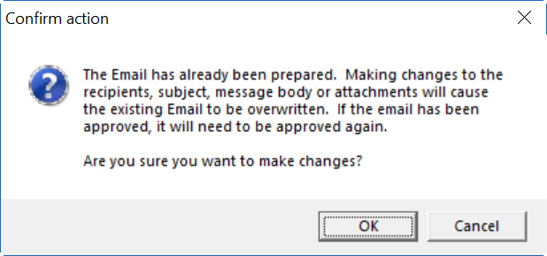

1. Click on Attach File to attach the scanned documents you want to send
2. You can click on the Email Recipients tab to see who is receiving an email

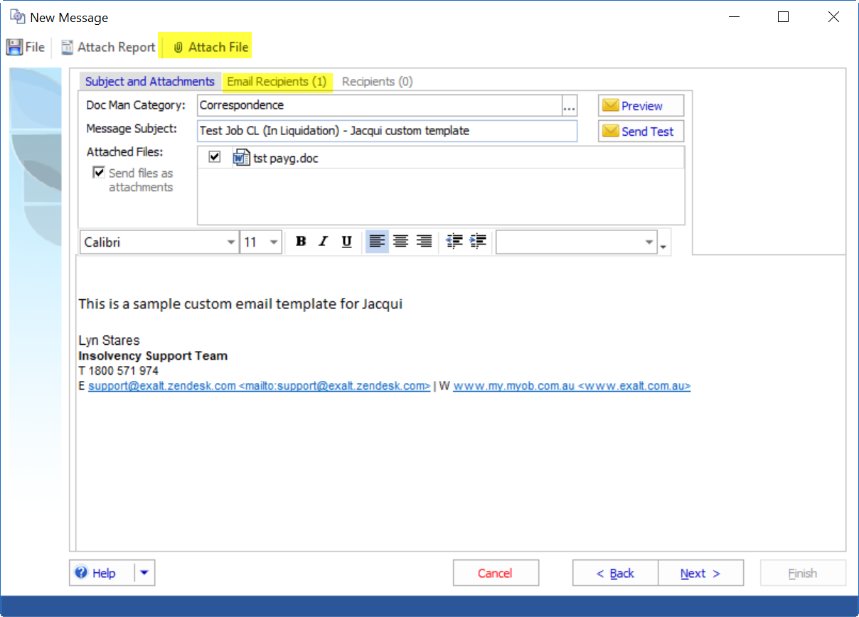

Click preview to view the email

1. Click next
2. If you are producing labels at the same time the label template will list in this screen. You can preview the labels by selecting preview. Click next
3. If electronic authorisation is switched on you can select request authorisation.
4. Tick Create recipient report, this will give you a list of email recipients and postal recipients. Tick preview if required. Click finish
5. If you are previewing you will switch to the Document Management folder.

# Send the Message

1. You can right hand click on the message in Document Management and select Send which will take you to the Message tab.

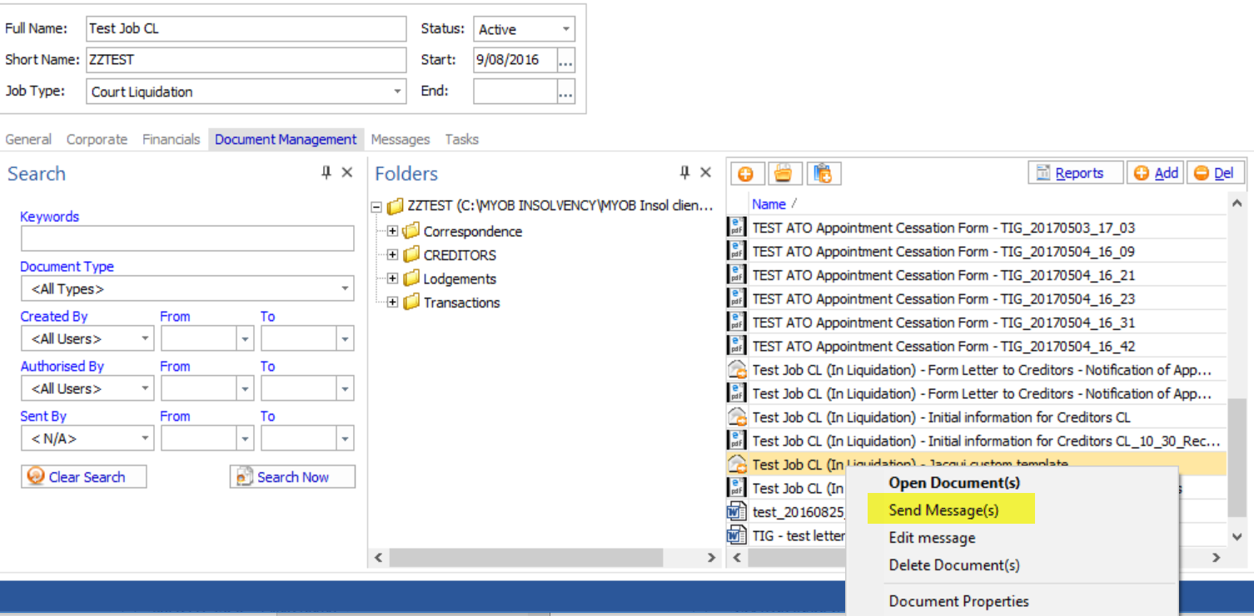

1. Or you can click on Messages tab from the main dashboard. Filter the status to Not Sent if need be.
2. Tick the message to be sent and click on Send 1 message

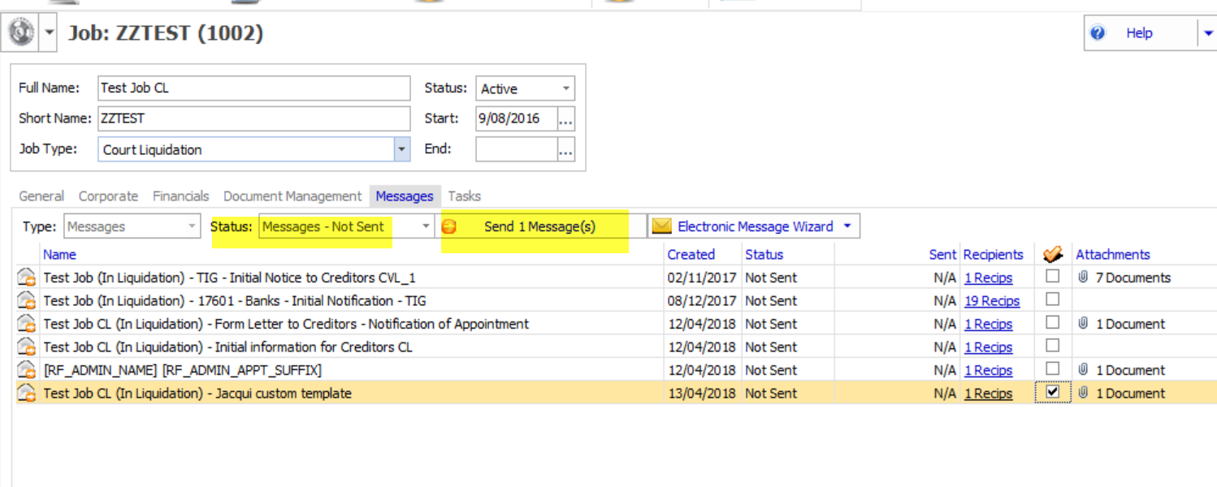

1. Confirm the Actions and click send

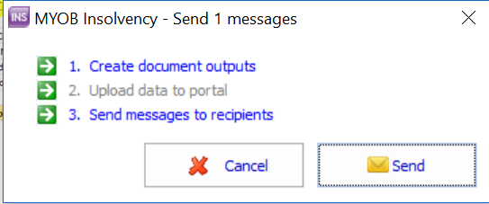

Your message will now appear in the Status – Messages sent