Creating an Email Template based on a Document Template
Instead of creating an email template you can create a word Template and select the word template when creating the email.
Using this method
- You can use RF codes and Merge Fields
- You cannot create mailing labels at the same time as creating an email. Therefor you will need to ensure recipients requiring a hard copy are marked as such in their creditor page.
- Style templates and scanned signatures will not populate on the end email and may cause an error
- Can attach documents to be sent via email
- Can edit the category, Message subject, and body of the email.
- The job name is auto populated in the Message subject box along with the template name, which you may want to remove or edit.

Create the word template
- Create a word template. Complete the details, data source etc. eg of content.
* If you use This Datasource and select <User defined> the email we produce the document in the body of the letter and also include it as an attachment to the email. You will need to untick the attachment.
If you select a datasource, Eg creditors, the email will be produced with the document in the body of the letter but with no attachment which I assume is the preferred.
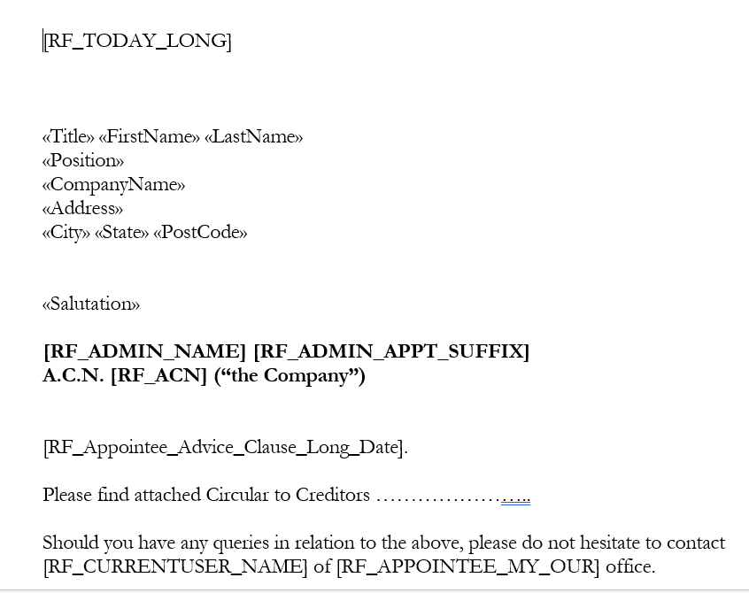

Prepare email
- From Circulars and Mailing select Electronic Message Wizard -> Email Template
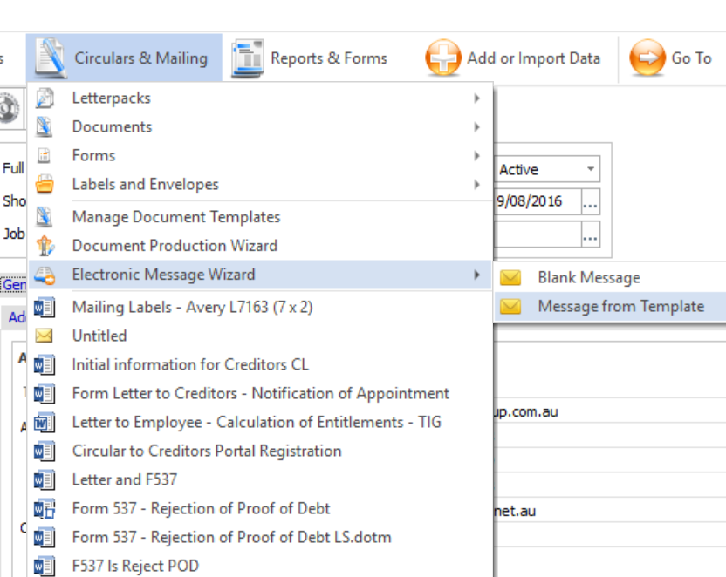
- Using the Search tab click on the drop down as highlighted and select Word Template.
- Search for your email document by entering a keyword. Double click on the document and it will appear in the Selected templates box. Click Next
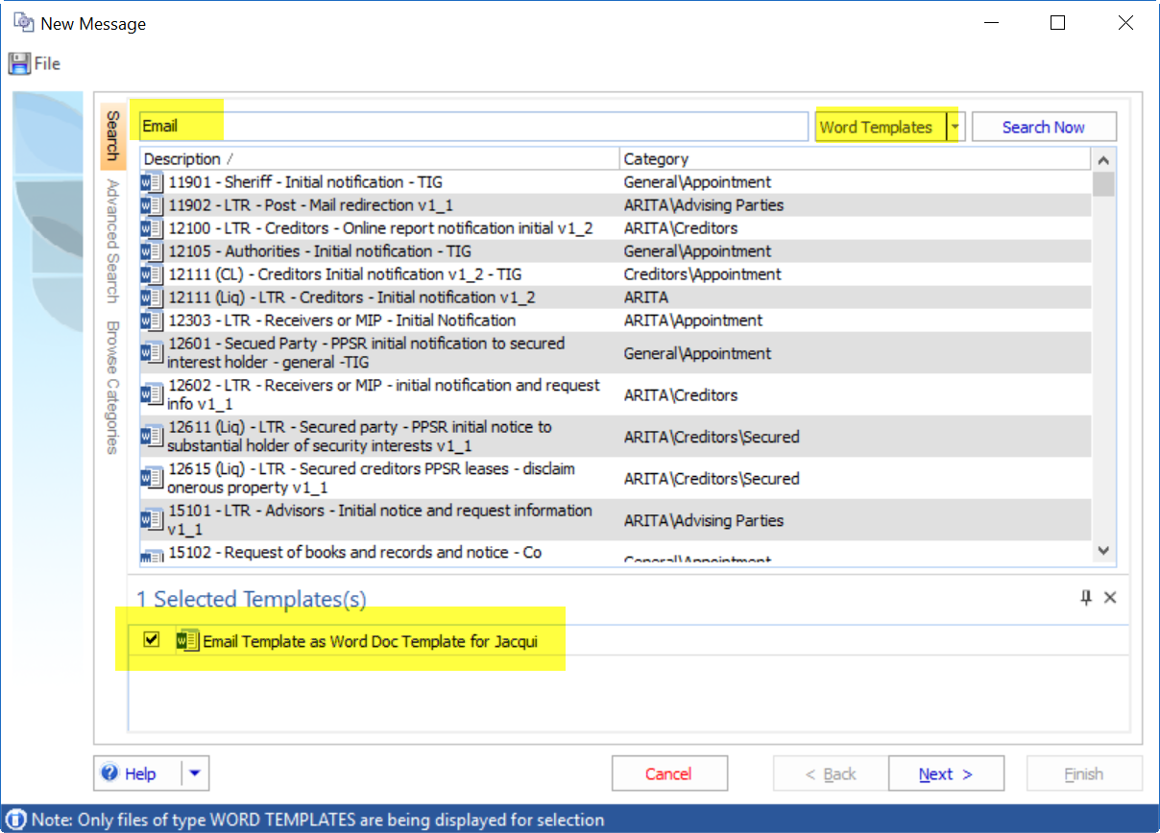
- Choose your options. NB. As you cannot run labels using this option select Electronic message to recipients -> choose option.
- Recipients listed here are based on the data source you selected in the word template and the options you selected on the previous screen. Click next
- Recipients name and email address list. Click next
- RF codes used in the document and how they will produce. Edit if necessary. Click next
- Your message has populated. Review the Doc Man Category, Message subject etc
- You will note your RF codes have populated but your merge fields have not. Preview the email and you will see the merge fields populate for each email.
- Attach the document(s) to be included in the email. Click next
- Tick create a recipient’s report… Click Finish
- Click on the message tab

Send the Message
- You can right hand click on the message in Document Management and select Send which will take you to the Message tab.
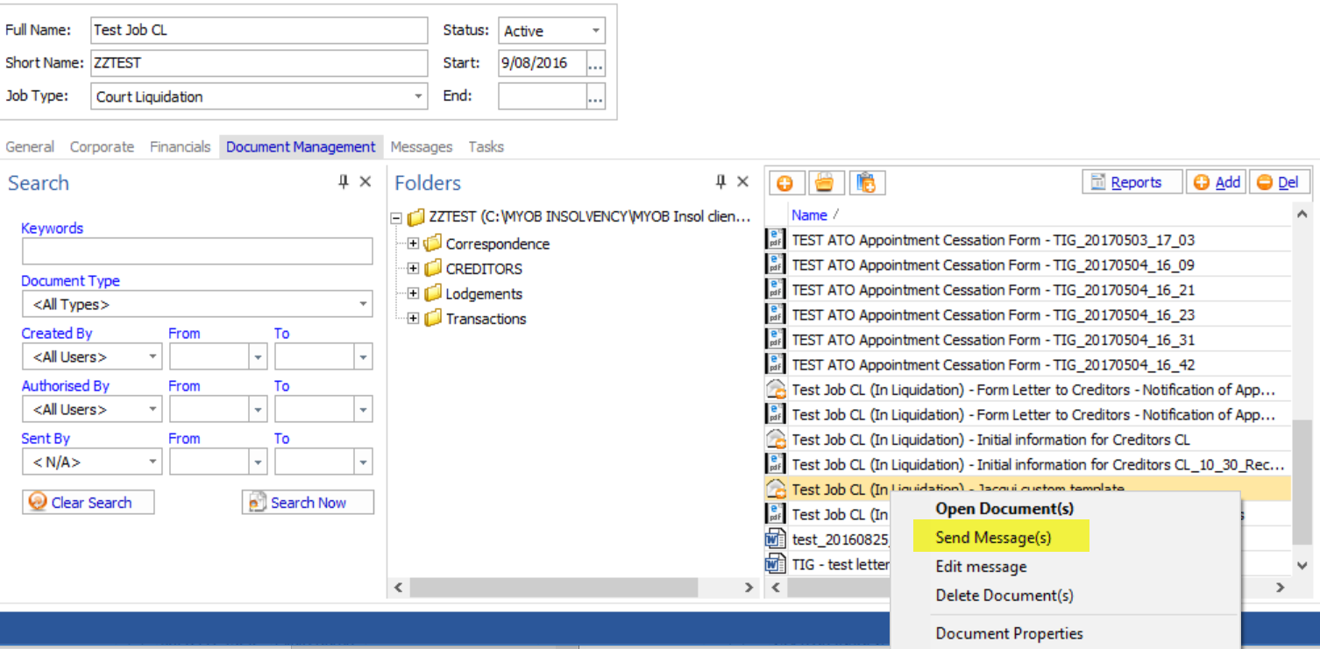
- Or you can click on Messages tab from the main dashboard. Filter the status to Not Sent if need be.
- Tick the message to be sent and click on Send 1 message
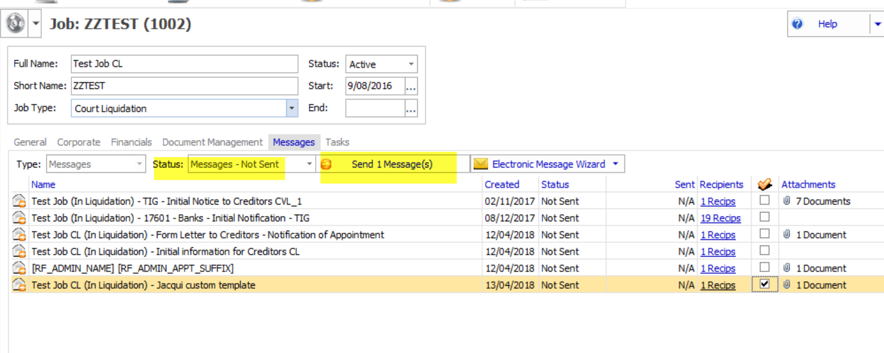
- Confirm the Actions and click send
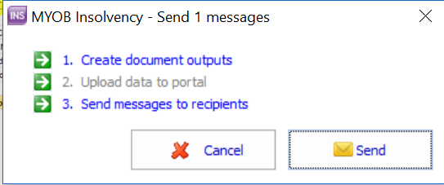
Your message will now appear in the Status – Messages sent

