Recording Realisation of Assets directly to Cash at Bank.

Firstly please note prior to using this method that the transaction will appear as one line in the Cash at Bank account with the Payee line being the Customer name entered in the Cash Sale as opposed to reading Group Receipt or Transfer when created via Group Deposits Payments.
This is not ideal if the payments were not made to the customer and made to several different payers. Eg Sydney Water, ABC Legal team, DEF auctioneers etc
The customer name will also appear in each receipt and payment line of the transaction on the Form 5602 and 5603. Again this may not be an accurate record of the transaction as the Payee and Payers are rarely one in the same. This is why we recommend using the Group Deposits Payment method.
Recording an Asset Realisation directly to the bank account.
Non Batch Entry
Users will need Add Receipts permission
Click on Financials > Accounts > Cash at Bank. Select New Cash Sale/Asst Realisation.
- Click on the Asset Realisation tab to select the asset to realise.
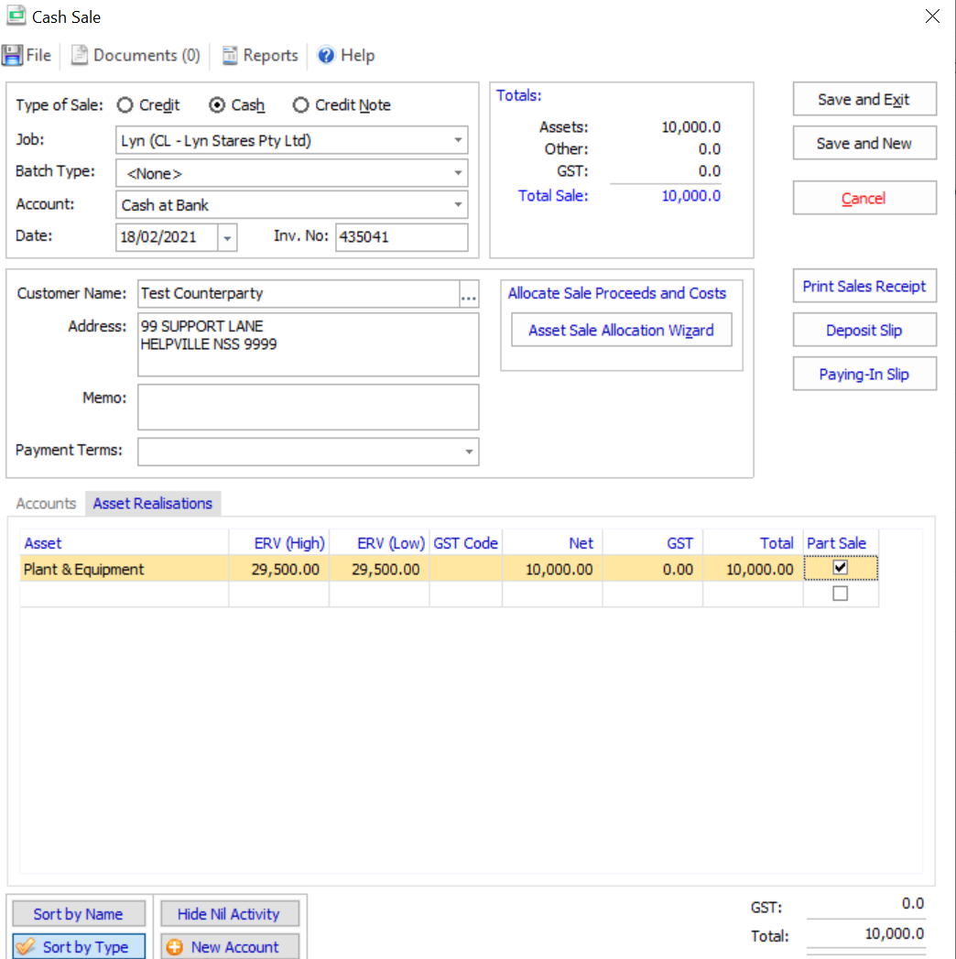
- Click on the Accounts tab to enter the payments relating to the sale. NB you need to enter – negative amounts for the payments.
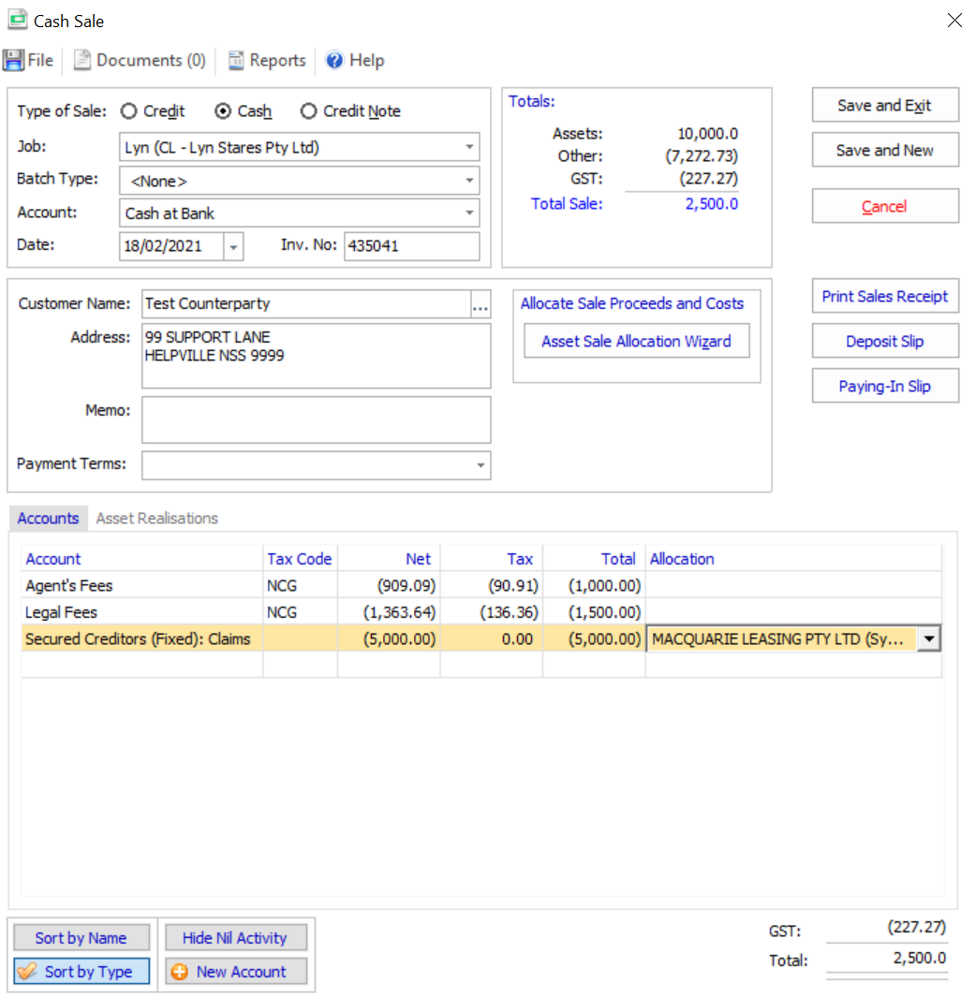
Deposit as it appears in Cash at bank.
If you do not have permission to post directly to the Cash at Bank account then you can Create a Pay in slip batch.
Batch Entry
Click on New Cash Sale/Asset Realisation and continue as above instructions.
Once you have completed the entry you can submit for approval.
The transaction will appear in the Cash at Bank account per above example.
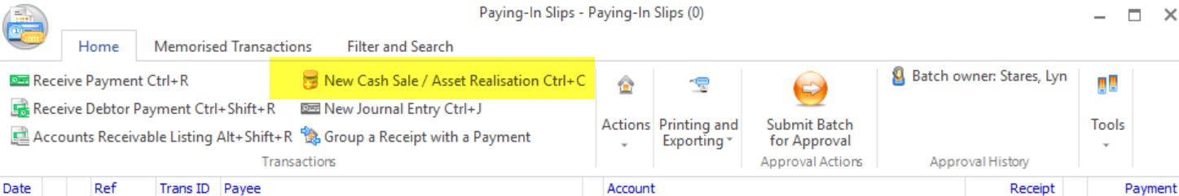
In the event the secured creditor is paid the balance of the sale proceeds and the receipt is nil you can either use the above method which will result in 0.00 receipt in the cashbook (that will need to be reconciled) OR you can process a journal as per below example, if you are not going to use the Group Deposits and Payments method.
Enter via Journal Entry
A journal could be entered as shown below, and flagged to be reported on the R&P reports.
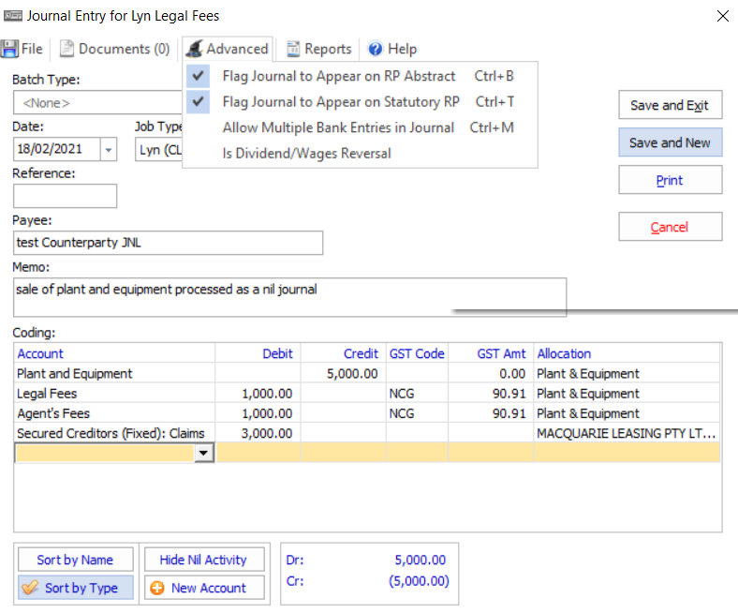​
This would be the resulting R&P
