Configuring System Task Alerts

Install the software
To configure System Tasks, first install the Insolvency Software on a server that can act as an application server. (I.e. a machine that remains turned on and users will not use this machine as a workstation).

Location of the System Task Application
The System Tasks application is located in the application directory.

The default location is C:\Program Files(x86)\Insol6\Insolvency\systasks.exe

Connection Dialogue
Ensure you right-hand click and Run as Administrator. When you run the System Tasks Application, you will be prompted to connect to the database:
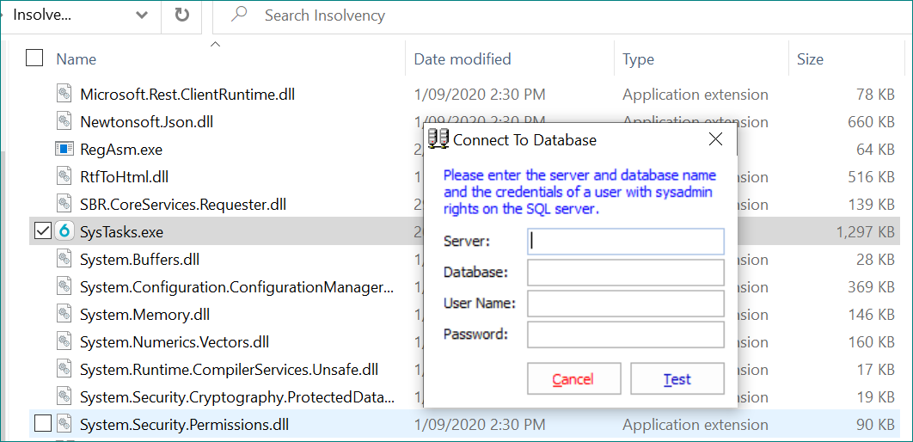

To connect to the System Tasks Application, you must enter credentials (username and password) of an SQL system database administrator.
The user name and password is found in SSMS.
Its default System Administrator – called ‘sa’ – can be used this if you know the PW. Though you are better off creating a new login specific for this exercise so they know the user name and PW.
To create a new SSMS login:
Open SQL Server Management Studio.
Under Security -> Logins -> RH new login -> Name it “InsolSysTasks” -> SQL Server authentication.
Create password:
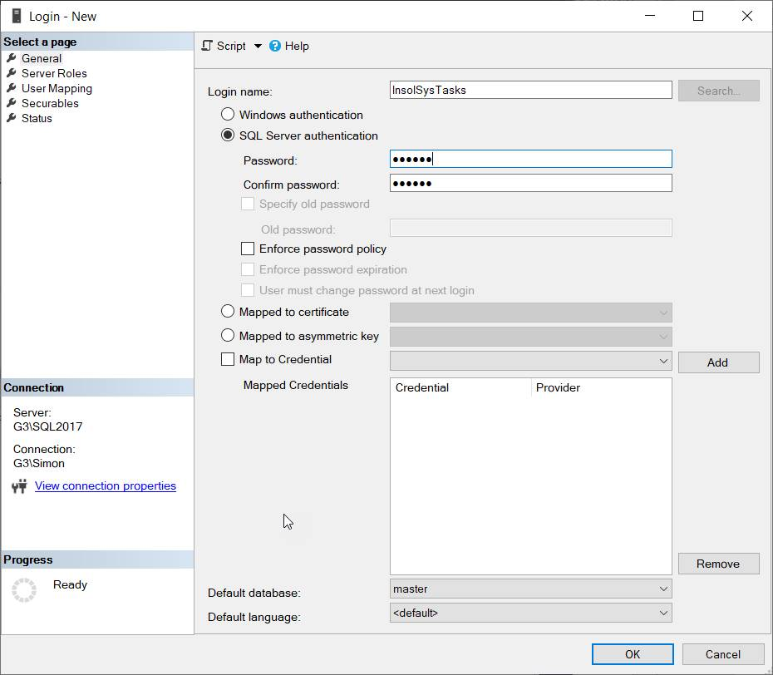
Select the appropriate authentication for your SMPT sever:
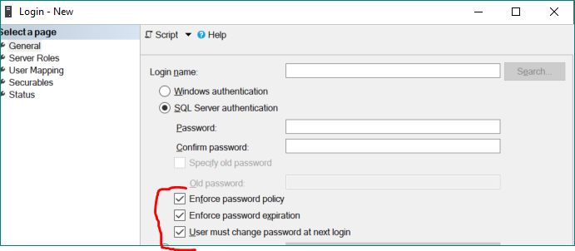
Server roles – tick sysadmin, then click ok.
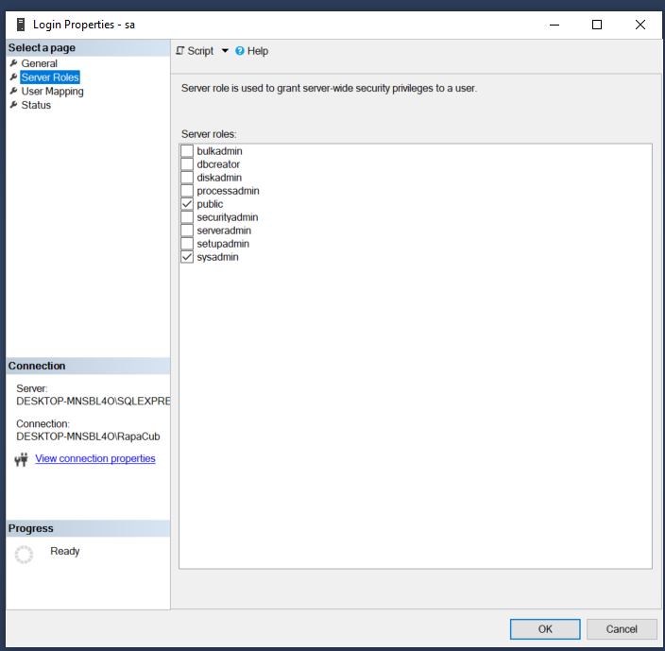

Setting up System Tasks
Setting up system Tasks is a two-step process, as follows:
- Complete the System Task Configuration
- Setup Scheduled Windows tasks (control panel) with administrator permissions using the run command parameters (specified below).

Configuring System Tasks

Below is the System Tasks application:

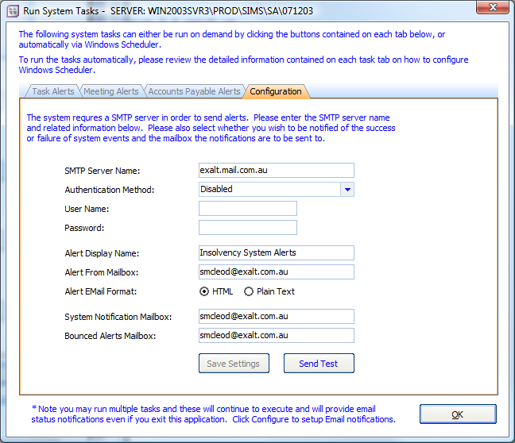

These settings may already be setup if you are using such functions as Electronic Authorisation or the Creditors Portal.
If not you can configure the Email settings here or via Manage Application Settings > Email Settings.

Enter the following information:
SMTP Server Name – the name of your mail server.
An authentication method should not normally be required.

If there is an error connecting to the SMTP Server check whether the server needs to specify a port number with the server IP address (in the format 10.2.3.4, 25).
Ensure the SMTP service is enabled on the mail server.

You should be able to ping and telnet to the server to test the connection.
User – Email address of your firms Insol administrator
Password – Password for the email address of the Insol administrator
Alert From Mailbox – this should be an internal email address (usually the Insol6 administrator)
System Notification Mailbox - this should be an internal email address (usually the Insol6 administrator)
Bounced Alerts Mailbox - this should be an internal email address (usually the Insol6 administrator)
Email Debug file path: A file path to where the debug report will be saved.

Additional information on Configuring the software settings for emails
https://exalt.zendesk.com/hc/en-us/articles/218486707-Configuring-the-software-settings-for-email
Configuring emails for Office 365
https://exalt.zendesk.com/hc/en-us/articles/360000496535-Configuring-Email-settings-when-using-Microsoft-Office-365

Configuring Task Alerts
Task Alert Commands
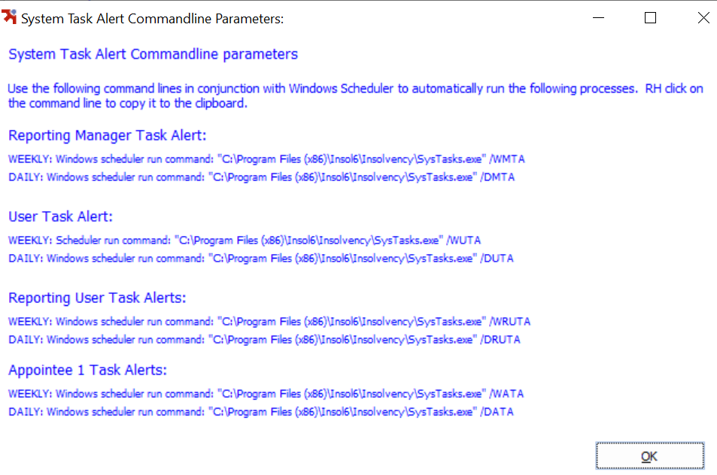
Insolvency alerts run from scheduled Windows tasks which are configured in the control panel of a server machine.

You need to have permissions to create Windows tasks.
Windows 10 - SEARCH TASK SCHEDULER
Windows 7 -http://windows.microsoft.com/en-au/windows/schedule-task#1TC=windows-7
Windows task scheduler can be found in Control Panel-> Administrative Tools -> Task scheduler
Alternatively, you can press Windows key + R then type “tasksch.msc” and hit enter
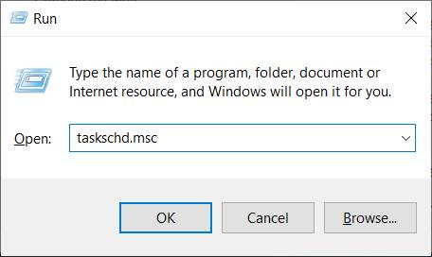

Create Windows tasks for Weekly Reporting Manager Task Alerts (WMTA)
Under Task Scheduler select CREATE TASK
In the GENERAL TAB
Enter the Name: Weekly Reporting Manager Task Alerts
Select: Run whether user is logged on or not
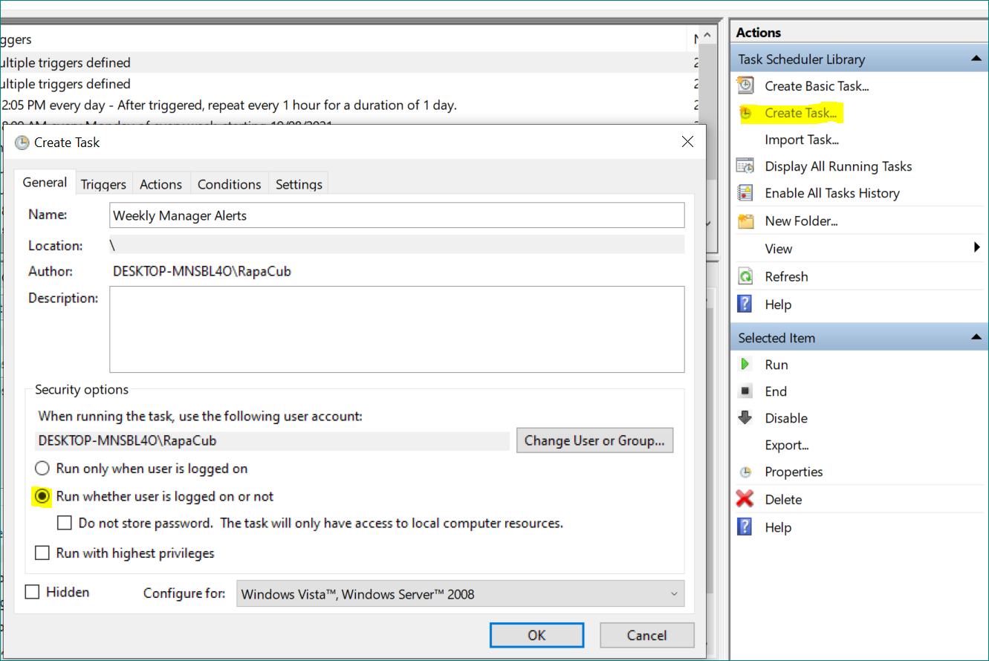
TRIGGERS TAB
Click on the Trigger tab. Click New.
Select the following settings:
Weekly
Start time ??
Recur every ??
Click OK.
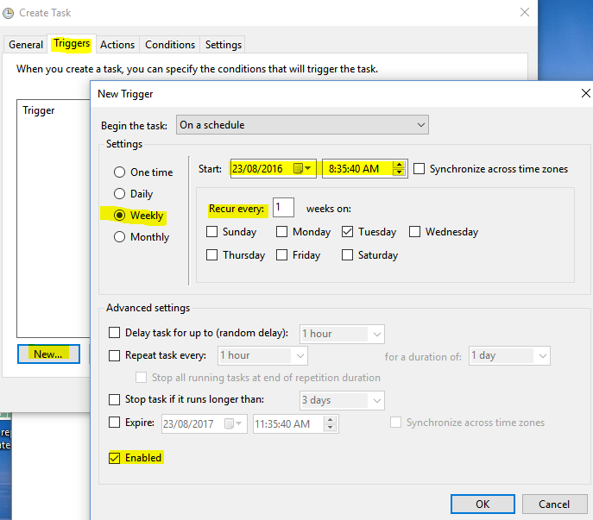

Click ACTIONS Tab.
Click NEW
Click OK

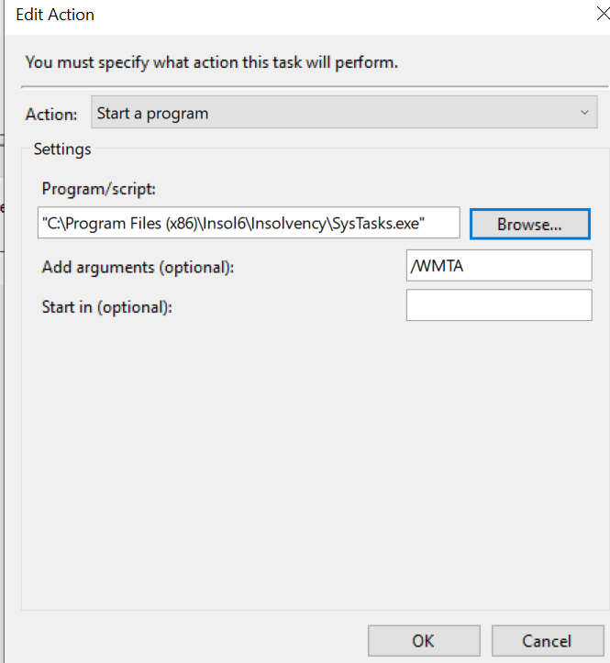

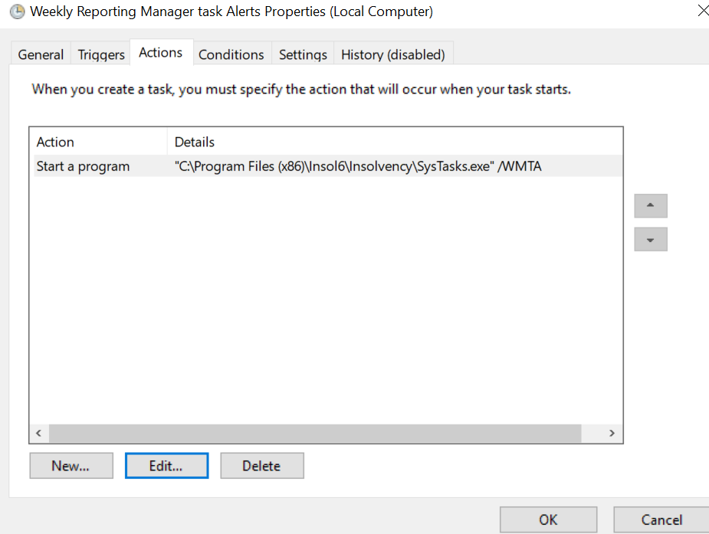

SETTINGS tab
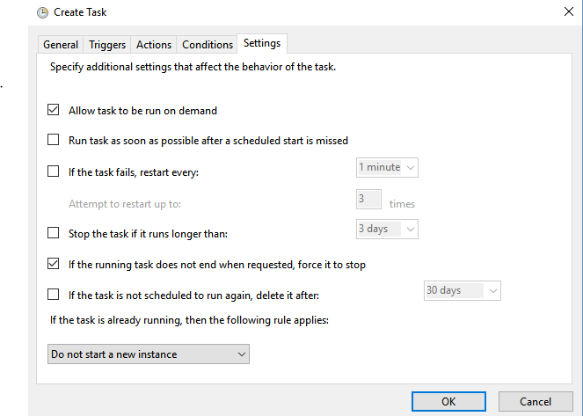

Enter the security credentials. (login details)
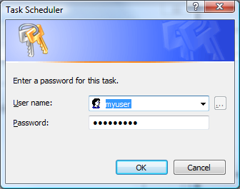

Repeat above steps for setting up Weekly Appointee alerts (WATA) and weekly user alerts (WUTA) or reporting user (WRUTA).

Testing Task Alerts

Once the task has been created, right click and select run.Testing that it runs via systasks.exe will check the database and SMTP config is all correct, but doesn’t check that the task scheduler is working and connecting to the app okay. So to test that you can right click on the scheduled task and click Run to run it manually:
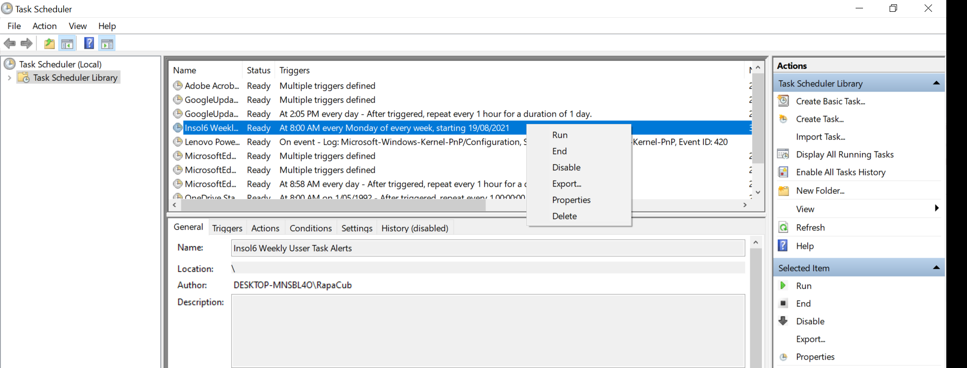

Task Manager should receive a Task Alert email
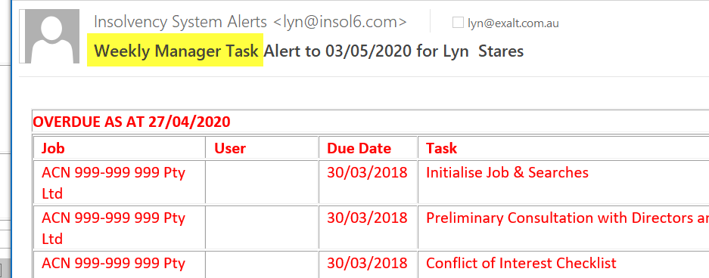

Command Line parameters
Click View Command Line parameters to see the command line that needs to be inserted into the scheduled task.

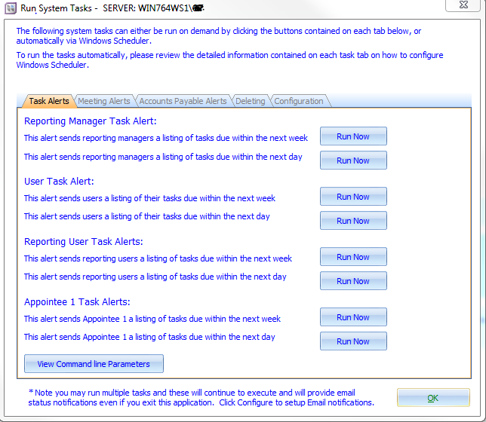

Configuring Meeting Alerts
The following shows the command line options for configuring meeting alerts.
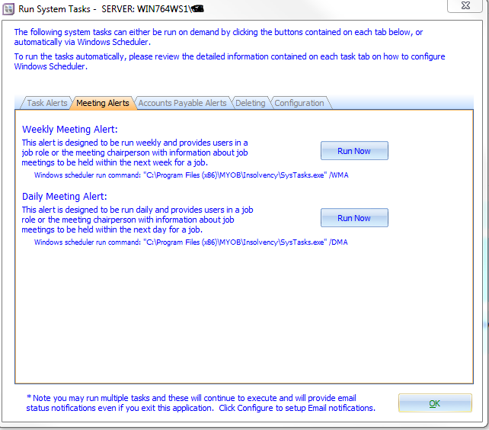

Accounts Payable Alerts
The following shows the command line options for configuring accounts payable alerts.
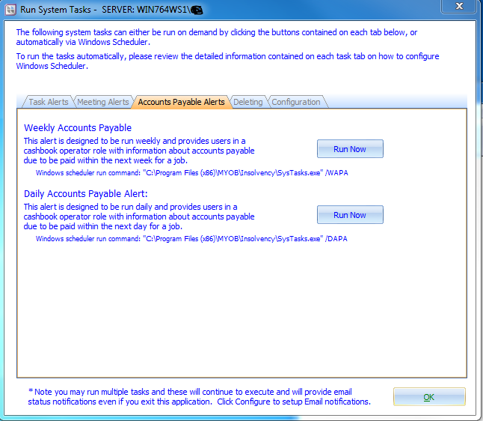

To configure Windows tasks under Windows XP / Windows 2003
The Task Alert Schedule will resemble the following:

