Insolvency Creditors’ Portal

The creditor’s portal provides a website for creditors to manage their claims and receive notifications from external administrators in relation to insolvent entities and debtors.

For an insolvency practitioner, the creditor’s portal is a place to communicate with creditors.

Contents
The Creditors’ Portal: 3
Creditors’ Portal Address 4
On-boarding a Practice 4
Configuring the Secure Web Service 4
Web Service Installer 4
Sub-domaining (Additional Costs quoted) 4
Posting a Job on the Web Portal 5
Viewing the job portal page 6
Synchronication Options 6
Taking down a job from the portal 6
Manual Synchronisation 7
Bank Account Details 7
Configuring the portal to post creditor bank details 7
Entering Counterparty bank details 8
On-boarding / Uploading Portal Creditors 9
Filtering the creditor register by portal status 9
Selecting the portal creditors for upload 9
Uploading creditors 10
Select only one group of portal status 10
Which creditors are uploaded? 11
Alerts to creditors 11
Updating Creditor Claims 11
Determining a creditor’s registration status on the creditor register 11
Counterparty Registration 12
Counterparty consolidation 12
Creditor Registration 13
Configuring User Access 13
Specifying a different User to administer a specific claim 13
Portal code 13
Creditor Event log 14
Uploading Portal Documents 15
Creating a portal message using a mail merge 15
Use of letter packs 15
Contents of the email 16
Additional documents of the letter pack 16
Send files as hyperlinks / Send files as attachments 16
Message Output 18
Review and editing output documents 19
Setting User Access to Portal Documents 19
Requesting Authorisation 19
Document Despatch (Approval, Signatures, PDF, Sending and Publishing) 20
Sending messages to Portal Creditors 22
Pre-requisites 22
Publishing Messages on the Portal 22
Preparing a single document for publishing 27
Publishing a single document on the portal 30
Taking down a document from the portal 32
Web Users and Counterparty access by an alternative user 33
Adding a different admin user for a creditor claim (not using the counterparty email) 33
How do creditors register for the portal? 34
Creditor Registration Process The creditor registration process is as follows: 34
Declarations to receive electronic communications 35
Additional claims for a creditor that has already registered on the portal 35
The portal job information 37
Portal Creditor claims 38
Uploading files in Support of their claims 38
Bank Details 39
Knowledgebase articles for Creditors 39
Submitted Proofs of Debt – How do they appear in the software? 39
Creditor Declaration 39
Uploaded Proofs of Debt Documents – How do they appear in the software 40
Viewing a creditors documents (proof of debt and supporting information) 40
Opening Portal Documents 40
Registering Practice Users on the Web Portal 40
Creditor User Maintenance 41
Supplying ABN details 41
Notifications 41
Adding a Creditor End-to-End 42
Practice User Uploads a Claim 42
Creditor viewing their claims on the portal 43
Practice Users viewing the submitted claims and supporting documents 48
Open the document links 48
Adding an Employee End-to-End 50
Practice User Uploads a Claim 50
The employee may view their details on the portal 51
Dealing with concurrency Issues 52

The Creditors’ Portal:

- Allows practice users to upload creditor communications, debtor information, documents, meeting information and receive claims from creditors.
- Allows creditors to register, login, see debtor information, view their claim information and access documents and communications to creditors
- Allows creditors to complete their proof of debt and attach files in support of their claims
- Information submitted by creditors is automatically updated in the practice database
- Information on creditor read history is automatically updated in the practice database so practices may ascertain which creditors have seen or read circulars
- Allows creditors to securely verify their payment details

- Creditors can vote on Proposals without Meetings electronically
https://exalt.zendesk.com/hc/en-us/articles/360001472536-Creditors-Portal-Voting-facility
Future version release
- Practice users may action payment authorisation via a mobile device, while out of the office without requiring a connection back to the practice network database
- Creditor auto-generated alerts

Creditors’ Portal Address

The creditors’ portal is located at:

https://creditors.accountants

A pre-deployment test site is set up at:

https:// creditors.azurewebsites.net

On-boarding a Practice

Communications between the insolvency database and the Creditors’ Portal is handled by a Windows service. The service watches for updates that practices users send and then publishes data to the portal.

Configuring the Secure Web Service

A secure background service is responsible for automatically uploading data to the website. Once the web service is configured, any job may be enabled to post documents and creditor claims online.

An installer and separate instructions are available for implementing the creditors’ portal InsolData service.

Web Service Installer

Instructions for configuring your practice to integrate with the portal are found here:

https://exalt.zendesk.com/hc/en-us/articles/115000905894-Instructions-to-setup-the-Creditors-Portal

Sub-domaining (Additional Costs quoted)

Sub-domains allow practices to put their own on the data accessed by creditors.
An example of a sub-domain is:
https://insolco.creditors.accountants
Sub-domaining will provide the following additional features:

- Implement your own practice’s unique creditor portal address
- Personalised business logos and branding
- Customise email footers for creditor communications per location
- Filtering data on the creditors’ portal so creditors are presented with practice information

Posting a Job on the Web Portal

Once your database is configured for portal publishing, you can start to publish jobs to the web.
Making a job live

To publish a job to the creditors’ portal:

- Click on the Portal tab
The portal tab appears on the job’s main tab control.
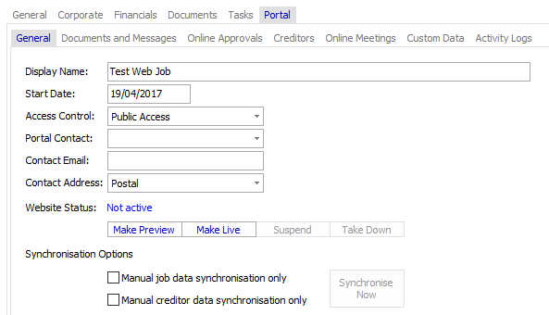
- Complete the portal details
Specify the job’s display name, the access control method, and the contact email details.
Access Control: Set the access control method to “Public Access” or “Require Login”.
If the access level is set to “Public Access” anyone can view the job details, but will not be able to see any documents or claims that are assigned to the individual creditors. This may be advantageous to allow unlisted creditors to contact the practice contact for the job.
If the access level is set to “Require Login” only creditors and document recipients will be able to access the job once they’re log on.
- Upload the Job to the portal

Post the job by changing the portal status by clicking the Make Live button. The website status will be updated to pending upload while the job is posted to the portal.
The job is now live on the portal. Depending upon the access control settings the job information is now displayed on the portal.
- Check the Job is published
Once the job has been successfully uploaded to the portal, the job will display as Published Live. You may click on the Published Live hyperlink to display the job on the portal.

Viewing the job portal page

To view the portal page, click the “Published live” hyperlink on the main “Portal” tab.

Synchronisation Options
The creditor synchronisation method may be set to manual or automatic.
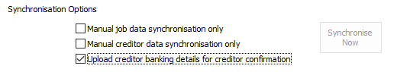

Taking down a job from the portal

To take down a job, click “Take Down” on the main “Portal” tab.

Confirm the action, by clicking “OK”.

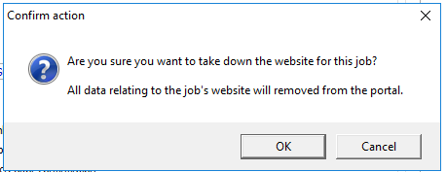

The job has now been taken down from the portal. If you make the site live again, all existing claims and documents will become accessible once more.

Manual Synchronisation

If you do not select manual synchronisation, as you make changes to the job or creditors, the updated changes will be reflected on the portal. You will see messages displayed as the software uploads updates. This is the default operation.
The manual synchronisation settings do not affect the following actions:

- You will always need to perform the initial upload of the job manually
- You will always need to perform the initial upload of the creditors manually
- You will always need to upload documents and messages to the portal manually, documents do not update automatically.

Steps for publishing creditors and documents are described in detail below.

Bank Account Details

You have the option of displaying bank details for unsecured creditors. If you have entered the bank details, creditors may confirm the details are correct if you set this option.

Configuring the portal to post creditor bank details

On the main “Portal” tab, select the portal option to include/exclude the bank details for creditors.

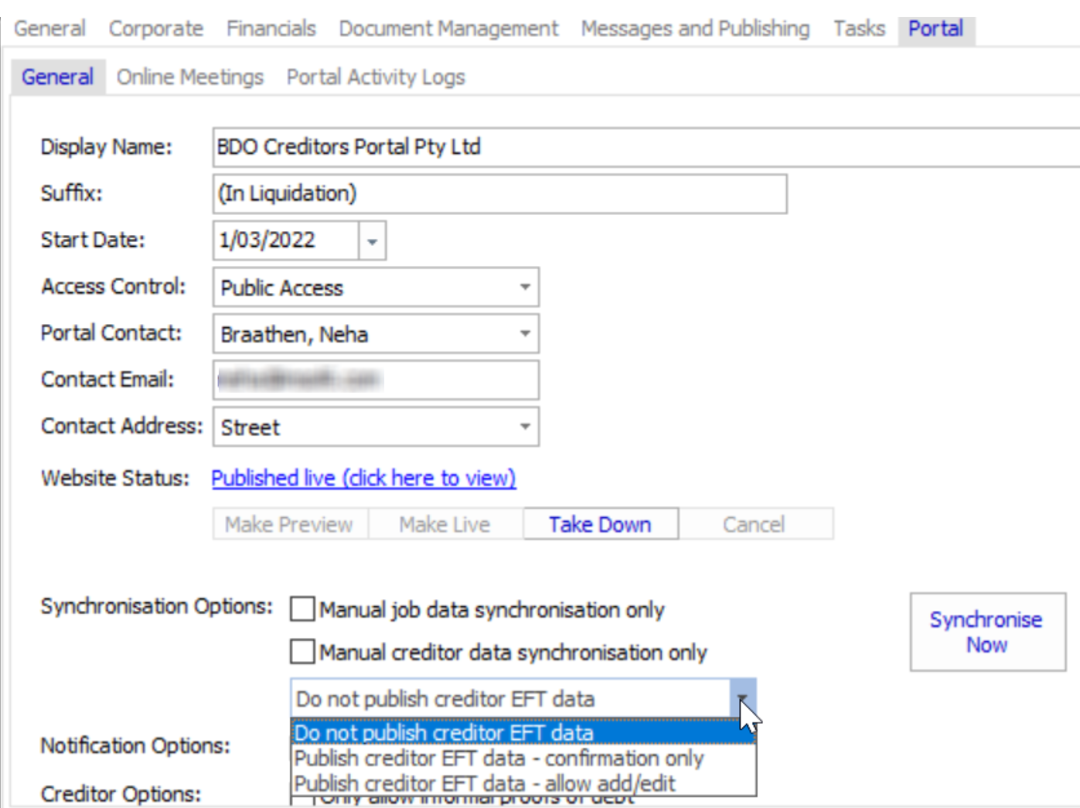

Entering Counterparty bank details

The bank details for counterparties have been expanded in Version 5. Creditor’s Counterparty’s Bank Details can be set in the Counterparty record under the Banking & Advanced tab, as displayed:

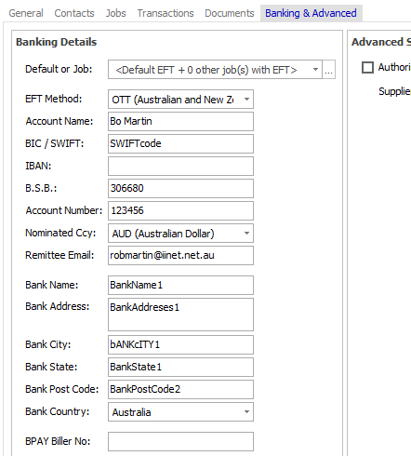

The bank details appear to the creditor when submitting their proof of debt.

On-boarding / Uploading Portal Creditors

Once a job is live on the portal, the portal status of each creditor is displayed in the creditors’ register. When you import or enter a creditor, the portal status will be set to “not uploaded”.

Check the creditor status in the “Portal” tab on the creditor register. You will see different options on this tab if the job is registered on the portal.

Filtering the creditor register by portal status

By clicking on the creditor portal status radio button, you may filter the creditor register by the selected Status.

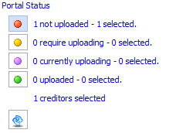

Note: The Portal status button is shaded after the filter is applied.

The list of creditors will change with the filter applied for the selected portal status. Unclick the portal status button to un-apply the filter.
Note: This filter selection will remain applied. Sometimes when you return to the creditor register the portal status filter will be applied as previously selected. If you navigate to another job the filter will be reset.

Selecting the portal creditors for upload

To select the creditors for uploading click “Select” next to the portal status.
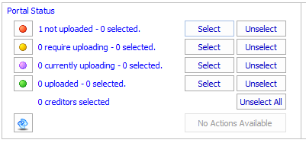
The creditors are now selected for uploading. A tick will appear in the right-hand column for each selected creditor.

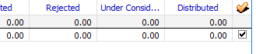
The action button will change to “Upload Selected”.

Uploading creditors

When you select creditors for a portal status, the button will match the feature for the selected group of creditors.

To upload the creditors click “Upload Selected”.

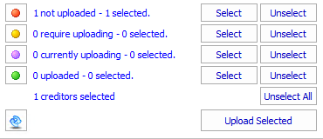

The selected creditors will be set to upload pending. Once the creditors are uploaded, the portal status will be changed to uploaded.

A green status radio button appears against each uploaded creditor in the register.
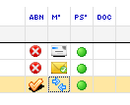

Select only one group of portal status

To perform an action, such as uploading creditors, make sure you have only selected creditors belonging to the same portal status:

Otherwise actions will not be available.

If you have problems uploading creditors, see Trouble Shooting – Exalt (zendesk.com)

Which creditors are uploaded?

All selected creditors are uploaded to the creditors’ portal. Generally, you would select all creditors for uploading to the portal, so, when they choose to register they will have immediate access to their claims and documents.
Note: Even though the claims have been uploaded to the portal, if the creditor is not registered then the creditor will not be aware the claim is available unless you communicate with the creditor.

Alerts to creditors

Alerts are yet to be configured, but, when they are configured the creditor will receive automatic updates of any changes to their claims via an auto-generated email. Recipients that have email addresses, but, have not registered will also receive auto-generated emails to encourage them to log in and view their details online.

Updating Creditor Claims

Depending upon the synchronisation settings, you may need to upload any updates you make to creditor claims.

Determining a creditor’s registration status on the creditor register

You can determine the registration status of a creditor, i.e. whether a creditor has logged on to the portal, from the creditor register by navigating to the filter views available on the Circulars & Mailing tab.

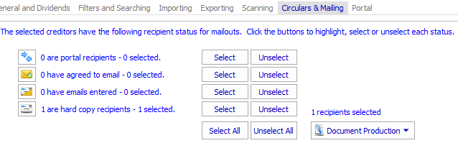

Creditors have the following statuses:
“Portal recipients” are creditors that have registered on the portal.

“Agreed to email” are creditors that have agreed to receive email notifications but have yet to be registered with the portal.
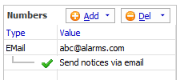

“Have emails” are creditors that have an email address entered, but you don’t have any specific guidance on whether the creditor has accepted email communications. This is the default option for setting up a creditor.
“Hard copy recipients” are creditors that have specifically asked for hard copy notifications.

If you open an unsecured creditor you can mark the creditor as
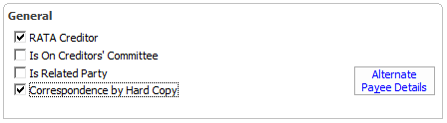

Counterparty Registration
When a creditor registers, the counterparty in the practice database is marked as a registered “web counterparty”.
This logo moniker appears for registered counterparties.

Counterparty consolidation

When using the counterparty lookup for entering transactions or entering creditors, the registered portal counterparties show at the top of the list for selection. These enhancements result in a more consolidated approach to counterparty management. Previously, users were not presented with an easy way to determine which counterparty record was the single source of truth. Now, web registered counterparties appear at the top of all lists for selection.

Additionally, the process for consolidating counterparties has been improved within the software functionality.

ABN Lookup

An “ABN Lookup” feature has also been added in the software when adding counterparties. The look up facility provides the ABN number and the correct business name. Rather than using free txt to enter a counterparty’s name, now, the organisation you’re dealing with has been correctly identified against the ABN register.

You may also use the drill down features on the ABN Lookup to determine whether each organisation is tax registered.

There is now validation on the counterparty ABN. If another counterpart exists with the same ABN then a validation warning appears. This further helps reduce the duplication of counterparty records.

The creditor will confirm their own ABN and entity name
You may still add a counterparty that may not have an ABN entered or doesn’t use the name sourced from the ABN register.

When a creditor registers on the web, however, the creditor user is required to identify their correct ABN and name (unless the creditor is an employee). When the counterparty data is updated to the practice database the name and ABN is updated correctly.

All counterparty changes are detailed in the Version 5 software release notes.

Creditor Registration

The process for registering as a creditor is described below.

Configuring User Access

User access is ultimately determined by the creditor. The creditor will create their user profile on the creditors’ portal, verify their email address and then enter their creditor portal code. This creates a link between a registered user account and a creditor claim.

Despite this process, by selecting a counterparty or contact, the practice user determines which email address is used to communicate with the creditor until the creditor registers.
The email address for communicating with portal recipients is the same method used for communicating with email recipients. The screenshot below shows the counterparty numbers:

Specifying a different User to administer a specific claim

There may be cases where a creditor may have a different user to administer one claim as compared to other claims. In this case you can specify a different user (email address) by setting a contact person for correspondence a specific claim.

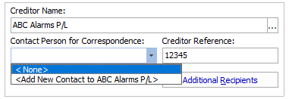

In this case, the creditor record uses the contact email address, rather than the default counterparty address.

Portal code

Users registered on the portal create a link to their claims by using a unique creditor portal code. The portal code is displayed on the creditor claim “Portal” tab.
A merge field allows you to send letters or emails via “Circulars and Mailing” to communicate the portal code to creditors. The portal merge field code is «PortalCode».

The portal code is located on the “Portal” tab of the creditor details page, however, users will not necessarily need to know the code, only how to send correspondence to creditors.

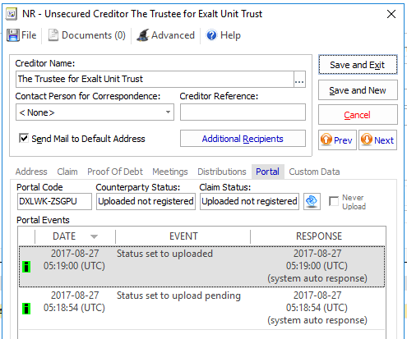

Creditor Event log

The creditor event logs tracks portal events to give you a history of interactions with a portal creditor.

Uploading Portal Documents

There are several ways to upload documents to the portal:

- Outputting a merge document or letter pack creates a portal message
- Upload a single document

Creating a portal message using a mail merge

When producing a merge document or letter pack on a portal registered job, the software will:

- Create a message to be sent as an email to portal registered users and agreed email recipients, and
- Prepare the documents for publishing on the portal
- Prepare a hard copy
When running document production (“Circulars & Mailing”), the document options are displayed below:
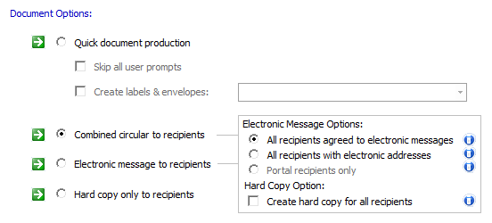

When a document is created for a portal registered job and the job has portal or email recipients, the software creates a message. The message can be uploaded to the portal and an email message may be sent to the recipients.

Use of letter packs

By using letter packs you can specify a header document, which contains the contents of an email that will be sent to creditors:

The letter pack below shows the “Initial information to Creditors”.

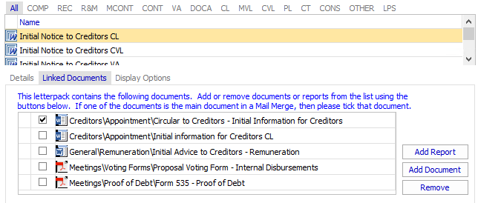

Contents of the email

When using letter packs for portal communications, the main document provides the content of the email sent to creditors. The main document is denoted with a tick next to the document template in the letter pack.

Additional documents of the letter pack

The other documents in the letter pack are additional documents that are sent to the creditor as attachments to a message.
Editing the documents following document production
Once you complete the data production wizard, you may access the output documents and edit these documents prior to uploading the documents to the portal or sending.
The documents can be either single “pro-forma” documents or personalised merge documents.

Send files as hyperlinks / Send files as attachments

When creating messages to recipients, the user can determine whether “additional documents” are sent as attachments to the email or hyperlinks to a portal location. The additional documents are posted on the portal regardless, so creditors can logon to the portal to retrieve the documents.
The text of the email content needs to be reviewed to reflect the practice policy to suit the publishing workflow.
There is new document template content available in the application for communications to creditors.
The screen shot shows the document production wizard for portal and email messages. A letter pack example is shown where the header document text appears as the text of the email message and the additional documents appear as attachments.

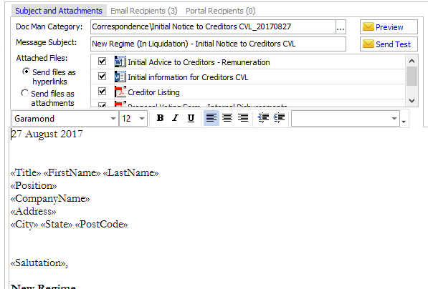

By selecting the default option “Send files as hyperlinks” the software will post attached documents to the creditor portal when uploading the message.

When selecting the option “Send files as attachments” documents will be converted to PDF documents and sent as attachments to email messages. The documents will also be posted on the creditors’ portal.

Message Output

Once the document production wizard is complete, the screen shot shows the portal message output.

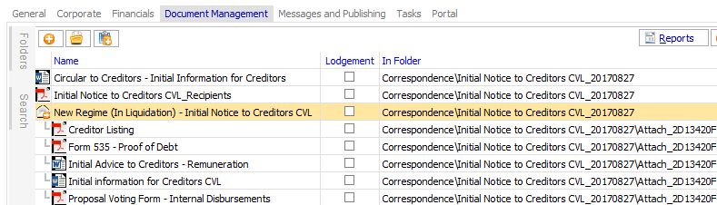

The output shows:
- A hard copy MS Word version of the message (This may be sent to hard copy recipients)
- A record of the recipients in a PDF document
- The portal message or email
  - The header message containing the email text
  - The document attachments
A portal message or email will only be created if there are portal or email nominated recipients.

The hard copy
This document may be mailed to each hard copy recipients. The hard copy recipients are recipients that haven’t registered on the portal or haven’t nominated to receive communications via an email address.
A data source of a hard copy mail merge can contain all creditors, provided you select the option for creating a hard copy for all recipients. See the tick box “create hard copy for all recipients” below:
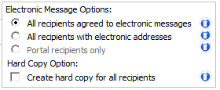

The message

The message is a container for communications to creditors either via email or on the portal. The message provides a way to consolidate communications to creditors.

Review and editing output documents

Once you have created the document outputs you are free to edit the pre-merged documents by double opening and editing the documents.

Open the documents using the user interface by double clicking on the document outputs.

Setting User Access to Portal Documents
Before documents can be published you need to set user access. When you create a document from a mail merge the recipients of the mail merge are automatically configured with permission to access the documents on the creditors’ portal. When posting individual stand-alone documents to the portal you will need to configure user access (discussed separately).
The steps for setting access are provided in the examples illustrated.
Requesting Authorisation
All documents posted to the portal need to be authorised. A “Review” stage has been added to document production that will allow you to create the document outputs and view and edit the outputs before sending the documents for authorisation.
You can right-hand click on the document from Messages and Publishing tab and select “Request Authorisation”.
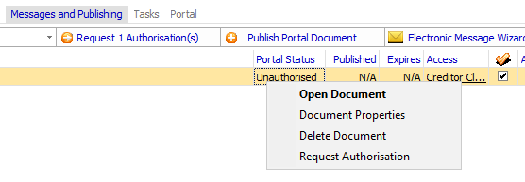

The authorisation recipient selection form appears.
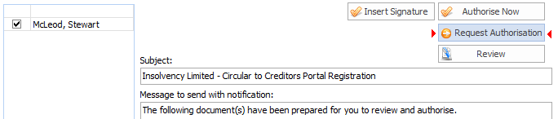
Select the appropriate person with document authorisation permissions and click “Next”.

Document Despatch (Approval, Signatures, PDF, Sending and Publishing)

Document authorisation has been enhanced. A new form has been developed that allows authorised users to approve or despatch documents.
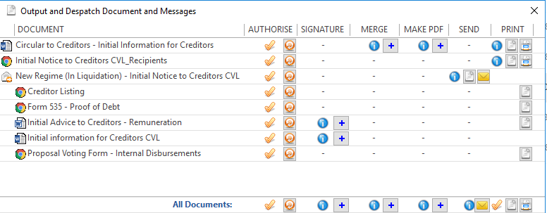

Document approval may be initiated through the document approval tasks, directly from an email or from the document.

If you access document approval directly from task notifications you receive via email, the approval process runs from a separate application rather than opening the insolvency software.

Authorisation

Each document with in a message may be authorised separately or click on the “All documents” authorisation line to authorise all documents.
Alternatively, if you have permission to authorise a document, you may select the “Authorised” button and click “OK”.
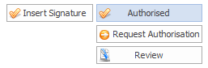

Inserting signatures

The method for inserting signatures has been separated from the document production process into the authorisation stage. You may access inserting signatures from the document despatch and authorisation form. If a document has not had a signature inserted a warning will appear before a document is uploaded (sent) or despatched.

PDF Conversion

You may convert documents into PDFs to ensure they are not edited after they have been signed off. The MS Word version of the documents are stored so you can always access the original editable source documents for any reason.

When letter pack documents are sent, the attached documents are automatically converted to PDF, so you don’t need to do this process before sending portal messages.

Publishing
When a document has been authorised you may publish the document.
Once authorised, the document portal status should now display as “Unpublished”. The document is now ready to publish.

Sending messages to Portal Creditors

Pre-requisites

To send email messages to creditors, you must have the SMTP server settings configured in the software’s Application Settings.

Publishing Messages on the Portal

When a message has been created, the document publishing is available on the “Messages and Publishing” tab. When a document is output that contains email recipients or portal recipients.
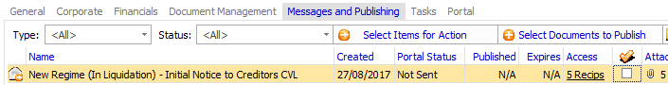

You may filter the portal messages list to include any unsent messages.

Sending messages
To send a message:

- Select the message
Tick the message you want to send.
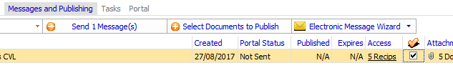

- Click Send Message
Validation warnings may appear to assist users. For example, a warning will appear if you have already sent the message or if one of the attachment documents contains a signature that has not been populated.
Once the validation messages have been dealt with, the Send message dialogue appears:
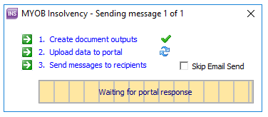
- Click Send
The messages are now being sent.
System Tray alerts
System tray alerts will keep you updated on the progress of sending messages and identify any wrong email addresses or issues with documents not posted or not sent.
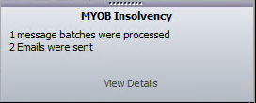

View message properties (message log)
Any issues with sending messages can be viewed in the message log. To view the Message Log, right-click on the message and select “Message Properties”.
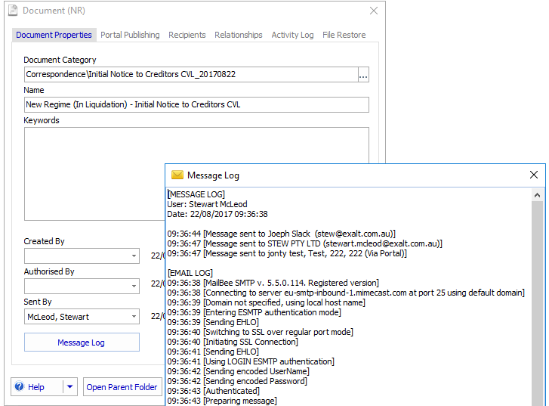
Click the “Message Log” button to view the message log details.

The following screen shots show documents published to the creditors’ portal.
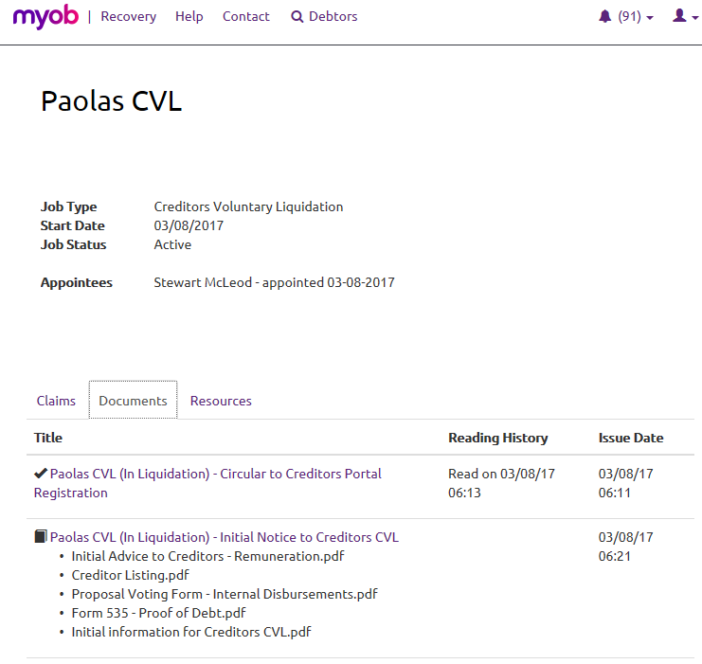

Shown above is:
- A single merge document that was created as a portal message.
- A letter pack containing a message header and subsidiary document attachments
The screen shot over the page shows the detail of the letter pack and access to the attached documents.
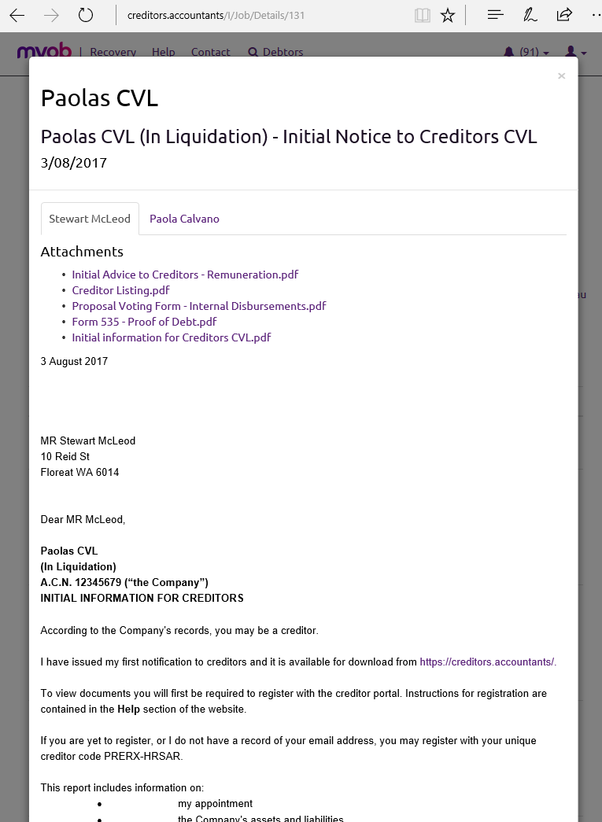

The letter pack and the attached documents.

Preparing a single document for publishing
To prepare a document for publishing on the portal:

- Add a document
Select the “Publish Portal Document” on the main “Messages and Publishing” tab.
- Locate the document
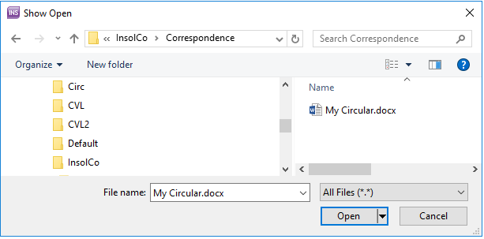
Click “Open” and you will be prompted to add the document to document management.
Note: You may also drag-and-drop documents onto the “Messages and Publishing” tab.
- Add to document management
If the document is already in document management then the record will not be added twice. Otherwise follow the steps to add to document management.
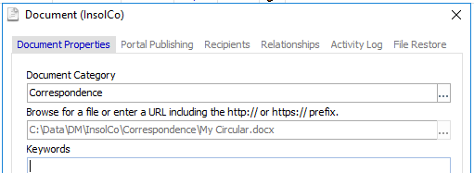
Confirm the “Add this file to document management”.
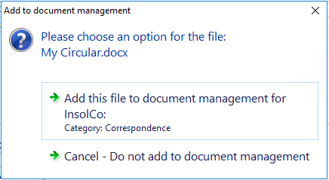
The document is now added, but, you will need to set the creditor access permissions to be able to publish the document.
- Setting User Access
Before documents can be published you need to set user access.

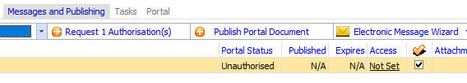
Click on the “Access” column next to the document to set access. The portal document access options appear.
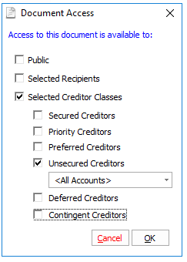
Choose the options and click ‘OK’.
- Document Authorisation
Once you the document is authorised, it is available for publishing.
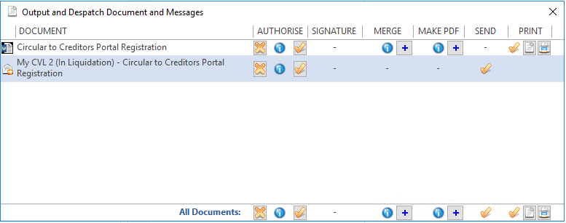

Publishing a single document on the portal

To publish a single document on the portal:
- Select items for publishing
Filter the “Messages and Publishing” tab to view any unpublished documents. Place a tick in the column to select the document.
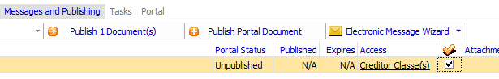
- Click Publish documents
- Click OK to confirm
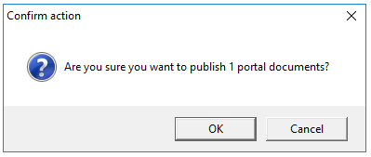
The document has now been submitted to the portal.
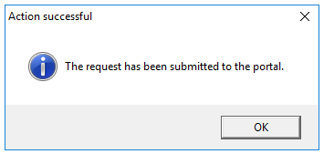

Previewing the document
To see how documents are viewed on the portal, you can temporarily post a public document and open the job’s portal page.
To view the portal page, click the “Published live” hyper link on the main “Portal” tab.
The screenshot shows how documents will appear for creditors on the portal.
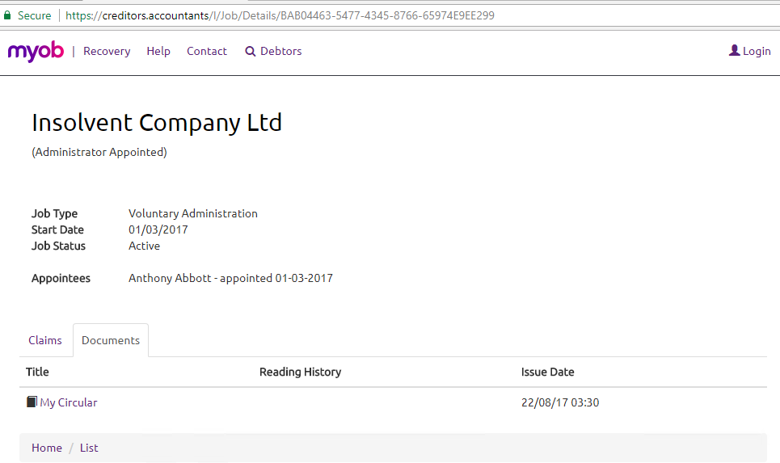

Note: If specific access is configured to a document, only those specific recipients will be able to view the documents.
If you want to change user access to a document, you first need to “take down” the document from the portal.

Taking down a document from the portal

To take down a document or a message:
- Navigate to the “Messages and Publishing” tab.
- Filter the Messages and Publishing list by Messages - Sent
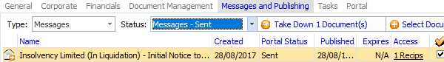
- Click Take Down
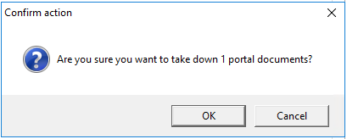
Click “OK” to confirm
- The document is now removed from the portal
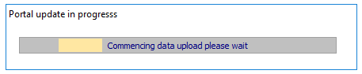
The document is now taken down from the portal

Web Users and Counterparty access by an alternative user

In normal circumstances the Counterparty Email will determine the admin user for the creditors’ portal.

If you want to add a different user to access the counterparty record then you can set the Contact Person for Correspondence. The contacts email will be set to the admin user.

Adding a different admin user for a creditor claim (not using the counterparty email)

To add an addition recipient for the creditor:

- Open the creditor record
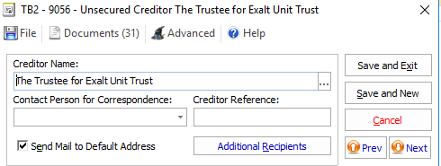
- Click Additional Recipients
- Select a contact
- Enter the user details for a contact
Make sure ‘Send notices via email’ is ticked
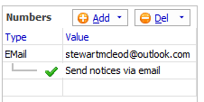
The creditor should require uploading to the web.
- Upload the creditor

How do creditors register for the portal?

The workflow for registration is as follows:
Send Notification
See the example provided to send an email notification or hard copy document to creditors.
The notification will provide a website address and registration code to the creditor.

Creditor Registration Process
The creditor registration process is as follows:

- The creditor is directed to the creditors’ portal site
The creditor will receive either email or hard copy communications directing them to the creditors’ portal. There is a specific URL provided that will take directly to a job’s home page.
The creditor navigates to or clicks on a provided link to the creditors’ portal website.
Note: If using sub-domaining the portal may be styled to suit each practice.
- The creditor registers as a user
- The user verifies their email address
- The user logs on
- The user creates a link to a unique creditor portal code
- The user confirms their ABN as part of the registration
(Employees do not need to provide their ABN).
- The user makes a declaration on behalf of the creditor to receive delivery of documents electronically
The creditor is now associated with the portal and can view their jobs and any associated documents relevant to them.
The creditor may have a claim uploaded to the website by an insolvency practitioner, and the creditor may submit their proof of debt and view any associated documents published to the portal.

Declarations to receive electronic communications

As part of the web registration process, creditors must make a general declaration to receive correspondence from insolvency debtors electronically.

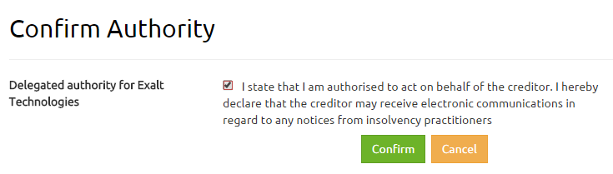

Additional claims for a creditor that has already registered on the portal
The creditor (“web counterparty”) only needs to register once. If another claim is added in the software and the registered web counterparty is selected as the counterparty on another claim, the “web counterparty” will be automatically associated with the claim.

Forgetting Passwords

If a creditor is already registered then use the “forgotten password” feature to access the account.

If the counterparty is not linked to any jobs then:
- Make sure the counterparty has a creditor claim
- Provide the creditor code so the creditor may link to the claim

A logged in creditor

Once a creditor has logged in they will see the following view:

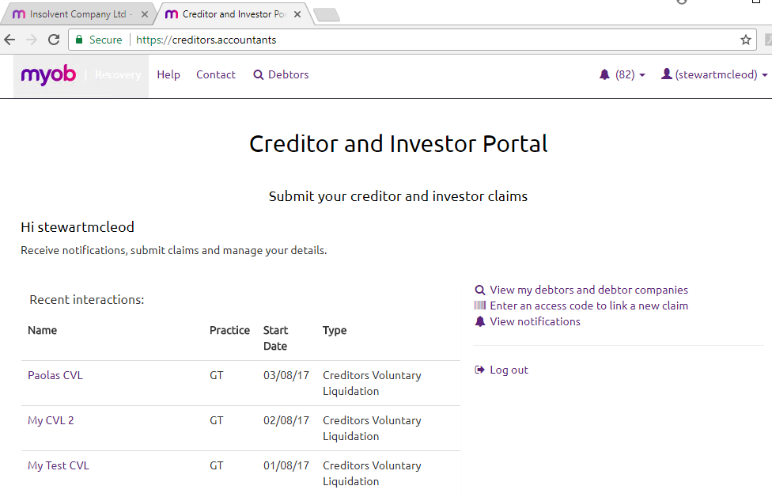

The portal job information

Each job has its own home page.

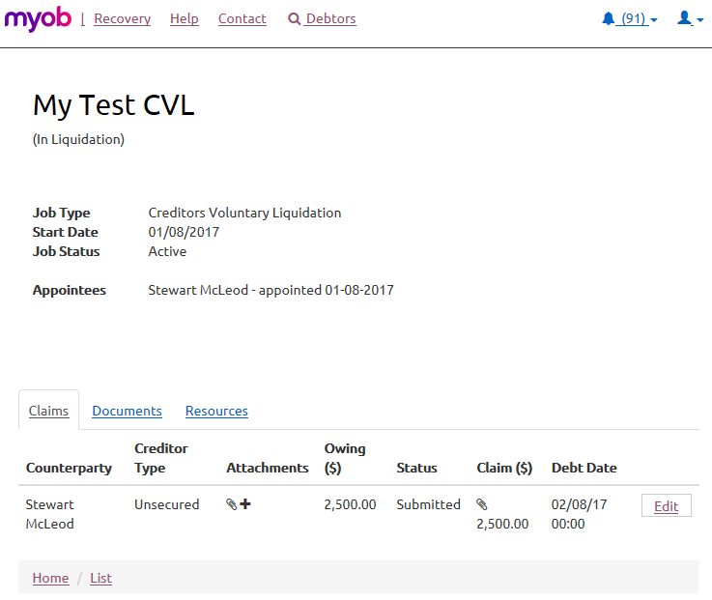

Portal Creditor claims

Creditors are presented with their claim information and may complete a proof of debt form.

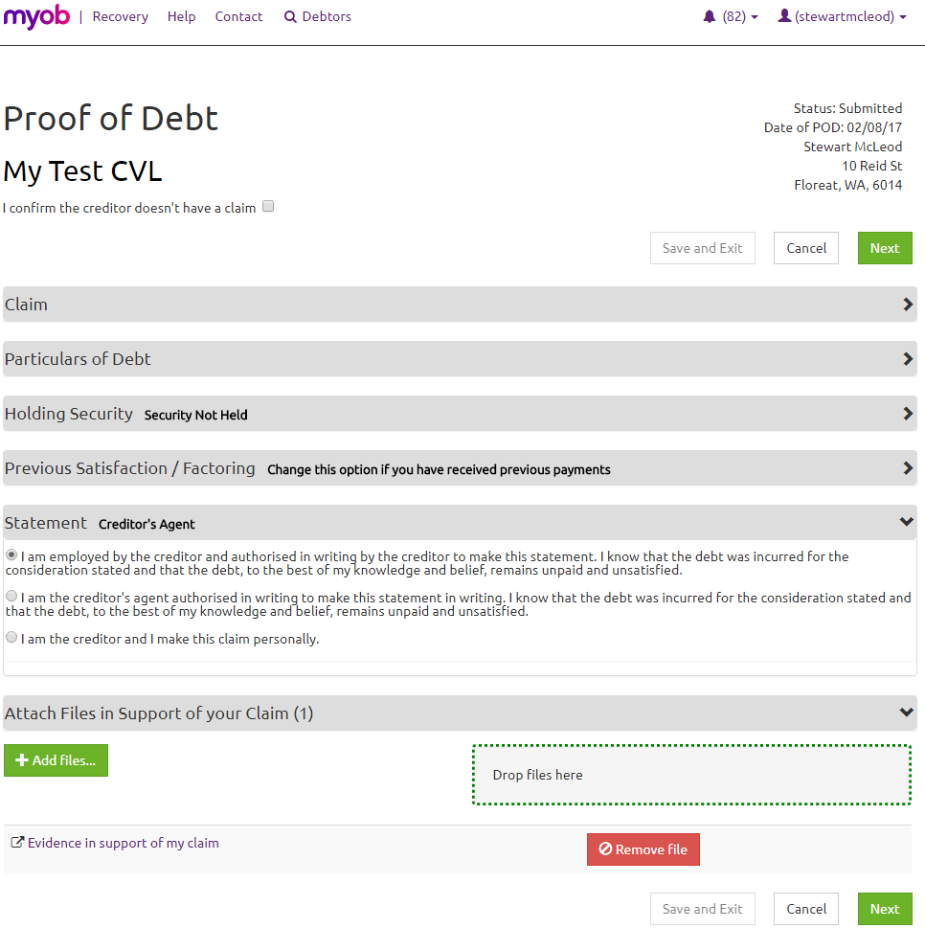

Validation warnings will ensure creditors complete the correct information.

Uploading files in Support of their claims

Creditors may upload documents to support their claims.

Bank Details

By selecting the portal option “Upload bank details”
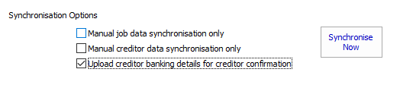

The bank details will display on the creditors proof of debt.

Knowledgebase articles for Creditors

A help website is available for creditors at:

https://creditors.zendesk.com

Submitted Proofs of Debt – How do they appear in the software?

Online submission by a Creditor of a Proof of Debt (POD) will send the POD form and any attached documents (as URLs) to the Practice, and the Job will be updated. No notification to the Practice User is sent, at this time, and the Job (if open during the arrival of new PODs) will have to be refreshed.

Creditor Declaration

At the completion of the Proof of Debt form the Creditor must declare that have the authority to submit a claim.

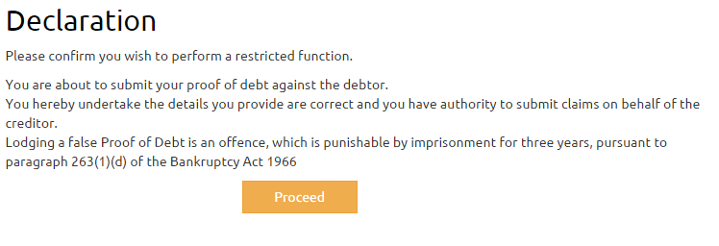
Note that the Corporations Act 2001 states that same rules for corporate jobs are to prevail and be observed with regard to debts provable as are in force for the time being under the Bankruptcy Act 1966
http://www.austlii.edu.au/au/legis/cth/consol_act/ca2001172/s553e.html

Uploaded Proofs of Debt Documents – How do they appear in the software

Any documents that are generated or attached to the Proof of Debt are saved online and when the POD is submitted they are sent to the Practice as URLs. The Practice User can access the documents by clicking the URLs, note: that registration and logon must be completed to access the document(s).

Viewing a creditors documents (proof of debt and supporting information)

An uploaded document may be viewed by the Insolvency Practitioner to assist with processing the claim by:
- Opening the Job’s Creditor and viewing the attachments by hovering over the paperclip icon.
- Opening the Job’s Creditor and Opening the Document List.

Opening Portal Documents

To open an online Portal document, click on the Hyperlink in the software and logon to the Web Portal. To view a creditor document a practice user needs to register with the creditor portal.

Registering Practice Users on the Web Portal

A practice user needs to register with the creditors’ portal.
https://creditors.accountants/Account/Register/practice

When a user registers with the same domain as the practice (and can confirm by receiving a verification email) the practice user will have access to your practices creditor documents.
Note: the link to the creditors’ documents may only be accessed through the software and the document link provided to the practice user is only accessible through a session that is available for a short-period of time.

Creditor User Maintenance

A user can maintain their own user information and link to additional creditor claims.

User Details
When a user registers for the first time they will be asked to enter their First Name and Last Name.

If a creditor uses a different email address to register than the practice has recorded the practice user would have to update the counterparty’s email address for future communications to be directed to a different email.

When alerts are activated then newly registered email will be alerted of any updates to documents and claims.

Change Password
The user can change their password.

Linking creditors

The user can link to other creditor claims by entering the creditor codes.

Supplying ABN details

For companies, the registration process validates the name of the creditor with ASICs business register and prompts the creditor to confirm a unique ABN number.

The creditor must use their supplied creditor code to access any creditor information and submit claims.

Notifications

Notifications show for creditors when they receive messages or have a claim updated for one of their debtors (jobs).

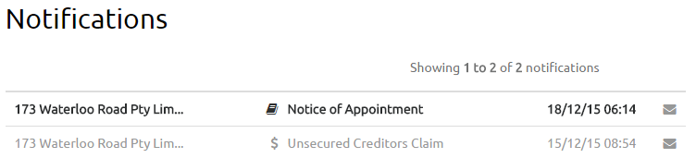

Adding a Creditor End-to-End

The process is summarised as follows:

- Practice User Uploads a Claim
- Creditor Registers and views documents and submits claims
- Practice User views the submitted claim and supporting evidence

Practice User Uploads a Claim
- Ensure the job is portal enabled job
- Add a creditor
  - With an email address
If you add an email address to the creditor register, the creditor can receive notifications and alerts vial email even if creditor is yet to register on the portal.
  - Without an email
Even if you don’t add an email address to the counterparty, the creditor will be posted to the web, regardless.
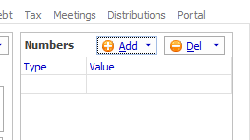
The counterparty receives a hard copy of the registration details and creates a user profile. The creditor may still create a link to their creditor claim on the web using their code as described below.
- Select the added creditors for uploading
When you add a creditor the status is set to not uploaded.
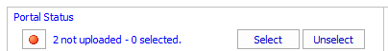
Select the creditors by clicking “Select”
- Upload
Click upload selected.
- Portal upload progress
As the data is uploaded to the portal the progress bar appears.
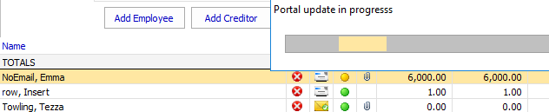
The data is now uploaded to the portal.
Creditor viewing their claims on the portal
Creditors will need to follow these steps:
- Register as a portal user
- Verify their email address
- Logon on
- View their claims
- Submit claim
- Add Supporting documentation

Register as a portal user

See the creditors’ portal for instructions on user registration.

Completing the verification

See the creditors’ portal for instructions on completing an email verification.

Login in

See the creditors’ portal for instructions on logging in.

Viewing claims

Once logged in, a creditor can view their linked claims from their home page. This is the view a creditor sees when logged on:
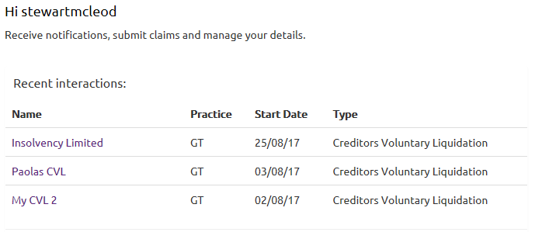
Drill down on the external administration to view your claims
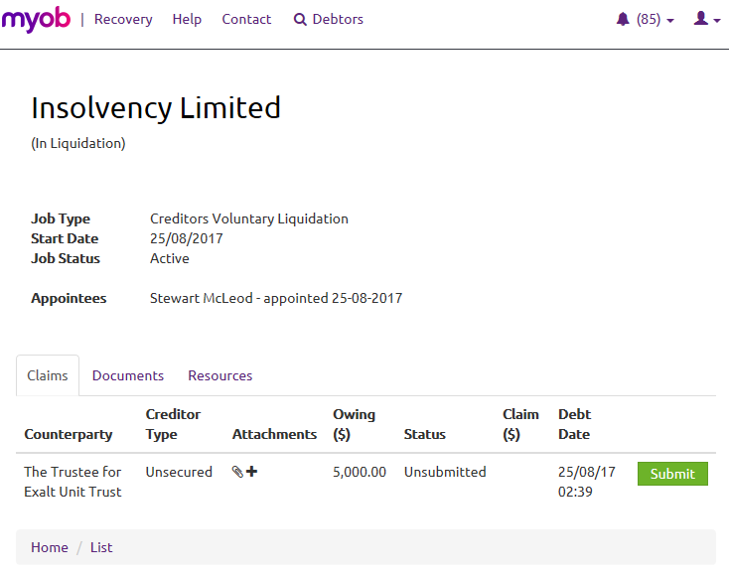
Click on Submit to view the proof of debt details

Complete each section of the proof of debt
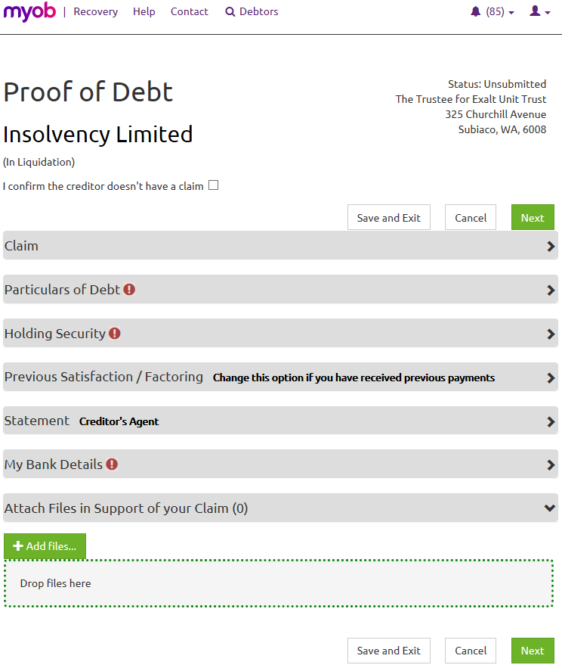

Complete all the sections of the proof of debt by entering the relevant information:
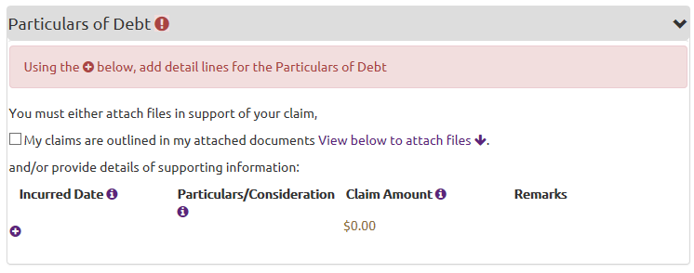
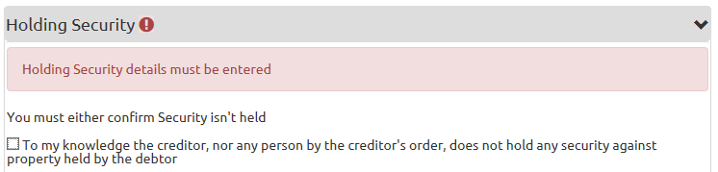

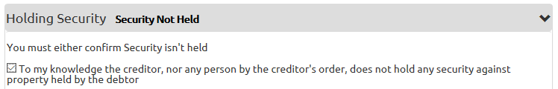
Upload files in support of your claim

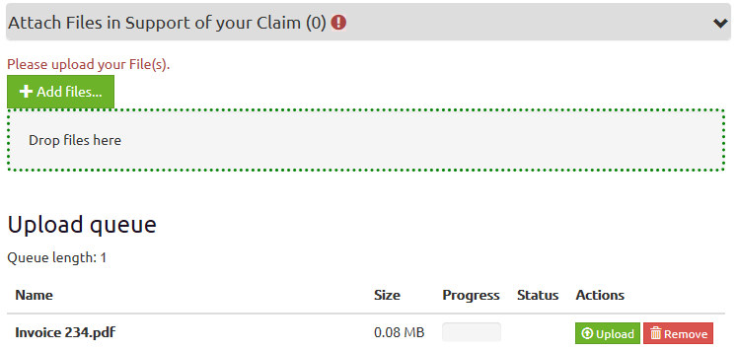

Click Next.

Submit

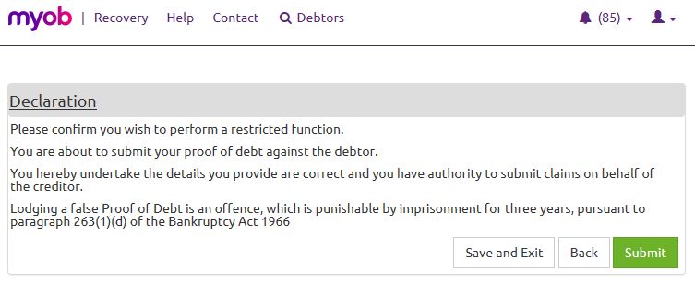

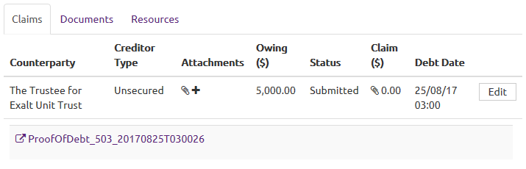

Practice Users viewing the submitted claims and supporting documents

When the creditor submits a proof of debt the claim information is saved back to the database.

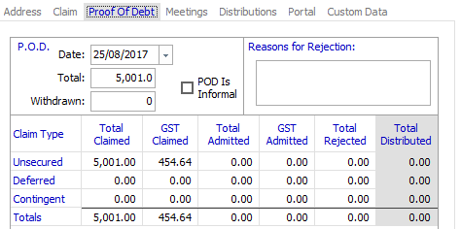

You can see above the creditor proof of debt automatically entered into a creditor’s claim. The URL link to the proof of debt document along with any supporting documents such as invoices are stored against the creditor’s claim in the practice database.

The PDF version of the proof of debt and any information uploaded is saved to a centralised document store. To access these documents:

- Log on to the creditor portal
- Double-click on the document links

Open the document links

You may access the document links directly from the creditor register using the paperclip icon appearing next to the creditor, or

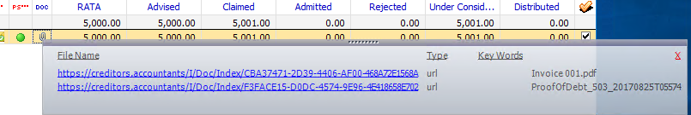

Access the document list from the creditor details form.

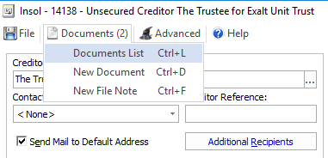
The document list is shown below:
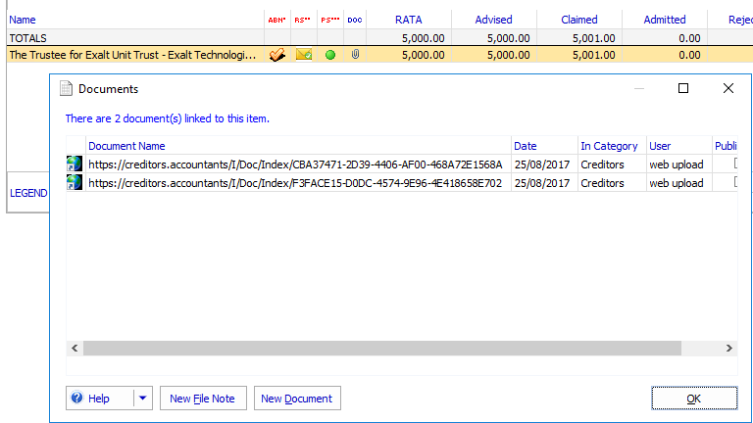

Adding an Employee End-to-End
The process is summarised as follows:

- Practice User Uploads a Claim
- Creditor Registers and views documents and submits claims
- Practice User views claims and supporting evidence

Practice User Uploads a Claim

- Working on a portal enabled job
- Add an employee
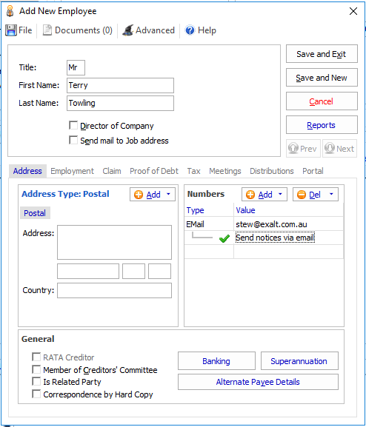
If you add an email address then the employee will receive notifications vial email.
- You don’t need to add an employee email address
Even if you don’t add an email, the employee will be posted to the web, regardless.
The employee would receive a hard copy of the registration details and create a user profile. The employee may still create a link to their creditor code as described below.
- Select the creditors for uploading
- Upload
The employee may view their details on the portal
View your employee details on the Portal
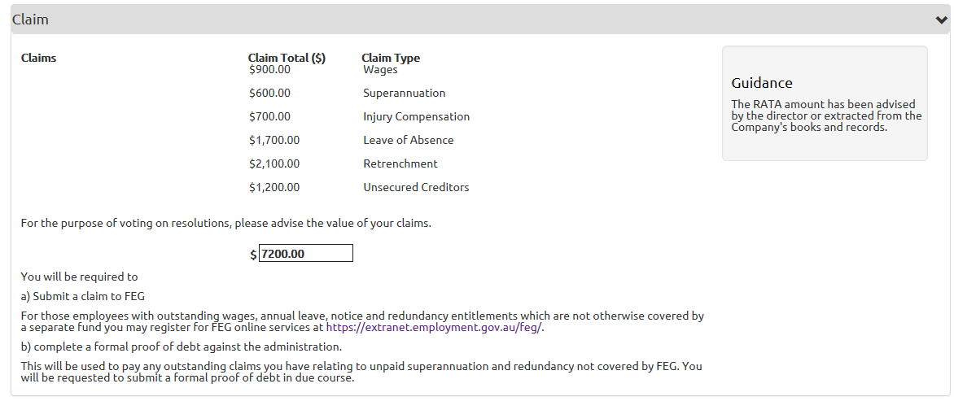
- Register as a portal user
- Confirm email address
- View claims
- View documents and messages
- Submit a claim
- Practice User reviews the employee’s claim

Dealing with concurrency Issues

Concurrency describes an update of data that occurs simultaneously, this may very rarely occur (if ever) where a practice user changes data at practically the same as a creditor.

If this does occur then the creditor’s update may be added to the portal messages.

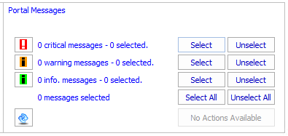

The portal message contains all the information submitted by the creditor to ensure the creditors update can be processed.

The practice user will need to action any critical warning messages to ensure any concurrency issues are resolved and all the claim information is received from the creditors.

